## School of Physics and Astronomy

### PX4310 Project Session 2014-2015

### MPhys Project Interim Summary Report

### Project Supervisor: Matt Griffin & Chris North

### Project Assessor: Steve Eales

### Title: Characterising inter-stellar dust with Herschel SPIRE

### Name: Tom Badran

### 1. Project Goals

1. Review relevant physics and astrophysics and how Herschel/SPIRE work

2. Assist the SPIRE Post-Operations Team in the evaluation of the HIRES routine to enhance angular resolution of SPIRE maps through

* Investigation and characterisation of artefacts and flux conservation in maps
* definition of metrics for map quality, including evaluation of the scientific advantages of using HIRES and how these may depend on S/N ratio
* Definition of S/N thresholds for application of the HIRES technique
* Investigate the scientific advantages of HIRES by analysing images of resolved galaxies, constructing and comparing temperature and dust emissivity maps both with and without the application of HIRES
* Consider other investigations emerging from this work or other aspects of the SPIRE Post-Operations programme, as appropriate (to be reviewed roughly at the mid-way point)

### 2. Introduction

#### 2.1 Black Body

All thermal bodies emit EM radiation, a body in thermal equilibrium with its environment will emit according to a black body spectrum. While classical descriptions explained a portion of this radiation, it was not until 1900 that Max Planck described this emission fully. The black body emission is described by the following equation given in terms of both wavelength and frequency [1]:

#### 2.2 Herschel SPIRE

The Herschel space telescope was launched by the ESA on the 14th of May, 2009, observing in the infrared and submillimetre range of the EM spectrum, using a Cassegrain design with a 3.5-m primary mirror. Herschel has two direct detection cameras, PACS and SPIRE, and high resolution spectrometer, HIFI. The PACS camera observes at 55-210 m and SPIRE observes at 3 bands, 250 m, 350 m and 500 m [3].

The SPIRE instrument contains three arrays of bolometers cooled to 0.3K. The photometer has a viewing field of 4’x8’, observing simultaneously at 250 m, 250 m and 500 m [2]. This corresponds to a diffraction limited resolution of 18’’, 25’’ and 36’’ respectively.

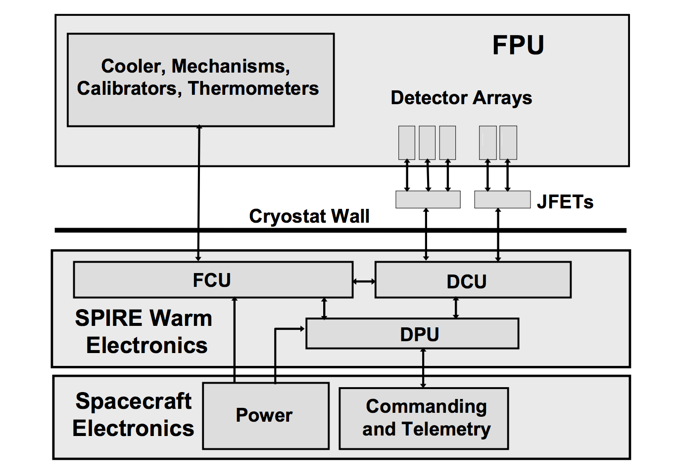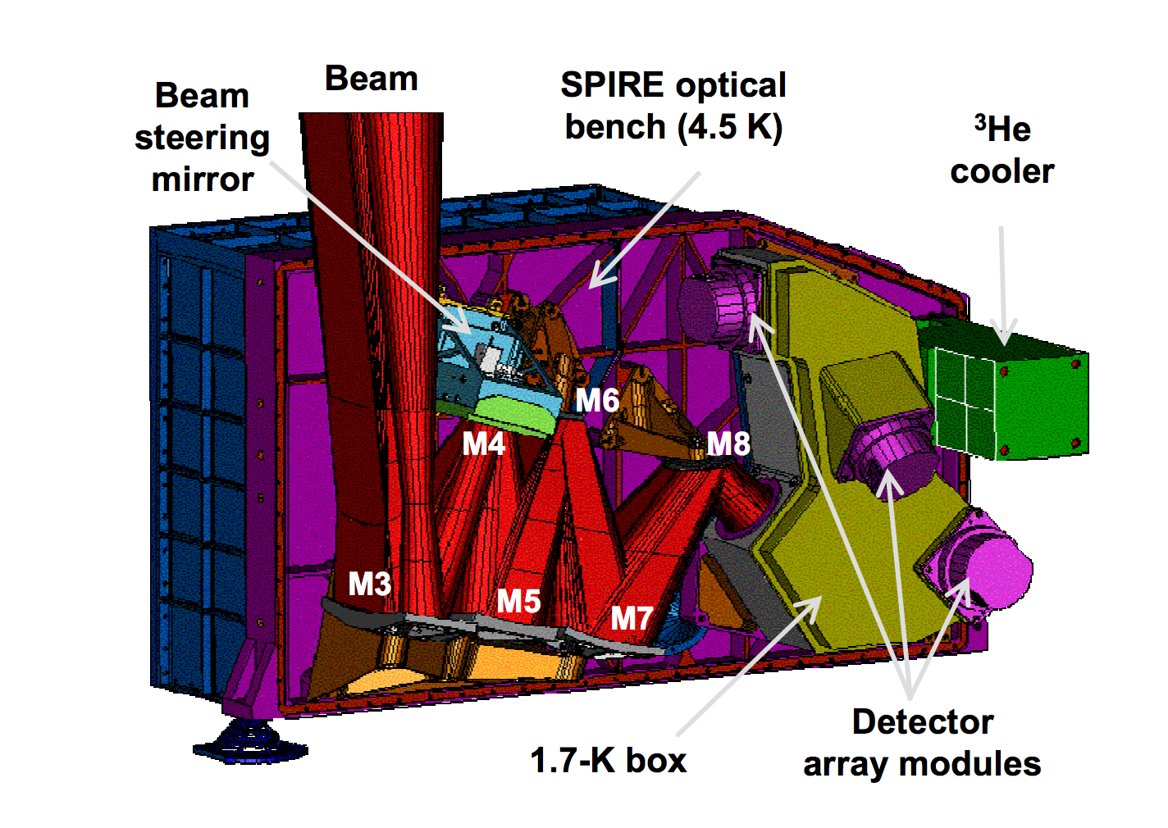

Figure . SPIRE Instrument architechture and photometer design[3]

#### 2.3 HiRes

The diffraction limited resolution of the telescope can be overcome to some extent by reversing the process that limits the resolution. Essentialy the image resolution is determined by a process which is essentially blurring the true sky image with the diffraction pattern produced by the telescope construction. If we have a very accurate representation of this telescope beam, we can reverse this process by performing a fourier deconvolution of the sampled image and the telescope beam [5]. Practically this can give us potentially a twofold increase in angular resolution, although this is dependent on a number of factors including the quality of the beam image and the amount of noise in the sky image.

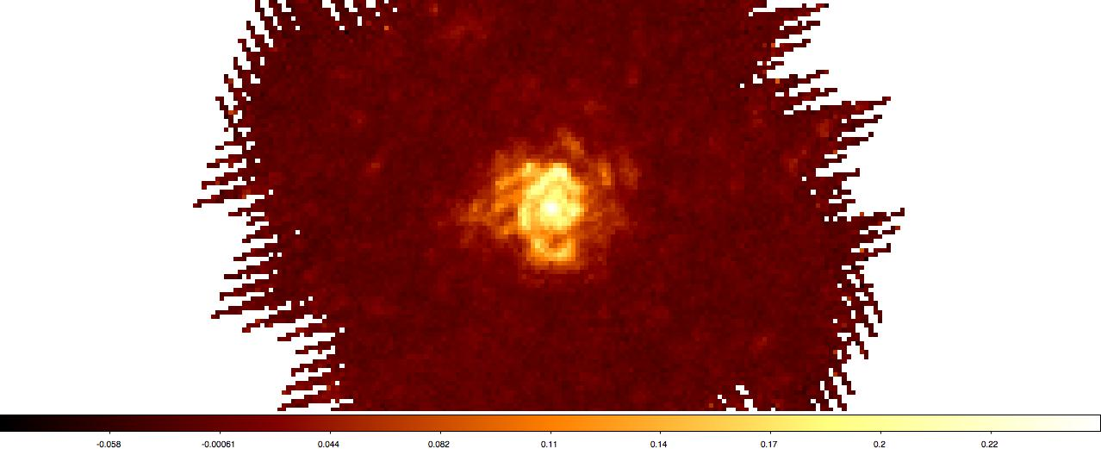 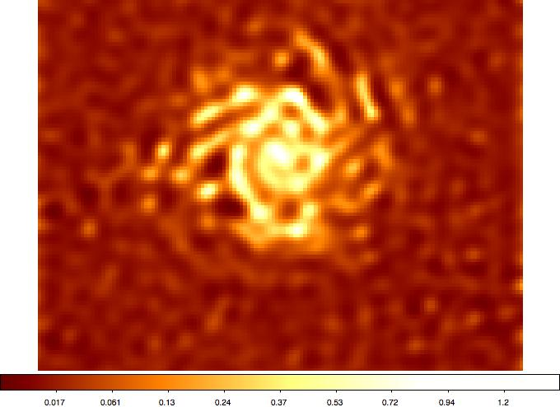

Figure 2. Comparison of original (left) and HiRes images (right)

### 3. Processing Pipeline

In order to begin experimenting with how HiRes behaves under different conditions, we first need to have controllable ‘truth’ data than can then be processed into SPIRE observations, so that we can create experimental conditions and manipulate the data to suit our needs. So far I have created a pipeline for creating a fake SPIRE observation from any data source, although currently it uses Spitzer images at 24 m as these are approximately similar.

1. Load existing SPIRE 500 m observation (in the test case we use m74 )

- 36’’ resolution

- Remove level 0 and 0.5 data as not needed – These are the raw uncalibrated data feeds from the SPIRE instrument, as we are working at the level where the data is already calibrated these can be discared

- Set any error data to 0

- This image covers a sky area that fully encloses the spitzer observation

2. Load existing spitzer 24um observation (again M74 as test case)

- 7’’ resolution

- Reprocess NaN values to zero, so that fourier convolution is possible

- May want to do some extra filtering to remove foreground stars, but not necessary for now

- This is now our expected image, although we could convolve with a beam or just do a basic gaussian smoothing to reduce resolution down to about 15-20’’, assuming that the best possible result from HiRes is about a 2x improvement over the original.

3. Load the SPIRE beam profile

- Regrid the spire beam to same pixel was as spitzer

- Set the WCS pixel grid to match

- Resize to same pixel sizes as spitzer for fourier convolution

4. Convolve the beam with the 24 m image

- 2d fourier transform both images

- Convolve the two images to give us an image with the same angular resolution as SPIRE

5. Process SPIRE observation and replace L1 data (the L1 data is the calibrated Herschel data, i.e. the lowest level data any science is usually perfomed):

The basic algorithm for loading the spritzer image into the SPIRE observation is as follows:

Loop over each scan:

Loop over each bolometer:

Loop over each data point:

Replace with value for current RA/DEC from convolved spitzer image (use NaN for data that dosn’t exist in source image)

6. Build map

- Use the NaiveScanMapper (this is the default mapper for generating a map from a suitable level 1 data set), this gives an image which can be used for visual inspection

7. Build hires map of this new data

- Now can compare to image generated in (2) visually, as well as adding quantifiable measures

Using this pipeline I was able to generate a fake SPIRE observation, and then run the HiRes process to produce the maps in figure 3.

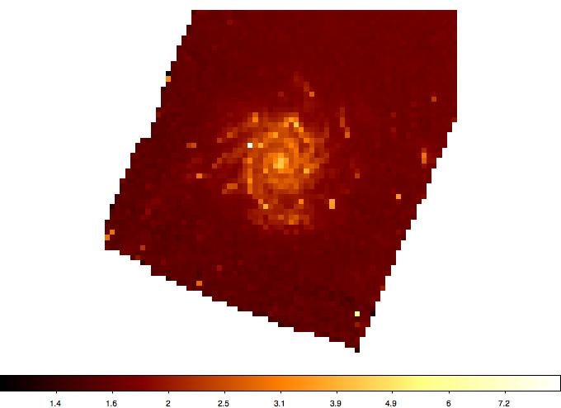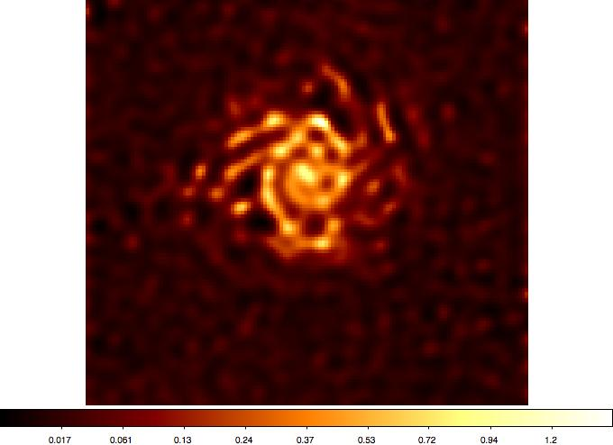

Figure 3. Spitzer image converted to SPIRE observation (left) and output of HiRes mapper on the image (right)

### 4. Avenues for Investigation during 2nd Semester

With the code for the processing pipeline already full developed, I am well placed for moving straight into investigational work for the second semester. Some of these may be disregarded if they quickly prove to not be useful.

1. Compare HiRes image to truth image, and create a quantifiable measure of accuracy.
2. Repeat for a fast sampled observation
3. Check power spectra of HiRes output beam
4. Check for artefacts
5. Are there features missing? E.g. can spiral arms be recovered from observations, does galaxy inclination affect this?
6. Compare power spectra of source image against the HiRes maps
7. Compare histograms
8. Investigate how SNR relates to how well HiRes works, i.e how does the output of HiRes degrade as SNR decreases, and what can we consider as a threshold value of SNR.

### 5. Rough schedule for 2nd Semester

Last 2 weeks autumn & Christmas break

* Finish getting the beam convolution working and tested
* Check image processing pipeline with primary focus on flux conservation
* Ensure physical units of the HiRes output match the normal maps
* Write some code for quickly generating power sepctra and histograms

Weeks 1-2

* Develop a quantifiable measure of how well HiRes has performed against the truth image
* Expand observation list to cover a wider range of targets. N.b. Chris has already done some work in this area and has an interesting set of observations I can start with

Weeks 3-4:

* Experiment with SNR, how does HiRes degrade as SNR increases? [4]
* Determine an SNR threshold for when HiRes should not be considered accurate

Weeks 5-6:

* Determine if different observation modes affect HiRes
* Determine how different observation types affect HiRes output

Weeks 7-8:

* Reserved for any extra investigation that seems promising

Weeks 10+:

* Finalise report
* Refactor any code that is needed for HIPE

### 6. References

[1] Planck, M. "The Theory of Heat Radiation, translated by M. Masius form the German edition of 1914." (1959).

[2] Griffin, M. J., et al. "The Herschel-SPIRE instrument and its in-flight performance." *Astronomy and Astrophysics* 518 (2010): L3.

[3] Pilbratt, GL, et al. "Herschel Space Observatory: An ESA facility for far-infrared and submillimetre astronomy." *Astronomy and astrophysics* 518.1 (2010).

[4] Aumann, H et al. “A maximum correlation method for image construction of IRAS survey data.” *Astronomical Journal* (ISSN 0004-6256), vol. 99, May 1990

[5] Lucy, L. B. “An iterative technique for the rectification of observed distribution.” *Astronomical Journal*, Vol. 79