# helllo!

## Use case diagram:

## GUI



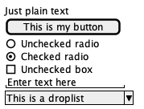

## Work breakdown structure: