DISCUSSTION:

This program read an array with RxC elements, and ask the user to choose one of the next 5 functions (with validation):

1) Print the Entered Array

2) Print Sum of a Row

3) Print Sum of a Column

4) Print Rows Sum

5) Print Columns Sum

Some functions, such as functions 4 and 5, use other functions inside them, like functions 2 and 3.

Read An Array:

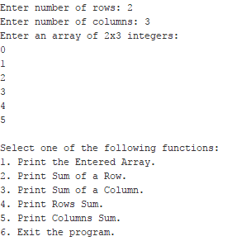

Main Menu:



Print the Entered Array:

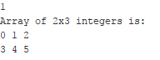

Print Sum of a Row:



Print Sum of a Column:



Print Rows Sum:

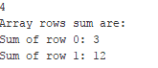

Print Columns Sum:

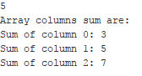

Input Validation:

