**Renter**

I got a good idea for a final project from my brother's work, I will build a program that will be able to solve a lot of peoples problems, my program will let the user to add a number of houses, how many bedroom in a house, and how much it costs to rent a house, I chose this idea specifically as it is a real world problem.

**for example:**

I will give the user 3 options to choose from 1) create a house 2) view all houses 3) choose a house

**Option 1:**

then it will ask him for address, how much he pays for the rent of that house, how many rooms, and finally will ask him the price of each room, and if they are rented or not, after all that it will save that house, put it in a folder where it will be saved for later use, but it will also give him if they house is making any profit, or if he is losing money on that house!

**Option 2:**

For option 2, it will list all of the houses that I have in my saved folder, I will be using an ArrayList to load up every house, and every room, for that house, it will be printing out the report of all the houses, and the profit for all the house

**Option 3:**

for option 3, it will list all the houses, but you can choose one of the houses to view how it is doing, such as printing out the profit for you for that specific house only!

**Data:**

I will also let the user to view the data using a csv file, if they don’t want to see it in terminal, my csv file will have titles on each column indicating what that column is really about, from there the user will be able to see all his houses, and his rooms, if they are rented or not.

**UI Design**

|  |  |  |  |  |
| --- | --- | --- | --- | --- |
| 19 |  |  |  |  |
| houseID | roomID | type | price | isRented |
| sarr rd | 0 | room | 750 | TRUE |
| sarr rd | 1 | room | 1000 | TRUE |
| 8833 ronald rd | 2 | room | 1000 | TRUE |
| 8833 ronald rd | 3 | room | 1500 | FALSE |
| 8833 ronald rd | 4 | room | 1750 | TRUE |
| 8833 ronald rd | 5 | room | 2300 | FALSE |
| 8833 ronald rd | 6 | room | 1500 | TRUE |
| 2138 rood rd | 7 | room | 500 | TRUE |
| 2138 rood rd | 8 | room | 700 | TRUE |
| 2138 rood rd | 9 | room | 600 | TRUE |
| 2394 lernard rd | 10 | room | 750 | TRUE |
| 2394 lernard rd | 11 | room | 1200 | FALSE |
| 2394 lernard rd | 12 | room | 900 | TRUE |
| 2394 lernard rd | 13 | room | 1000 | TRUE |
| 1500 rnoldo st | 14 | room | 1200 | TRUE |
| 1500 rnoldo st | 15 | room | 700 | TRUE |
| 1500 rnoldo st | 16 | room | 750 | TRUE |
| 1500 rnoldo st | 17 | room | 1500 | FALSE |
| 1500 rnoldo st | 18 | room | 650 | TRUE |

This is how my Csv file look like for all the houses with all of the their rooms, the first number being is the indicator of what is the nextID of the room that you will be making next, this is for the program!

But reading from the file for a user is quite easy.

**Algorithm**

The way I thought about it was, a house has rooms, so I was able to make 2 classes, a house.java and a room.java, I was able to make this UML diagram of how my program

Will look like when it is done!

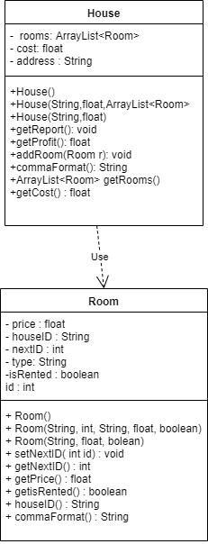

A way to connect house with rooms, is that I made for the house.java an arrayList of rooms, taking in all the rooms, and for the Room.java, I made a housed so it uses it to track each room and put it in the right house

House.java, I made a getReport method, for me to use as one of the options, so it prints out all the report for all the houses, and also a getProfit method for me to use to calculate how much money I made( or lost ) after paying the rent of the house ( it varies as some of the rooms are not rented )

I also added an addroom method, for me to use so I can add a room to a house when I am making a new house!

For my room.java: it was a bit trickier, as for my house it was just the ID, but for my rooms, I had to keep track of all the rooms in all of the houses, so I made a nextID method where it just keeps counting up, so when I make 5 rooms, the nextID will be 6, that number will be saved in a csv file to use later, because when I stop the program that number will reset to 0, doing that will break the program, or it will just overwrite an existing room, so the number has to keep going up!, I also made a method to for the price of the room, and if they are rented or not, finally I made a commaFormat method for me to use in saving and reading from a file!

**In conclusion:**

I believe that I did a decent job with my final project, I had a lot of fun making this program, but also learned from it, I hope that in the future I can work more on this program so someone could use it and solve their problems and make their life easier.