Row 1 Wind Turbine Simulink Model Guide
Contents
I. Getting Started 2
A. Introduction 2
B. Running the Model 3
C. Model Limitations 3
D. Model Troubleshooting tips 4
II. Bergey Excel 15 4
E. Aeromechanical model 5
F. General parameters from the manufacturer 6
G. Generator 7
H. Electrical model specifications 7
I. Intergrid inverter 8
J. Active power control 8
Frequency and voltage response 9
Power command tracking 9
K. Grid connection 9
III. QED PHX-20 9
A. Aeromechanical model 10
B. General parameters from the manufacturer 11
General model parameters provided by the manufacturer are shown in Table 5 [2]. 11
C. Generator 12
D. Electrical model specifications 12
E. QED-specific Limitations 12
IV. Eocycle EOX M-26 13
F. Aeromechanical model 13
G. General parameters from the manufacturer 14
General model parameters provided by the manufacturer are shown Table 7 [3]. 14
H. Generator 14
I. Electrical model specifications 14
J. Eocycle-specific Limitations 15
V. References 16
VI. Appendix 16

Getting Started

Introduction
Three new wind turbines are being installed at NREL's Flatirons Campus, one Bergey Excel 15, one QED PHX-20, and one Eocycle EOX M-26. This document describes models of these wind turbines developed in MATLAB Simulink. These high-fidelity models can be used for grid integration research, and to simulate distributed wind turbines providing grid services. The models use Simulink physical modelling connections and can be connected to any 3-phase grid or microgrid model with a physical modelling connection.
These models will enable future distributed wind modeling and hardware-in-the-loop (HIL) validation efforts for grid integration and advanced controls research. The Bergey model was built first, and the QED and Eocycle models were built from that model with modified parameters. Similarly, these models can be modified to represent other wind turbines. The Bergey model is fully described in Section II, and the modifications made to create the QED and Eocycle models are described in Sections III and IV, respectively.

Running the Model
The models are publicly available at the following git repository: https://github.com/badeshiben/Flatirons-Campus-Row-1-Wind-Turbines, where this documentation resides. To run the model:
- Clone the repository or download the repository’s zip file.
- Add the top-level folder, and all subfolders, to your MATLAB path.
- Navigate to the subfolder with your desired wind turbine model (Bergey-Excel-15, QED-PHX-20, or Eocycle-EOX-M26), open the Simulink model, and hit run. (Simulink models can also be run from the MATLAB command prompt).

Model Limitations

The modeled inverter output is 3-phase, matching other NREL Flatirons Campus models. The (real) Eocycle grid-side converter outputs 3-phase, as well. The Intergrid inverter used by the (real) QED and Bergey wind turbines outputs split-phase (aka dual-phase) power, but Simulink doesn't have a block to do this. If the user wishes to output split-phase power, they will have to convert three-phase to split-phase or replace the dynamic load block in the INVERTER area, which converts a real and reactive power signal to 3-phase power, with a block converting the power signal to split-phase power.

When DC voltage accelerates quickly, DC current responds vigorously in the other direction, causing power spikes. We haven't managed to damp this out completely with our rate-limiting filters, but it should be possible either by tuning the filter parameters or adding different filters. This filtering occurs in the APC > DC voltage control area.
- The grid side converter is represented as a DC voltage source on the DC link. DC link power outputs are fed as scalars into the simplified inverter model, which limits the DC power according to inverter specifications and outputs 3-phase AC power. This assumes that the DC link successfully isolates the wind turbine generator from grid electrical transients, which is true if the full-converter system operates as designed. This simplification was done based on manufacturer recommendation, as a detailed grid side converter and inverter model would require a large modeling effort and was out of scope. If a user desired to represent the DC link with higher fidelity, and connect it electrically to the inverter, they could replace the DC voltage source with a controllable grid-side-converter model and connect this to a detailed inverter model with a physical modeling connection.

Model Troubleshooting tips
- The model uses a discrete solver where the timestep = 2e-5 seconds. Normal or accelerator mode can be used.
- Input generator torque and dynamic load power commands should be negative.
- Increasing DC voltage increases generator & rotor RPM.
- Check that voltage and current bus measurements are consistent – line to line vs. line to ground, p.u. vs. Volts and Amps.
- The boost converter, inverter, and grid connection can be represented by a simple resistor in series with the DC link. For instance, the Bergey model’s voltage source and adjacent RC filter can be replaced with a 27.8 Ω resistor. This can help debug the wind turbine without the inverter and grid connection.
- Start the models at rated wind speed with a unity real power command, and in stable grid conditions, to match the initial state.

Bergey Excel 15
The Bergey Excel 15 is a wind turbine with a rated power of 15 kW, utilizing a 3-phase permanent magnet synchronous generator (PMSG) with a fixed wound stator. The wind turbine is an upwind, variable speed, stall-regulated, passive yaw, full-converter (type 4), upwind machine and is connected to a 20-kVAR Intergrid inverter that outputs 240 VAC. An overview of the modeled wind turbine architecture is shown in Figure 1. The main model components are the wind turbine rotor, PMSG, rectifier, DC link, inverter, active power controller (APC), and grid connection, shown in Figure 2. This model has a highly simplified mechanical and more-detailed electrical portions to facilitate HIL and grid integration research. Many model parameters are defined in the initialization MATLAB file. This section provides model details.
Figure 1. Main wind turbine model components.
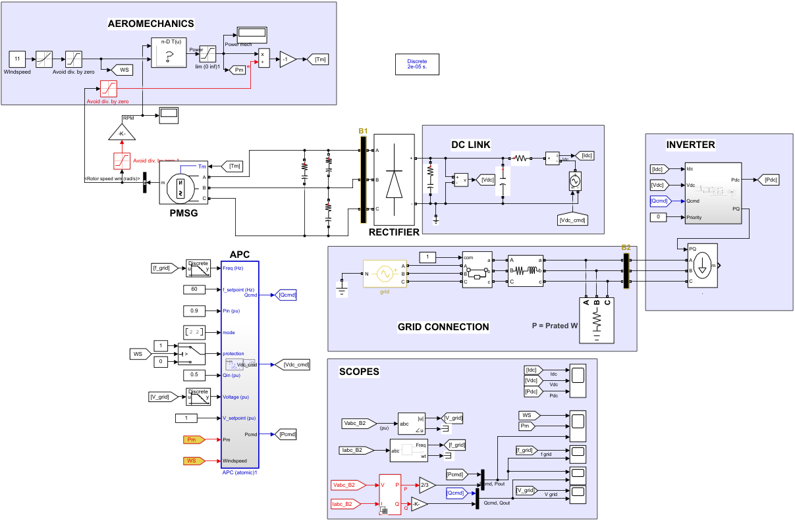
Figure 2. Top-level Simulink model of the Bergey Excel 15.

Aeromechanical model
The manufacturer provided a lookup table (Table 10) to compute rotor mechanical power from rotor RPM and wind speed. Wind speed is fed in from a constant block, and rotor speed is fed from the PMSG model. Mechanical power is divided by rotor speed to find mechanical torque, which is fed back into the PMSG model. Figure 3 displays power information across rotor RPMs and wind speeds.
Figure 3: Mechanical Power curve of Bergey Excel vs rotor RPM at various wind speeds.

General parameters from the manufacturer
General model parameters provided by the manufacturer are shown in Table 1
Table 1. General parameters.
Name | Value | Unit
Operating Current | 30 | A
Cut-in Wind Speed | 4.5 | m/s
Rated Wind Speed | 11 | m/s
Rated Power | 15 | kW
Rated RPM | 135 | RPM
Max RPM | 140 | RPM
Machine Efficiency | 90 | %
Inverter Output | 240 | VAC

Generator
PMSG model parameters provided by the manufacturer are shown in Table 2.
For future model development: If some values are missing, they can be calculated by the MATLAB generator parameter calculator [1].
Table 2. PMSG parameters.
Name | Value | Unit
Stator phase resistance | 0.51 | Ω
Stator inductance | 0.0128 | H
Voltage Constant | 4538 | V_{peak L-L} / kRPM
Inertia | 174.8 | kg•m²
Viscous Damping | 0 | N•m•s
Pole pairs | 16 | -
Static Friction | 5 | N•m

Electrical model specifications
There is a filtered, 3-phase electrical connection from the generator to the rectifier. On the DC side of the rectifier, there is a power correction capacitor. On the right side of the DC link, there is a voltage source representing a boost converter and inverter connection. The APC commands this voltage. DC voltage directly controls generator speed and hence power. Finally, an RC filter filters the voltage on the DC link.
A universal bridge from the Simulink library is used with parameters provided by the manufacturer. The discrete Simulink simulation required infinite snubber capacitance to run. Table 3 shows various electrical parameters used and their values.
Table 3. Electrical parameters.
Rectifier diodes
Name | Value | Unit
Forward Voltage | 0.6 | V
R_{on} | 1e-2 | Ω
Snubber capacitance C_{s} | inf | F
Snubber Resistance R_{s} | 1e6 | Ω
Power correction capacitor, right of rectifier
Capacitance | 2.2e-3 | C
Capacitor internal resistance | 0.84e-3 | Ω
Phase filters, left of rectifier
Capacitance | 55e-6 | C
Capacitor internal resistance | 1e-3 | Ω
DC voltage RC filter left of the voltage source
Capacitance | 0.01 | C
Resistance | 6 | Ω

Intergrid inverter
The 20-kVAR Intergrid inverter is represented by a dynamic 3-phase load block, which converts a real and reactive power input (representing DC) into a 3-phase AC output. Real and reactive power commands are fed from the APC and limited to 20-kVAR apparent power at any phase. Real or reactive power priority is also input into the inverter model. 0=real power priority, 1=reactive power priority. The prioritized power component may limit the other power component to adhere to the 20-kVAR apparent power limit by the equation:
$$P^{2}+Q^{2}=S_{lim}^{2}$$
Where P is the real power output, Q is the reactive power output, and S_{lim} is the apparent power limit. For example, if Q is prioritized and Q=15 kVAR, P is limited to 13.2 kVAR.

Active power control
The APC calculates the real and reactive power commands and the DC voltage command. The real and reactive power commands depend on the real and reactive power mode, displayed in Table 4. The mode is represented as a 2-field vector. E.g. [1, 2] is frequency response and reactive power command tracking.
Table 4. power mode numbers.
 | Real power mode | Reactive power mode
1 | Frequency response | Voltage response
2 | Command tracking | Command tracking
3 | Maximum power | Zero power

Finally, the APC calculates the DC voltage command, which controls turbine rotor speed and power. A DC voltage setpoint is calculated from a lookup table, generated by modifying the DC voltage command until the correct rotor speed was achieved for wind speeds across the operating range. This DC voltage provides maximum power at a given wind speed. It is modified by a DC voltage correction generated by a PID controller, which responds to the difference between the rotor mechanical power and the real power command. This allows the wind turbine to change its power capture according to the real power command. The DC voltage setpoint's derivative is rate limited to prevent excessive DC current spikes and is fed into the voltage source on the DC link.

Frequency and voltage response
Frequency and voltage are measured at B2, right outside of the inverter. The deadband and droop values used for frequency and voltage response are the default values for a Category III/B DER in standard IEEE 1547-2018. These DER categories are for machines in weak grids with the highest grid support capabilities.
The protection input, when set to zero, zeros all power commands. It is set to zero when the wind drops below the cut-in wind speed. The frequency and voltage setpoints, which are the target values for frequency and voltage support, are set to 60 Hz and one p.u. (per unit nominal value), respectively, and are configured as inputs so that they could be modified, for example, by a microgrid controller.

Power command tracking
In these modes, the power command input is fed through the APC, limited to
[0, 1] p.u. for real power and [-1, 1] p.u. for reactive power.

Grid connection
An infinite 3-phase voltage source represents the grid connection. A switch separates the grid from the wind turbine. An RL filter and a grounding load are used to stabilize the system.

QED PHX-20
The QED PHX-20 is a 20-kW wind turbine. Like the Bergey Excel 15, it is an upwind, variable speed, stall regulated, full-converter machine with a PMSG, connected to a 20-kVAR Intergrid inverter with 240 VAC output. However, it has active yaw control. The QED wind turbine modeling architecture is the same as Bergey’s, as shown in Figure 1. The main model components are the wind turbine rotor, PMSG, rectifier, DC link, inverter, active power controller (APC), and grid connection, shown in Figure 4. Most model parameters are defined in the initialization MATLAB file. This section provides model details.

Aeromechanical model
The Bergey aeromechanical model was replaced. We obtained a tip speed ratio (TSR)-to-Cp curve from an OpenFAST model that NREL and QED are developing together. Cp, Ct and Cq data are given in Table 11. TSR is calculated by
$$TSR=\frac{wr}{v}$$
Where w is the rotor speed (rad/s), r is the rotor radius (m), and v is the wind speed (m/s).
Cp is used to find mechanical power P_{m} by
$$P_{m}=\frac{1}{2}ρCpAU^{3}$$
Where ρ is the air density (kg/m³), A is the swept area of the rotor (m²), and U is the wind speed (m/s). The mechanical power is divided by rotor speed to find mechanical torque T_{m}, which is fed back into the PMSG model.
$$T_{m}=\frac{P_{m}}{w}$$
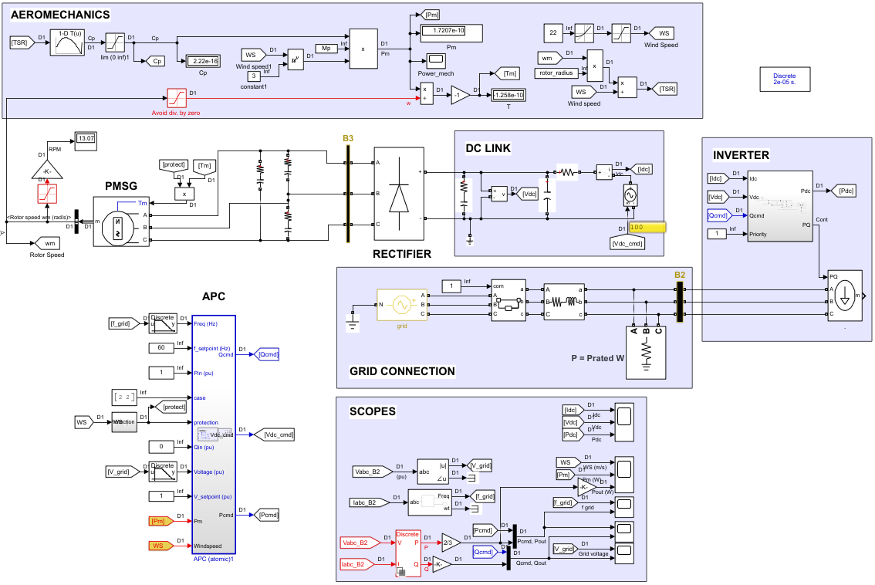
Figure 4. Top-level model view of the QED PHX-20

General parameters from the manufacturer

General model parameters provided by the manufacturer are shown in Table 5 [2].
Table 5. General parameters.
Name | Value | Unit
Operating Current | 28 | A
Cut-in Wind Speed | 3 | m/s
Rated Wind Speed | 11 | m/s
Cut-out Wind Speed | 20 | m/s
Rated Power | 20 | kW
Rated RPM | 90 | rpm
Max RPM | 180 | rpm
Machine Efficiency | 76 | %
Inverter Output | 240 | VAC

Generator
PMSG model parameters provided by the manufacturer are shown in Table 6.
Table 6. QED PMSG parameters
Name | Value | Unit
Stator phase resistance | 0.8333 | Ω
Stator inductance | 0.001364 | H
Voltage Constant | 7856.74 | V_{peak L-L} / kRPM
Inertia | 170 | kg•m²
Viscous Damping | 0 | N•m•s
Pole pairs | 18 | -
Static Friction | 5 | N•m

Electrical model specifications

The electrical model includes the inverter, DC link, and rectifier and is mostly unchanged from the Bergey model. See Table 3 for parameters. The only change from the Bergey model was the forward voltage drop in the rectifier, changed to 1 V.

QED-specific Limitations
- The Cp curve from the OpenFAST model yields 33 kW mechanical power at rated wind speed, significantly above the 20-kW rated electrical power. This seems too high and should be checked in future updates.
- The model oscillates significantly when tracking a 0.4 p.u. real power command. This will be investigated.
- The model produces the desired power on the DC link at all commands except 1 p.u., where it produces about 5% too much power. This is currently solved with a DC power saturation block and will be investigated.

Eocycle EOX M-26
The Eocycle EOX M-26 has a 90-kW power rating. Like the Bergey Excel 15, it is a variable speed, stall regulated, full-converter machine with a PMSG. However, it has active yaw control, a larger inverter with 480 VAC output, and is downwind. The Eocycle wind turbine modeling architecture is the same as Bergey’s, as shown in Figure 1, except with different parameters. The main model components are the wind turbine’s rotor, PMSG, rectifier, DC link, inverter, active power controller (APC), and grid connection, shown in Figure 5. Most model parameters are defined in the initialization MATLAB file. This section provides model details.

Aeromechanical model
The Eocycle has a similar aeromechanical model to the QED. For more details, see Section III A. We obtained a tip speed ratio (TSR)-to-Cp curve from the manufacturer, displayed in Table 12.
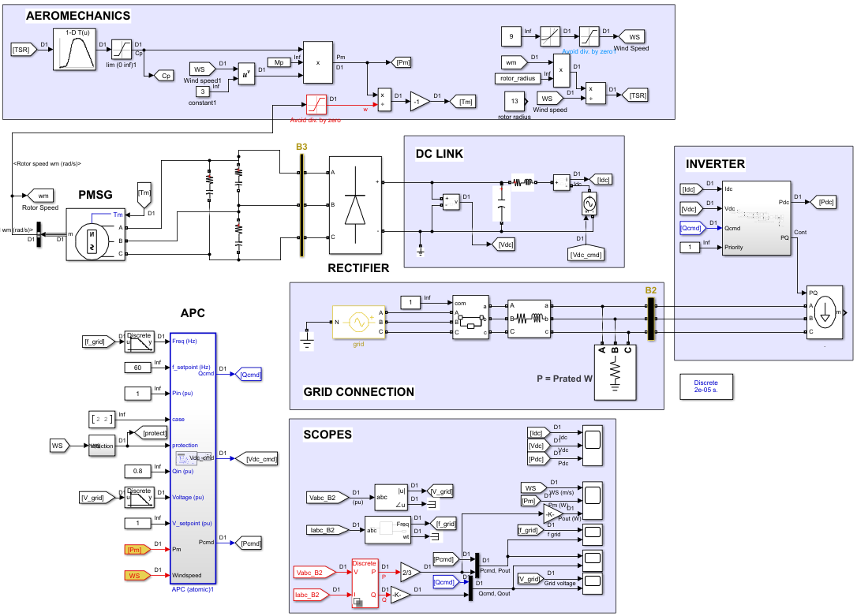
Figure 5. Top-level model view of the Eocycle EOX M-26

General parameters from the manufacturer

General model parameters provided by the manufacturer are shown Table 7 [3].
Table 7. General parameters. Rated wind speed was calculated based on rated power.
Name | Value | Unit
Cut-in Wind Speed | 2.75 | m/s
Rated Wind Speed | 9 | m/s
Cut-out Wind Speed | 20 | m/s
Rated Rotor Speed | 55 | RPM
Rated Power | 90 | kW
Inverter Output | 480 | VAC
Rotor Diameter | 26 | m

Generator
The PMSG model parameters are shown in Table 8. Parameters provided by the manufacturer, or calculated from provided information, are bolded. The other parameters were chosen to allow stable operation.
Table 8. Eocycle PMSG parameters
Name | Value | Unit
Stator phase resistance | 0.1 | Ω
Stator inductance | 0.000164 | H
Voltage Constant | 8630.74 | V_{peak L-L} / kRPM
Inertia | 1750 | kg•m²
Viscous Damping | 0 | N•m•s
Pole pairs | 20 | -
Static Friction | 0 | N•m

Electrical model specifications
The electrical model includes the inverter, DC link, and rectifier and is mostly unchanged from the Bergey model. Structural modifications were made to the DC link. The power correction capacitor was removed, and an inductor as added to the now-RLC filter to the left of the voltage source. Parameters were updated, as reported in Table 9. All parameters were estimated and chosen to promote stability.
Table 9. Electrical parameters.
Rectifier diodes
Name | Value | Unit
Forward Voltage | 1 | V
R_{on} | 0.03 | Ω
Snubber capacitance C_{s} | inf | F
Snubber Resistance R_{s} | 1e6 | Ω
Phase filters, left of rectifier
Capacitance | 55e-6 | C
Capacitor internal resistance | 0.001 | Ω
DC voltage RLC filter, left of the voltage source
Capacitance | 0.01 | C
Resistance | 6 | Ω
Inductance | 0.06 | H

Eocycle-specific Limitations
- Due to a lack of information from the manufacturer, most of the generator and electrical parameters were estimated to allow stable operation (except for pole pairs and stator resistance). Electrical components are also uncertain. Instabilities still exist:
  - The Eocycle can only derate down to about 90% of its maximum power before going unstable.
  - In region 3 (above rated wind speeds), excessively high DC voltage is required to curtail power output to rated, and the voltage command is oscillatory.
  - There are some power oscillations when tracking certain real power commands.
- To remedy the instabilities, complete generator, rectifier, DC link, and inverter information is needed from the manufacturer. Note: most of the required parameters are defined in Initialize.m, except for generator parameters, which are defined in the generator mask. The process for updating the model may proceed like this:
  - Update the estimated parameters reported in Table 8 and Table 9, along with any electrical components. DC link RLC filter parameters may be tuned to smooth the DC link power output.
  - Recalculate Vdc values in the WS_CP_VDC.xlsx table. To do this, at each wind speed, replace the Vdc_cmd From block in the DC LINK area with a Constant block. For each wind speed in the table, find the Vdc_cmd needed to hit the maximum Cp (~0.46). Populate the table’s Vdc column with these values. Finally, replace the Constant block with the original From block.
  - Update the active power controller gains in the APC > DC Voltage control > PID control block to allow smooth power command tracking. Other blocks in the same area, such as saturations and rate limiters, may need to be updated.

References
[1] Matlab, "Parameterize a Permanent Magnet Synchronous Motor." [Online]. Available: https://www.mathworks.com/help/physmod/sps/ug/parameterize-a-permanent-magnet-synchronous-motor.html.
[2] PHX-20 Specifications | QED Wind Power
[3] Eocycle EOX M-26 Specifications

Appendix
Table 10. Bergey generator mechanical power table from the manufacturer, in Watts. Y axis is rotor speed in RPM. X axis is the wind speed in m/s.
Table 11. QED power curve data from the manufacturer
TSR | Cp | Ct | Cq
2 | 0.03611882 | 0.11338689 | 0.01805941
2.5 | 0.0620593 | 0.14008007 | 0.02482372
3 | 0.09603471 | 0.17668206 | 0.03201157
3.5 | 0.14347456 | 0.23140109 | 0.04099273
4 | 0.20541766 | 0.30714289 | 0.05135441
4.5 | 0.25980285 | 0.37876266 | 0.05773397
5 | 0.29296827 | 0.42921047 | 0.05859365
5.5 | 0.31578709 | 0.47031303 | 0.05741583
6 | 0.33171237 | 0.50591713 | 0.05528539
6.5 | 0.34060541 | 0.53546455 | 0.05240083
7 | 0.34290237 | 0.55941504 | 0.04898605
7.5 | 0.33911211 | 0.5784883 | 0.04521495
8 | 0.32971892 | 0.59333794 | 0.04121487
8.5 | 0.31527399 | 0.60476053 | 0.03709106
9 | 0.2962616 | 0.61359014 | 0.03291796
9.5 | 0.272963 | 0.62044271 | 0.02873295
10 | 0.24549707 | 0.62571105 | 0.02454971
10.5 | 0.2138929 | 0.62965311 | 0.02037075
11 | 0.1781241 | 0.63244123 | 0.0161931
11.5 | 0.1381259 | 0.63419393 | 0.01201096
12 | 0.093794 | 0.63498856 | 0.00781617
12.5 | 0.04499173 | 0.63487536 | 0.00359934
13 | -0.00843344 | 0.63388988 | -0.00064873
13.5 | -0.06664213 | 0.63205957 | -0.00493645
14 | -0.12980001 | 0.62940658 | -0.00927143
14.5 | 0.19807655 | 0.62594917 | -0.01366045
Table 12. Eocycle power curve data from the manufacturer. The Cp-TSR relationship was estimated as having a constant slope of -0.09 above TSR=11.
TSR | Cp
0 | 0
0.111111111 | 0.001671982
0.222222222 | 0.00327389
0.333333333 | 0.004805313
0.444444444 | 0.006265843
0.555555556 | 0.007655066
0.666666667 | 0.008972575
0.777777778 | 0.010217957
0.888888889 | 0.011390802
1 | 0.012490699
1.111111111 | 0.013517239
1.222222222 | 0.014470011
1.333333333 | 0.015348603
1.444444444 | 0.016152606
1.555555556 | 0.01688161
1.666666667 | 0.017535202
1.777777778 | 0.018112974
1.888888889 | 0.018614514
2 | 0.019039412
2.111111111 | 0.019387257
2.222222222 | 0.019657639
2.333333333 | 0.019850147
2.444444444 | 0.019964372
2.555555556 | 0.02
2.666666667 | 0.02
2.777777778 | 0.020103102
2.888888889 | 0.029793333
3 | 0.03
3.111111111 | 0.033501891
3.222222222 | 0.041886484
3.333333333 | 0.048105777
3.444444444 | 0.058739252
3.555555556 | 0.071568501
3.666666667 | 0.081833278
3.777777778 | 0.093062081
3.888888889 | 0.106505286
4 | 0.121386002
4.111111111 | 0.137785875
4.222222222 | 0.155470558
4.333333333 | 0.174402408
4.444444444 | 0.194115743
4.555555556 | 0.211446171
4.666666667 | 0.227006879
4.777777778 | 0.24318985
4.888888889 | 0.26262061
5 | 0.285388594
5.111111111 | 0.306838471
5.222222222 | 0.324778386
5.333333333 | 0.341946851
5.444444444 | 0.358141944
5.555555556 | 0.373069607
5.666666667 | 0.386435784
5.777777778 | 0.397946416
5.888888889 | 0.408018514
6 | 0.417672029
6.111111111 | 0.426376695
6.222222222 | 0.433555917
6.333333333 | 0.438633106
6.444444444 | 0.441439574
6.555555556 | 0.443498891
6.666666667 | 0.445140808
6.777777778 | 0.446502153
6.888888889 | 0.447719759
7 | 0.448930453
7.111111111 | 0.450270917
7.222222222 | 0.451814955
7.333333333 | 0.45347921
7.444444444 | 0.455156333
7.555555556 | 0.456738973
7.666666667 | 0.458119779
7.777777778 | 0.459191402
7.888888889 | 0.459846491
8 | 0.46
8.111111111 | 0.460297025
8.222222222 | 0.46
8.333333333 | 0.459923798
8.444444444 | 0.459585745
8.555555556 | 0.45897858
8.666666667 | 0.458103519
8.777777778 | 0.45696178
8.888888889 | 0.455554582
9 | 0.453883142
9.111111111 | 0.451948677
9.222222222 | 0.449752405
9.333333333 | 0.447295545
9.444444444 | 0.444579313
9.555555556 | 0.441604928
9.666666667 | 0.438373607
9.777777778 | 0.434886567
9.888888889 | 0.431145028
10 | 0.427150205
10.11111111 | 0.422903318
10.22222222 | 0.418405583
10.33333333 | 0.413658218
10.44444444 | 0.408662442
10.55555556 | 0.403419471
10.66666667 | 0.397930524
10.77777778 | 0.392196818
10.88888889 | 0.386219571
11 | 0.38

