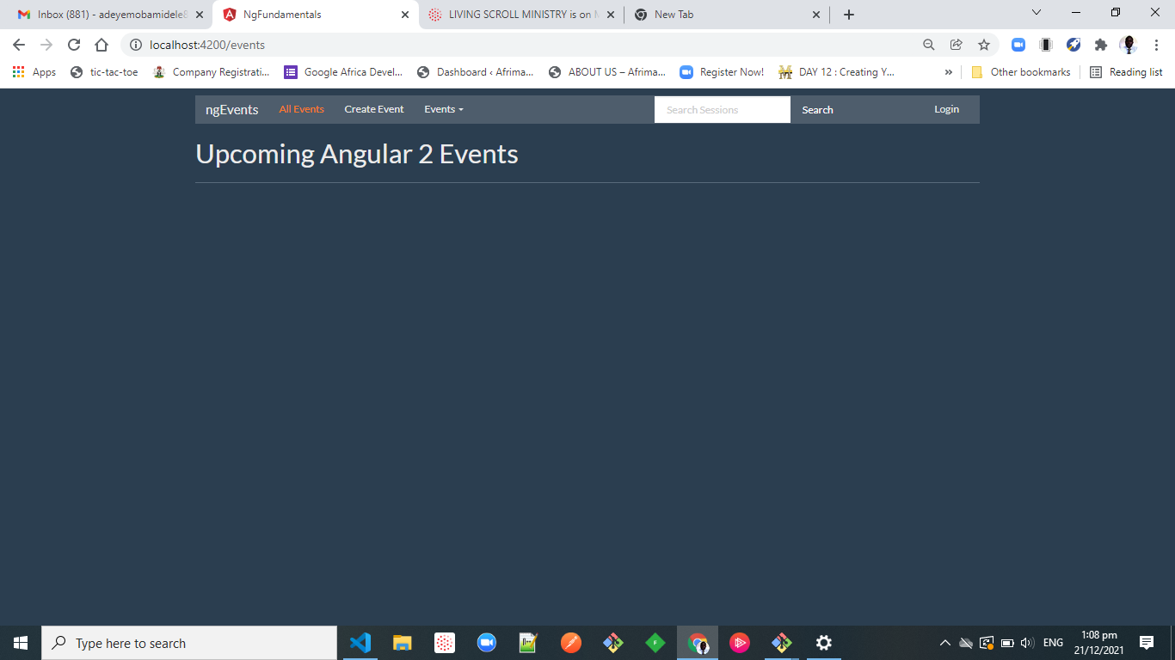

Event Management Main-Menu.

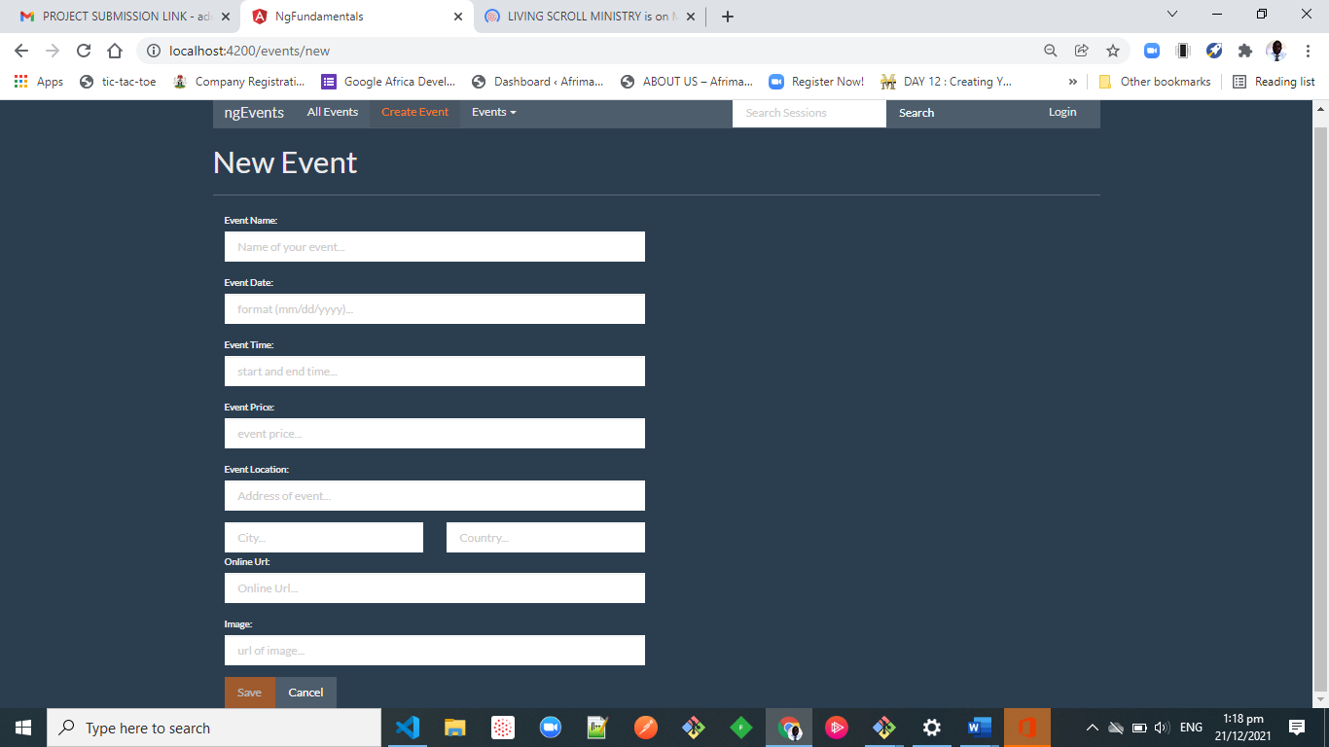

Event Creation template.

Event Creation Form Entry.