**Amplitude Modulation and Demodulation**

By:

Connor Barth

Xavier Joaquinho

You Wu

**Abstract:**

**Data:**

A carrier was generated using the function generator. A sinusoidal wave was generated with a frequency of 630kHz. The modulating frequency was set to 5kHz.

2. Initiate amplitude modulation by pressing AM.

3. Change the modulating frequency to 5kHz. You should be able to see a nice looking AM

signal when you connect the output channel to a Digital Oscilloscope.

4. Change the modulating frequency and the percentage modulation, and view the

resulting waveform on the Oscilloscope.

5. View the magnitude spectrum using the FFT function on the Oscilloscope. If this

function is not available, then save your data to USB stick and compute the spectrum

using the spectra.m (the MATLAB function used in your pre-lab), and display the

magnitude of the function.

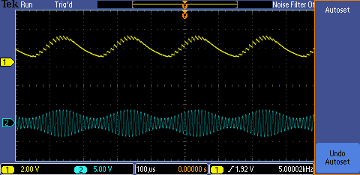

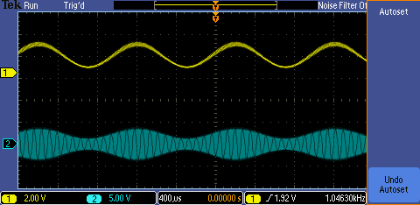

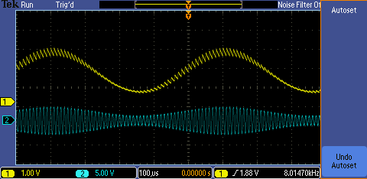

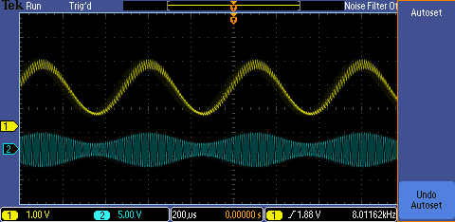

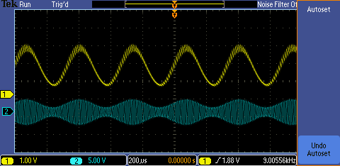

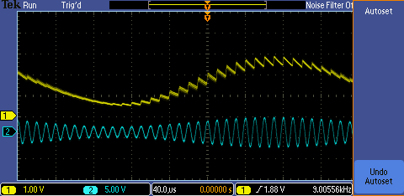

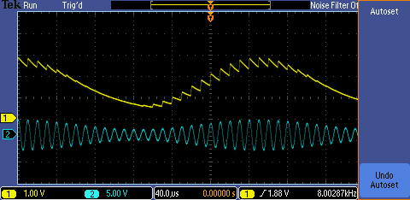

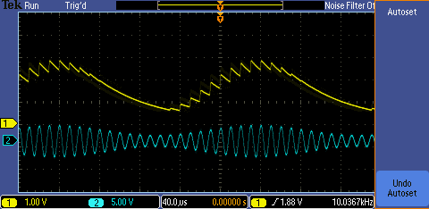

**Analysis:**

**Conclusion:**