You Wu

ECE 222

Lab 1: HSPICE Simulation

Part 1: Characterize Diodes

A D1N4148 diode was synthesized and its IV characteristics were measured using a DC sweep. The saturation current was measured to be -2.6850E-09. The diode current is measured to be $I_{D}=I_{S}(\exp\left(\frac{V_{D}}{nV_{T}}\right)-1)$. Assuming an ideal diode, n=1 and setting $V_{D}$ to -3V, $I_{D}$ computes to 2.685nA. For AC analysis, $V_{D}$ was set to 1V and $C_{D}$ was measured to be 58.85nF.

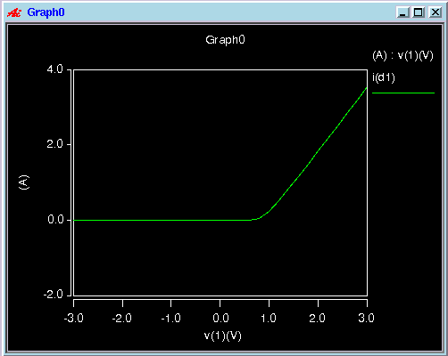



Part 2: Characterize MOSFETs

The IV characteristics are plotted below. The NMOS characteristics are on the left and the PMOS characteristics are on the right.

 

From the sqrt(ID) vs Vgs graph, it can be observed that the threshold voltage for both the NMOS and the PMOS is 0.7V, which corresponds with model parameters.

 

Part 3: Voltage Doubler

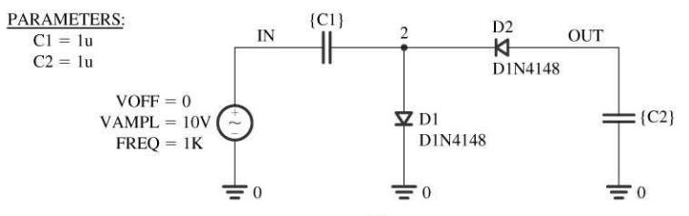

In the screen capture image below, v(1) is the input signal, v(2) is the signal at node 2, v(3) is the output signal. The waveforms appear to match identically with what is expected.

