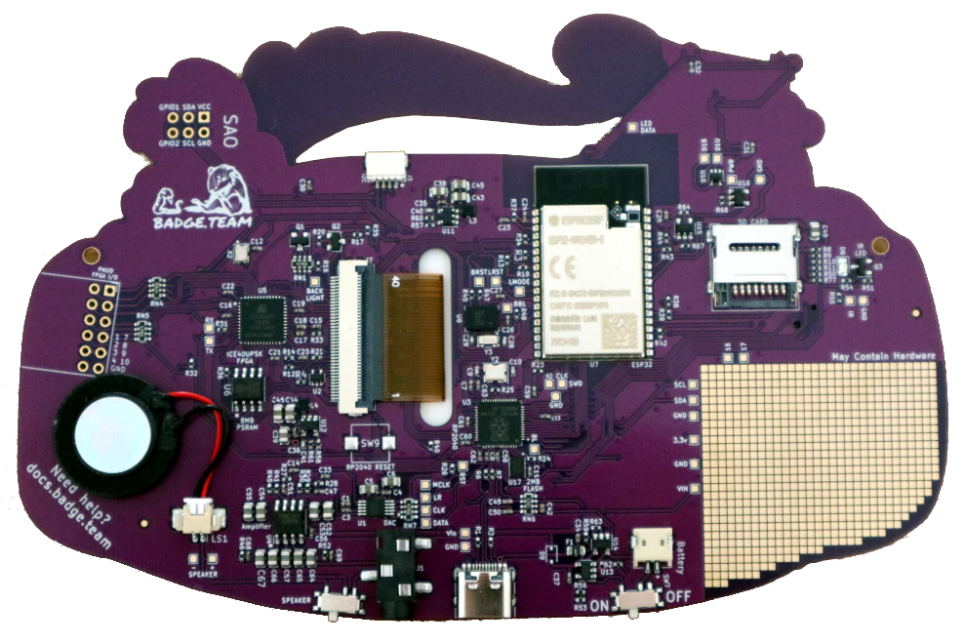
Qwiic connector
ESP32 main processor
Micro SD card socket
RP2040 co-processor
Battery connector
Power switch
USB-C socket
Speaker switch
Audio DAC and amplifier
Speaker connector
PMOD connector
ICE40UP5K FPGA
Shitty Add-on connector

