**Table Creation**

Creating Database Named **‘assignment_two’**

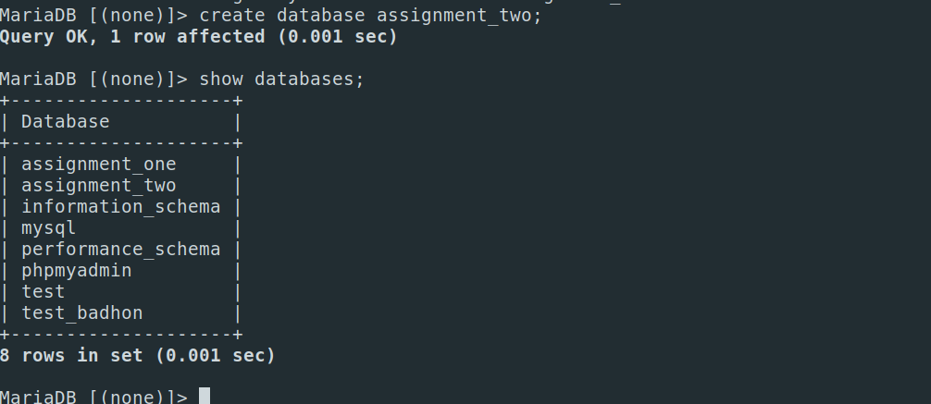

Creating a table named ‘**employees**’ with given information

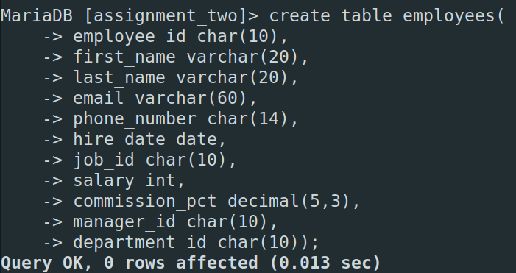

Newly Created Table

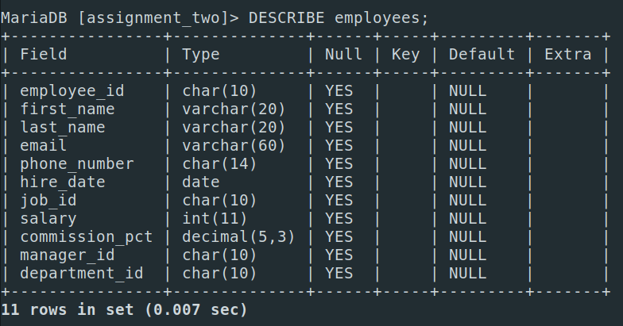

Giving Data

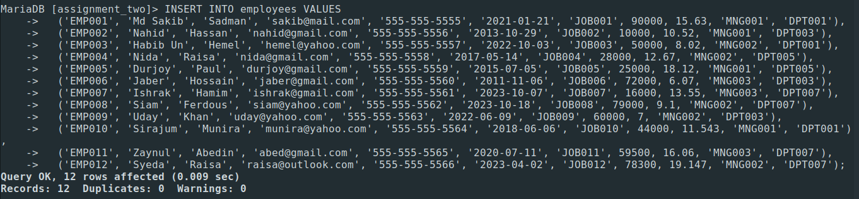

Table

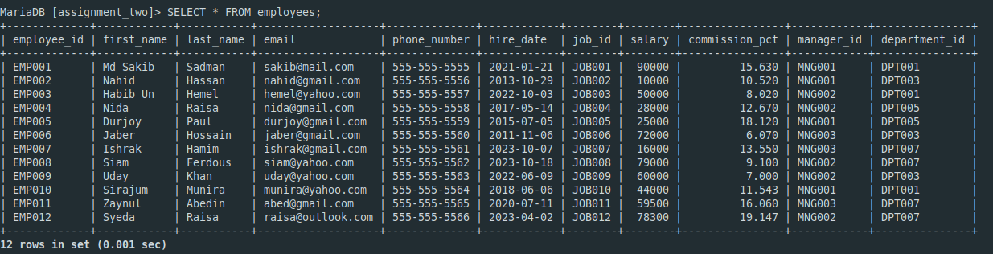

**Task 1**

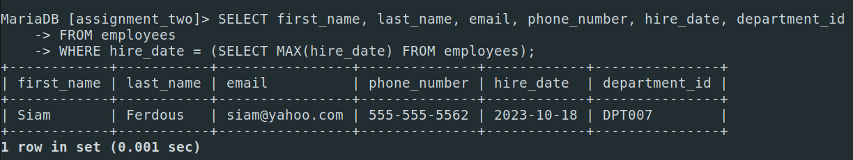

**Task 2**

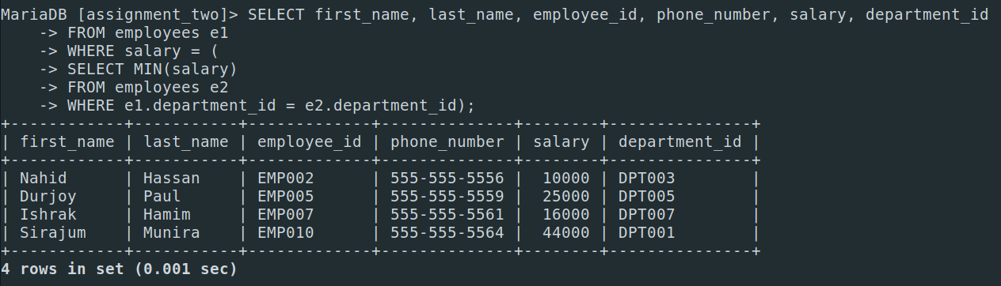

**Task 3**

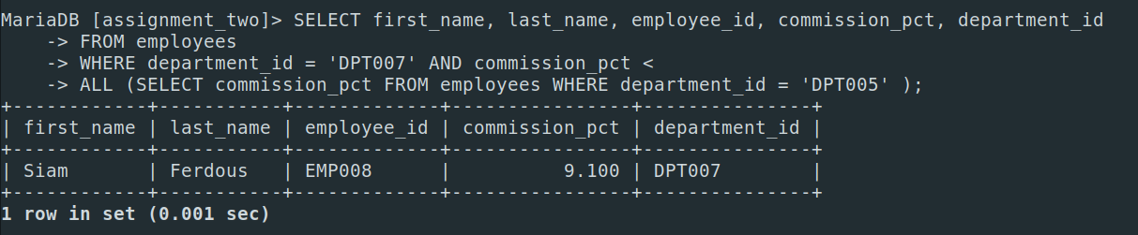

**Task 4**

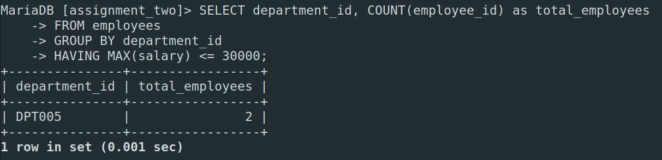

**Task 5**

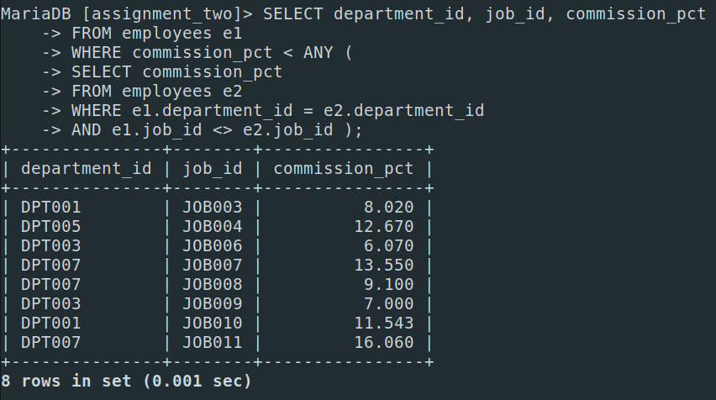

**Task 6**

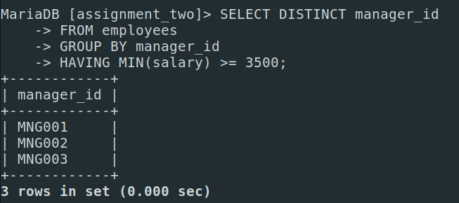

**Task 7**

