**task 4,5 wrong, taks 2 duplicate data**

**Task 1**

SELECT c.customer_name, l.loan_number

FROM customer c

JOIN borrower b ON c.customer_id = b.customer_id

JOIN loan l ON b.loan_number = l.loan_number

WHERE l.branch_name= 'Downtown';

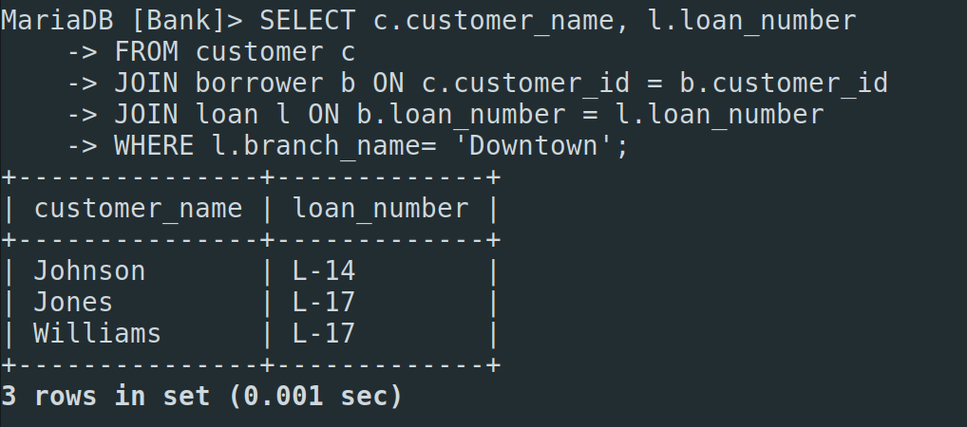

**Task 2**

SELECT c1.customer_name AS Customer1, c2.customer_name AS Customer2,

c1.customer_city as City FROM customer c1, customer c2

WHERE c1.customer_city = c2.customer_city AND c1.customer_name != c2.customer_name;

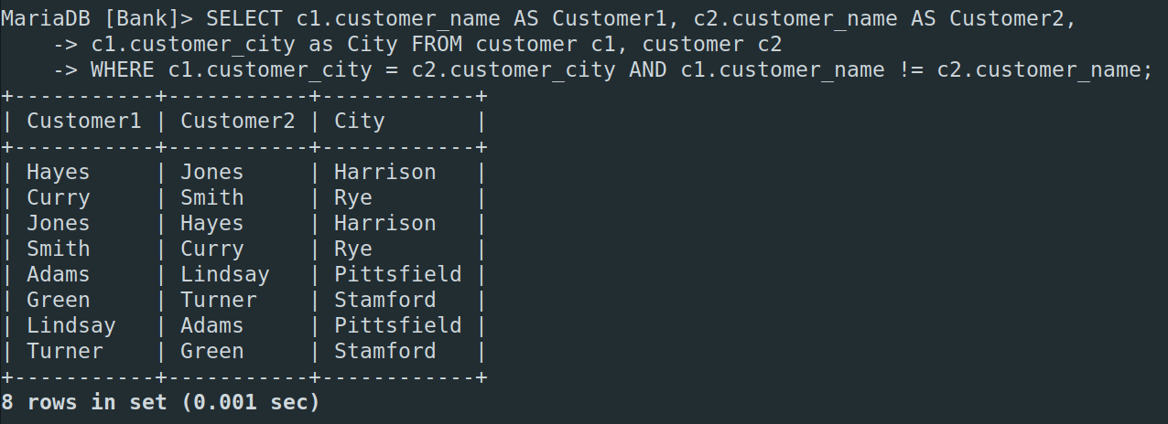

**Task 3**

SELECT a.branch_name as Branch_name,

SUM(a.balance * 0.04) as Total_Interest

FROM account a

GROUP BY a.branch_name;

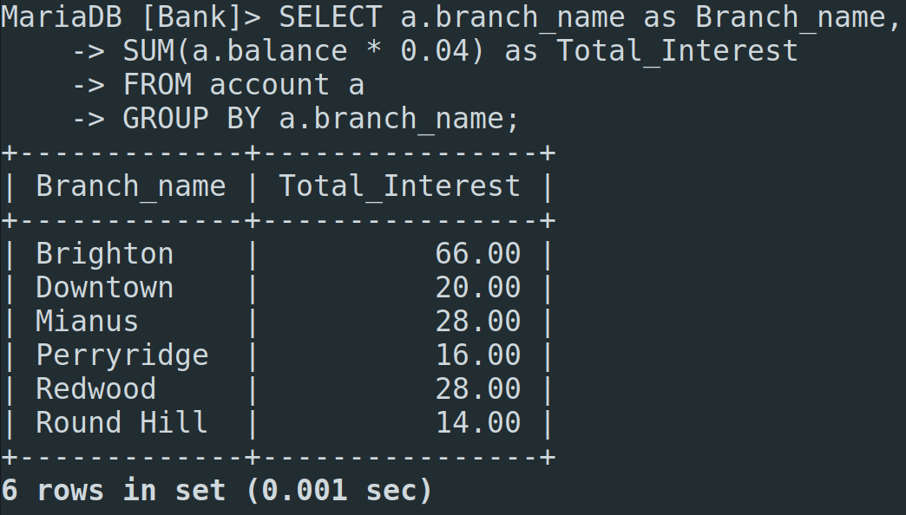

**Task 4**

SELECT b.branch_city, a.account_number, a.balance

FROM account a

JOIN branch b ON a.branch_name = b.branch_name

WHERE (b.branch_city, a.balance) IN (

SELECT branch_city, MAX(balance)

FROM branch b

JOIN account a ON b.branch_name = a.branch_name

GROUP BY branch_city);

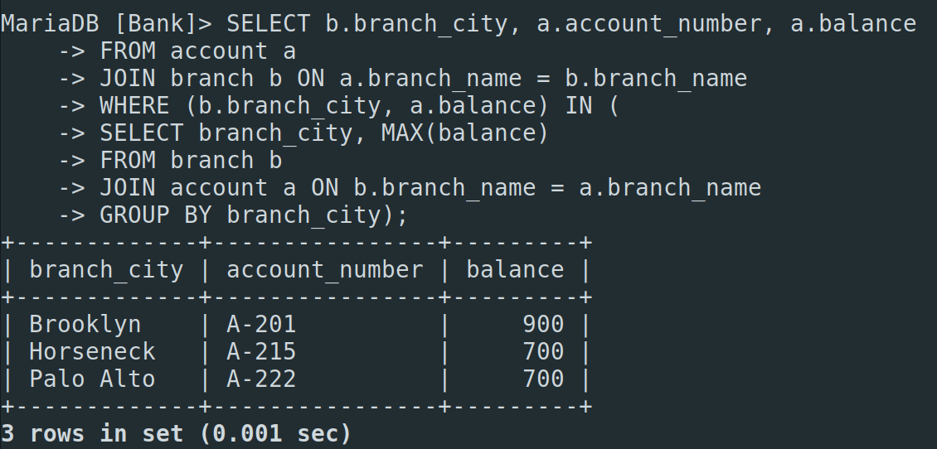

**Task 5**

SELECT l.loan_number, l.amount as loan_amount, c.customer_name

FROM loan l

JOIN borrower b ON l.loan_number = b.loan_number

JOIN customer c ON b.customer_id = c.customer_id

ORDER BY l.amount ASC, l.loan_number DESC

LIMIT 5;

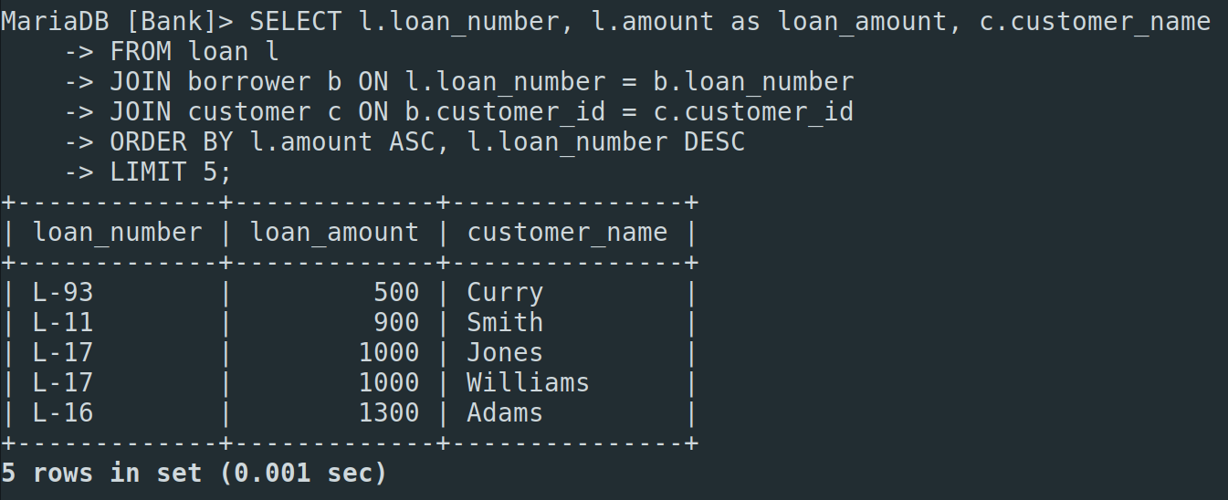

**Task 6**

SELECT DISTINCT c.customer_name

FROM customer c

JOIN depositor d ON c.customer_id = d.customer_id

JOIN account a ON d.account_number = a.account_number

JOIN borrower b ON c.customer_id = b.customer_id

JOIN loan l ON b.loan_number = l.loan_number

JOIN branch br ON a.branch_name = br.branch_name

WHERE br.branch_name = 'Perryridge';

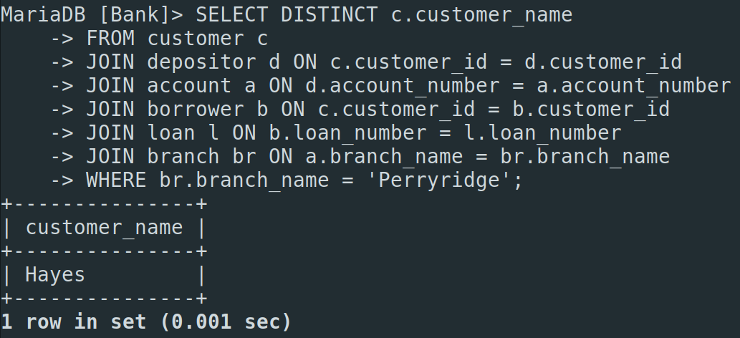

**Task 7**

SELECT c.customer_name, SUM(l.amount) as total_loan

FROM customer c

JOIN borrower b ON c.customer_id = b.customer_id

JOIN loan l ON b.loan_number = l.loan_number

GROUP BY c.customer_id, c.customer_name

HAVING COUNT(b.loan_number) >= 2;

