**CSE370 : Database Systems Lab**

**Database Challenge 02**

**Activity List**

**Task 1**

Create and use the database “DC_Battles”.

**CREATE DATABASE DC_Battles;**

**Task 2**

You have three tables in your database: Heroes, Villains and Battles. All three tables are created for you and the necessary data has been inserted. .…………………………………………………………………………………………………….

**CREATE TABLE Heroes(**

**Hero_id varchar(3),**

**Name varchar(30),**

**Location varchar(30),**

**Primary key(Hero_id)**

**);**

**CREATE TABLE Villains(**

**Villain_id varchar(3),**

**Name varchar(30),**

**Location varchar(30),**

**Primary key(Villain_id)**

**);**

**CREATE TABLE Battles(**

**Battle_id varchar(3),**

**Hero_id varchar(3),**

**Villain_id varchar(3),**

**Battle_Date date,**

**Hero_points int,**

**Villain_points int,**

**Battle_location varchar(30),**

**Primary key(Battle_id),**

**Foreign key(Hero_id) references Heroes(Hero_id),**

**Foreign key(Villain_id) references Villains(Villain_id)**

**);**

**INSERT INTO Heroes values**

**('h01', 'The Flash', 'Central City'),**

**('h02', 'Batman', 'Gotham'),**

**('h03', 'Green Arrow', 'Star City'),**

**('h04', 'Wonder Woman', 'Themyscira'),**

**('h05', 'Green Lantern', 'Coast City'),**

**('h06', 'Black Canary', 'Star City');**

**INSERT INTO Villains values**

**('v01', 'Reverse Flash', 'Central City'),**

**('v02', 'Deathstroke', 'Star City'),**

**('v03', 'Joker', 'Gotham'),**

**('v04', 'Riddler', 'Gotham'),**

**('v05', 'Harley Quinn', 'Gotham'),**

**('v06', 'Ares', 'Mount Olympus');**

**INSERT INTO Battles values**

**('b01', 'h01', 'v01', '2017-12-12', 85, 90, 'Central City'),**

**('b02', 'h01', 'v06', '2016-10-09', 40, 98, 'Metropolis'),**

**('b03', 'h03', 'v02', '2018-06-11', 90, 93, 'Star City'),**

**('b04', 'h04', 'v06', '2016-10-10', 99, 98, 'Central City'),**

**('b05', 'h06', 'v05', '2018-07-08', 92, 85, 'Star City'),**

**('b06', 'h03', 'v02', '2017-06-11', 90, 88, 'Star City');**

………………………………………………………………………………………………………

Please check that all data has been inserted correctly in all three tables.

**Task 3**

Run appropriate queries to retrieve the requested data below [Use a single query for each question]:

1. Retrieve the name and average point of each hero.

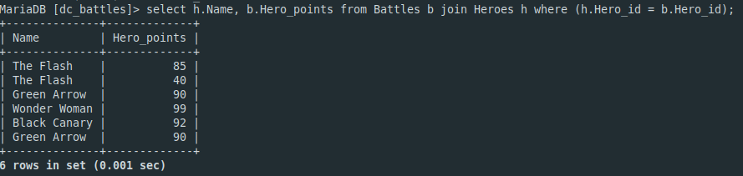

1. Retrieve the name of heroes, name of villains, date and location of battle where the heroes have scored lower than the villains.                                        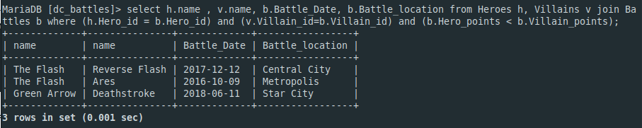
2. Retrieve the name of the villains who have fought the same hero more than once.

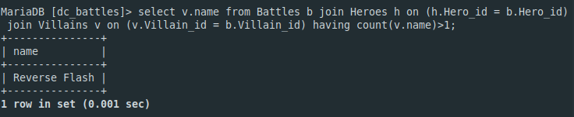

1. Retrieve the name of villains whose locations are not the same as their battle location.

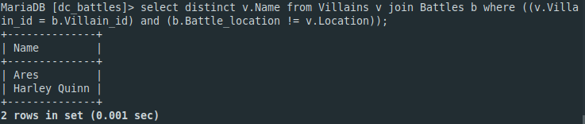

1. Reverse flash cheated in his battle by time traveling. So he will lose 20% of his points. [Hint: Do not directly use Reverse flash’s ID, use subquery]

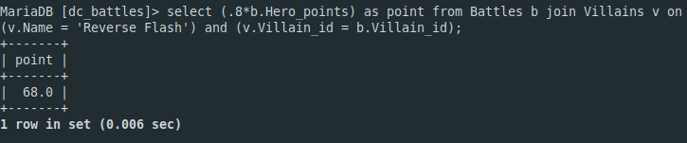

1. **Retrieve the name of the hero who achieved the maximum points in all battles.**

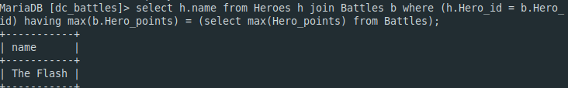

1. **Retrieve the name of the villain who achieved the minimum points in all battles.**

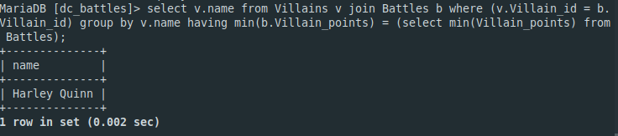

1. Retrieve the name of villains who have fought more than 1 battle.

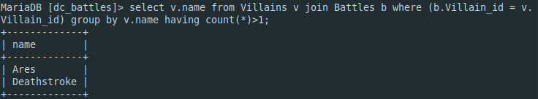

1. Retrieve the name of the heroes who have fought in more than one distinct city.

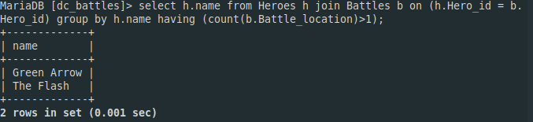

1. Retrieve the name of the villains who have the top 3 scores.

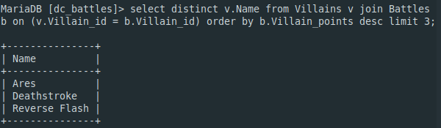

1. Retrieve the name of the heroes who have the bottom 3 scores.

