**Criterion B: Design Overview**

All user interface designs were made using the graphic design platform Canva *(Canva)*.

***Application Hierarchy***

Default page from which the client can sign into the application

Alert pop-up from which the client can sign out of the application

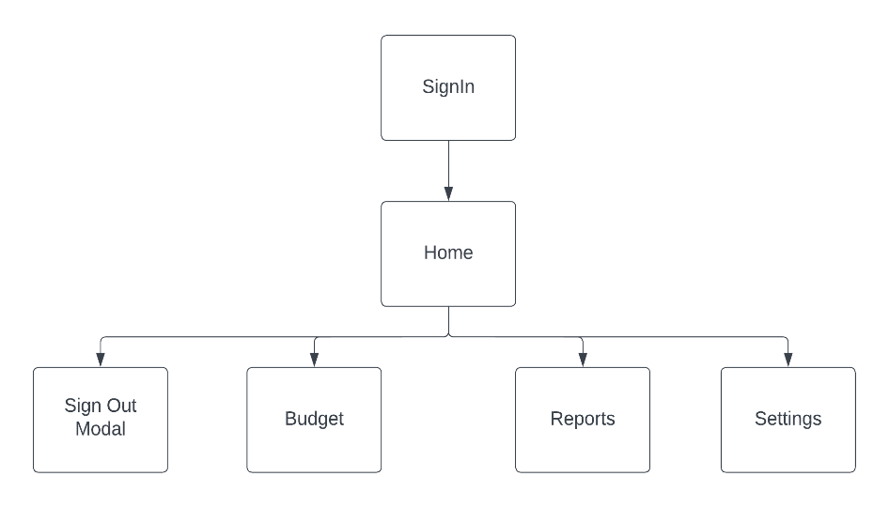

***Firestore Database Model***

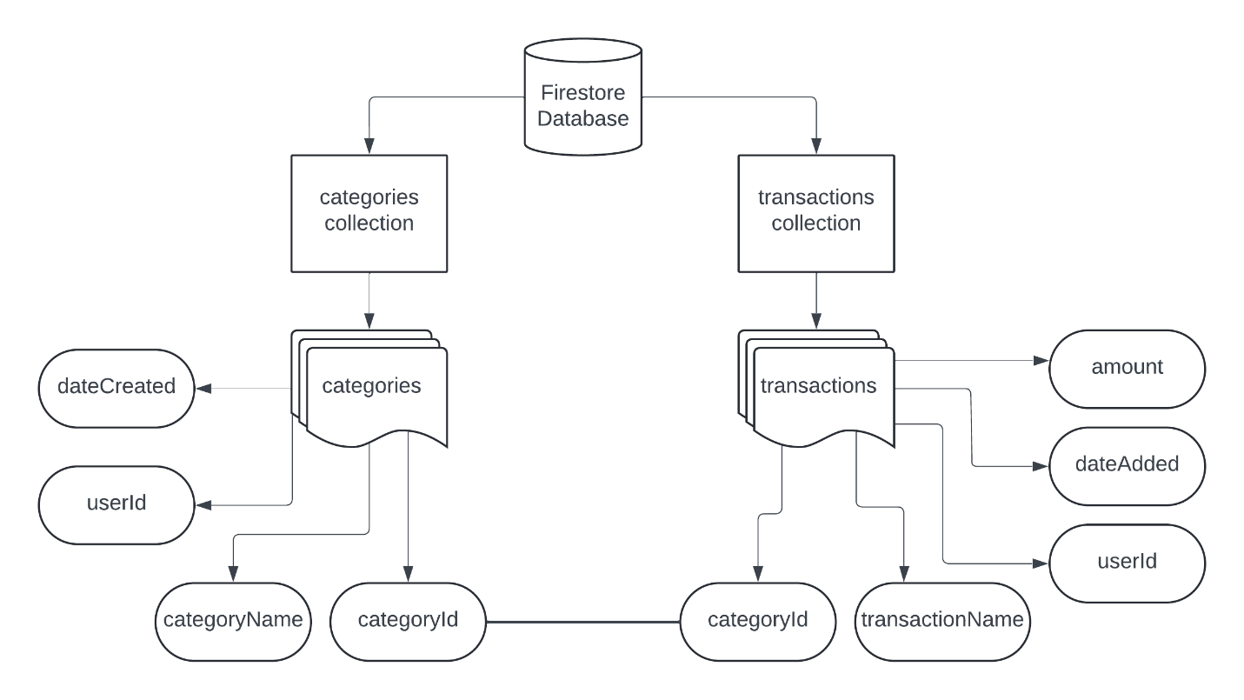

***Application Data Flow Diagrams (DFDs)***

Level 0

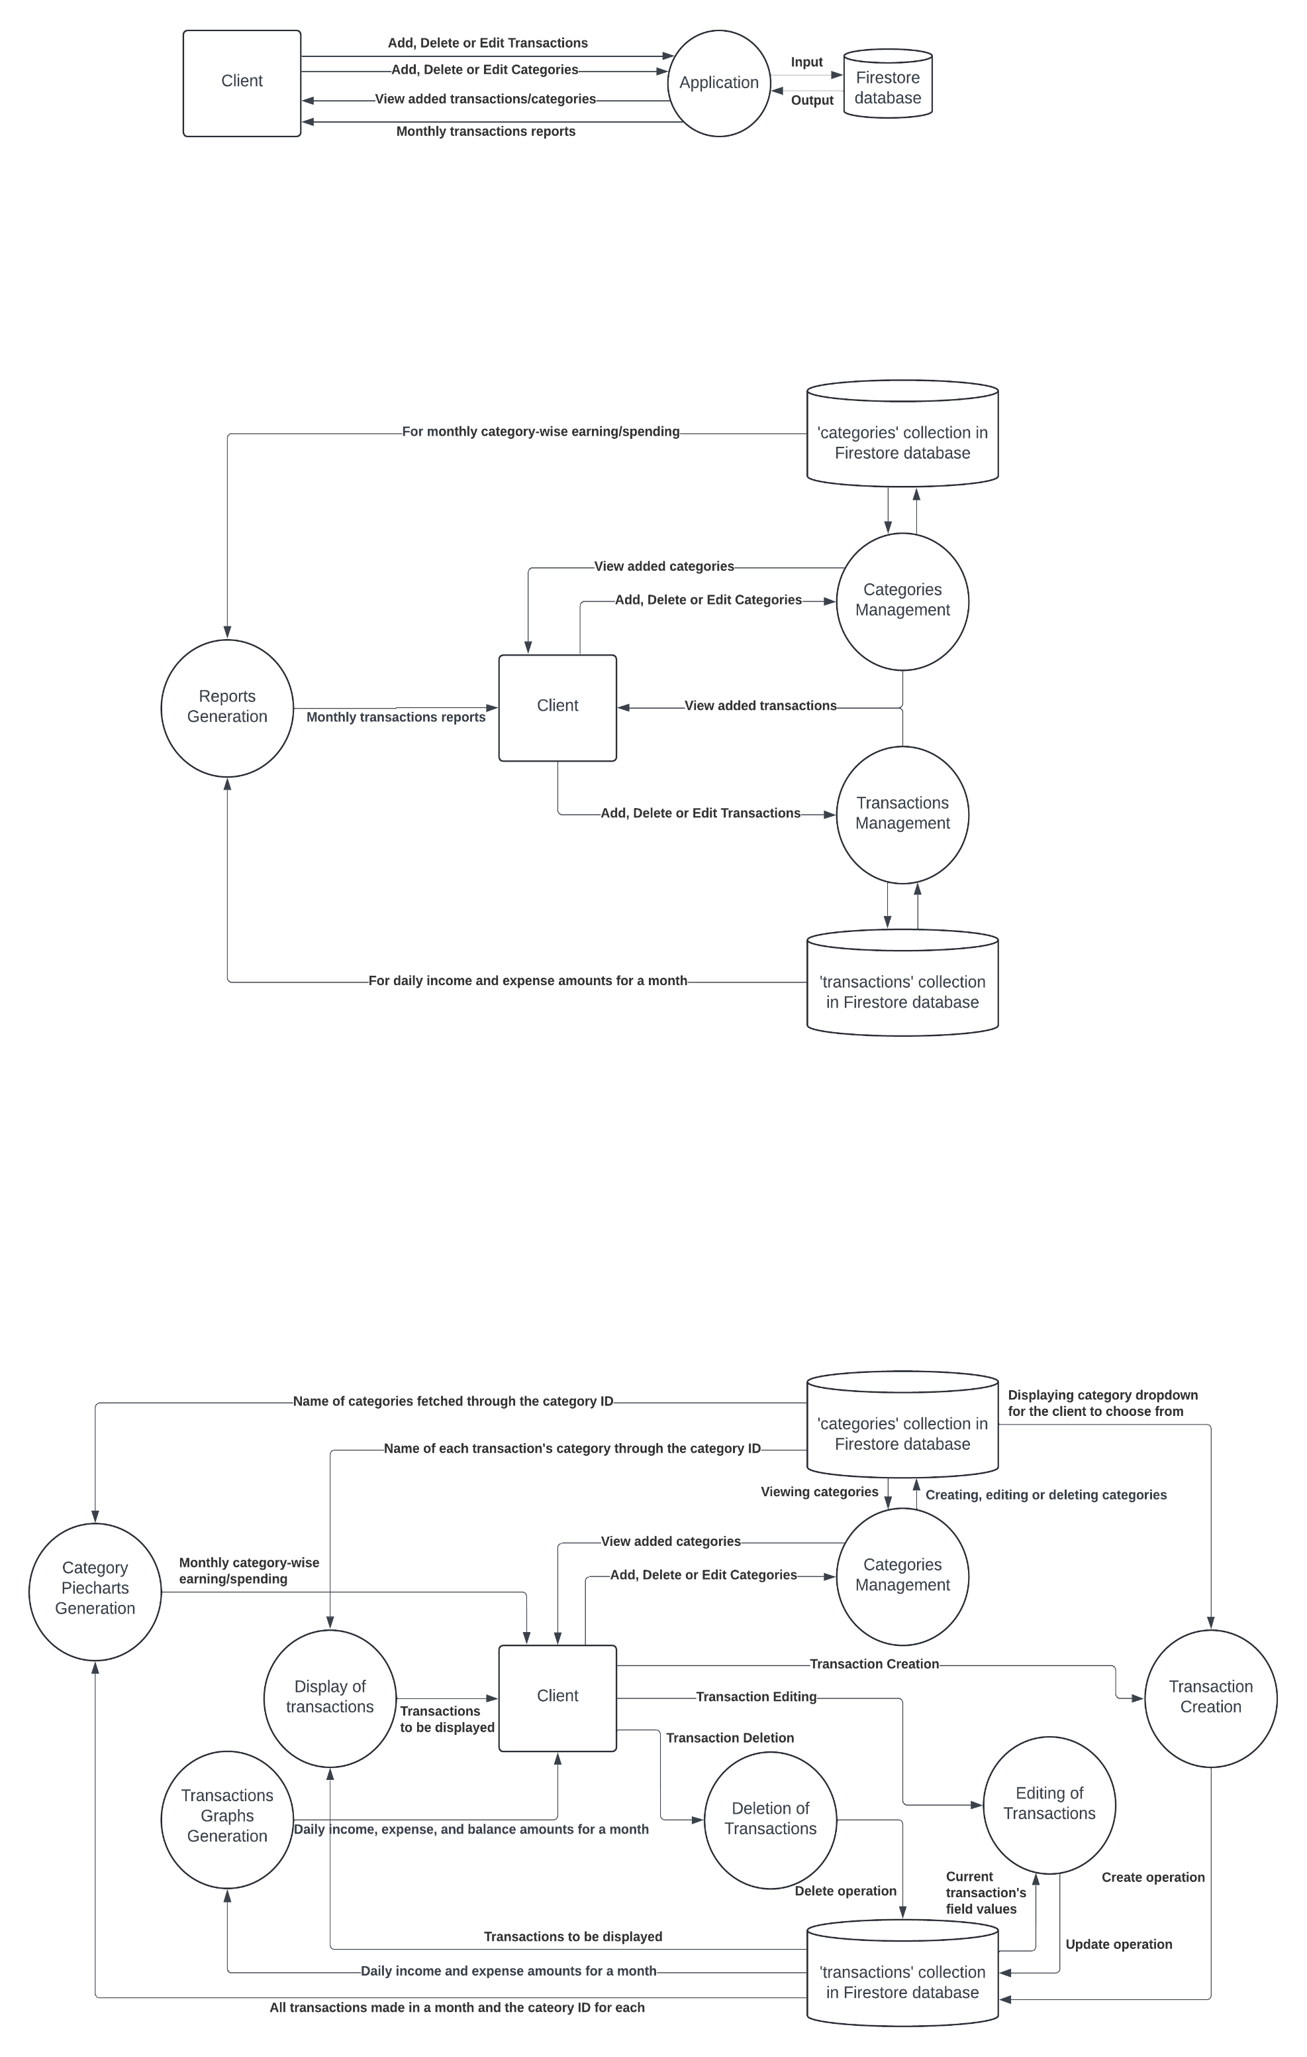

Level 1

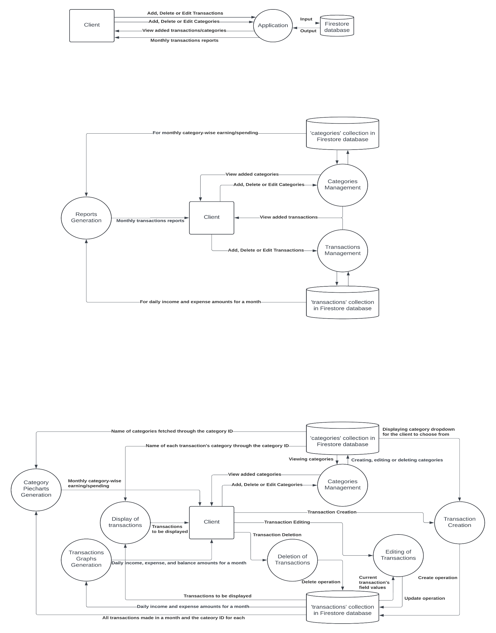

Level 2

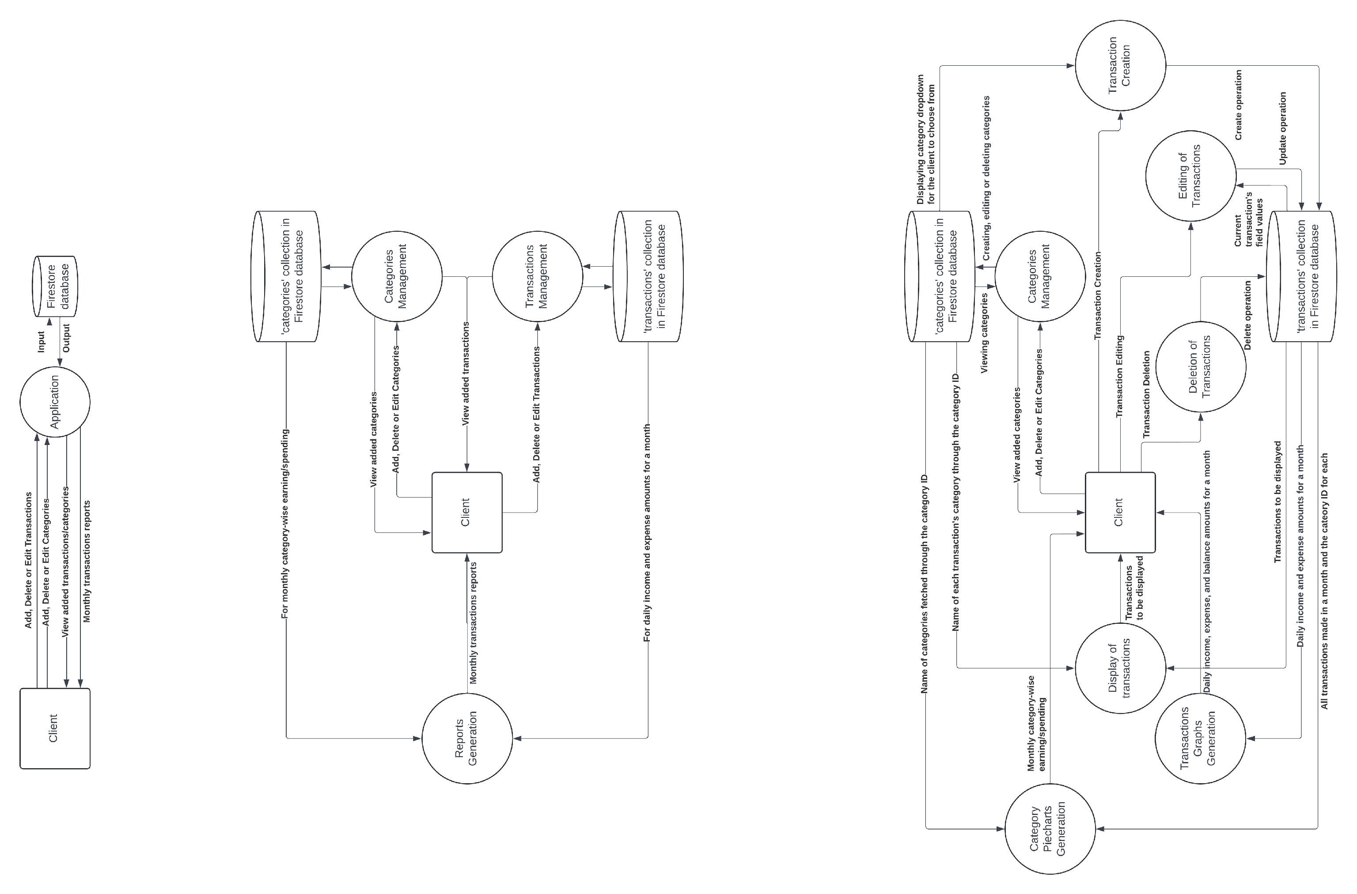

***Authentication Check Flowchart and Pseudocode for All Pages***

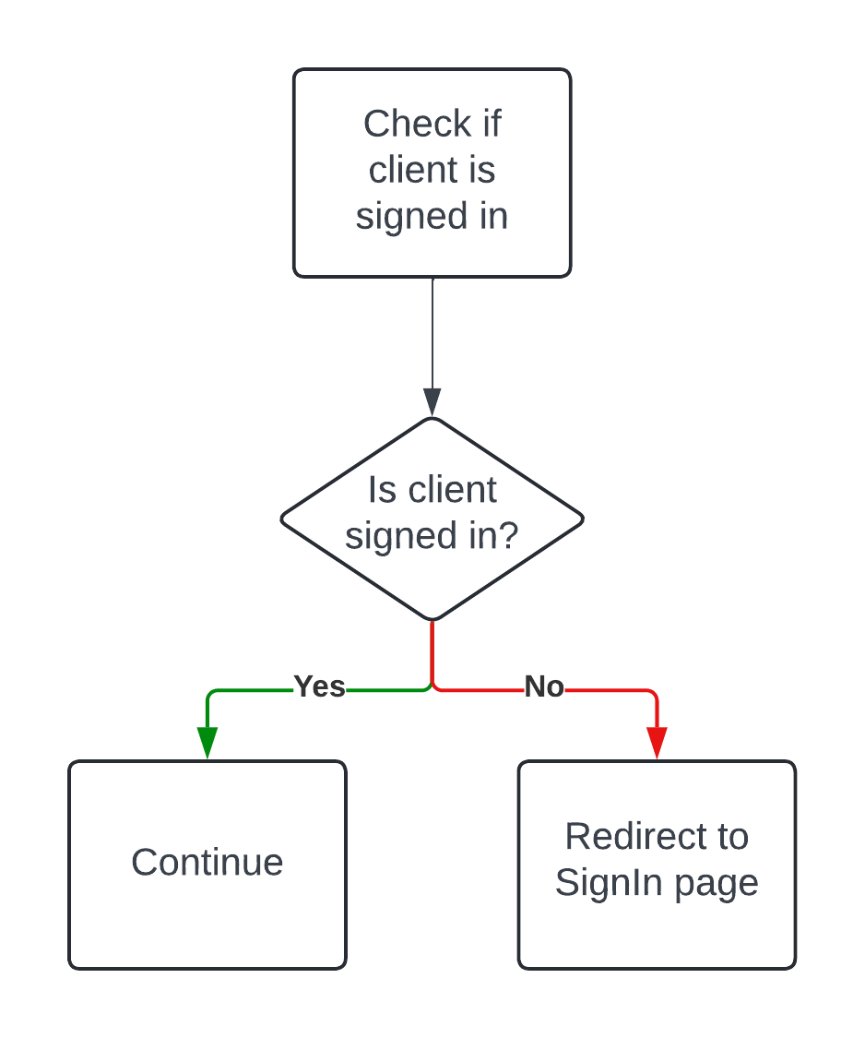

|  |
| --- |
| signedInStatus = checkSignInStatus() // Check if the client is signed in  if signedInStatus = false then // If true, then the page loads as normal  redirectToSignInPage() // Redirects client to SignIn page if he is not signed in with a Gmail account  end if |

***SignIn Page – Design, Structure, and Flowcharts***

Page Design and Sign in with Google screen popover

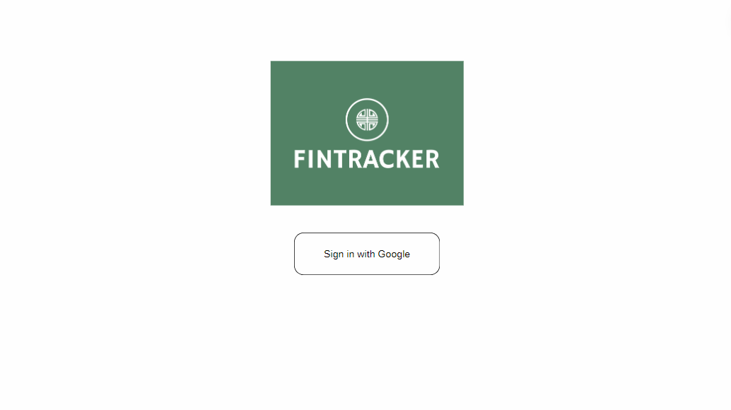

Google’s sign-in popover which enables the client to sign in using his Google accounts.

Google accounts selection area

Button whichcalls the *googleSignIn* function when clicked.

googleSignIn Flowchart and Pseudocode

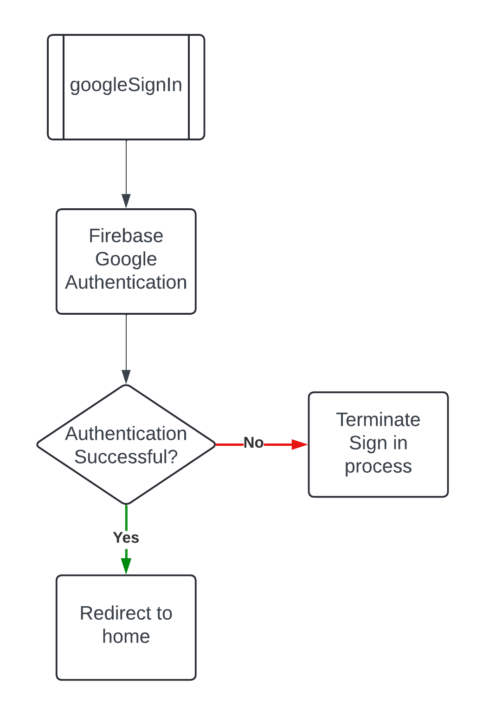

|  |
| --- |
| subprogram googleSignIn (  authenticationStatus = firebaseGoogleAuth() // Perform Firebase Google Authentication  if authenticationStatus = true then // Check if authentication was successful  redirectToHomePage() // Redirect to the Home page if client signs in successfully  else  cancel() // Terminate the sign in process if a failure occurs  alert(“Sign in unsuccessful, try again.”) // Inform client sign in process was unsuccessful.  end if  ) |

Authentication Check Flowchart and Pseudocode (for SignIn page only)

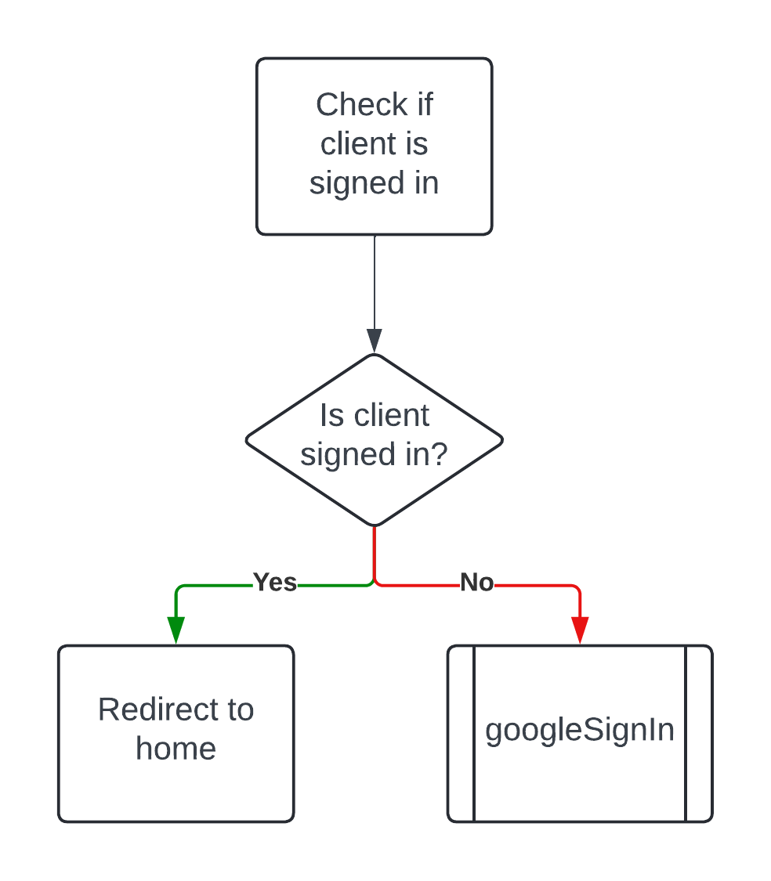

|  |
| --- |
| signedInStatus = checkSignInStatus() // Check if the client is signed in  if signedInStatus = true then // If true, then the client gets redirected to the Home page  redirectToHomePage() // Redirects client to SignIn page if he is not signed in with a Gmail account  else  googleSignIn()  end if |

***Header Component***

Design



Button that opens the SignOutModal component, which allows the client to sign out of the currently signed in account. Displays the signed-in Gmail account’s profile picture if available.

Navigation buttons used for navigating through the pages of the application.

Header – Sign Out Modal

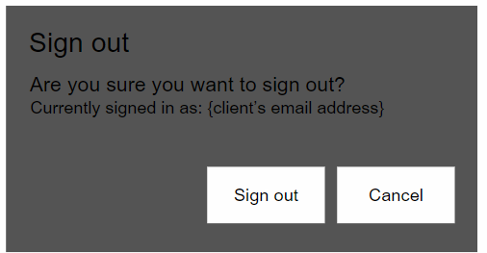

Calls the googleSignOut function when clicked

|  |
| --- |
| subprogram googleSignOut (  signOut = firebaseGoogleSignOut() // Sign out function from Firebase  if signOut = true then // Check if signOut was successful  redirectToSignInPage() // Redirect to the Home page if client signs in successfully  else  cancel() // Terminate the sign out process if a failure occurs  alert(“Sign out unsuccessful, try again.”) // Inform client sign out process was unsuccessful.  end if  ) |

***Home Page – Design, Structure, and Flowcharts***

Structure

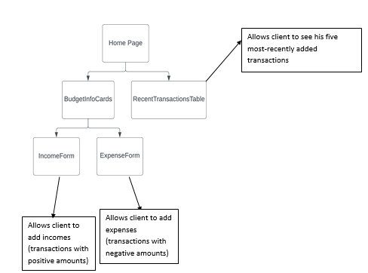

Page Design and RecentTransactionsTable when Opened

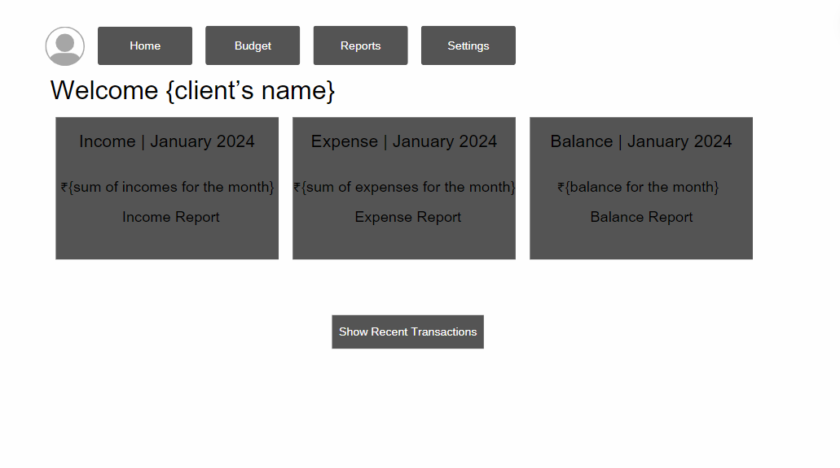

BudgetInfoCards

Button to open RecentTransactionsTable

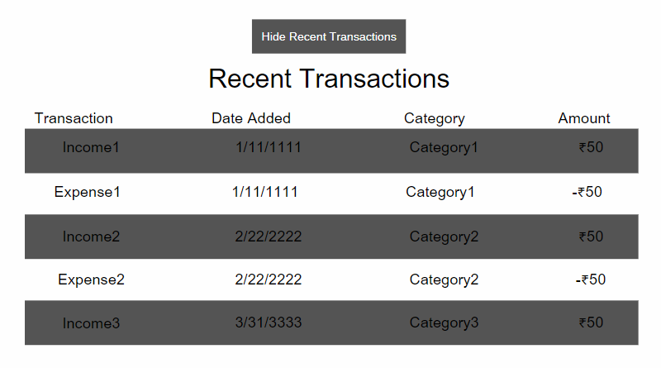

Button to close RecentTransactionsTable

IncomeForm

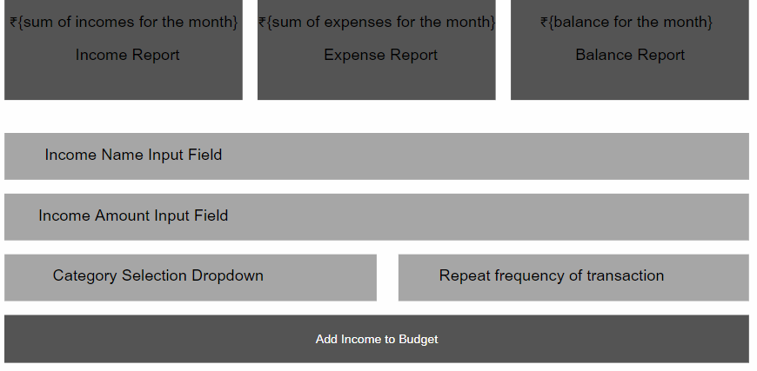

IncomeForm

Button which calls the onSubmitIncome function when clicked

onSubmitIncome Flowchart and Pseudocode

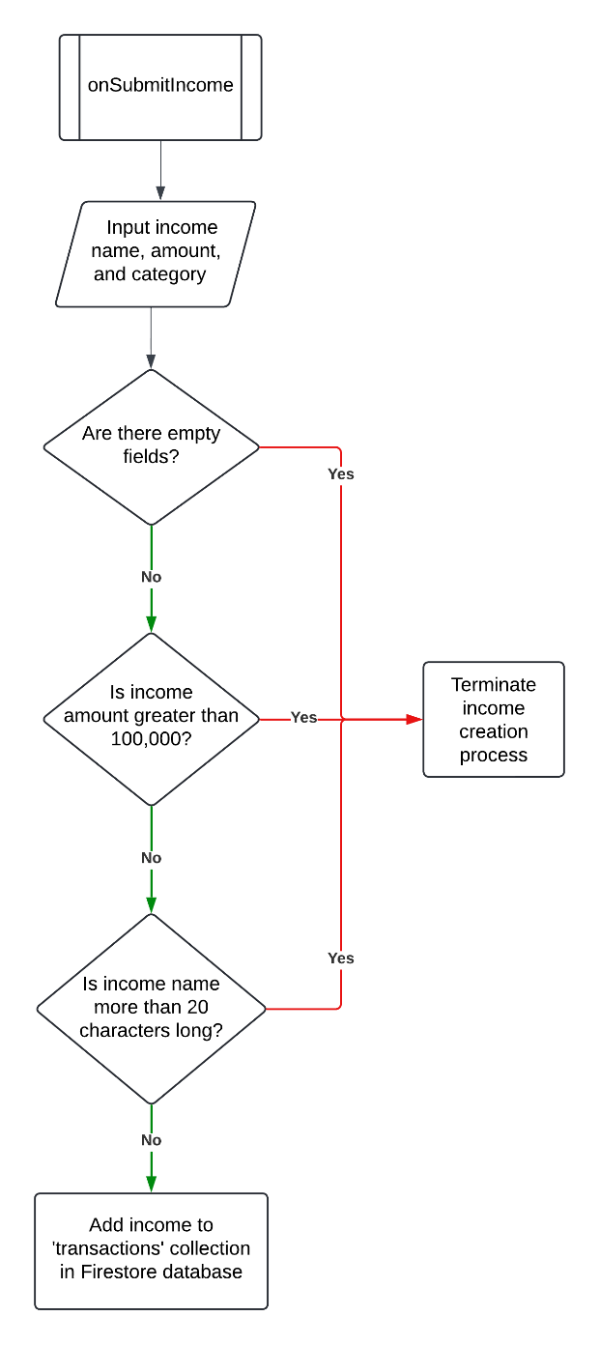

|  |
| --- |
| subprogram onSubmitIncome(  incomeDocument = input(incomeName, incomeAmount, transactionCategory)  if anyFieldIsEmpty(incomeDocument) = true then // Check if any of the input fields are empty  cancel() // Terminate income creation process  alert(“Please fill out all the fields.”) // Inform client that all the fields need to be filled out.    else if incomeAmount > 100,000 then // Check if the income amount is greater than 100,000  cancel()  alert(“Income amount should be less than or equal to 100,000”)  // Inform client that incomeAmount should be less than or equal to 100,000.  else if incomeName.length > 20 then  // Check if incomeName has more than 20 characters.  cancel()  alert(“Income name should be less than 20 characters long”)  // Inform client that incomeName should be less than 20 characters long.    else  addToFirestore(incomeDocument)  // Add income to the 'transactions' collection in the Firestore database.  end if  ) |

ExpenseForm

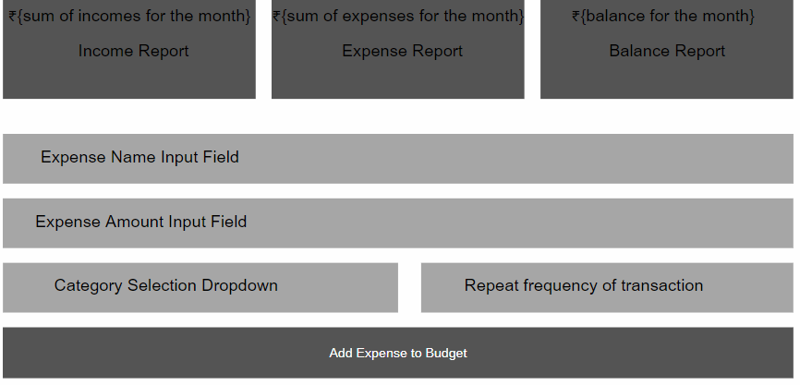

ExpenseForm

Button which calls the onSubmitExpense function when clicked

onSubmitExpense Flowchart and Pseudocode

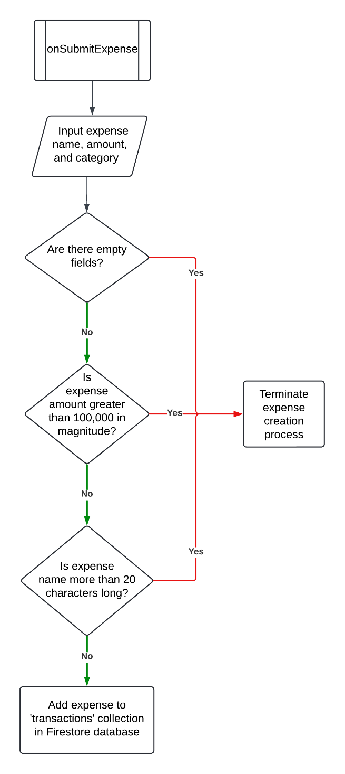

|  |
| --- |
| subprogram onSubmitExpense(  expenseDocument = input(expenseName, expenseAmount, transactionCategory)  if anyFieldIsEmpty(expenseDocument) = true then // Check if any of the input fields are empty  cancel() // Terminate expense creation process  alert(“Please fill out all the fields.”) // Inform client that all the fields need to be filled out.    else if expenseAmount > 100,000 then // Check if the expense amount is greater than 100,000  cancel()  alert(“Expense amount should be less than or equal to 100,000”)  // Inform client that expenseAmount should be less than or equal to 100,000.  else if expenseName.length > 20 then  // Check if expenseName has more than 20 characters.  cancel()  alert(“Expense name should less than 20 characters long”)  // Inform client that expenseName should be less than 20characters long.    else  addToFirestore(expenseDocument)  // Add expense to the 'transactions' collection in the Firestore database.  end if  ) |

***Budget Page – Design, Structure, and Flowcharts***

## Structure

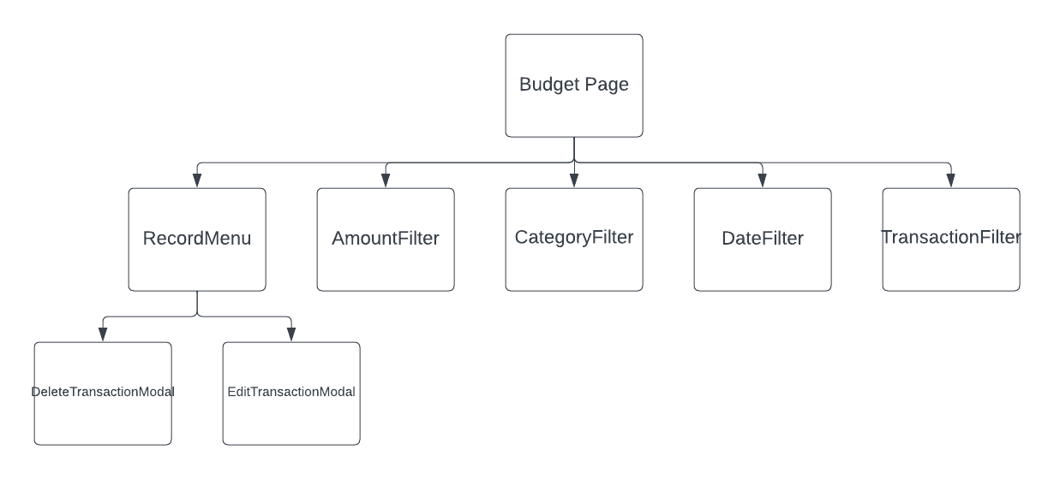

Allows for filtering by the magnitude of the transaction amount

Allows client to edit

or delete a specific

transaction.

Filters transactions by income/expense

Filters transactions by time

Filters transactions by category

Page Design

Allows client to edit a transaction

Allows client to delete a transaction

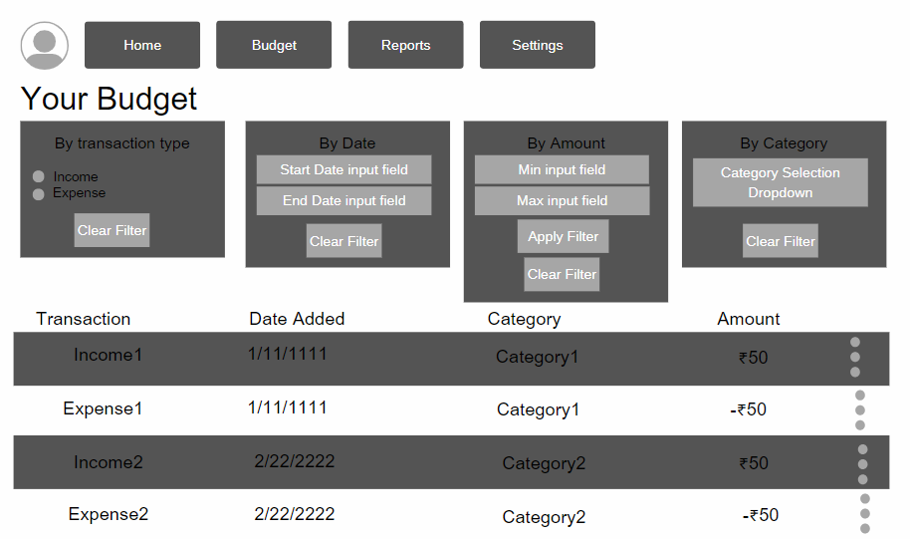

TransactionsFilter

DateFilter

AmountFilter

CategoryFilter

RecordMenu

RecordMenu when Opened

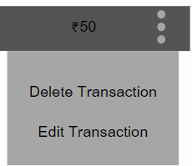EditTransactionsModal

Opens the DeleteTransactionModal component

Opens the EditTransactionModal component

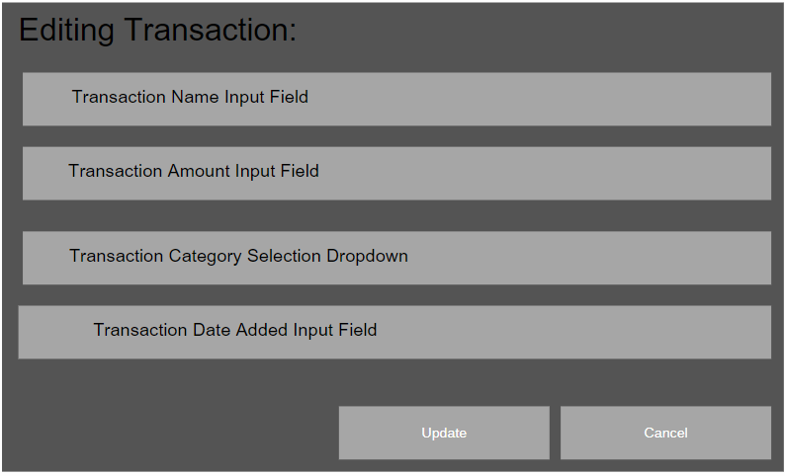

Input fields will be pre-filled with the transaction data passed down from the RecordMenu component.

Calls the updateTransaction function when clicked

Terminates transaction editing process

updateTransaction Flowchart and Pseudocode

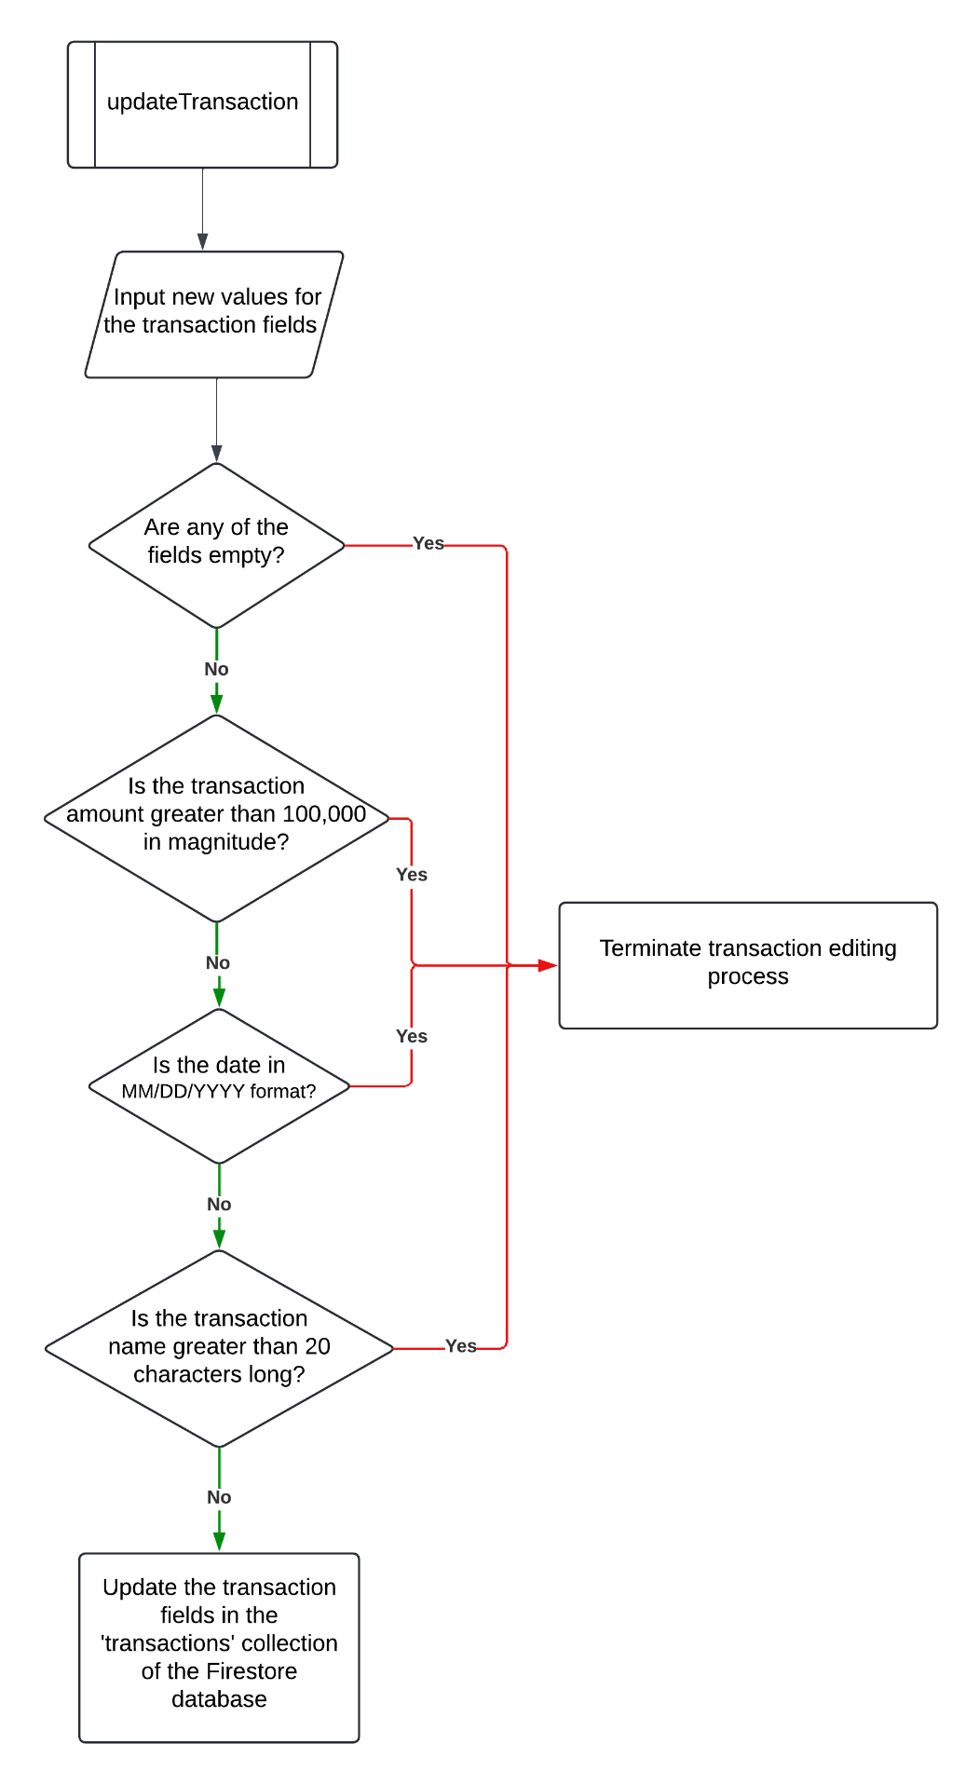

|  |
| --- |
| subprogram updateTransaction(  transactionDocument = input(transactionName, transactionAmount, transactionCategory, transaction Date)  if anyFieldIsEmpty(transactionDocument) = true then // Check if any of the input fields are empty  cancel() // Terminate transaction update process  alert(“Please fill out all the fields.”) // Inform client that all the fields need to be filled out.    else if transactionAmount > 100,000 then  // Check if the transaction amount is greater than 100,000.  cancel()  alert(“Transaction amount should be less than 100,000”)  // Inform client that transactionAmount should be less than 100,000.  else if transactionDate ≠ “MM/DD/YYYY” then // Check if date is in MM/DD/YYYY format  cancel()  alert(“Date must be in MM/DD/YYYY format.”)  // Inform client that transactionDate must be in MM/DD/YYYY format.  else if transactionName.length > 20 then // Check if name is more than 20 characters long  cancel()  alert(“Transaction name should be less than 20 characters long.”)  // Inform client that transactionName must be less than 20 characters long.  else  updateInFirestore(transactionDocument)  // Update the transaction document in the 'transactions' collection in the Firestore database.  end if  ) |

DeleteTransactionsModal

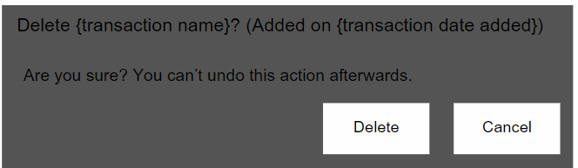

Calls the deleteTransaction function when clicked

TransactionFilter

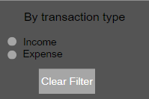

Enables filtering by transactions with positive amounts (incomes) or negative amounts (expenses)

Removes the filter

DateFilter

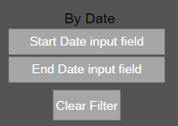

Allows client to filter transactions by the date they were added

Removes the filter

AmountFilter

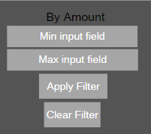

Allows for filtering by the magnitude of the transaction amount

Removes the filter

The filter is not applied in real time in order to perform validation checks on the inputted amount values

CategoryFilter

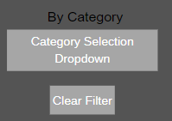

Removes the filter

Displays all the categories from the ‘categories’ collection in the Firestore database to allow client to filter transactions by their category.

Transactions Filtering Pseudocode

|  |
| --- |
| const query = transactionsQuery(clientAccountID, transactionType, startDate, endDate, minAmount, maxAmount, category)  firestoreDatabaseQuery(query) // Applies the client’s transaction filters on the Firestore database.  subprogram transactionsQuery(clientAccountID, transactionType, startDate, endDate, minAmount, maxAmount, category) (  TransactionFilter(transactionType) // Apply the transaction type filter (income/expenses)  dateFilters(startDate, endDate) // Apply date filters  amountFilters(minAmount, maxAmount) // Apply amount filter  categoryFilter(category) // Apply category filter  ) |

## ***Reports Page – Design, Structure, and Flowcharts***

Structure

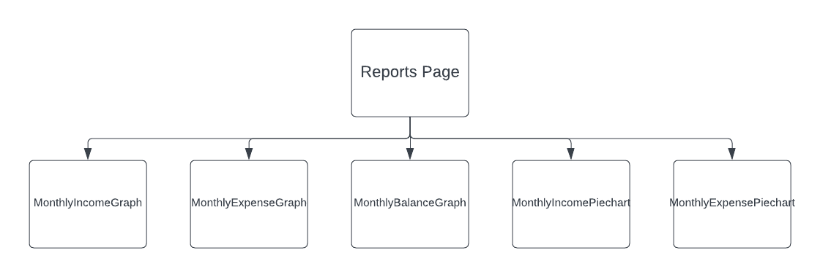

Displays cumulative daily income for the month

Displays cumulative daily expense for the month

Displays daily balance for each day of the month

Displays the total income amount magnitude per category

Displays the total expense amount magnitude per category

Page Design – 1

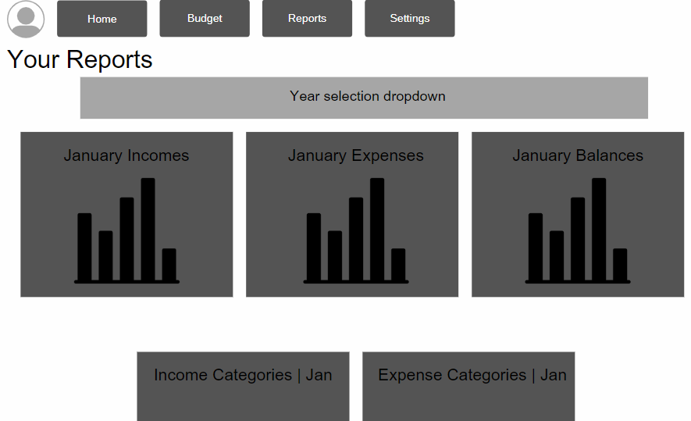

Year selector whichallows for filtering transactions by year added

Month selectors which allow for filtering transactions by month added

MonthlyIncomeGraph

MonthlyExpenseGraph

MonthlyBalanceGraph

Page Design – 2

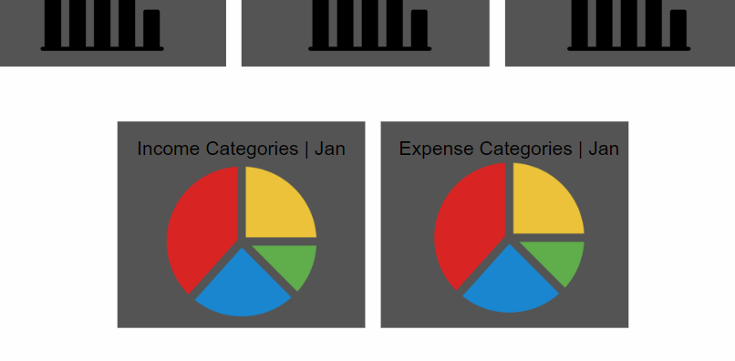

Month selectors which allow for filtering transactions by month added

Total magnitude of income and expense amounts per category in the month

MonthlyIncomePiechart

MonthlyExpensePiechart

***Settings Page – Design, Structure, and Flowcharts***

Structure

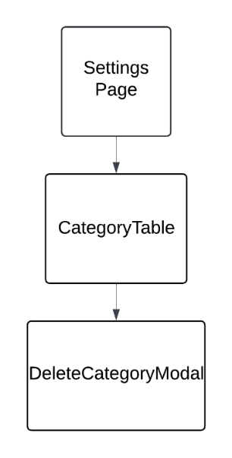

Allows client to delete a category.

Displays transaction categories

Page Design

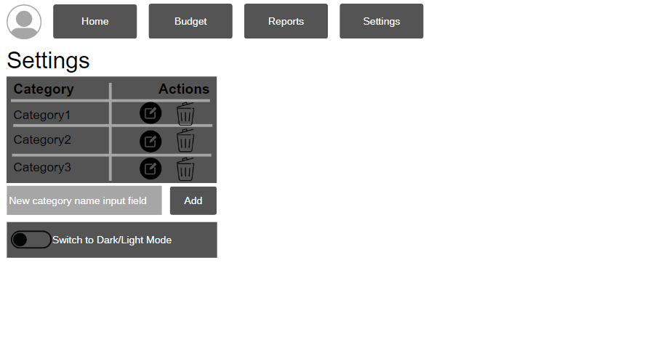

CategoryTable

Button which allows client to edit a category name

Button which calls handleDeleteCategory when clicked

Button which calls handleAddCategory when clicked

Page Design – Editing Category



Button which calls handleEditCategory when clicked

handleAddCategory Flowchart and Pseudocode

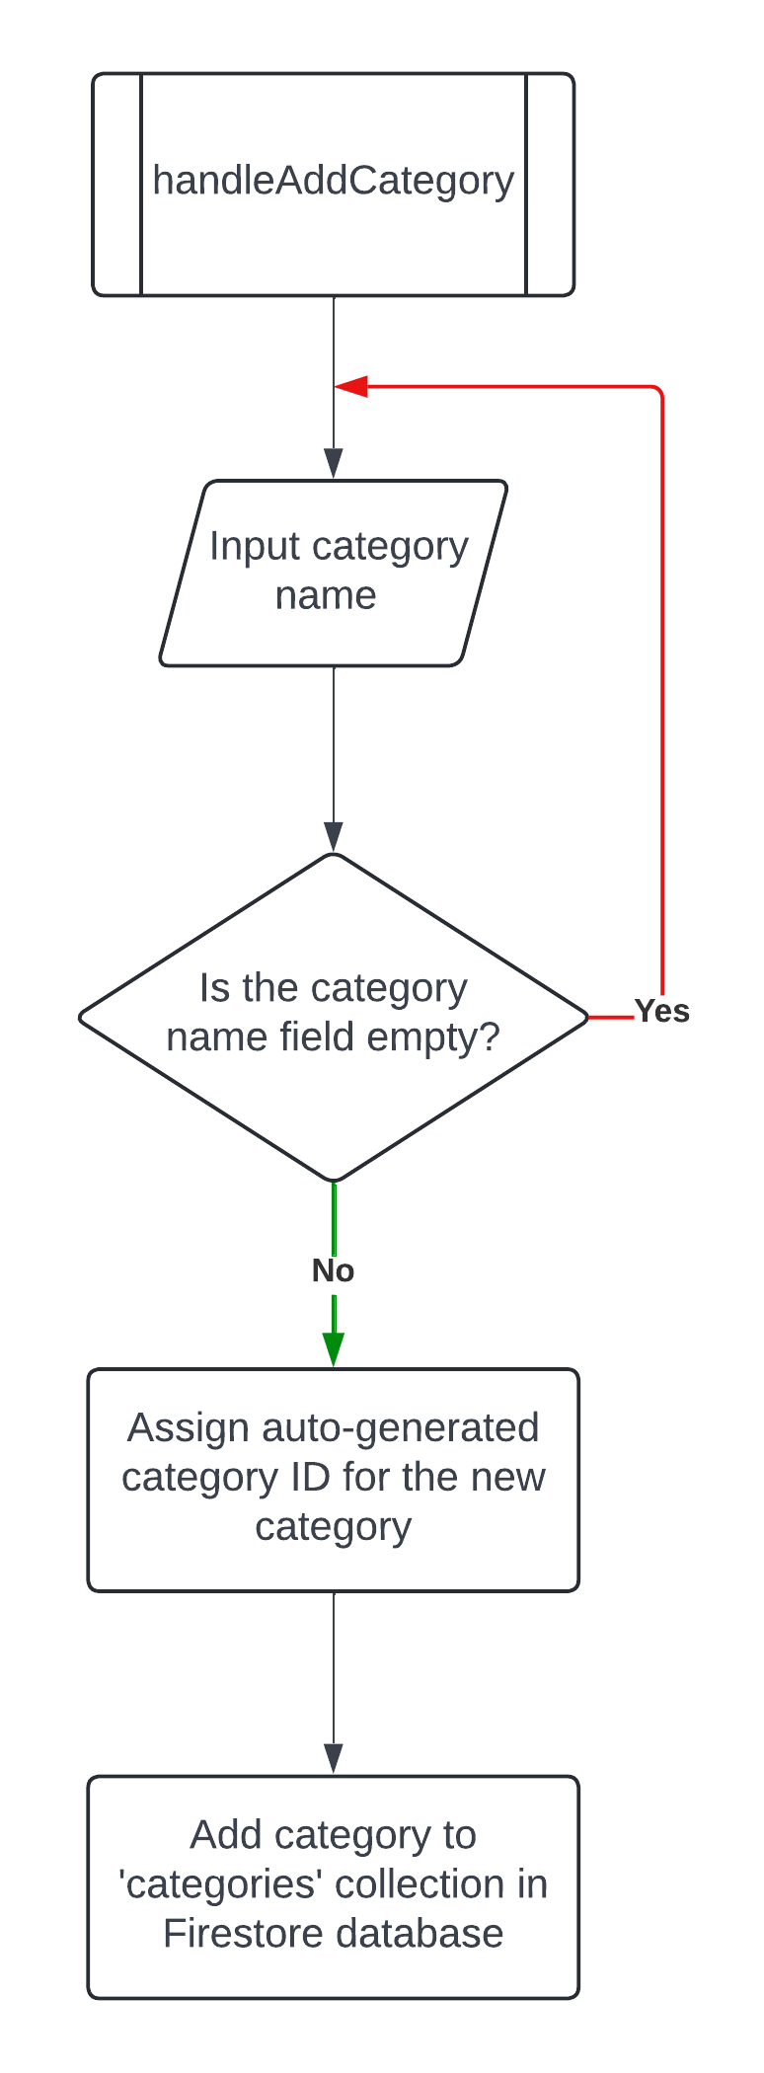

|  |
| --- |
| subprogram handleAddCategory(  categoryName = input("Enter category name") // Client inputs category name  if categoryName = "" then // Check if the category name field is empty  cancel() // Terminate category creation process  alert("Category name cannot be empty.") // Inform client that the category name is required.    else  categoryID = generateCategoryID() // Assign auto-generated category ID for the new category  addToFirestore(categoryID, categoryName)  // Add category to 'categories' collection in Firestore database.  end if  ) |

handleEditCategory Flowchart and Pseudocode

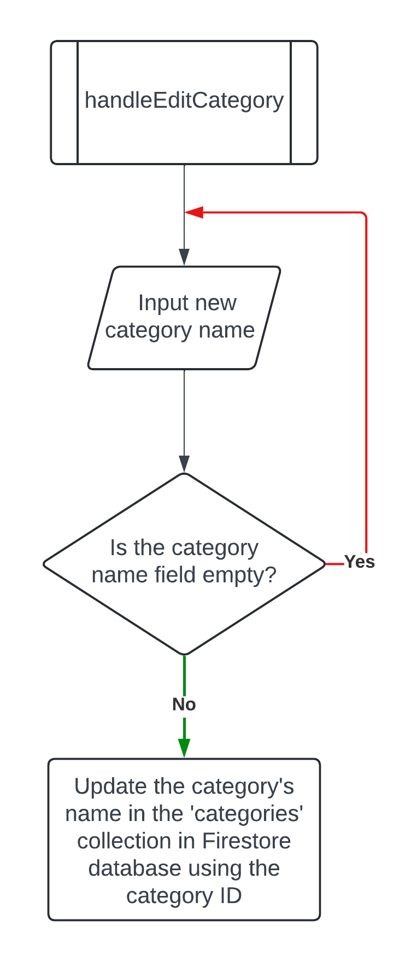

|  |
| --- |
| subprogram handleEditCategory(  newCategoryName = input() // Input new category name  if newCategoryName = "" then // Check if the category name field is empty  cancel() // Terminate category editing process  alert("Category name cannot be empty.") // Inform client that a category name is required.    else  updateCategoryInFirestore(categoryID, newCategoryName)  // Update category name in the 'categories' collection in Firestore using the category ID.  end if  ) |

handleDeleteCategory Flowchart and Pseudocode

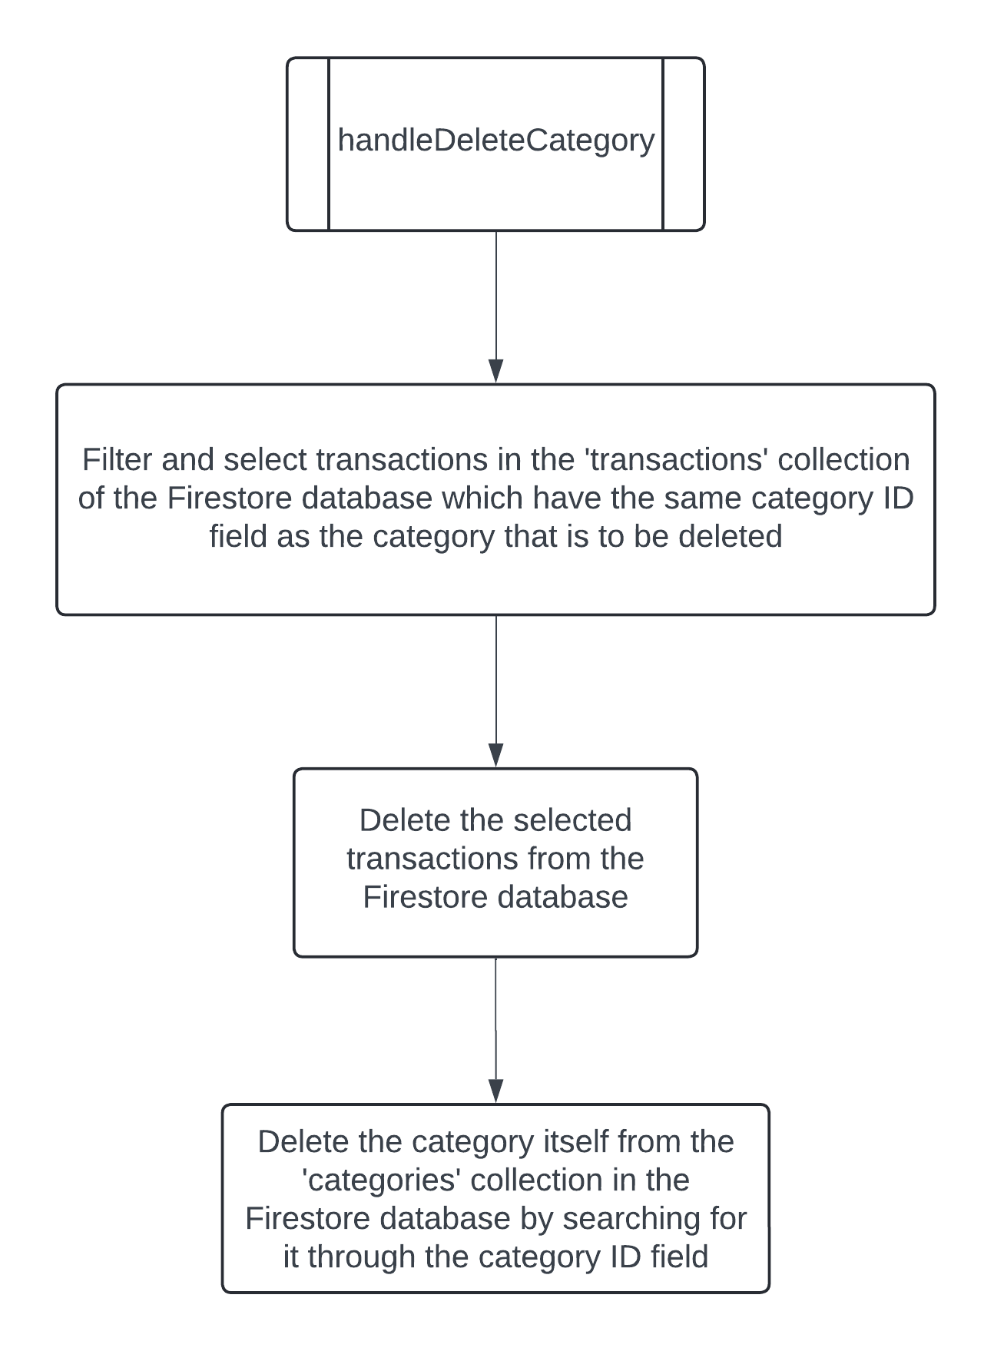

|  |
| --- |
| subprogram handleDeleteCategory(  transactionsToBeDeleted = filterTransactionsByCategory(categoryID)  // Filter and select transactions in the 'transactions' collection of the Firestore database which have the same category ID field as the category that is to be deleted.  deleteInFirestore(transactionsToBeDeleted)  // Delete the selected transactions from the Firestore database.  deleteCategoryInFirestore(categoryID)  // Delete the category itself from the 'categories' collection in the Firestore database by searching for it through the category ID field.  ) |

# ***Bibliography***

Canva. *Canva Homepage*. n.d. 25 September 2023. <https://www.canva.com/>.

# ***Test Plan***

|  |  |  |  |
| --- | --- | --- | --- |
| **Success Criteria Tested** | **Action to be tested** | **Test method** | **Expected Result** |
| **Success Criterion 1:**  **The client must be able to switch between his personal and work Gmail accounts without losing any of his financial data. Each account’s data should be isolated, ensuring that only the transactions and categories related to the signed-in account are accessible.** | Ability to sign in and out using different Gmail accounts | Signing into the application using the SignIn page using different Gmail accounts and then signing out | Clicking on the ‘Sign in with Google’ button opens up the Google sign-in popup. After signing in successfully, the profile picture of the signed-in Gmail account is shown in the left side of the Header component at the top of the application. Clicking on this opens the SignOutModal component which displays their current Gmail address. Clicking on the ‘Sign Out’ button in the aforementioned component signs the user out and redirects them to the SignIn page |
| Effect of closing Gmail sign-in popup before singing in | Clicking on the “Sign in With Google” button and closing the popup that appear afterwards before signing in | Application does redirect client to the Home page. An error message is displayed to the client, which should prompt him to try again |
| Effect of inputting an incorrect password and then closing the Gmail sign-in popup | Clicking on the “Sign in With Google” button and then selecting an account to sign in with. After inputting an incorrect password, the popup is then closed | Application does redirect client to the Home page. An error message is displayed to the client, which should prompt him to try again |
| Testing if the transactions and transaction categories made in different Gmail accounts are visible in other Gmail accounts as well | Signing into the application using a new Gmail account (other than the test Gmail account which contains some transactions and transaction categories which are visible in the Firestore database) | When the user is signed into a new Gmail account, they should not be able to see or access the transactions and categories that were made in different Gmail accounts in any part of the application whatsoever. This should be achieved through filtering the Firestore data using the Firebase-provided userId value before showing the data to the user |
| **Success Criterion 2:**  **The application must ensure that sensitive financial data is only accessible when the client is logged in using one of their Gmail accounts. Attempts to access the application without logging in must redirect the user to the sign in page.** | Accessing the application without signing into a Gmail account | Navigating to the different pages of the application by changing the URL after signing out | The application redirects the user to the SignIn page, thus preventing malicious actors from being able to access the financial data |
| Trying to access transactions and categories created by other Gmail accounts | Signing into the application using a new Gmail account (other than the test Gmail account which contains some transactions and transaction categories which are visible in the Firestore database) | When the user is signed into a new Gmail account, they should not be able to see or access the transactions and categories that were made in different Gmail accounts in any part of the application whatsoever. This ensures that the client’s kids cannot view his office finances and vice versa for his co-workers |
| **Success Criterion 3:**  **The client should be able to add new incomes and expenses on the Home page. The transactions must also be validated – transaction amounts cannot exceed 100,000 and transaction names cannot be longer than 20 characters long.** | Addition of an income to the database with amount that falls under the 100,000 limit (normal value) | Creating a new income via the IncomeForm component and typing in 50,000 in the amount field | Able to see success/error message regarding the addition of the income. If addition was successful, the newly added income should be visible in the ‘transactions’ collection in the database as a Firestore document with the correct values in each field |
| Addition of an expense to the database with amount that falls under the 100,000 limit (normal value) | Creating a new expense via the ExpenseForm component and typing in 50,000 in the amount field | Able to see success/error message regarding the addition of the expense. If addition was successful, the newly added expense should be visible in the ‘transactions’ collection in the database as a Firestore document with the correct values in each field |
| Addition of an income to the database with amount 100,000 (extreme value) | Creating a new income via the IncomeForm component and typing in 100,000 in the amount field | Able to see success/error message regarding the addition of the income. If addition was successful, the newly added income should be visible in the ‘transactions’ collection in the database as a Firestore document with the correct values in each field |
| Addition of an expense to the database with amount 100,000 (extreme value) | Creating a new expense via the ExpenseForm component and typing in 100,000 in the amount field | Able to see success/error message regarding the addition of the expense. If addition was successful, the newly added expense should be visible in the ‘transactions’ collection in the database as a Firestore document with the correct values in each field |
| Addition of an income to the database with amount greater than 100,000 (abnormal value) | Creating a new income via the IncomeForm component and typing in 2,00,000 in the amount field | Able to see error message informing the user that the amount specified must be under 100,000 |
| Addition of an expense to the database with amount greater than 100,000 (abnormal value) | Creating a new expense via the ExpenseForm component and typing in 2,00,000 in the amount field | Able to see error message informing the user that the amount specified must be under 100,000 |
| Adding a transaction name that is less than 20 characters in length (normal value) | Creating a new income and expense via the IncomeForm and ExpenseForm components and typing in a 15-character name for the transaction | Transaction name should be permitted and, if successfully added to the ‘transactions’ collection of the database, should be visible in the ‘transactionName’ field of the transaction’s Firestore document |
| Adding a transaction name that is 20 characters in length (extreme value) | Creating a new income and expense via the IncomeForm and ExpenseForm components and typing in a 20-character name for the transaction | Transaction name should be permitted and, if successfully added to the ‘transactions’ collection of the database, should be visible in the ‘transactionName’ field of the transaction’s Firestore document |
| Adding a transaction name that is longer than 20 characters in length (abnormal value) | Creating a new income and expense via the IncomeForm and ExpenseForm components and typing in a 25-character name for the transaction | Error message shown to client alerting that transaction names should be less than or equal to 20 characters long |
| Effect of leaving a field’s value as blank when creating a new income (abnormal value) | Creating a new income but leaving the transaction name field blank. Clicking on the “Add Income” button. Steps to be repeated for each field in the IncomeForm component | Able to see warning message informing the user that all transaction fields must have a value |
| Effect of leaving a field’s value as blank when creating a new expense (abnormal value) | Creating a new expense but leaving the transaction name field blank. Clicking on the “Add Expense” button. Steps to be repeated for each field in the ExpenseForm component | Able to see warning message informing the user that all transaction fields must have a value |
| Effect of non-numerical characters in the transaction amount field in the IncomeForm and ExpenseForm components (abnormal value) | Inputting non-numerical characters in the transaction amount field in the IncomeForm and ExpenseForm components | Non-numerical text not being added in the transaction amount field |
| **Success Criterion 4:** **The client must be able to view five of his recently made transactions in the Home page.** | Effect of clicking on the ‘Show Transactions’ button in the Home page | Clicking on the ‘Show Transactions’ button at the bottom of the Home page | The RecentTransactionsTable component should come into view, the ‘Show Transactions’ button should now display ‘Hide Transactions’, and the user’s view window should automatically scroll downwards to keep the RecentTransactionsTable closer to the center of the screen |
| Effect of clicking on the ‘Hide Transactions’ button in the Home page when the RecentTransactionsTable is visible | Clicking on the ‘Hide Transactions’ button at the top of the RecentTransactionsTable | RecentTransactionsTable goes out of view, the ‘Hide Transactions’ button should display ‘Show Transactions’, and the user’s view window should automatically scroll upwards to keep the rest of the components in the Home page at the center of the screen |
| Testing the transaction limiting filter of the database query function in RecentTransactionsTable | Clicking on the ‘Show Transactions’ button at the bottom of the Home page when there are 4, 5, and 6 transactions in the database | The component must display all 4 transactions in the first case, then all 5 transactions in the second case, then only the 5 most recent transactions in the third case |
| Effect of changing the dataAdded field in an old transaction so that it becomes the recent-most transaction and vice versa | Making 6 transactions in the database, opening the RecentTransactionsTable component, then changing the dateAdded fields of the oldest and newest transactions so that they become the newest and oldest respectively then re-opening the RecentTransactionsTable | In the first opening of the component, the oldest transaction should not be visible while the newest transaction should be on the top. In the second opening, the previously oldest transaction should be on top and the previously newest transaction should not be displayed |
| **Success Criterion 5: The client must have the ability to edit or delete existing transactions. Editing transactions will carry the same validation limitations (maximum amount being 100,000 and maximum transaction name length being 20 characters).** | Deletion of transactions | Deleting a transaction through the DeleteTransactionsModal component | Able to see success/error message. If deletion was successful, the deleted transaction document should no longer be visible in the ‘transactions’ collection of the database. The deleted transaction must not appear in any components of the application |
| Ability to edit the fields of existing transactions | Editing all the fields for a transaction with different normal data values through the EditTransactionsModal component | Able to see success/error message. If successful, the edited transaction document in the ‘transactions’ collection of the database should show the updated values for all the fields. The changes in the field values must be reflected in all components of the application |
| Effect of leaving a field’s value as blank when trying to edit a transaction (abnormal value) | Deleting the pre-filled value of one of a transaction’s fields in EditTransactionsModal and clicking on the update button. Steps to be repeated for each field in the EditTransactionsModal component | Able to see warning message informing the user that all transaction fields must have a value and the transaction editing process not be executed |
| Effect of inputting a date that doesn’t follow the MM/DD/YYYY format (abnormal value) | Editing the date added field of a transaction via the EditTransactionsModel to be in the DD/MM/YYYY format (where the number of the month is above 12 and/or the date is above 31) . Other transaction fields left unchanged | Able to see warning message informing the user that the date added field of the transaction must be in the MM/DD/YYYY format and the transaction editing process not be executed |
| Editing transaction amount to be less than 100,000 (normal value) | Editing an existing transaction’s amount field to be 50,000 (if it is not already). Other transaction fields left unchanged | Able to see success/error message regarding the edit of the transaction amount. If the update was successful, the new transaction amount should be visible in the ‘transactions’ collection in the database as a Firestore document with the correct updated values in each field |
| Editing transaction amount to be equal to 100,000 (extreme value) | Editing an existing transaction’s amount field to be 100,000 (if it is not already). Other transaction fields left unchanged | Able to see success/error message regarding the edit of the transaction amount. If the update was successful, the new transaction amount should be visible in the ‘transactions’ collection in the database as a Firestore document with the correct updated values in each field |
| Editing transaction amount to be greater than 100,000 (abnormal value) | Editing an existing transaction’s amount field to be 2,00,000. Other transaction fields left unchanged | Able to see error message informing the user that the amount specified must be under 100,000 and the transaction editing process not be executed |
| Adding a transaction name that is less than 20 characters in length in EditTransactionsModal (normal value) | Editing an existing transaction’s name to be 15-characters long. Other transaction fields left unchanged | The new transaction name should be permitted and, if successfully added to the ‘transactions’ collection of the database, should be visible in the ‘transactionName’ field of the transaction’s Firestore document |
| Adding a transaction name that is 20 characters in length in EditTransactionsModal (extreme value) | Editing an existing transaction’s name to be 20-characters long. Other transaction fields left unchanged | The new transaction name should be permitted and, if successfully added to the ‘transactions’ collection of the database, should be visible in the ‘transactionName’ field of the transaction’s Firestore document |
| Adding a transaction name that is longer than 20 characters in length in EditTransactionsModal (abnormal value) | Editing an existing transaction’s name to be 25-characters long. Other transaction fields left unchanged | Error message shown to client alerting that transaction names should be less than or equal to 20 characters long and the transaction editing process not be executed |
| Effect of non-numerical characters in the transaction amount field in the EditTransactionModal component (abnormal value) | Inputting non-numerical characters in the amount field in the EditTransactionsModal component | Non-numerical text not being displayed in the transaction amount field |
| Effect of non-numerical characters in the date added field in the EditTransactionModal component (abnormal value) | Inputting non-numerical characters in the date added field in the EditTransactionsModal component | Non-numerical text not being displayed in the date added field |
| **Success Criterion 6: In order to segregate transactions, the solution should have the functionality to create, edit, and delete transaction categories, and they should be less than or equal to 25 characters in length.** | Creating a category with a name that less than 25 characters in length (normal value) | Creating a new transaction category via the CategoryTable component and typing in a 20-character name for the category | Category name should be permitted and, if successfully added to the ‘categories’ collection of the database, should be visible in the ‘categoryName’ field of the category’s Firestore document |
| Creating a category with a name that is 25 characters in length (extreme value) | Creating a new transaction category via the CategoryTable component and typing in a 25-character name for the category | Category name should be permitted and, if successfully added to the ‘categories’ collection of the database, should be visible in the ‘categoryName’ field of the category’s Firestore document |
| Creating a category with a name that longer than 25 characters in length (abnormal value) | Creating a new transaction category via the CategoryTable component and typing in a 30-character name for the category | An error message should be shown which alerts the client that the category name cannot be longer than 25 characters in length |
| Effect of leaving the category name field blank when trying to add a category (abnormal value) | Not inputting any value in the category name input field in the CategoryTable component and clicking on the add button | Able to see warning message informing the user that the category name field must have a value and not be left blank |
| Editing the name of an existing transaction category with a name that is less than 25 characters long (normal value) | Clicking on the edit button next to a category’s name in the CategoryTable component and inputting a new name that is 20-characters long | Able to see success/error message. If successful, the edited category document in the ‘categories’ collection of the database should show the updated value for the categoryName field. The change in the field’s value must be reflected in all components of the application |
| Editing the name of an existing transaction category with a name that is 25 characters long (extreme value) | Clicking on the edit button next to a category’s name in the CategoryTable component and inputting a new name that is 25-characters long | Able to see success/error message. If successful, the edited category document in the ‘categories’ collection of the database should show the updated value for the categoryName field. The change in the field’s value must be reflected in all components of the application |
| Editing the name of an existing transaction category with a name that longer than 25 characters long (abnormal value) | Clicking on the edit button next to a category’s name in the CategoryTable component and inputting a new name that is 30-characters long | An error message should be shown to the client which alerts him that category names cannot be longer than 25 characters in length |
| Effect of leaving the category name field blank when trying to edit a category’s name (abnormal value) | Clicking on the edit button next to a category’s name in the CategoryTable component and then not inputting any value in the category name input field and clicking on the tick button | Able to see warning message informing the user that the category name field must have a value and not be left blank |
| Deleting transaction categories | Clicking on the trash-bin button next to a category’s name in the CategoryTable component | Able to see the DeleteCategoriesModal component. Clicking on ‘Delete’ button in the aforementioned component should result in the user being able to see success/error message. If deletion was successful, the deleted category document should no longer be visible in the ‘categories’ collection of the database. The deleted category must not appear in any components of the application. Moreover, the transactions that were within the deleted category must not exist anywhere in the application or in the database as documents in the ‘transactions’ collection |
| **Success Criterion 7: The client must be able to filter transactions by their type (income/expense), category, date added and the magnitude of the amount.** | Ability to filter transactions by their type (income/expense) | Selecting either "Income" or "Expense" from the TransactionFilter component’s dropdown menu. No filters specified for the other filtering components | Only the transactions of the selected type (income/expense) are displayed in the Budget page |
| Ability to filter transactions by category | Selecting a category from the CategoryFilter component’s dropdown menu. No filters specified for the other filtering components | Only the transactions belonging to the selected category should be displayed |
| Ability to filter transactions by the date they were added | Selecting a start and end date within the current year using the DateFilter component. The end date should be on or after the start date. No filters specified for the other filtering components | Only the transactions within the selected date range should be displayed |
| Ability to filter transactions by the transaction amount | Entering a minimum and maximum amount (normal values only) in the AmountFilter component and clicking on the “Apply Filter” button. Repeated by inserting a hyphen sign (-) in the input fields. No filters specified for the other filtering components | For positive values, incomes with an amount that falls within the specified range are displayed. For negative values, expenses with an amount that falls within the specified range are displayed |
| Ability to remove filters and display all transactions | Clicking on the "Remove Filter" button in the CategoryFilter, DateFilter, and AmountFilter components. No filters specified for the other filtering components | All transactions should be displayed |
| Ability to apply multiple filters simultaneously (type, category, date, amount) | Selecting valid values and options in multiple filters: TransactionFilter, CategoryFilter, DateFilter, and AmountFilter components. No filters specified for the other filtering components | Only the transactions that match all selected filters should be displayed |
| Validation of the amount input in the AmountFilter fields using normal data | Inputting 50,000 and 70,000 in the AmountFilter fields for the minimum and maximum amount values respectively. No filters specified for the other filtering components | Transactions with an amount that falls within the specified amount range are displayed |
| Validation of the amount input in the AmountFilter fields using extreme data | Inputting 0 and 100,000 in the AmountFilter fields for the minimum and maximum amount values respectively. No filters specified for the other filtering components | All transactions are shown |
| Validation of the amount input in the AmountFilter fields using abnormal data | Attempting to input non-numerical characters and then 200,000 in either of the AmountFilter fields. No filters specified for the other filtering components | Non-numerical values not displayed in the input fields. Alert shown to client if either of the amount fields exceed 100,000 in magnitude. All transactions are shown |
| Validation of the amount input in the AmountFilter fields when the maximum amount is lower than the minimum amount | Inputting 10,000 and 5,000 in the AmountFilter fields for the minimum and maximum amount values respectively. No filters specified for the other filtering components | Alert shown to client regarding this data validation error. All transactions are shown |
| Selecting an “End Date” date that is before the “Start Date” | Selecting a “Start Date” as the current date and attempting to select yesterday’s date in the “End Date” field | This action is not permitted as the dates before the current date are “grayed out” (meaning they cannot be selected by the client). All transactions are shown |
| **Success Criterion 8: The implemented solution should display monthly transaction data in graphs (daily incomes/expenses, daily balance, and monthly categorical earnings/spendings). This data must be filtered by month and year.** | Effect of changing the selected month in each graph in the Reports page | Selecting various months through the dropdown located in the top of each graph component in the Reports page | Each graph must update with the new transactions to reflect the changes in the selected month |
| Effect of changing the selected year in the Reports page | Selecting various years through the dropdown located at the top of the Reports page | All graphs must update with the new transactions to reflect the changes in the selected year |
| Effect of hovering over each bar and section in the bar graphs and pie charts respectively | Hovering the mouse cursor over each bar and section in the bar graphs and pie charts respectively | The graphs must show a hover-box below the cursor to show more information regarding each bar/section (hovering over bars should show the magnitude of the daily income/expense or the daily balance) (hovering over sections should show the name of the category and the sum of its incomes/expenses) |
| **Success Criterion 9: The application must be fully accessible and functional on both the client’s MacBook and Windows desktops. The interface should maintain consistency across devices, ensuring that there is no loss of functionality between platforms.** | Testing if and how the application appears in the client’s Macbook laptop and Windows desktop | Opening the application in both the client’s Macbook at home as well as his Windows desktop at the office | The application must function as expected in both operating systems. The app’s components should be placed in similar positions/areas in both systems after accounting for the varying screen dimensions |
| Adding, deleting and editing transactions in both of the client’s computer systems | Adding, deleting and editing transactions using normal, extreme, and abnormal data in the client’s Macbook and then performing the same transaction operations in his Windows desktop | The transaction operations must process as expected without any errors in both systems |
| **Success Criterion 10: The product should be able to handle data validation errors and provide feedback regarding the completion of database operations with clear success/warning/error messages.** | Checking if application prevents submission when any transaction form fields are left empty | Attempting to submit the IncomeForm and ExpenseForm components with empty fields and clicking on the submit button | Client receives an error message (“Please fill out all the fields.”) and the form submission is cancelled |
| Ensuring that transactions with amounts greater than 100,000 are rejected | Entering 200,000 (abnormal value) as the amount value in the IncomeForm and ExpenseForm components then clicking on the submit button | Error message "Transaction Amount should be less than or equal to 100,000" appears, and form submission is cancelled |
| Verifying that the transaction name cannot exceed 20 characters | Entering transaction name 30 characters in length (abnormal value) in the IncomeForm and ExpenseForm components then clicking on the submit button | Error message "Transaction name should be less than or equal to 20 characters long" should be displayed, and the form submission should be cancelled |
| Ensuring that transaction dates follow the "MM/DD/YYYY" format during transactions editing | Editing the date field for a transaction in the EditTransactionModal component and inputting a date in an incorrect format (DD/MM/YYYY) then clicking on the “Update” button | An error message alerts the user with "Date must be in MM/DD/YYYY format" and the edit does not proceed |
| Ensuring that category names do not exceed 25 characters | Enter a category name 30 characters in length (abnormal value) in the CategoryTable and then clicking on the “Add” button | An error message alerts the client with "Category name cannot be longer than 25 characters," and the category should not be added |
| Verifying that the user receives feedback when a transaction is successfully added to the database | Create an income or expense with normal data values and submit the form | A success message appears, confirming that the income or expense has been added to the database for the client |
| Ensuring that the user is notified when a transaction is edited successfully | Edit a transaction in the EditTransactionModal using normal values and clicking on the "Update" button | A success message appears, and the updated transaction values should be reflected in the database |
| Ensuring that the user receives error feedback when invalid data prevents a transaction from being updated | Edit a transaction with invalid data (e.g., name longer than 20 characters or amount greater than 100,000) in the EditTransactionModal and click the "Update" button | The client receives an error message explaining the issue relating to the specific field in which the abnormal value is present in (ex. "Transaction amount should be less than or equal to 100,000") and the transaction is not updated |
| **Success Criterion 11: All changes (adding, editing, or deleting transactions and categories) must be updated in real-time across the client’s devices and reflected immediately in the application.** **11. All changes (adding, editing, or deleting transactions and categories) must be updated in real-time across the client’s devices and reflected immediately in the application.** | Adding a transaction is reflected in real-time across all devices | Add a transaction using the IncomeForm component on one device. Immediately check the same transaction on a different device | The newly added transaction should be visible in the transactions table on both devices without the need for a page refresh |
| Editing a transaction is reflected in real-time across all devices | Edit an existing transaction using the EditTransactionModal component on one device. Immediately check the updated transaction on a different device | The edited transaction with updated values should be visible on both devices in the transactions table without requiring a page refresh |
| Deleting a transaction is reflected in real-time across all devices | Delete a transaction using the DeleteTransactionsModal component on one device. Immediately check if the transaction has been removed from a different device | The deleted transaction should no longer appear in the transactions table on both devices without needing a page refresh |
| Adding a category is reflected in real-time across all devices | Add a new transaction category using the CategoryTable component on one device. Immediately check the category list on a different device | The newly added category should appear in the categories dropdowns and lists across both devices without a page refresh |
| Editing a category is reflected in real-time across all devices | Edit an existing transaction category using the EditCategoryModal component on one device. Immediately check the category on a different device | The edited category name should be updated in the categories list on both devices without a page refresh |
| Deleting a category is reflected in real-time across all devices | Delete a category using the DeleteCategoriesModal component on one device. Immediately check the category list on a different device | The deleted category should no longer appear in the categories dropdowns and lists across both devices without needing a page refresh. Any transactions associated with the deleted category should also no longer appear in any component across both devices |
| Filtering transactions by category should update in real-time across devices | Apply a category filter using the CategoryFilter component on one device. Immediately check if the filter is applied consistently on a different device | The filtered list of transactions should be displayed correctly across both devices |
| Filtering transactions by amount should update in real-time across devices | Apply an amount filter using the AmountFilter component on one device. Immediately check if the filtered results are reflected on a different device | The filtered list of transactions by amount should appear correctly on both devices without needing a page refresh |
| Adding a large number of transactions should update in real-time across devices without delay | Add a batch of 50 transactions using the IncomeForm and ExpenseForm components on one device. Check for any delays or missing transactions on a different device | All added transactions should appear in real-time on both devices without any delay |