1. **Introduction**

In this paper, Quadrature Amplitude modulation (QAM) technique is used for communication and hence for evaluating the performance of the filter .The vector encoded waveform representation of QAM and PAM are very similar and they only differ in the amplitudes .QAM has a complex amplitude thereby containing information bearing signals in two phases and PAM has a real amplitude thereby limiting it to a single dimension constellation.

The white Gaussian has it’s energy spread across all frequency components uniformly thereby resulting in an autocorrelation equal to a delta function. The delta function is uncorrelated with shifted versions of itself and hence with other functions .This particular property of white Gaussian noise enables the matched filter to perform well by computing correlations.But the same matched filter fails to perform in the presence of impulsive noise because the power spectral density of these noises are not uniform and the signal will have non-zero correlation with it’s own delayed versions.

This is where median filters come into place,because of their susceptibility to impulsive noise.Since these noises are very common in communication systems,median filters will be of immense help at the receiver end.

1. **Matched Median Filters**

Before going into Matched median filters, a simple median filter is explained in order to develop intuition. A median filter acting on a 1-dimensional sequence of data will perform the following operations.

1. Starts from the first element of the sequence and computes the median of the subsequence defined by the order of the filter after sorting it in ascending order
2. Replaces the value with the computed median and repeat till the end.

As we can see, selecting the median will by default get rid of outlier values and thereby reduce the noise present in the data. An example figure is shown below where the median filter is applied to a noisy sinusoidal signal and the output is plotted.

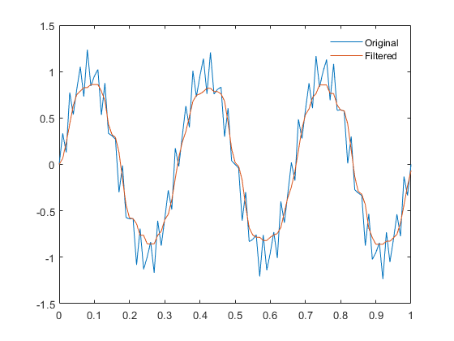

Another way to look at the median filter is to view it as a device producing the maximum likelihood estimate of the location parameter of the bi-exponential distribution based on the samples in the current window. In a similar manner the average is the maximum

likelihood estimate for the Gaussian distribution.

A simplified expression for QAM received pulse will be as follows



Here, *a*si* is a deterministic term whereas, the noise w is a random variable following a bi-exponential distribution and hence,the received pulse will also be a random variable with it’s mean shifted to *a*si* .Because of the whiteness property ,the samples will not be correlated with each other which results in the following likelihood function.



Maximizing the above equation is similar to minimizing the below equation.



The minimizing value ( ‘a’ ) belonging to one of the received samples makes it easier for detection .

1. **Vector Median Method**

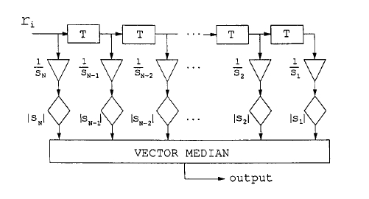

The operation of a simple median filter which was described above is particular to scalar values. Since the signals are vector encoded before transmission, the simple median filter cannot be applied directly. Also, applying the median filter to each of the vector components separately would discard the correlation between the dimensions which is not desirable. So,a new method is needed for extending the median filtering to vector values. When extending the median operation to vector-valued signals, we place some requirements for the resulting vector median operation. First of all, we want the operation to have properties similar to those of the median operation in the scalar case, that is, zero impulse response and good robust data smoothing ability while retaining sharp edges in the signal. We also require that the vector median reduces to the scalar median when the vector dimension is one.

There are many versions of vector median filters and one of them is discussed below. Assume we get N vectors at the receiver end and the target is to find out the actual signal that was transmitted. The algorithms followed is as follows

1. For each vector x, compute the distances to all the other vectors using either the L, or the L2 norm and add them together, resulting in



1. Find x_min (belonging to the samples received) such that it minimizes the above equation.
2. Vector median is x_min

.