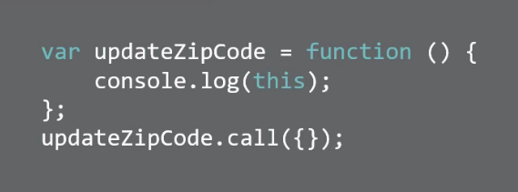

What shows in the console?

Correct Answer: object {}

Distractor#1: object {}

Distractor#2: nothing

Distractor#3 ({})

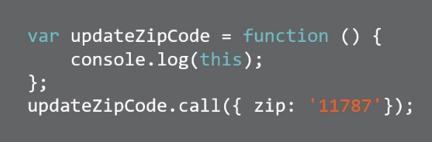

What is shown in the console?

Correct Answer: object {zip: “11787”}

Distractor#1: zip: 11787

Distractor#2: {zip: “11787”}

Distractor#3 {zip: 11787}

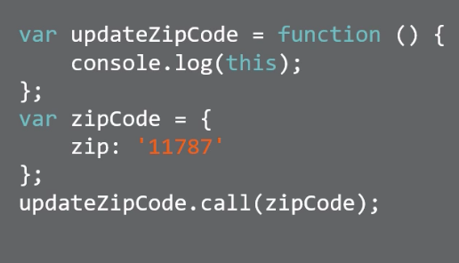

What shows in the console?

Correct Answer: object {zip: “11787”}

Distractor#1: zip: 11787

Distractor#2: {zip: “11787”}

Distractor#3 {zip: 11787}

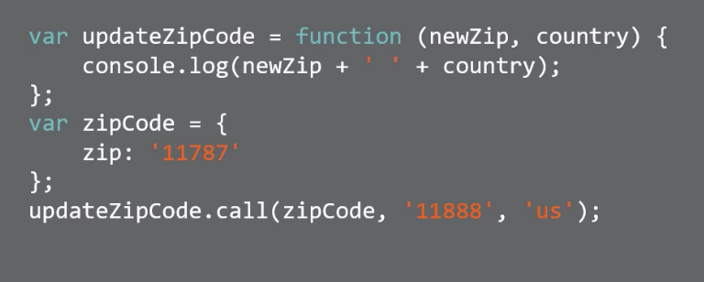

What shows in the console?

Correct Answer: 11888 us

Distractor#1: zipcode ‘11888’ ‘us’

Distractor#2: zipcode 11888 us

Distractor#3: 11888 us

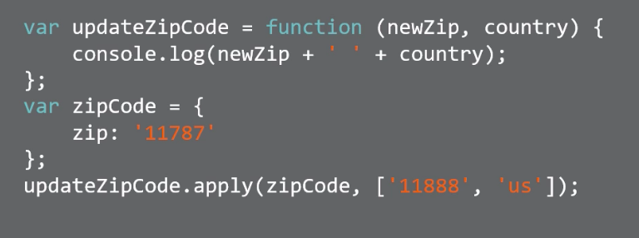

What is being passed here?

Correct Answer: an array

Distractor#1: a function

Distractor#2: an object

Distractor#3 an array

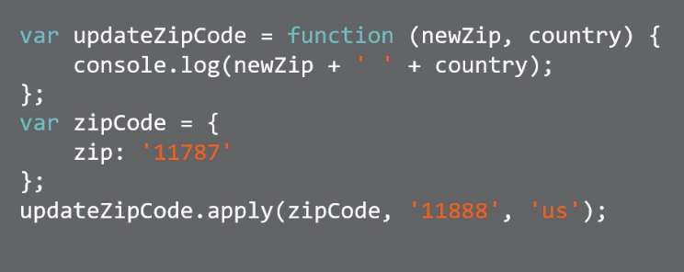

What shows in the console?

Correct Answer: Uncaught TypeError

Distractor#1: Uncaught TypeError

Distractor#2: zipcode, 11888, us

Distractor#3: 11888 us