**Quality of Service (Qos) Modelling and Analysis**

**In An Integrated Femtocell and Macrocell**

**Environment.**

**Author Lecturer**

**Bakary Badjie Assoc. Prof. DR. Yonal Kirsal**

**Email:** [**bakarybadjie10@gmail.com**](mailto:bakarybadjie10@gmail.com)

**Institute of Graduate and Research Studies**

**European University of Lefke**

***Abstract***

**Enhancing quality of service (QoS) in an integrated femtocells and macrocell environment is of absolute necessity to both the mobile network operators (MNO) and the subscribers. It is proposed by researchers that enhancing QoS in femtocell and macrocell in long term evolution (LTE) wireless network environment can coordinate the current existing 4G network with future networks like the 5G. Femtocells are service access points mount by the users to provide better indoor service coverage and expansion of the system's overall capacity with high speed data rate. The integrated femtocell/macrocell networks offer an effective method to increase system’s capacity by improving the quality of service and coverage while their deployment cost is affordable to the users. This paper present the techniques of modelling QoS in an integrated femtocell and macrocell environment where, paper focuses on the design of advanced heterogeneous network architecture (AHMN) in long term evolution (LTE) [5] which comprises of various techniques of enhancing QoS in the Macro-Femto integrated environment such as, deployment of femtocell base stations, integrating femtocell into macrocell, interference management, handover technology, guard channel strategy, management of probability of blockage and spectrum splitting. However, heterogeneous Networks (HetNet) requires the arrangement of small cell networks that can exist along with the current macrocell [1]. To give a high quality of Service (QoS) to subscribers with affordability, various subscribers are provided with a macro-femto base station by equipping an enormous multiple-input-multiple-output (MIMO) with a HetNet network. AHMN architecture comprises of stack of numerous cell layers [5] wherein the upper layer is the macrocell layer while under this layer [5], there are various lower small cell layers. Considering femtocells as the most regular ideal models of small cells, which provides service for indoors femtocell users and we considered the matrocell layer which provides services to outdoors femtocell users as well as the overspill traffic from femtocells [5]. In addition, heterogeneous network (HetNet) in essence, is a network structure that integrates macrocell channel with other small cell channels such as femtocell channel in a wireless network such as LTE wireless link. We also discusses the metrocell layer which served as a supportive layer in between the macrocell and femtocell layers and provide the handover traffic communication between the edge layers [3]. However, in this paper, the capabilities of AHMN in reducing the traffic overloading and the probability of blockage compared to the conventional or traditional macrocellular network is shown by theoretical analysis and simulation. The paper also discuss three significant aspects of the emerging small cell network in order to enhance the QoS. First, the architectures of femtocell and macrocell network in LTE wireless networks, with specific references to the present network standards [1]. Second, the performance assessment of overlay femtocell integrated with the underlay macrocell. Third, the future patterns of femtocell deployment in 5G and the basic technical preparations that should be done to permit coordination with the current 4G and 3G networks [1].**

***Keywords: Quality of Service, Performance Evaluation, Integrated Femtocell and Macrocell, Femtocell, Macrocell.***

**1.0 Introduction**

There is a growing concern in the high demand for mobile data service in the present generation due to the widespread of smartphones laptops and tablets and as result [2], mobile network operators (MNO) are forced to enhance their quality of service in order to meet the customer's expectations as well as to be able to survive in the highly competitive market. As subscribers expect fast and reliable use of data service anytime and anywhere [2], enhancing the quality of service in an integrated macrocell and small cells such as femtocell is a key challenge that the MNOs have to take upon themselves.

As of recent, the MNOs look for approaches to expand their network capacity and coverage in order to meet the demand and expectations of the network society by delivering high data throughput with latency [2]. In the earlier days, there was deployments of network infrastructures such as microcell, hot spots, distributed antennas and relays. However, a less expensive and reliable alternative has recently been proposed which is concept of femtocell deployment known as the home base station.

The high demand for fast, omnipresent data is continually expanding. Up to this point time, Long Term Evolution (LTE) [4] uses the techniques of extending “Single-Input/Single-Output (SISO) links to Multiple-Input/Multiple-Output (MIMO) links and the technique of extending Wideband Code Division Multiple Access (WCDMA) to Orthogonal Frequency-Division Multiplexing (OFDM)” in order to satisfy the demand for higher speed data. Both of these techniques were physical-layer [4] changes that basically "broadened the line". The progress from 3G cellular technology to LTE was basically a resolution at the physical layer [4] in the OSI protocol.

Deployment of small cells such as femtocell in a cellular network in LTE wireless network is a solution to satisfy the demand of an escalating number of subscribers by Mobile Network Operators (MNOs) in recent years [1]. According to a recent survey on cellular communication structure, around 67% of the MNOs have recently deployed indoor cells femtocell in particular and recent researchers believed that the number of these deployed femtocells will extensively increase from 4.3 million to 36.8 million in 2021 [1].

Furthermore, in the view of cellular communication structure, small cell networks such as femtocell represent the shift of cellular technology from the conventional unified macrocell approach to a more self-coordinated approach, where femtocell and other small cells are integrated with existing macrocell in all possible environment both indoors, outdoors in various kinds and sizes [1].

The idea of the deployments of femtocell in LTE wireless network is a proficient and affordable approach to accomplish the objective of providing high service capacity with high speed data to enhance the QoS in an integrated femtocell and macrocell environment. By the method of deploying femtocell in heterogeneous network which is evolved in LTE wireless network, the MNOs [2] can be able to serve the flooding traffic demand by subscribers at various locations. However, deployment of low power femtocell base stations is also a challenge as it requires new and inventive network management tools such as interference management and handover (HO) tools and blocking probability management tool.

Interference management and handover measures are one of the most important capacities in heterogeneous macrocellular mobile networks [2] because the handover process is responsible for keeping up a consistent network connectivity of user equipment (UE) over numerous cells and prevent handover-dropping while interference management oversees the overall channels in a macrocellular network and prevent them from overlapping i.e. managing cross-tier interference. However, according to various access control strategies (open, hybrid or closed access) [2] that is utilized in femtocell network, we have distinctive handover and interference situations. In the technique of HetNet network structuring in LTE, handover between femtocell and macrocell should operate effectively and smoothly to maintain a strategic distance from service interference [2].

Further, because of the expanded number of cells in the network, it is hard to support the consistent mobility of UEs in a HetNet situation. Specifically, utilizing a similar arrangement of handover parameters of a conventional macrocellular network for a HetNet-based femtocell [2] network will corrupt the mobility execution of the UEs. In this way, handover is a significant capacity in HetNets, by methods for radio link control and estimations reporting. In addition, to reduce handover-dropping, a guard channel (GC) scheme for femtocell and macrocell network layers is also proposed [2].

The improvement of a practical teletraffic logical system [2] based on “lining hypothesis and Markov chains” permit us to assess and measure the presence of the proposed overall interoperability structure. Furthermore, according to the limited number of femtocell subscribers, we utilize a more reasonable formula rather than adopting the Erlang formula that was used in earlier works to assess the quality of service (QoS) metric performance [2]. Besides, to moderate cross-tier interference due to overlapping of cells, satisfactory radio spectrum coordination between the two network layers must be accomplished in the proposed designs.

Consequently, the proposed heterogeneous collaboration system is a savvy option in contrast to two-layer deployment comprising of macrocells and femtocells, satisfying the growing service demands and diminishing macrocell traffic loads [2]. Notwithstanding, the efficiency of the overall spectrum can be improved by other new technologies, for example, utilizing the self-organizing network (SON) [2] innovation, huge MIMO, “beamforming”, and improved inter-cell interference coordination [2] (iICIC) methods and spectrum splitting. These techniques of enhancing QoS in an integrated femtocell and macrocell environment are consecutively discussing in this paper.

Nonetheless, the concurrence of different types of network gadgets with different specifications on the same spectrum [1] has raised another concern about designing the network structure. This issue is a significant challenge that needs to be urgently settled out in order to meet the demands and expectations of the subscribers.

The primary point of this study is to propose a methodology as well as an analytical study of the enhancement of QoS in a coordinated overlay femtocell with the underlay macrocell in the LTE network environment. The overall commitments of this investigation can be summed up as follows [1]:

1. To propose a methodology to deploy an overlay femtocell incorporated with the underlay macrocell in the LTE network to improve the QoS in the environment of escalating demand of service in which we have two fundamental objectives [1]:
2. to give a full radio signal [1] coverage zone with high QoS delivery with a fast data rate production, and
3. to upgrade energy efficiency [1] in an integrated femtocell and macrocell atmosphere.
4. To examine and assess the exhibition of the proposed deployment methodology regarding data rate and energy efficiency at the edge of the macrocell; where these two matrices are significant tools to evaluate subscribers QoS and affect the performance of the network with power consumption [1]
5. Recognize potential difficulties and technical readiness in regards to future small cell deployment in the 5G cellular network and incorporated with the 4G cellular network [1]

**1.1 Network Infrastructure**

Vikram Chandrasekhar and Jeffrey G. Andrews, have made an overview on the network structuring of Femtocells and macrocell networks in other to find a solution for the better enhancement of the quality of service in an integrated femtocell and macrocell environment. Reviewing their overview, I have stumbled on certain interesting details on the network infrastructure [3].

In a femtocell domain, the network operator will need to structure a safe and adaptable interface over the internet at a reasonable expense to the users. Radio Network Controllers [3] (RNC) are designed to manage quite a number of macrocells which make their structuring process possible.

Three network interfaces have been proposed [3], of which the IP multimedia media subsystem (IMS), Session Initiation Protocol (SIP) [3] and unlicensed mobile access (UMA) - based interfaces appear to be the architectures of choice [3].

**Iu-b over IP:** Traditional RNCs connect with femtocells through an advanced Iu-CS (circuit-exchanged) [3] also, Iu-PS (packet-switched) interfaces found in macrocell networks. This network interface has a low-expenditure since the operator can leverage the already existing RNCs. However, the inadequacies are the absence of scalability and that the interface isn't yet up to the expected standard.

**IMS/SIP**: The IMS/SIP interface [3] enables users to access the core network situated between the femtocells and the operator. The IMS interface changes user traffic into IP packets and utilizes voice over IP (VoIP) utilizing SIP [3], and exists together with the macrocell network.

The fundamental points of interest of this interface are adaptability and rapid standardization [3]. The inadequacies include the high cost of maintaining two individual core networks for the Marco-cell and femtocell.

**RAN-gateway based UMA:** A radio access network (RAN) [3] source exists between the IP and the operator's networks, clustering traffic from femtocells. In between the femtocell and the RAN gateway, the UMA convention utilizes secure IP burrowing for transferring the femtocell signals over the internet [3].

**1.2 Femtocell Integrated Environment**

Femtocell are small-size data access base stations installed by mobile network user at homes and offices to provide better indoor voice coverage. The coordinated femtocell/macrocell networks offer a productive method to expand access capacity by improving coverage and QoS while the deployment cost for the mobile network operators is kept at amazingly low levels. They communicates with the cellular network in the HetNet nework over a wideband links such as digital subscribers line (DSL), modem cable, or a separate radio frequency (RF) high capacity channel. It is a layer in the HetNet architecture that is integrated with macrocell layer to provide QoS to its users. In this section we discussed the technical challenges obstructing the femtocell network, business challenges, QoS matrix, and deployment strategies in the light of enhancing quality of service in its integrated environment. Even though, femtocell are introduced as an alternative means of enhancing QoS with high service capacity and data rate and to enable users to access fast and reliable service delivery with low cost, but as a mobile network operator, before putting taking femtocell as an alternative to deliver excellent QoS, the technical and business point of view as well as challenges must be looked at. For that been the case, we have looked at the following point of view in the femtocell integrated environment.

**1.2.1 Current Standardization and Deployment of Femtocell Network**

Due to the escalating competitive market and high expenses challenges, providing excellent standard and accurate deployments of femtocell is of high necessity in order to provide solutions to this challenges. The accomplishment of the accurate deployment of femtocell and other small cell networks depends upon how MNOs can incorporate femtocell into the current mobile access networks (MANs) to provide consistent network connectivity, high capacity, and enhanced QoS. Advanced “UMTS Terrestrial Radio Access Network (E-UTRAN) is a development of the third (3rd) Generation Partnership Project (3GPP) Universal Mobile Telecommunications System (UMTS) radio access innovation, in which Long Term Evolution (LTE) is the radio interface and Evolved Packet Core (EPC)” is characterized to oblige the rapid LTE access [3].

**1.2.1.1 Close Access Mode**

In this mode, a femto-BS provides services to only the registered users. Unregistered people, the like of Um1 and Um3 [5] in Fig1 can't access the femto-BS regardless of whether they are in close range to the femto-BS. As indicated by a review, home subscribers prefer femtocells with this accessing mode because they would not share their limited capacity they get from femto-BSs and landline throughput with others, assuming no incentive is given. Most recent business femtocell products uphold mode switch so that subscribers can change the mode of their femto-BS from closed access mode to open access mode [5]. In this mode, spectrum distribution strategy and overlapping management [5] are the major challenges. However, these challenges can be overcome by using a technique of spectrum splitting which eliminates cross-tier interference [5].

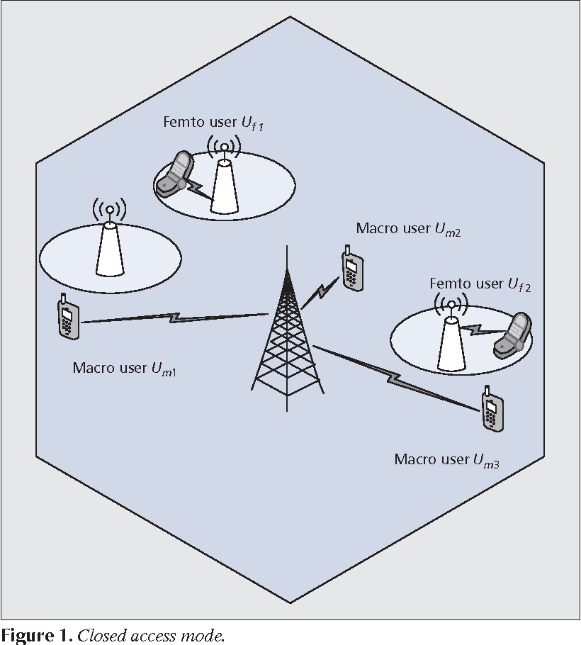

**1.2.1.2 Open Access Mode**

This access mode was introduced as a possible answer for the dead zone issue. In this access mode, femto-BSs can provide service to both femtocell users and nearby macrocell subscribers, which made it different from closed access mode which can only serve femto registered subscribers, this has drawn more attention to open access mode. As appeared in Fig. 2, Um1 and Um3 are permitted to access close by femto-BSs in open mode [5].

Numerous researchers have agreed that open access mode is more effective in improving the capacity of the system since short-distance femtocell transmissions compliment the long-distance macrocell ones, which encounter significant path losses. It can likewise minimize the burden of macro-BSs and prevent femto-BSs from loss of resources while the problem of dead zone can equally be avoided [5].

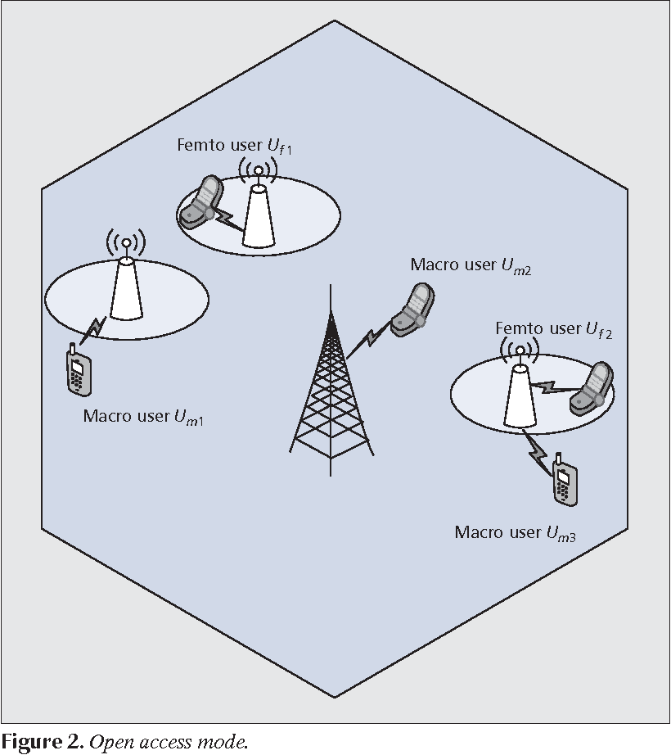

**1.2.2 Technical Challenges in Femtocell Environment**

**1.2.2.1 Physical and Medium Access Layers: Broadband Femtocells**

There is a going concerned which is also a problem for operators regarding the issue of eliminating RF interference and efficiency dispensing spectrum in femtocell networks [3]. Eliminating interference will require creative arrangements since the low-cost device possibly requires downsized signal processing abilities inside femtocells [3]. These led a series of standing challenges facing femtocells in the physical and medium access layers due to its broad bandwidth and they are as follows [3]:

**Challenge 1: How Will a Femtocell Adapt to Its Surrounding Environment and**

**Allocate Spectrum in the Presence of Intra and Cross-Tier Interference [3]?**

The 3rd Generation Partnership Project (3GPP) LTE and WiMAX standards guarantee intra-cell symmetry among macrocellular users and relieve inter-cell interference through fragmentary frequency reuse [3]. Since the femtocells are deployed by different users, centralizing the frequency is always a challenge due to lack of coordination between femtocells and Macrocell networks [3]

**Challenge 2: How Will Femtocells Provide Timing and Synchronization?**

Femtocells will expect synchronization to adjust received signals to limit multi-access interference and guarantee an average carrier offset so that macrocell users can switch-off to femtocell or the other way around, which still made more difficult as a result of lack of coordination between the two networks [3].

In time-division duplex frameworks [3], for a proper and effective coordination of absolute phases for the link transmission in a forward and reverse directions, femtocell will require a precise reference and bounding the timing drift [3].

Finally, high-accuracy crystal oscillators [3] might be utilized inside femtocells, acquiring extra expense and periodic alignment which is still a standing challenge.

**Challenge 3: How Will Backhaul Provide Acceptable Quality of service QoS?**

IP backhaul [3] requires QOS for delay- sensitivity adjustment, while existing macrocell networks give latency guarantees within 15ms, current backhaul networks are not prepared to give delay resiliency. It ought to give adequate ability to try not to make a traffic bottleneck.Another problem arises when backhaul is using a WIFI traffic and femtocells are at the same time ready to be put into usage.

It has been discovered that whenever WIFI [3] are employed for usage, femtocells encounter difficulties in data transfer and even low bandwidth service especially voices.This is a major problem in femtocells networks since voice is the main driving source of femtocells.

**1.2.2.2 Physical and Medium Access Layers: Voice Femtocells**

This also a major source of technical challenges facing Femtocells networks which brought about more questions about the quality of service in an integrated femtocell environment due to the voice channel in the femtocell network.

**Challenge 4: How Will Femtocells Manage Cross-Tier Interference?**

Path loss, fading, and shadowing are compensated by the deployments of CDMA networks which also provide uniform coverage [3]. When femtocells are added, power control makes dead zones, prompting non-uniform coverage. Which means, on the reverse link, macrocell users near the cell edge transmitting at a greater power makes inadmissible interference to close by femtocell users. Likewise, femtocell users near the cell edge encounter significantly higher obstruction than interior femtocell users [3].

On the forward link, at the exterior end where femtocells are generally required, macrocell users are upset by close by femtocell transmissions since they endure higher path loss than cell near the interior users [3].

**Challenge 5: Should Femtocells Provide Open or Closed Access?**

A closed access femtocell [3] has a fixed set of home users that are authorized to utilize the femtocell for security and privacy reasons with a recognized license. Open access femtocells, then again, offer support to macrocell users in the event that they pass close by.

Radio signal interference is overseen by permitting strong macrocell interferers to communicate with close by femtocells. Although open access provide higher capacity as the number of users that communicate with each femtocell is high which will as a result strain the backhaul [3].

Therefore, femtocell should provide open access to provide significant capacity as the number of femtocell user increase but making sure to differentiate the zero traffic home users and pay-per-minute users. This brought the idea of hybrid method of accessing femtocells [3].

**Challenge 6: How Will Handoff Be Performed In Open Access?**

Significantly, hand-off from femtocell to macrocell is easier than from macrocell to femtocell as there is only on macrocell base station while there are series of femtocells base stations installed in various user’s homes. Open access can easily perform handoff due to the fluctuating channels in the open access which easily enable macrocell users to perform multiple handovers at the same time. However, research on open access is developing easy algorithms to predict a time duration before a Macrocell user handing off to a close by femtocell user [3].

**Challenge 7: Can Subscribers Carry Their Femtocells For Use Outside Their Homes?**

It can be possible but in many cases, femtocell mobility can cause problems especially in a situation where a user carried their femtocells in a location where the only service provide at that location is a rival operator [3]. This can cause a lot of interferences which may result to poor network deliverance. At that point in time, the user can only be able to access a rival’s service when there is GPS in the Femtocell for location tracking and even though the rival operator may charge the user on roaming [3].

**Challenge 8: How Will Femtocells Provide Location Tracking For Emergency-911, And Should They Service Nearby Macrocell Users With Poor Coverage?**

Although government make it as a mandate to all network operator enable 911 emergency service [3] for all users with no cost but the question is whether ethically or legal dilemma the Femtocell users are allowed to use the macrocell service to call the 911 emergency service if they are within the radio rand? Nonetheless, this problem can be solved in open access networks by handoff [3].

**1.2.2.3 Advantages of Femtocell Networks**

1. **Improved Network overage**: Providing broad in-building network coverage has for some time been a problem for MNOs. This is even a more challenging issue for MNOs operating at higher frequencies, where RF propagation loss is higher. Femtocells can give a better solution to this problem since Femto base stations situated inside the building structures, using the fundamental concept of spectrum re-use they can enhance the coverage of the network and its capacity. FBSs are privately
2. installed by subscribers therefore, improving the coverage is easy since interference management can be easily managed.
3. **Reduced foundation and capital costs:** Femtocells utilize the current home broadband connectivity for backhauling the femtocells' traffic. Accordingly, by guiding subscribers' traffic into their own FBSs and away from the macrocells, femtocells diminish the costly backhaul expenses of macrocellular networks.
4. **Power saving:** Since femtocells are mainly established to provide coverage for indoors users, the transmission power is altogether smaller compared with the transmission power of the macrocellular network that is needed to enter the building.
5. **Provisioning of QoS:** The radio frequency path loss near the edge of a macrocell can be very extreme. Femtocells can specifically improve the QoS for subscribers with poor macrocell reception.

**1.3 Macrocell Integrated Environment**

Macrocell layer is an overlay layer for small cells such as femtocell, metrocell, and microcell in a heterogeneous networks [2]. This layer is an important layer in the future fifth generation 5G network. It comprises most of the recently deploy small cell in various geographical location which a major source of enhancing QoS in their integrated environment.

In this paper, we discuss the importance of macrocell and their role in a network structure [2].

Moreover, MBS provides service to originating traffic from macrocell subscribers and the handoff traffic from nearby macrocells [2]. Consequently, there are five classifications of traffic measures in macrocell as follows, the new traffic from the macrocell users [2] with a predefined rate, the HO traffic obtain from nearby macrocells due to macrocell subscribers with a predefined appearance rate, the originating traffic obtained from the femtocells due to outside activities with a certain rate, the traffic flooding obtained from the underlaid metrocells [2] with a certain overflow rate and finally the HO traffic from the neighboring macrocells due to the metrocell with a predefined rate of HO [2].

**2.0 The Evolution of Network Architecture to Integrated Femtocell/Macrocell Networks [6]**

There are various options for deploying the integrated femtocell/macrocell network [6]. For a specific circumstance, the decision of this structuring relies upon various underlying factors, for example, the network size, characteristic of already existing networks, the future rollout and intermingling plans of the MNOs, planning of the system capacity, ability to coincide and cooperate with the current network, and the anticipated network evolution. Therefore, three strategies for incorporation of the femtocells with the macrocellular framework are discussed in this section [6]:

**2.1** **The small-scale Deployment of femtocell/ macrocell networks using the Existing Macrocellular Radio Network Controller (RNC) Interface** [6]

This method of deployment of femtocell/macrocell incorporated network design show how FBSs are deployed to provide QoS for the subscribers. Such a design could be helpful in a less populated or a densely populated region, where a couple of femtocells are required [6].

**2.2. The Medium-and Large-Scale Deployment of femtocell/macrocell network utilizing a Concentrator and IP Multimedia Subsystem (IMS) [6]**

HSDPA/HSUPA networks use concentrated RNC to control [6] their related Base Stations. A unique RNC is responsible for the management of radio signal around hundred macrocellular Base Stations [6]. Nonetheless, since it is imagined that many numbers of femtocells may exist inside a zone of one macrocell, one RNC is unequipped for controlling quite an enormous number of femtocells. Hence, it is necessary to adopt an alternate and more productive femtocell control scheme [6].

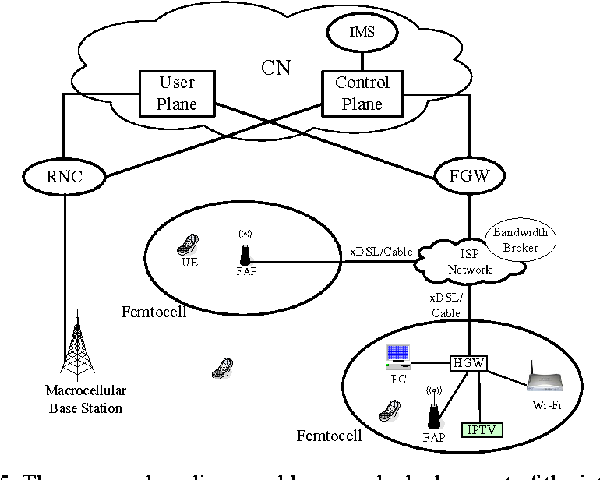

Fig.3 Medium-and Large-Scale deployment of femtocell/macrocell network using IMS interface

**2.3 The Large-Scale and Highly-Dense Deployment Architecture utilizing SON and CR alongside Concentrator and IMS**

Conventionally, macrocellular networks require unpredictable and costly manual system planning and arrangement. Presently, 3GPP LTE-Advanced and IEEE 802 [6].16m are normalizing the SON idea for IMT-Advanced networks. The principal functionalities of SON for incorporated femtocell/macrocell networks is that it has the ability to configure itself, optimize itself, and heal itself [6].

The function of self-configurations includes smart frequency allotment among neighboring FBSs; self-improvement property incorporates optimization of transmission power among neighboring FBSs [6],

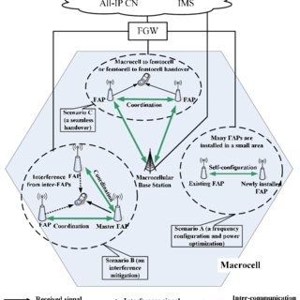

Fig.4 SON features for the large-scale and highly-dense deployment of an integrated femtocell/macrocell network architecture

**3.0 The Technical Challenges of QoS Provisioning In Femtocell/Macrocell Integrated Networks**

**3.1 Interference Management**

In the course of my review of femtocell and macrocell integration [5], I learned that because of the specially appointed geography of femtocell locations, only the interference cancellations strategies will demonstrate incapable in femtocell networks. Progressive interference abrogation, in which each user deducts out the most active neighboring interference from receive signals seems to be promising at the initial state nonetheless, interference cancellations errors invalidate its usefulness [3].

In CDMA femtocell networks with universal frequency reuse [3], for instance, frequency shirking through time-hopping and directional antennas give a 7× improvement in the framework capacity [3] when macrocell and femtocell users share the same bandwidth this in essence this can enable the integration Femtocell and macrocell networks. The following are an extensive techniques of integrating femtocell networks with macrocell networks [3].

**3.2 Frequency and time hopping**

This technique of integrating femtocell with macrocell enables the Global System for Mobile Communication networks [3] to offer femtocell users and nearby transmitting macrocell users the ability to avoid the continuing mutual interference between the two networks through slow frequency hopping [3]. This uses sub-channels to reduce the probability of persistence collision with nearby networks through OFDMA networks [3].

**3.3 Adaptive Power Control**

Based on the geographical location of the femtocell, the received power is varied in efficiency by this strategies. “Automatic adaptation” protocols are used by some commercial femtocells to minimize cross tier interference by increasing the transmit power over a distance in certain locations [3].

Companies like “Sony Ericsson” used this strategies to integrate femtocell and macrocell networks by proposing that the only way to reduce interference to macrocell user is by decreasing the transmit power of femtocell in a predefined location and also creating a distance between femtocell transmit power and the macro base stations. They suggested that this should be done in a forward link in closed access [3].

Based on my observations, we suggest that the cross tiers interference can be reduce by enabling higher received power to femtocell users in conjunction to macrocell users relatively using the reverse link in an open access but this may also varied depending on the geographical locations of the femtocells [3].

**3.4 Handover Management**

In the femtocell/macrocell integrated environment, handover is a very vital technique of maintaining user equipment network connectivity and reducing the call dropping probability. The handover techniques for the existing 3G/4G network are introduced to enhance the QoS in femtocell/macrocell integrated environment. Therefore, in order to design an effective integrated cellular network, handover must be put into consideration. Handovers are; handover from femtocell-to-macrocell and handover from macrocell-to-femtocell. The handover strategies are fundamentally partitioned into two stages: the preparation stage (data gathering, handover choice), and the performance stage. During the data-gathering stage, the BS gathers data about the handover cells, and validations are procured for security purposes. In the handover choice stage, the best handover applicant is resolved. At last, in the wake of performing an actual handover, the UE starts to interface with new AP. For the handover among macrocell and femtocell.

However, insignificant handover is another difficult issue for femtocell/macrocell integrated environment as the area of femtocell coverage territory is small and there are possibilities to remain extremely small time whenever uE with high speed enters into femtocell coverage region. A fast UE causes two pointless handovers because of development from macrocell region to femtocell region and again femtocell territory to macrocell region. In the integrated environment, insignificant handovers reduce the QoS level and as a result, the overall capacity of the system is reduced.

**4.0 Optimization of QoS in the Integrated Femtocell/ Macrocell iNetwork Environment**

**4.1 System modelling and description**

In modelling the quality of service in an integrated femtocell and macrocell environment, we focuses our research in the following areas while also considering the challenges in modelling the QoS in this integrated environments. The connection between the MBS and the FBS is known as a wireless backhaul link [1], which is a wireless radio interface for interfacing the FBS with the MBS. Nonetheless, this section paper also focuses on the wireless link between the FBS and the user equipment (UE), which is known as a wireless access link (FBS-to-UE) and the wireless link between the MBS and the UE (MBS-to-UE) [1].

**4.2 The HetNet Architecture**

A significant objective for the Mobile Network Operators (MNOs) [2] is to reduce the deployment and maintenance expenses of their services. As we observed the current 3G/4G networks [2], there is an ineffectiveness in the service quality especially for the indoors service users [2]. The traditional way of deploying cell towers cannot solve this problem. Therefore, the establishment of HetNet will improve the overall system quality and capacity which will make it effectively possible for the use of wireless spectrum while solving the problem of overloading by adjusting capacities [2].

In addition, the improvement of multi-interface base stations with various technologies of radio access availability will additionally improve the accessibility of the network [2]. As of late, the introduction of HetNet which enhance the QoS in an integrated femtocells and macrocell environment in the openings of 3G and 4G networks have attracted more attention significantly and as a result, more MNOs are now deflecting into HetNet [2] layouts to improve their QoS.

Fig 1 below illustrated how the HetNet architecture make use of various small cells and integrate them into the already existing network topology to meet the requirements for achieving an excellent quality of service.

Accordingly, these demonstrate that the user closed to the cell site, are subjected to excellent network coverage and service while the users who are farther away from the cell site [2], can in any case be offered sufficient network coverage and service. This architecture consist of three network layers which are described as the top and the bottom layers [2], this gave an excellent service coverage as long as there is effective coordination between the layers to avoid interference. The benefit of this multi-layers approach is that, it is an important feature of quality of service matrices such as, probability of blockage, total throughput and handover dropping probability [2].

**4.3** **Spectrum Management (Interference management)**

In the proposed HetNet, cautious planning is expected to avoid overlapping of layers which is one of the major sources of interference. The quality of service relies strongly on the radio coordination between the femtocell and macrocell networks [2]. Generally, in the femtocell and macrocell networks, there are three access techniques. (a) closed access (CA) [2], in which only those registered users (closed subscriber group—CSG) are permitted to interface with the femtocell, (b) open access (OA), where all users may access the femtocell and (c) hybrid access (HA) [2], where some resources of femtocell are designated for open access users and the leftover is used by the CSG users. At the point when the small cells lose coordination, there is always inefficiency in the radio spectrum which results in decreasing the capacity [2].

**4.4 Spectrum Sharing**

HetNet's spectrum can be shared. On account of shared spectrum, MNO shares a single bandwidth to macrocells and femtocell networks [2]. Taking up the OA or HA access modes for the femtocell and macrocell along with the spectrum sharing approach may appear good but definitely prompts the issue of interference increment and coordination problem [2]. Nonetheless, can be solved if proper integration is accomplished between the macrocell and femtocell. However, eICIC in HetNets made out of macrocells and femtocells.

As at present, considering the currently accessible innovations and our aim to enhance the quality of service in an integrated femtocell and macrocell environment, developments of teletraffic [2] system for analyzing networks interactions due to handover situations in HetNet is of importance and the effective and easier way to achieve this approach is by using spectrum sharing strategy along with closed access femtocells.

**4.4.1 Importance of spectrum splitting**

Spectrum splitting reduce the cross-tier interference between the macrocell and femtocell networks which is of fundamental importance for HetNet architecture [2], where users can switch from overlaid femtocell to overlaid macrocell vice-versa without overlapping hence improving the QoS.

In the considered system model, a sharing spectrum strategy for interference management, as portrayed in Fig. 2 is utilized. Let take C as the total spectrum accessible to all traffic channels possessed by a Mobile network operator. As demonstrated in the figure, this spectrum is shared among macrocells, metrocells and femtocells as required by interference management. However, our focus here is spectrum splitting between femtocell and macrocell traffic channels [2].

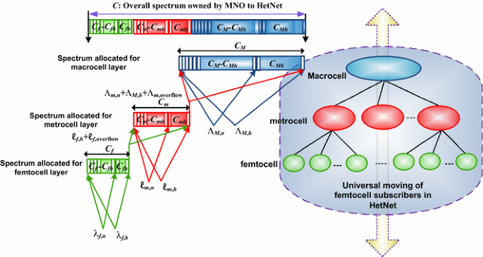

Fig.5 spectrum splitting technique

In the above technique of spectrum splitting, the spectrum is split into three in which the CM channels [2] are designated for Macrocell and Cm channels are designated for femtocell while the Cf channels are designated for metrocell as shown in fig. 2.

**4.5 Using Guard Channel (GC) Scheme**

Numerous reservation schemes have been proposed by researchers for decreasing the handover-dropping rate by preferring handover over initiating new calls. The idea of reducing the handover-dropping has brought the guard channel (GC) [2] reservation schemes into play. Handover from the femtocell to macrocell easy to be implemented based on the already known strategies but handover from macrocell to femtocell represents some issues.

Consequently, to keep up the consistent network availability to femtocell users in HetNet layers, it is important to support these users by prioritization scheme [2].

By utilizing other technologies, like, self-organizing networks (SON) technology, massive multiple-input multiple-out (MIMO) technology, beamforming, and eICIC strategies [2], the GC is designed to maximize the spectral efficiency while reducing the probability of handover failure.

As indicated by GC scheme [2], the base station saves a few channels for the HO calls from the overall accessible channels. In addition, a few strategies have built up the thought of GC based on active reservation where GC scheme is introduced in each layer to be able to limit the HO dropping rate for mobile users that handover to femtocells and macrocells channels [2]. The GC scheme enable the femtocell users to roam within the HetNet without any problem of handover-dropping because the handover calls are given high preference over new calls [2]. The proposed GC method is introduced in all base station as demonstrated in fig. 6.

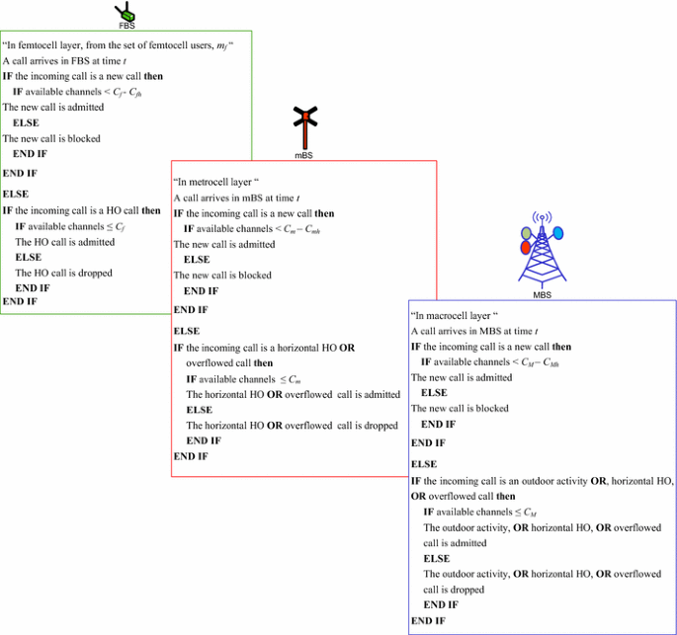

Fig.6 Implementation of GC scheme in HetNet layers

**4.6 Quality of service (QoS) Matrix in Femtocell environment**

Femtocell consolidates a finite number of femtocell subscriber $(mf)$ [2].Consequently, the Erlang B equation is improper for computing the probability of blockage in the femtocell network. Instead, we consider a more reliable and appropriate equation for computing the blocking probability initiated calls and probability of failure for HO demands in femtocell. This equation resembles the equation for computing the semi-arbitrary traffic of a finite number of femtocell subscribers ''Engset recipe''. In this method, we built up the state probability of the Femto base station (FBS), and accordingly, we can compute the QoS measurements in femtocell. The state $j$ of a FBS is characterized as the number of femtocell users, being taken care of by the FBS [2]. This state portrayal represents all occasions, happening in femtocell. The condition of the FBS is changed because of

either an appearance or a takeoff of a femtocell user as portrayed in Figure below.

**4.7 Quality of service in Macrocell Environment**

The probability of call blocking/dropping [2] in macrocell can be computed by utilizing the Erlang formula because of the infinite number of subscribers in the macrocell layer, unlike the femtocell layer where there is a finite number of subscribers [2].

As indicated by the GC scheme in the macrocell layer, the channel is divided between the handover macrocell users and new macrocell users with a probability of handover-dropping and probability in a macro base station (MBS) respectively. At any point in time, macrocell users can access the MBS without any channel interference from another macrocell user.

As From the technical viewpoint, there is a high reduction in the randomness of the mobile networks. The WSP owns the entire resources (range, femtoBSs, and backhauls) [5] which enable system scheduling elaboration simpler. From the economic viewpoint, the free establishment of femto-BSs is very alluring to users and it serves as a competition mechanism against opponents. All this possible because the WSP takes it as a responsibility to offer preferable indoor service rather than giving all the responsibility to home users [5]. “Japan's network operator called Softbank Mobile launched its 3G network using this method of deployment”.

It gives a free asymmetric digital subscriber line (ADSL) in addition to femto-BS arrangement to homes and small scale business customers [5].

**5.0 Results and Discussions**

In this section, we present the results to assess and evaluate the performance of the proposed femtocell/macrocell integrated design in HetNet architecture with LTE wireless network. First, we analyze the performance of macrocell network that co-existed with other small cells such as femtocell. At that point, we present the performance of the overall network structure in which we realize that the proposed design presents a meaningful solution to the poor service coverage by the traditional method of service delivery and also a solution to the escalating mobile data by an infinite number of users. Radio Network Controllers (RNC) are designed as a solution to manage the infinite number of macrocells which make their structuring process possible and easier and integrate them with small cells. They are connected with femtocells through an advanced Iu-CS (circuit-exchanged) also, Iu-PS (packet-switched) interfaces found in networks structure. In addition, a successful result was obtained by using the IMS/SIP interface which enables users to access the core network situated between the femtocells and the operator. The IMS interface changes user traffic into IP packets and utilizes voice over IP (VoIP) using SIP, and exists together with the macrocell network. A possible solution is also provided for cross-tier interference between the integrated networks by applying the spectrum splitting technique.

A possible answer has been provided for the dead zone issue by using the open-access model where femto-BSs provide adequate service to both femtocell users and nearby macrocell subscribers which enhances the QoS in the integrated environment. In the light of deployment issues, a positive result is obtained by applying recently involve deployment techniques such as small-scale Deployment of femtocell/ macrocell networks using the existing macrocellular radio network controller (RNC) Interface, medium-and large-scale deployment of femtocell/macrocell network utilizing a concentrator and IP multimedia subsystem (IMS) and large-scale and highly-dense deployment architecture utilizing SON and CR alongside Concentrator and IMS. All these deployment strategies provide high service capacity and a high data rate at a low cost. Performance evaluation has also been performed on the QoS provisioning in femtocell/macrocell integrated networks by analyzing and adopting proper interference management, frequency-hopping, time-hopping, adaptive power control blocking probability estimation. Results from the simulation point of view is been obtained in which we realized that the SNR ratio was reduced to 10dB in which a perfect cellular signal is obtained.

**6.0 Summary and Conclusion**

Incorporation of femtocellular networks with macrocellular networks is important for the effective deployment of the recently adopted femtocell technology. We proposed here four possibilities of structuring at atmosphere for the development of the integrated networks, which are based on enhancing the QoS with low-cost data availability for the users. To make this integration effective and possible, we talked about a number of the technical issues that need to be urgently addressed in order for the MNOs to offer excellent QoS to meet the expectations of the subscribers. We however offer some possible ways to deal with these issues such as; interference management, handover control, frequency control, spectrum management, dynamic QoS provisioning of the xDSL-based backhaul, deployment strategies adaptations. To put these possible solutions into reality, there must an intelligent strategy put in place to deal with the disturbing issues. Managing cross-tier interference is one of the major challenges in an integrated cellular network setup. Therefore proper coordination between the integrated networks is very important. Using various coordination techniques such as SON-based coordination is a very helpful coordination technique between the FBS and MBS and can improve the spectral usage and QoS performance. Therefore, proper coordination of femtocell/macrocell network should be furnished with self-enhancing, auto-designing, interworking, and between operability, capacities to meet the necessity subscribers. Future exploration should focus on the financial aspect of the femtocell/macrocell coordinated network and on the QoS-guaranteed technique for the integrated environment to improve the network coverage. In cellular structuring, the path loss exponent must be assessed for a femtocell deployment atmosphere and the coverage of a cell is determined based on the modulation techniques, coding techniques, signal gains, signal interference ratio (SIR), and the radio frequency bandwidth of the base station and user equipment antenna. This paper also features the simulation situations, propagation and, signaling models. The LTE downlink (DL) transmission of an orthogonal frequency division multiplexing (OFDMA) heterogeneous networks [1] that comprise of a macrocell served by a macro-base station (MBS) with an overlaid femtocell and other small cells served by a Femto-base station (FBS).

In this structure, the femto-BSs are given by the mobile network operator, and subscribers pay for the indoor establishment, either as an irregular payment or by monthly payment [5]. Femto-BSs for the first time take a few minutes to detect the radio environment, confine positions, register themselves, and auto-configure the boundaries, after which they will work steadily later [5]. The wireless session protocol knows about their presence and adjusts some framework parameters and strategies. As users rightfully owned the base stations, then can uninhibitedly move and turn on/off the femto-BSs whenever they wish.

However, the operators gain a lot of profit by reducing their capital and operational expenses while providing an excellent quality of service to the subscribers. This is why almost all mobile operators are utilizing this method to enhance their quality of service. The femtocell and macrocell networks are correctly integrated to avoid overlapping between them which made it possible to come up with an idea of femto-base station [5]. This can further be divided into accessing modes for the smooth and possible integration of femtocell and macrocell.

**References**

1. Alsharif, M. H., Nordin, R., Shakir, M. M., & Ramly, A. M. (2019). Small Cells Integration with the Macrocell Under LTE Cellular Networks and Potential Extension for 5G. *Journal of Electrical Engineering & Technology*, *14*(6), 2455-2465.
2. Abd El-atty, S. M., & Gharsseldien, Z. M. (2017). Performance analysis of an advanced heterogeneous mobile network architecture with multiple small cell layers. *Wireless Networks*, *23*(4), 1169-1190.
3. Chandrasekhar, V., Andrews, J. G., & Gatherer, A. (2008). Femtocell networks: a survey. *IEEE Communications magazine*, *46*(9), 59-67.
4. [www.wikipedia.com](http://www.wikipedia.com)
5. Claussen, H., Ho, L. T., & Samuel, L. G. (2008). An overview of the femtocell concept. *Bell Labs Technical Journal*, *13*(1), 221-245.
6. Chowdhury, M. Z., Jang, Y. M., & Haas, Z. J. (2010). Network evolution and QoS provisioning for integrated femtocell/macrocell networks. *arXiv preprint arXiv:1009.2368*.