IT 2045C Computer Programming II   
Prof. Tom Wulf   
Ass 02: File StreamsSpring 2022  
20 pts

Objective: Practice with Object and RandomAccess file streams  
 **You will need your completed Lab 01 source code for this lab.** You should be able to download it with GitHub,.  
  
Note: you will be creating Java Swing GUI programs here. I did not define these rigorously and leave that to you but they should have a reasonable layout and complete functionality (Quit button etc.).  
   
**Discussion:**   
   
 Previously, in Lab 01 we created Product and Person classes. We coded programs to work with text file storage of Product and Person records. This time we will explore how to use the binary streams with these classes.

For the Random Access file, we will have to force our Product records to have a fixed size in bytes. This means that we will have to decide the lengths for the String fields in the class.

The Object stream is easier to use. We do have to declare the Serializable interface.  
  
Create an IntelliJ IDEA Java project called **FileStreams** place it under GitHub source control.

**Part 1: Product Random Access file**

1. Snag a screen shot clearly showing the internals of your Product data file that you created for Lab 01. (We will compare it to the binary random access file.)
2. Here is **Product**

Fields:

String name  
String description  
String ID // should never change   
double cost

1. We have to fix the number of characters we will use for the 3 String fields.
   * name will be 35 characters
   * description will be 75 characters
   * ID will be 6 characters  
       
     For the Random access file to work, we have to force these fields to have these lengths by padding them with spaces. We just use the trim() String method to remove the spaces when we need to for processing.   
     NOTE: add some utility functions to the Product class to return correctly formatted Random Product records!
2. Create a Swing GUI program **RandProductMaker.java** based on your Lab 01 program. Your program should display a GUI form for the user to enter Product data. It should pad the fields to the correct lengths and save them to a RandomAccess file. The form should have an add Button that confirms that the user entered all the data fields and validates the fields before then writing the data record to the random file. It should clear all the field displays each time between record input. Add a record count textField that shows the count of the records being entered.  
     
   **Insert screen shots here that show:  
   - a record being entered  
   - after a record has been entered starting the next record input (should see the record count here)**

Now, use your program to (re)-create the Product data file. Be careful to use the exact same inputs that you did for Lab 01 so we can compare the file formats.   
  
*Open your data file in MS Wordpad and take a screen shot. How does it compare to the text data file from Lab 01?* **LOL!  
  
Put the two screen shots of the files here!**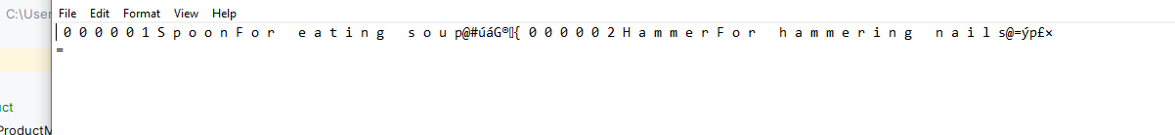

1. Create a second Swing GUI program **RandProductSearch.java**. It should prompt the user for a partial product name and then return a display of every product that matches the name.   
    **Again screen shots to establish you did this.** A screenshot of a computer

   Description automatically generatedA screenshot of a computer

   Description automatically generated

Rename this file with your screen shots to **LastName_FirstName_Ass02.docx** (using your actual name) and submit your GitHub repo link and this document using the Canvas assignments mechanism.