**Lab No.** 012006140166 **Age/Gender** 22 YRS/MALE **Coll. On** 12/Dec/2020 04:20PM

**Name** Mr. KARAN SAWHNEY 0708400008888 **Reg. On** 12/Dec/2020

**Ref. Dr.** BANSAL HOSPITAL **Approved On** 13/Dec/2020 08:27PM

**Rpt. Centre** BANSAL HOSPITAL **Printed On** 13/Dec/2020 08:45PM

**Test Name**

**Value**

**Unit**

**Biological Reference Interval**

## COVID-19 Virus QUALITATIVE PCR \**, swab*

*Method : RT PCR*

## Interpretation:

**Microbiology**

Negative Please refer the table below

|  |  |
| --- | --- |
| **Result** | **Remarks** |
| Positive | SARS-CoV-2 (COVID-19) specific RNA detected |
| Presumptive Positive | Only B-βCoV specific RNA detected. This might be due to low viral load or due to  mutation in the SARS-CoV-2 (COVID-19) specific RNA.  ***All presumptive positive reports are released only after re-extracting the RNA and performing a repeat RT-PCR.*** |
| Negative | RNA specific to B-βCoV and SARS-CoV-2 (COVID-19) not detected |
| Inconclusive | This could be due to presence of inhibitors in the sample. A repeat sample is recommended in such cases.  ***All inconclusive reports are released only after re-extracting the RNA and performing***  ***a repeat RT-PCR.*** |

## Note:

1. ICMR Registration number for Covid -19 is PROGD001.
2. Negative result does not rule out the possibility of Covid-19 infection. Presence of inhibitors, mutations & insufficient RNA specific to SARS-CoV-2 can influence the test result. Kindly correlate the results with clinical findings. A negative result in a single upper respiratory tract sample does not rule out SARS-CoV-2 infection. Hence in such cases a repeat sample should be sent. Lower respiratory tract samples like Sputum, BAL, ET aspirate are appropriate samples especially in severe and progressive lung disease.
3. Covid-19 Test conducted as per kits approved by ICMR / CE-IVD / USFDA.
4. Kindly consult referring Physician / Authorized hospitals for appropriate follow up.
5. Test conducted on combined Oropharyngeal & nasal swabs

**Comments:** Coronaviruses (CoV) are a large family of viruses that cause illness ranging from the common cold to more severe diseases such as Middle East Respiratory Syndrome (MERS-CoV) and Severe Acute Respiratory Syndrome (SARS-CoV). Coronavirus disease (COVID-19) is a new strain that was discovered in 2019 and has not been previously identified in humans. Common signs of infection include respiratory symptoms, fever, cough, shortness of breath and breathing difficulties. In more severe cases, infection can cause pneumonia, severe acute respiratory syndrome and kidney failure

**\*Disclaimer: This is an electronically validated report, if any discrepancy found should be confirmed by user. This test was performed at Prognosis Laboratories, 515-516, Sector 19, Dwarka, New Delhi-110075.**

# The Tests marked with an * are not accredited by NABL.

*** End Of Report ***

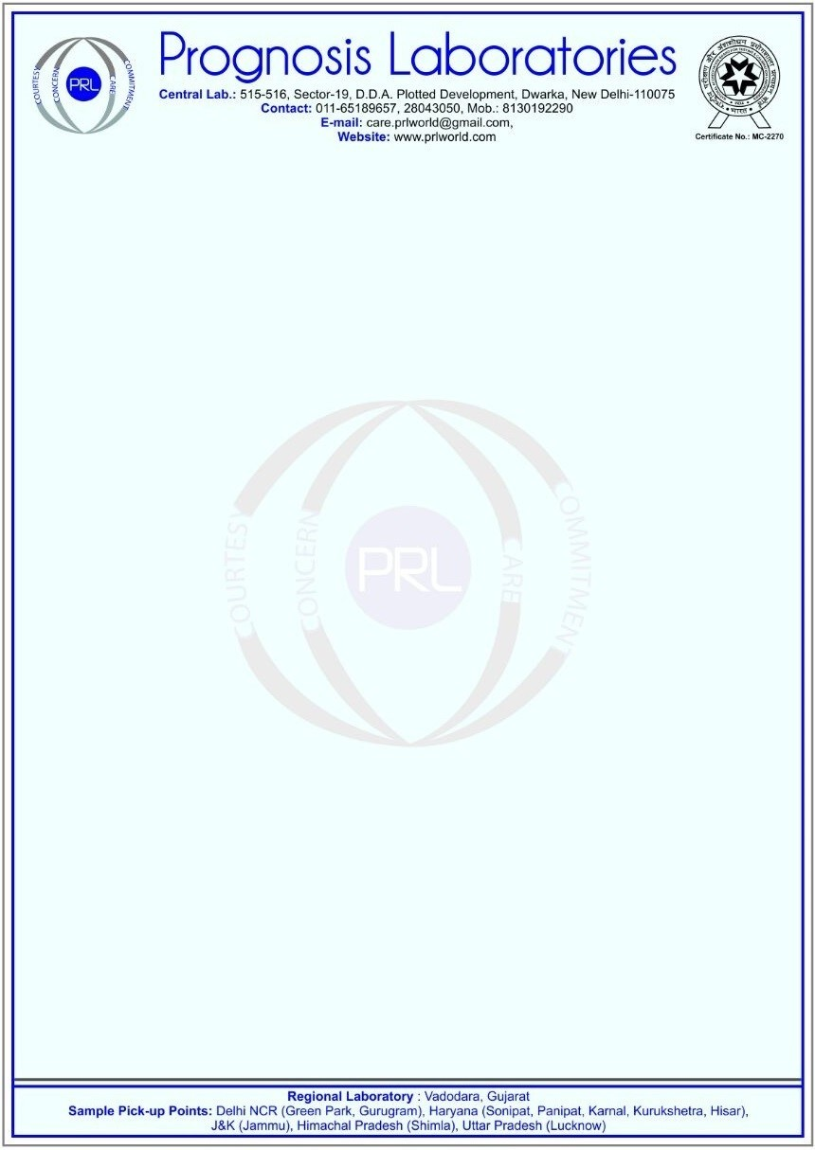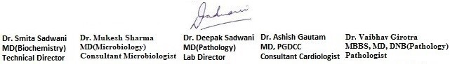

Address:R 64 2ND FLOOR GK 1 NEW DELHI, Mobile:9873644225

# Page 1 of 1