**PHILOSOPHY 11**

1. **WHY MAN SEEKS FOR THE TRUTH?**

* The truth makes man fulfill his rational nature.

1. **HOW PHILOSOPHY BEGINS?**

* By wonder

1. **WHAT ARE THE DEFINITIONS OF PHILOSOPHY?**

* It is the search for the truth.
* Pythagoras called himself the Lover of Wisdom
* The knowledge of all things through their ultimate causes acquired through the use of reason
* The sciences that study all things in its ultimate causes and **1st principles** in the light of reason.
* Philosophia – “Love of Wisdom”

1. **WHAT ARE THE MATERIAL AND FORMAL OBJECTS OF PHILOSOPHY?**

* These are the certain knowledge about reality. The ultimate truths are the objects of philosophy.
* ***Material Objects*** – objects such as the study of all things. These refers to the sensible & material beings or bodies that are perceived by the senses and are all aspect of reality.
* ***Formal Objects*** – these studies the material objects and their ultimate causes and the 1st principle by seeking the deepest explanations.
* Here, we go deeper and deeper until arriving at the first cause.

1. **WHY DO WE STUDY PHILOSOPHY?**

* “To seek only for its own sake”
* Philosophy refers to the search for a profound knowledge going beyond spontaneous knowledge.
* It is knowing for the sake of knowing and to satisfy the demands of his/her intellect.

1. **WHAT IS THE NUCLEUS OF PHILOSOPHY?**

* ***METAPHYSICS*** – the nucleus of philosophy, which is the study of things that exist, the reality, and nature of all things.
* Meta means “beyond” or “after”, thus *metaphysics* simply means beyond physics.
* It answers the question “What is?” and encompasses everything that exists.

1. **WHAT ARE THE OBJECTS OF PHILOSOPHY?**

* Certain knowledge about realities, including the ultimate truths are the objects of Philosophy.
* *Ex.* Existence of God, Immortality of the Soul, and the Natural Law

1. **WHAT IS WISDOM?**

* Wisdom is a science that enables man to discover the meaning of his life to act in an upright way.
* “Wisdom as a certain knowledge of the deepest causes of everything” – St. Thomas Aquinas
* The wisdom has a guiding and judging role with regard to other forms of knowledge.
* Wisdom is important in directing human existence towards its purpose or end.
* The desire for knowledge is natural to man and his happiness is closely linked with wisdom.

1. **WHAT IS IGNORANCE?**

* It refers to the contrary to wisdom, it is the source of discover and errors in behavior, which prevents him from attaining happiness.
* It is the cause of various obstacles that hinder the task, and is a serious harm to individuals.

1. **PHILOSOPHY & ORDINARY KNOWLEDGE**

* Ordinary Knowledge is the certain knowledge about the realities including the ultimate truths which are objects of philosophy.
* It can be attained by the human intellect in a **natural way without scientific study**.
* Philosophy does in agreement and in continuity with spontaneous knowledge.
* According to Descartes, “philosophers must doubt all knowledge and begin from zero”

1. **WHAT IS PHILOSOPHY AS A SCIENCE?**

* Philosophy is the root of all sciences and has many branches.
* Philosophy is a science in an eminent way, since science is “certain knowledge” through causes, and philosophy is a science that studies the deepest causes of reality, it is more eminent among all sciences.
* Science is a knowledge attained by a way of demonstration starting from some principles.

1. **DIFFERENCES BETWEEN PHILOSOPHY & PARTICULAR SCIENCES**

* ***Philosophy***
* it studies the deepest and most basic aspects of reality.
* It seeks the ultimate causes, and goes beyond the limits of particular sciences.
* It studies all realities tries to discover the ultimate explanation in its very being
* ***Particular Sciences***
* It studies only a specific aspects of reality
* It seeks more immediate or proximate causes
* It is limited to some aspects of reality and limited by the object of its studies.

1. **SPECULATIVE SCIENCE VS. PRACTICAL SCIENCE VS. THE ARTS**

* ***Speculative*** – geared towards knowledge of the truth
* ***Practical*** – requires knowledge, but are more interested in its application in order to carry out specific deeds or work.
* ***Arts*** – attempts to copy reality, right reason of things to be done, technique. Arts as the rationality of actions through which objects are produced.

1. **WHAT ARE THE SENSES?**

* The senses refer to something that we can feel and understand.
* ***External Senses*** – these are external abilities such as: **Sight** (see color & figure), **Hearing** (hear sound), **Smell** (smell odors), **Taste** (taste and speak), and **Touch** (have impressions and feelings of surfaces)
* ***Internal Senses*** – one’s senses that are internally felt.
* **Imagination** – ability to imagine thoughts & visions
* **Estimative** – a special power of humans similar to animals’ natural instinct
* **Cognitive** – conscious activity and thinking of man
* **Sensible** – ability of man to sense

1. **WHAT ARE THE SYSTEMATIC WAYS OF PHILOSOPHY?**

* Every human knowledge begins and is attained through the external, internal senses, and the intellect. Philosophy uses a systematic way of all the means available to human knowledge.
* **SENSES** – refers to the five (5) external senses, and four (4) internal senses
* **EXPERIENCE** – refers to one’s previous experiences
* **INDUCTION** – logic
* **REASONING** – refers to the ability to choose good and reject evil.

1. **WHAT IS PHILOSOPHY AND INTELLECTUAL EVIDENCE?**

* Intellectual Evidence starts from the senses and is formed into “DATA”.
* It is able to reach the essence of things, and is known as “EVIDENCE”
* The external accidents are grasped by the senses, and the universal judgement is known through induction, by means of the universal and necessary.

There are three operations of the mind: simple apprehension,judgement,andreasoning.

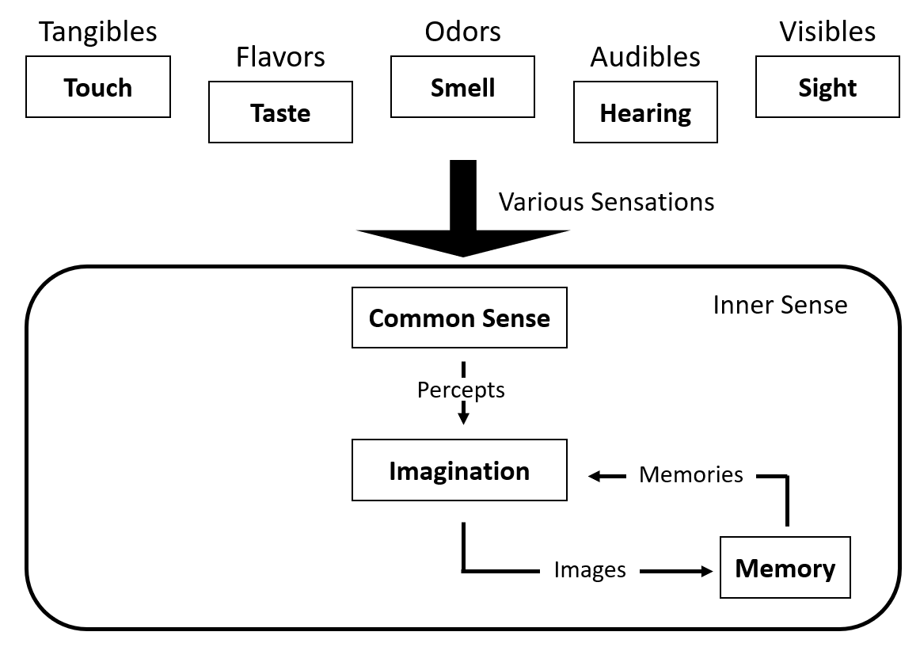

**ACCIDENTS** are defined as the changes that we can grasp on ourselves.

**WISDOM** – the integration, understanding, applied, reflected upon, actionable, accumulated

**KNOWLEDGE** – idea, learning, notion, concept, synthesized, compared, thought-out, discussed

**INFORMATION** – organized, structured, categorized, useful, condensed, calculated

**DATA** – individual facts, figures, signals, and measurements

**PROCESS OF ABSTRACTION**

* It is intellect that grasps the essence of things
* IDEA / CONCEPT is Universal
* It starts from what is sensible & individual that leads to finally actions and the intellect and universal.
* *Ex.* Man 🡪 images are individual, sensible 🡪 produced by imagination. Philosophy analyzes the different types of “Changes” found in nature; it comes to know that every being subject to change must be composed of act and potency.

1. **WHAT IS MATERIAL AND IMMATERIAL BEINGS?**

* ***Material*** means you can see and can touch
* ***Immaterial*** means it is spiritual and you cannot see or touch.

1. **WHAT IS A BEING?**

* A being is all things that exist through reality.
* The term being is “*ens*” in Latin meaning “that which is”
* Science of being as being ultimate causes and first principles and causes.
* It is everything that is real.
* Physics studies God as the ‘First Cause’ of the act of being of all things

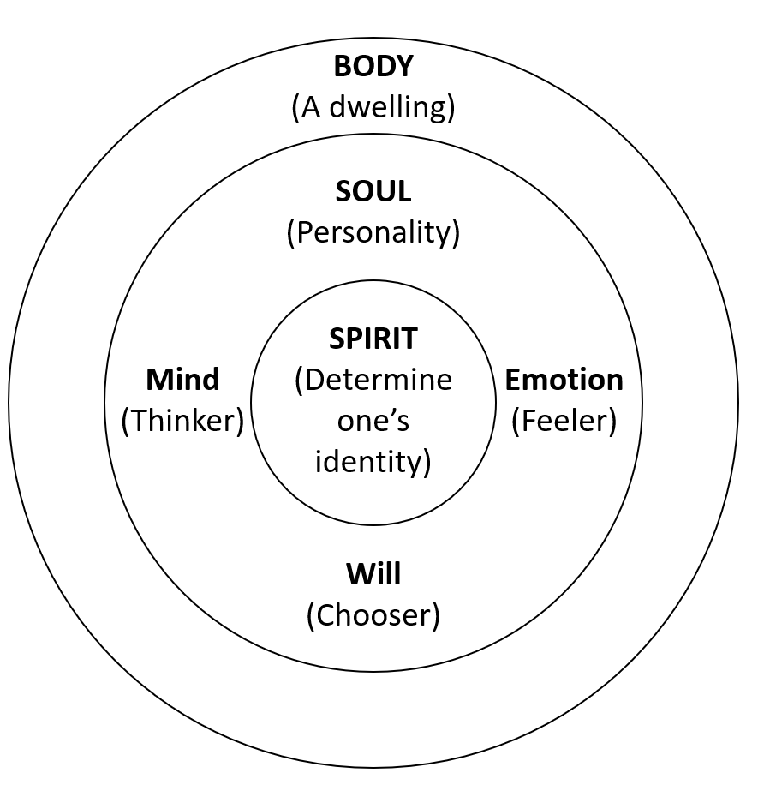

1. **WHAT ARE THE FOUR CAUSES PROPOSED BY ARISTOTLE?**

* ***MATERIAL CAUSE***
* WHAT is it made from? It is the matter in which it is made.
* It is the matter of the substance out of which the effect is produced.

INTRINSIC

* ***FORMAL CAUSE***
* It is the shape of form given to the substance for the production of an object/effect
* It is HOW it is arranged.
* ***EFFICIENT CAUSE***
* It refers to the skill or energy necessary for the production of the effect

EXTRINSIC

Beyond the “ens”

* It is what caused it to be produced or made, and also WHO made the object
* ***FINAL CAUSE***
* The final cause of the thing is a very purpose for which the change is brought in.
* The ends or purpose, the aim of why it is created.
* It answers WHY it was made?

1. **WHAT ARE THE PARTS OF METAPHYSICS?**
2. ***General Metaphysics:***

* It deals with the structure of the being of things.
* It studies the fundamental nature of reality, existence, and beings.

1. ***Natural Theology:***

* Studies God as the subsistent being as the 1st cause of all things.
* It studies the spiritual beings like angels etc.

1. ***Gnoseology:***

* A philosophical study of the scope of metaphysics which is knowledge itself, including its nature, limits, and validity.
* Studies the human knowledge.

1. **WHAT IS THE PHILOSOPHY OF LIVING BEING?**

* “Life” of the “good life” is eudaimonia (flourishing or happiness), achieved through the rational activity of the soul in accordance with the virtues.
* A living being possesses a “life” that allows him to live.

1. **WHAT IS LOGIC?**

* **Logic** is the study of theory.
* The logic focuses on the logical structure of language.
* It looks into whether there are rules or principles that govern reasoning.
* It incorporates the analysis of the methods of deduction and induction.
* Logic is simply the science of correct thinking
* It is the science of correct thinking.
* *Ex*. “All women love a man”, firstly, it cannot be. It can mean “Every woman loves a man” which also cannot be, or “All women love Jovanotti”
* However, it can be better explained through proper disposition such as “All woman loves their man”

1. **WHAT IS ETHICS?**

* It is derived from the Greek “*ethos*” meaning “moral philosophy” or the “custom habit”.
* It refers to the concern about human conduct and morality of the human actions.
* It deals with how human persons are ought to act and search for definition of conduct and habit.
* ***Ethics*** is the theory of right action and greater good, while ***Morality*** is the practice of the rightness or wrongness of Human Action.

1. **WHAT IS PHILOSOPHY OF NATURE?**
2. ***Cosmology***

* Comes from the word “Kosmos” and “Logos” meaning “World” and “Knowledge of Study”.
* It studies the world including its origin, dynamics, and characteristics, as well as the laws governing its order.