Supplement
Distinct molecular profiles characterize the spontaneous growth rate of IDHmt diffuse low-grade glioma WHO, grade II

Amélie Darlix^{1,2;*}, Pierre Bady^{3,4;*}, Jérémy Deverdun^{5,6}, Emmanuelle Le Bars^{5,6}, Arthur Coget⁶, Justine Meriadec⁶, Mathilde Carrière⁶, Hugues Duffau⁷, Monika E. Hegi^{3,8}

¹Department of Medical Oncology, Institut Régional du Cancer de Montpellier, University of Montpellier, Montpellier, France
²Institute of Functional Genomics IGF, University of Montpellier, CNRS, INSERM, Montpellier, France
³Neuroscience Research Center and Service of Neurosurgery, Lausanne University Hospital and University of Lausanne, Lausanne, Switzerland,
⁴Translational Data Science Facility, Swiss Institute of Bioinformatics, AGORA Cancer Research Centre, 1011 Lausanne, Switzerland
⁵I2FH, Institut d'Imagerie Fonctionnelle Humaine, Department of Neuroradiology, Montpellier University Medical Center, Montpellier, France, Montpellier, Switzerland,
⁶Department of Neuroradiology, Gui de Chauliac Hospital, Montpellier University Medical Center, Montpellier, France,
⁷Department of Neurosurgery, Gui de Chauliac Hospital, Montpellier University Medical, Montpellier, France,
⁸L. Lundin and Family Brain Tumor Research Center, Departments of Oncology and Clinical Neurosciences, Lausanne University Hospital and University of Lausanne, Lausanne, Switzerland.

Contents Supplement

Supplement 1
Supplementary Tables 3
Table S1. Tumor Volume Growth Rate (TVGR) estimated by bootstrap procedure. 3
Table S2. Tumor Diameter Growth Rate (TDGR) estimated by bootstrap procedure. 3
Table S3. Results of GSEAs for non-codeleted (CNV, Expression, DNA methylation) from marker ranking based on the rank-rank linear models. 3
Table S4. Results of GSEAs for codeleted (CNV, Expression, DNA methylation) from marker ranking based on the rank-rank linear models. 3
Table S5. Molecular Group Partition (GP) subtypes and survival analysis from cox regression models 4
Table S6. Spontaneous Tumor Volume Growth Rate and Survival analysis from cox regression models 5
Supplementary Figures 6
Figure S1. Flow diagrams for sample selection (A) and analyses (B). 6
Figure S2. Tumor Diameter Growth Rate (TDGR) 7
Figure S3. Quality control of mixed linear model and estimation for Tumor Volume Growth Rate (TVGR) by bootstrap. 8
Figure S4. Association of the TVGR (1/year) with the initial tumor volume (mm3). 9
Figure S5. Heatmap of TVGR associated pathway activities extracted for the entire IDHmt LGG population (codel & non-codel). 10
Figure S6. Top 30 pathways associated with TVGR in non-codel and codel LGG. 11
Figure S7. Common pathways associated with TVGR in non-codel and codel LGG. 12
Figure S8. Cascade K Means partition comparison and Calinski plot versus number of clusters by LGG subtype. 13
Figure S9. Comparison of TVGR associated pathway activities in the Montpellier cohorts to respective patterns in TCGA-LGG IDHmt grade II, stratified by LGG subtype (non-codel, codel). 14
Figure S10. Mutation and CNV analysis for the non-codeleted and codeleted samples (n=77). 15
References 16

Supplementary Tables

Table S1. Tumor Volume Growth Rate (TVGR) estimated by bootstrap procedure.

Table S2. Tumor Diameter Growth Rate (TDGR) estimated by bootstrap procedure.

Table S3. Results of GSEAs for non-codeleted (CNV, Expression, DNA methylation) from marker ranking based on the rank-rank linear models.

Table S4. Results of GSEAs for codeleted (CNV, Expression, DNA methylation) from marker ranking based on the rank-rank linear models.

Table S5. Molecular Group Partition (GP) subtypes and survival analysis from cox regression models
 | Characteristic | N | N Events | log(HR) | 95% CI | p-value
 | Non-Codel
 | GP, FIFS | 48 | 48
 | Non-codel-1 |  |  | - | - | -
 | Non-codel -2 |  |  | 3.24 | 1.27, 8.31 | 0.014
 | Non-codel -3 |  |  | 2.38 | 1.16, 4.88 | 0.019
GP, ²diagn to NxtTr after TMZ |  | 48 | 46
 | Non-codel-1 |  |  | - | -
 | Non-codel -2 |  |  | 3.49 | 1.36, 8.99 | 0.01
 | Non-codel -3 |  |  | 2.14 | 0.99,4.61 | 0.052
 | GP, ³start TMZ to NxtTr | 48 | 46
 | Non-codel 1 |  |  | - | -
 | Non-codel -2 |  |  | 2.21 | 0.94, 5.23 | 0.07
 | Non-codel -3 |  |  | 0.96 | 0.46, 1.88 | 0.9
 | GP, ⁴overall survival | 48 | 39
Non-codel 1 |  |  |  | - | -
Non-codel -2 |  |  |  | 1.2 | 0.29, 2.1 | 0.010
Non-codel -3 |  |  |  | 0.52 | -0.23, 1.3 | 0.2
 | Codel
GP, ¹FIFS |  | 29 | 29
Codel-1 |  |  |  | - | -
Codel-2 |  |  |  | 0.38 | -0.45, 1.2 | 0.4
GP, ²diagn to NxtTr after TMZ |  | 29 | 23
Codel-1 |  |  |  | - | -
Codel-2 |  |  |  | 0.01 | 0.91, 0.885 | >0.9
GP, ³start TMZ to NxtTr |  | 29 | 23
Codel-1 |  |  |  | - | -
Codel-2 |  |  |  | 0.33 | -0.56, 1.2 | 0.5
GP, ⁴overall survival |  | 29 | 6
Codel-1 |  |  |  | - | -
Codel-2 |  |  |  | -0.11 | -1.7,.1.5, | 0.9
 | Abbreviations: GP; Molecular Group Partition; CI = Confidence Interval, HR = Hazard Ratio; FIFS, First Intervention-Free Survival
 | ¹Time interval from diagnosis to start of TMZ, FIFS
 | ²Time interval from diagnosis to next treatment after TMZ
 | ³Time interval from start TMZ to next treatment
 | ⁴Time interval from diagnosis

Table S6. Spontaneous Tumor Volume Growth Rate and Survival analysis from cox regression models
 | Characteristic | N | N Events | log(HR) | 95% CI | p-value
 | Non-Codel
 | TVGR, ¹diagn to start TMZ; FIFS | 48 | 48 | 4.1 | 0. 67, 7.6 | 0.019
 | TVGR, ²diagn to NxtTr after TMZ | 48 | 46 | 4.9 | 0.84, 9.0 | 0.018
 | TVGR, ³start TMZ to NxtTr | 48 | 46 | 6.4 | 2.7,10 | <0.001
TVGR⁴, overall survival |  | 48 | 39 | 6.1 | 1.8, 10 | 0.005
 | Codel
 | TVGR, ¹diagn to start TMZ; FIFS | 29 | 29 | 4.3 | -1.2, 9.7 | 0.13
 | TVGR, ²diagn to NxtTr after TMZ | 29 | 23 | 5.4 | -0.39, 11 | 0.068
 | TVGR, ³start TMZ to NxtTr | 29 | 23 | 6.7 | 0.55, 13 | 0.033
 | TVGR, ⁴overall survival | 29 | 6 | 5.3 | -6.3, 21 | 0.3
 | Abbreviations: TVGR, Tumor Volume Growth Rate; CI = Confidence Interval, HR = Hazard Ratio; FIFS, First Intervention-Free Survival
 | ¹Time interval from diagnosis to start of TMZ, FIFS
 | ²Time interval from diagnosis to next treatment after TMZ
 | ³Time interval from start TMZ to next treatment
 | ⁴Time interval from diagnosis

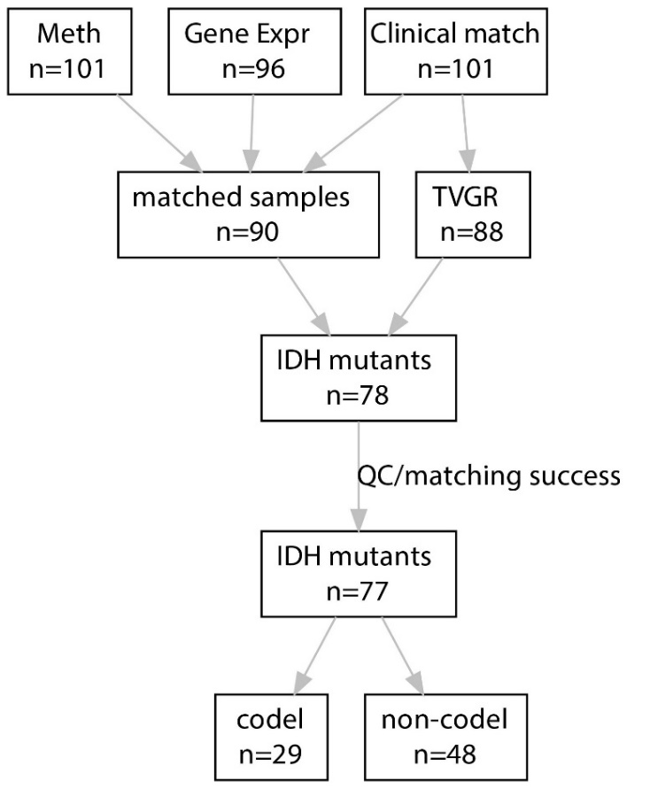
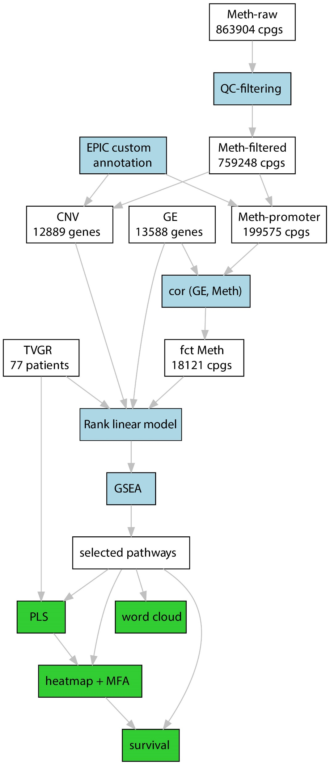
Supplementary Figures
A
B

Figure S1. Flow diagrams for sample selection (A) and analyses (B).

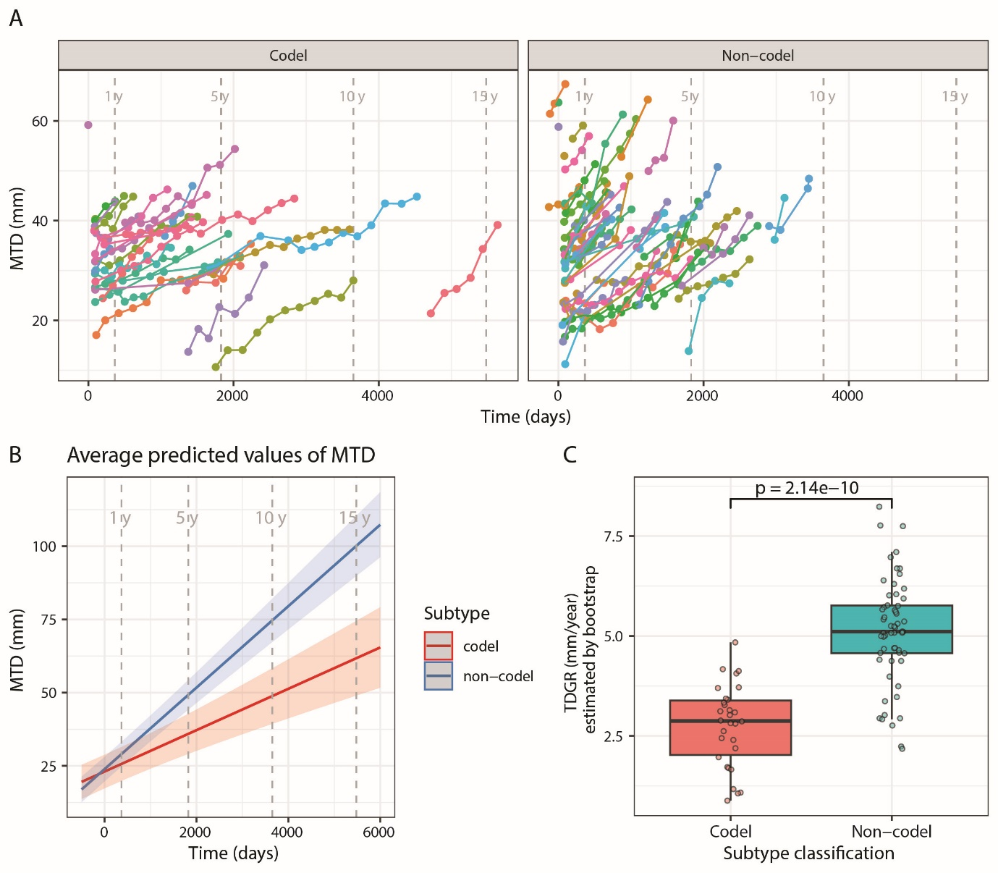

Figure S2. Tumor Diameter Growth Rate (TDGR)
(A) Representation of the tumor diameter (mm) in function of the time (t=0, time of diagnosis) by subtype (codel, n=30; non-codel, n=58). (B) Average predicted median diameter by subtype, the shaded areas correspond to the 95% confidence interval. (C) Mean Tumor Diameter Growth Rate (TDGR) estimated by bootstrap in codeleted and non-codeleted LGG, visualized in a Box plot as mean TDGR (mm/year) by subtype.

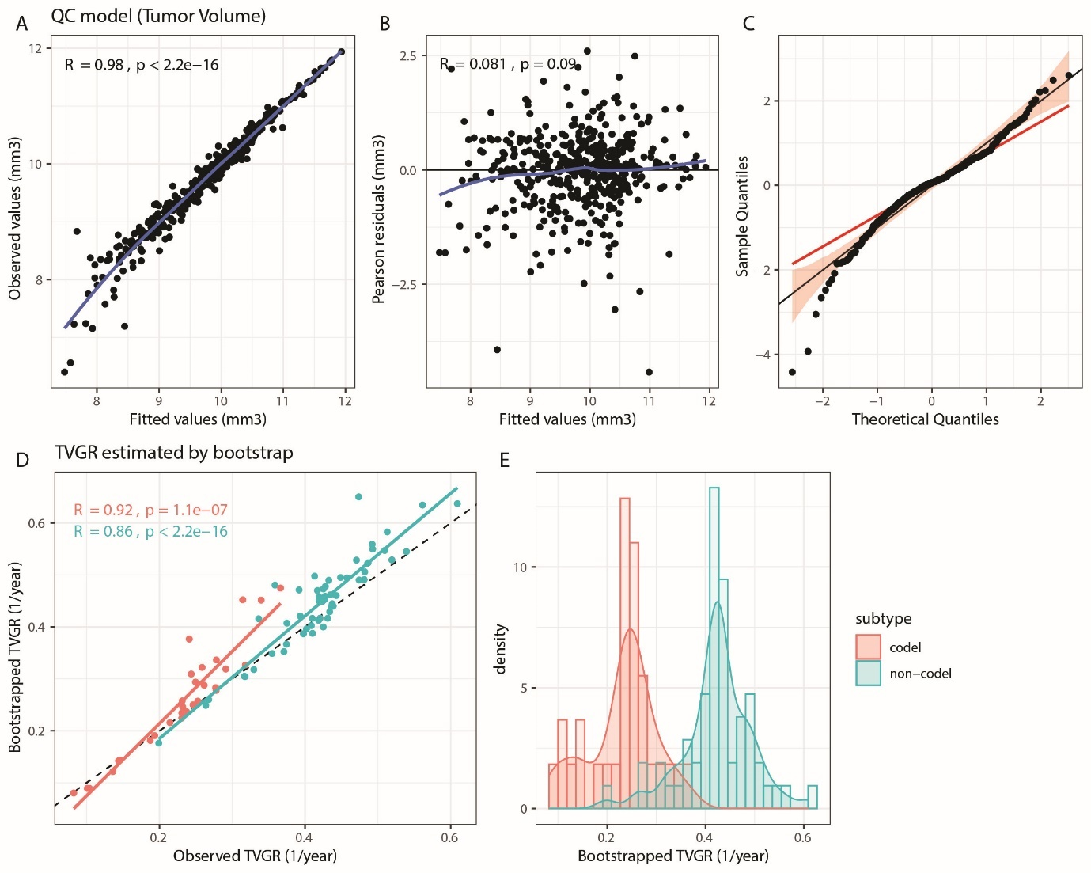

Figure S3. Quality control of mixed linear model and estimation for Tumor Volume Growth Rate (TVGR) by bootstrap.
Representation of the fitted against observed values for the tumor volume (A). The Pearson residuals are represented against fitted values (B) and residuals are plotted against theoretical quantiles from Normal distribution (C). The estimation of the TVGR is obtained by the mean of the slopes of bootstrapped mixed linear model from 50 repetitions. TVGR from bootstrap procedure are compared to the observed values (D) by 1p/19q codeletion subtype. The distribution TVGR are given in function of the 1p/19q codeletion subtype by density plot (E).

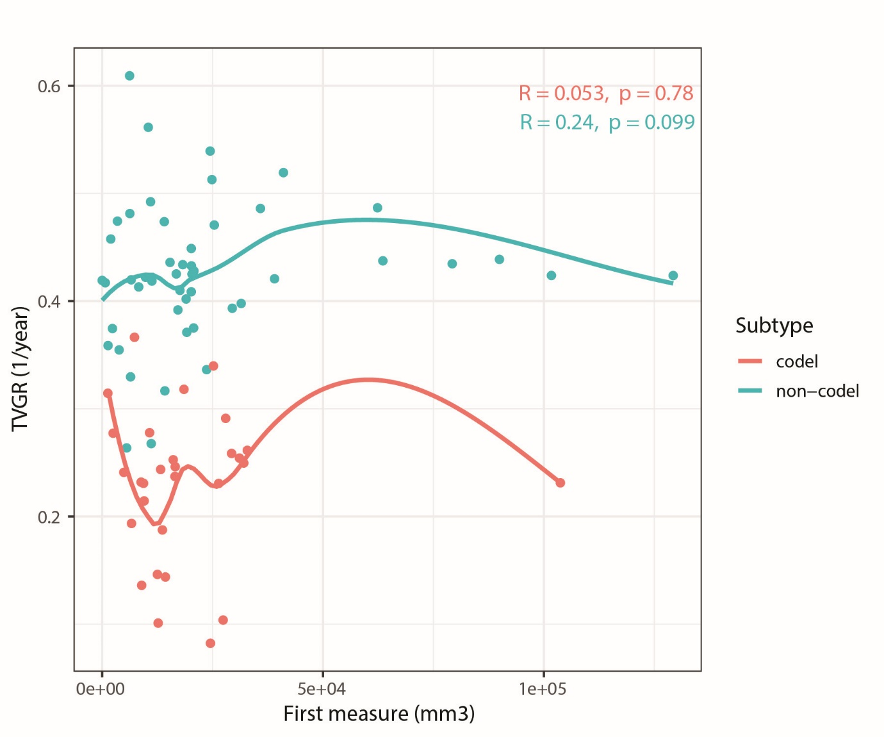

Figure S4. Association of the TVGR (1/year) with the initial tumor volume (mm3).
Representation of the TVGR (1/year) in function of the first MRI of the series for each patient. The loess trends and Spearman correlation coefficient are given for each subtype (non-codeleted and codeleted).

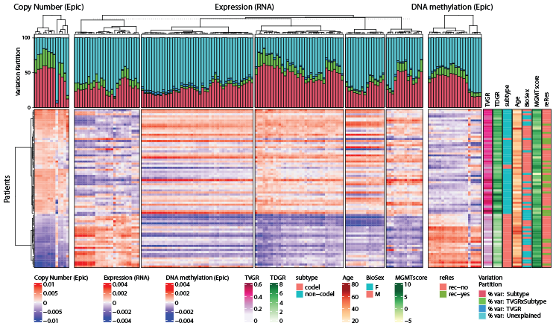

Figure S5. Heatmap of TVGR associated pathway activities extracted for the entire IDHmt LGG population (codel & non-codel).
The heatmap is based on the averaged gene expression, CNV and DNA methylation of the significant pathways emerging from GSEA (p ≤ 0.05). The CNV, DNA methylation and gene expression normalized datasets were weighted by their total inertia for the simultaneous heatmap representation as used in multiple factor analysis (MFA) beforehand. The dendrograms are based on Euclidean distance and Ward’s classification. The samples are clustered by copy number variation. The contribution of subtype and TVGR to explain the variance is evaluated by variation partitioning represented by bar plots of variation fractions (percentage) for the two supplementary variables (variation explained by subtype, TVGR, and interaction between subtype and TVGR). Sample annotations comprise the TVGR, TDGR, subtype by 1p/19q codeletion status, age, time from diagnosis to first oncologic treatment initiation (FIFS, first Intervention Free Survival), MGMT-STP27score, surgery type, reresections (reRes), sample ID.

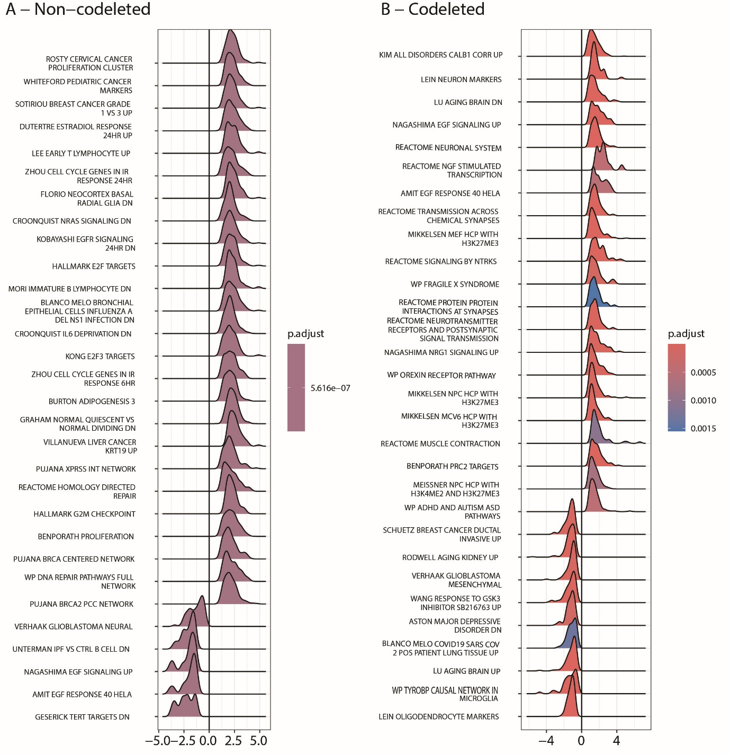

Figure S6. Top 30 pathways associated with TVGR in non-codel and codel LGG.
The top 30 pathways selected by GSEA are shown in ridge plots, illustrating the distributions of the z-scores in the (A) Non-odeleted and (B) codeleted LGG.

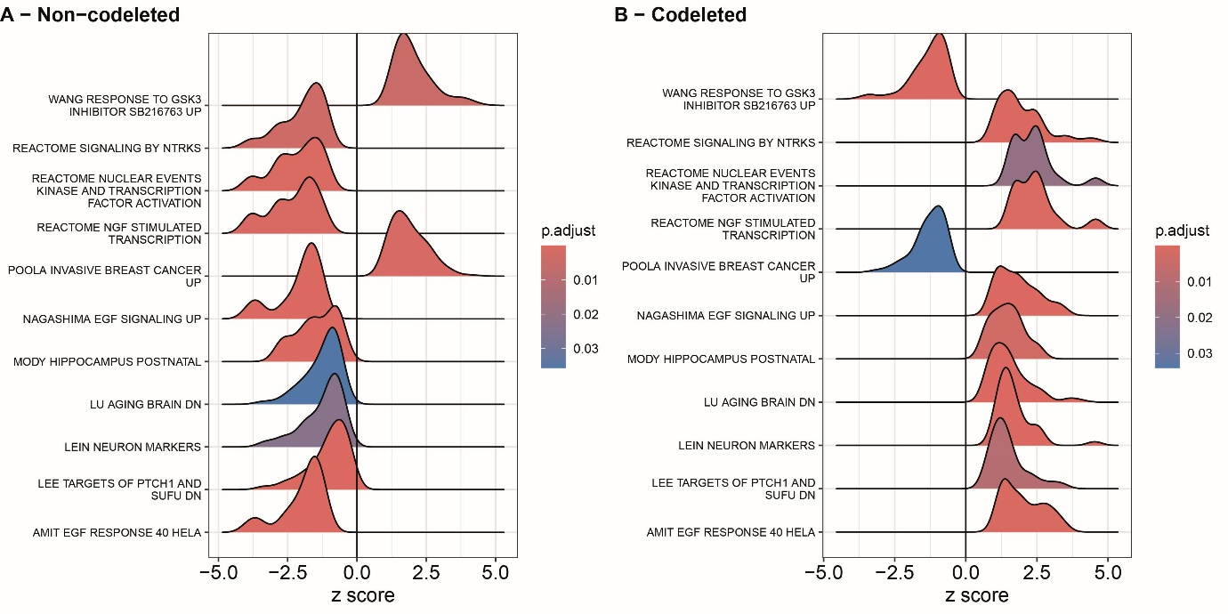

Figure S7. Common pathways associated with TVGR in non-codel and codel LGG.
The distributions of the z-scores are illustrated in the ridge plot for the 11 common pathways selected by GSEA in non-codel (A) and codel (B) LGG. Of note, the significant association of the rank order has opposite signs.

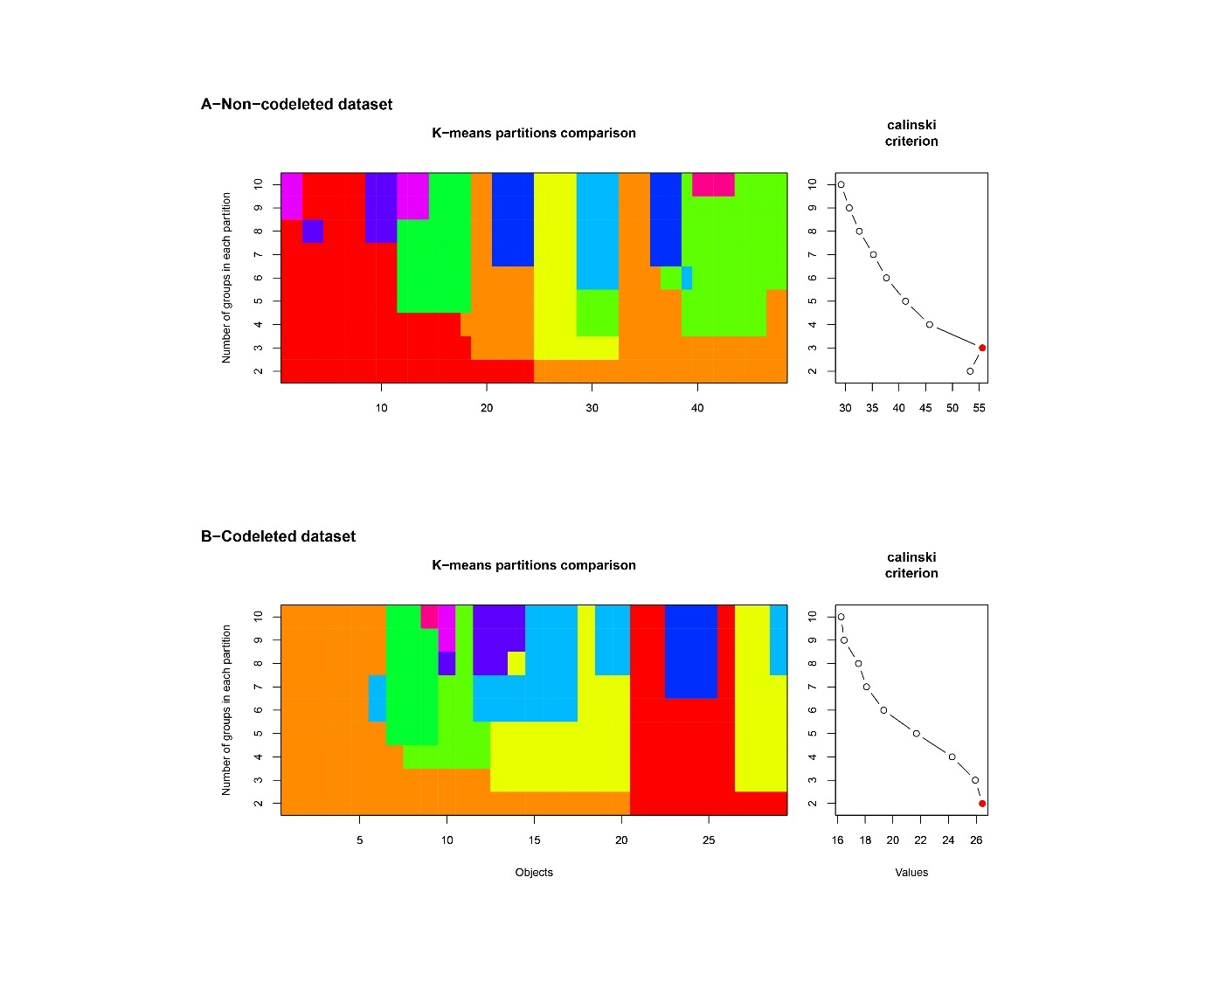

Figure S8. Cascade K Means partition comparison and Calinski plot versus number of clusters by LGG subtype.
Non-codel, A; codel, B. The color plots give the distribution of the samples in function of the groups defined by K-means. The calinski plot provides the optimal group number characterized by the higher values (red point). The optimal group number is 3 for IDHmt non-codel and 2 for codel LGG subtype.
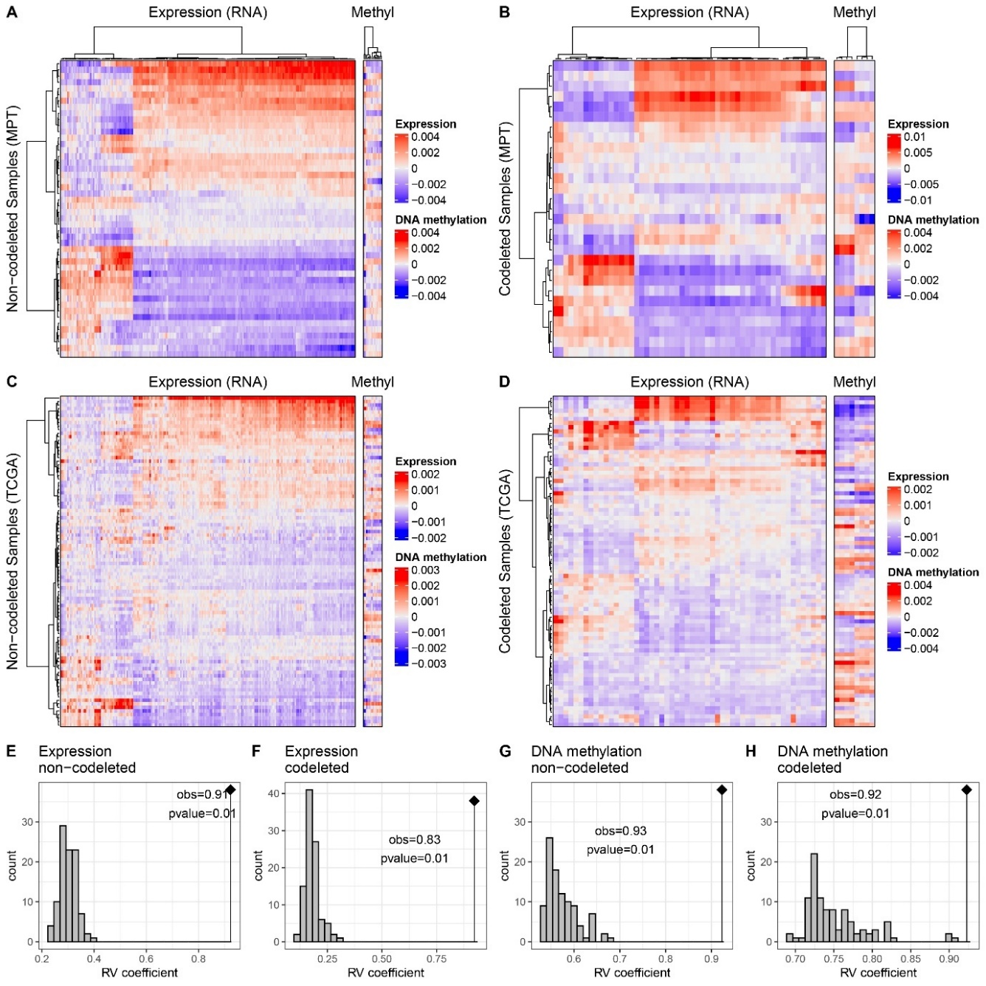

Figure S9. Comparison of TVGR associated pathway activities in the Montpellier cohorts to respective patterns in TCGA-LGG IDHmt grade II, stratified by LGG subtype (non-codel, codel).
The order of the pathways correlated with the TVGR were defined as determined in the non-codeleted (A) and codeleted (B) Montpellier cohorts and the respective data of the TCGA cohorts (C, non-codeleted; D, codeleted) were ordered accordingly. The heatmaps are based on the averaged gene expression and averaged functional DNA methylation of the significant pathways emerging from GSEA (p ≤ 0.05). The gene expression and DNA methylation normalized datasets were weighted by their total inertia for the simultaneous heatmap representation as used in multiple factor analysis (MFA) beforehand. The dendrograms are based on Euclidean distance and Ward’s classification. The expression and DNA methylation structures were compared by RV coefficient tests based on 99 permutations for non-codeleted and codeleted datasets: (E) expression for non-codeleted, (F) expression for codeleted; (G), DNA methylation for non-codeleted, and (H) DNA methylation for codeleted.
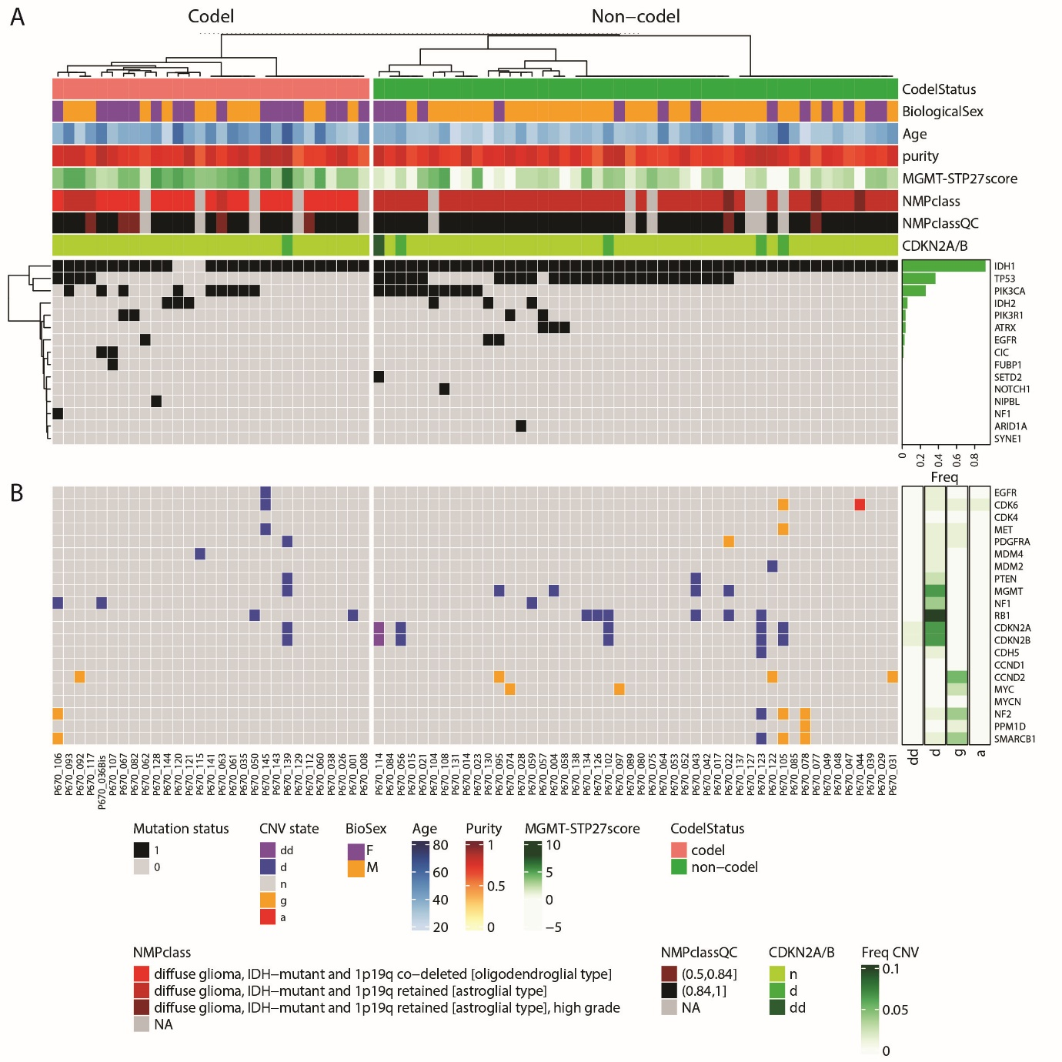

Figure S10. Mutation and CNV analysis for the non-codeleted and codeleted samples (n=77).
The samples were ordered by subtype (codeletion status). Additional sample annotations comprise: Biological sex, Age, Purity, MGMT-STP27 score, NMPclass, NMPclassQC (Capper et al., 2018a; Capper et al., 2018b) and CNV state of CDKN2A/B. (A)The RNA-seq data was used to determine mutations in the most commonly mutated genes reported from LGG and GBM in the COSMIC database (Tate et al., 2019). (B) The gene copy number variation (CNV) information was assessed for a gene set proposed by (Shirahata et al., 2018) reported to be relevant for progression of IDH mutant glioma, and classified by CNV states (a, amplification; g, gain; n, normal; d, hemizygous deletion; dd, homozygous deletion) as previously described (Bady et al., 2016; Bady et al., 2018).

References
Bady, P., Delorenzi, M., and Hegi, M.E. (2016). Sensitivity analysis of the MGMT-STP27 model and impact of genetic and epigenetic context to predict the MGMT methylation status in gliomas and other tumors. J Mol Diagn 18, 350-361. 10.1016/j.jmoldx.2015.11.009.
Bady, P., Kurscheid, S., Delorenzi, M., Gorlia, T., van den Bent, M.J., Hoang-Xuan, K., Vauleon, E., Gijtenbeek, A., Enting, R., Thiessen, B., et al. (2018). The DNA methylome of DDR genes and benefit from RT or TMZ in IDH mutant low-grade glioma treated in EORTC 22033. Acta Neuropathol 135, 601-615. 10.1007/s00401-018-1810-6.
Capper, D., Jones, D.T.W., Sill, M., Hovestadt, V., Schrimpf, D., Sturm, D., Koelsche, C., Sahm, F., Chavez, L., Reuss, D.E., et al. (2018a). DNA methylation-based classification of central nervous system tumours. Nature 555, 469-474. 10.1038/nature26000.
Capper, D., Stichel, D., Sahm, F., Jones, D.T.W., Schrimpf, D., Sill, M., Schmid, S., Hovestadt, V., Reuss, D.E., Koelsche, C., et al. (2018b). Practical implementation of DNA methylation and copy-number-based CNS tumor diagnostics: the Heidelberg experience. Acta Neuropathol. 10.1007/s00401-018-1879-y.
Shirahata, M., Ono, T., Stichel, D., Schrimpf, D., Reuss, D.E., Sahm, F., Koelsche, C., Wefers, A., Reinhardt, A., Huang, K., et al. (2018). Novel, improved grading system(s) for IDH-mutant astrocytic gliomas. Acta Neuropathol 136, 153-166. 10.1007/s00401-018-1849-4.
Tate, J.G., Bamford, S., Jubb, H.C., Sondka, Z., Beare, D.M., Bindal, N., Boutselakis, H., Cole, C.G., Creatore, C., Dawson, E., et al. (2019). COSMIC: the catalogue of somatic mutations in cancer. Nucleic Acids Res 47, D941-D947. 10.1093/nar/gky1015.

