Get fresh 2.7 Python <https://www.python.org/downloads/windows/>

Install all components (pip required).

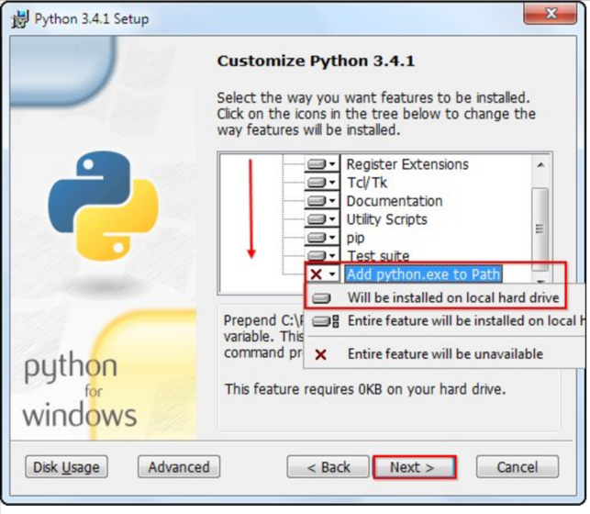

Run **install.bat**

Run **auth_service.bat** to start authentication service.

Run **web.bat** to start web app.

Open in a browser page <http://localhost:5000/>