**Project 7: COVID-19 using Cognos**

**Phase 2: Problem Definition and Design Thinking**

**By Badri N**

**Project Definition:** In this section you need to put your design into innovation to solve the problem. Create a document around it and share the same for assessment as per the instructions mentioned.

Consider incorporating data segmentation by time periods or countries for deeper insights.

**Applying Innovation:**

In this stage, we are going to innovate our previous design based on the COVID-19 Cases analysis. To make it more understandable, we are going to broaden our options to view the data in-depth as in having them display per country’s cases and deaths individually through means of visualizations.

**Ideology:**

We are going to create a dashboard in IBM Cognos Analytics. Then, import the COVID data module. Import datasets onto the dashboard and visualizations to view cases and deaths within each country individually.

**Steps:**

* To begin, create a new dashboard(Open menu > New > Under Present tab > Dashboard).
* Choose a format(Tabbed or Infographic).
* Once the empty dashboard is visible, import “COVID-19 Data Module” from “My Content”.
* Drag and Drop “cases”, “month” and “deaths” column data into empty blocks each having its individual block.
* Create a “Map” visualization by going into the Visualization tab. Add “countriesandTerritories”, “cases” and “deaths” as parameters.
* Add a “Drop down” from the “Visualization” tab and drag-drop “countriesandTerritories” data onto it.
* Dashboard is now completed. It can be modified in future if there’s any updates in datasets from the provided module. The new values can be compared and updated to view from different aspects as per need.

**Dashboard Visualization:**

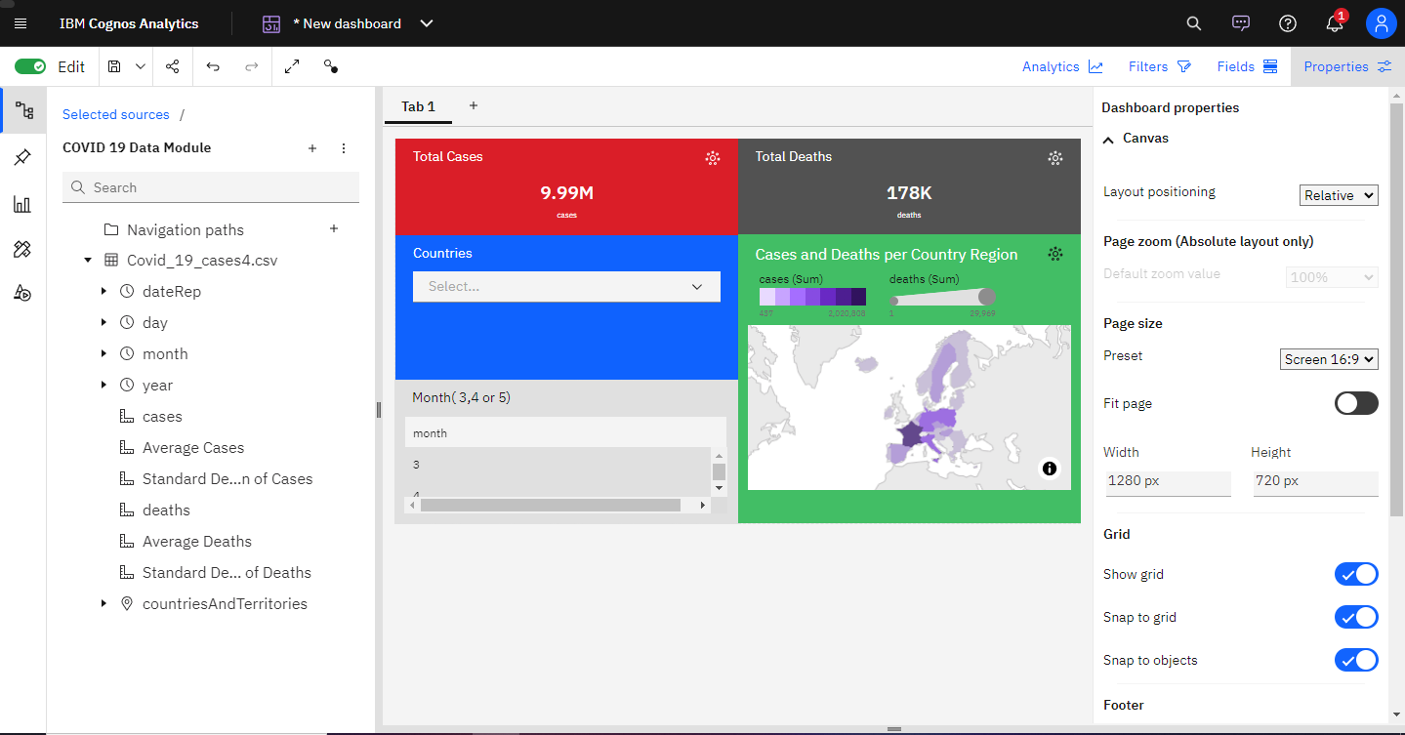

**Working with Example:**

Below listed are individual countries with their Total Cases and Total Deaths represented in the Dashboard.

* France(No months specified)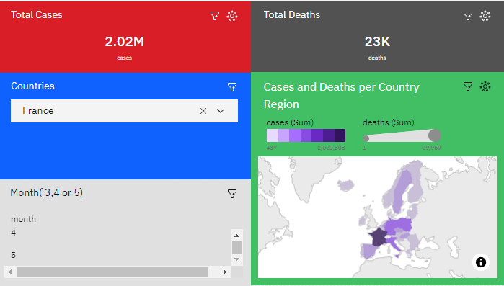
* France(3rd Month i.e. March)

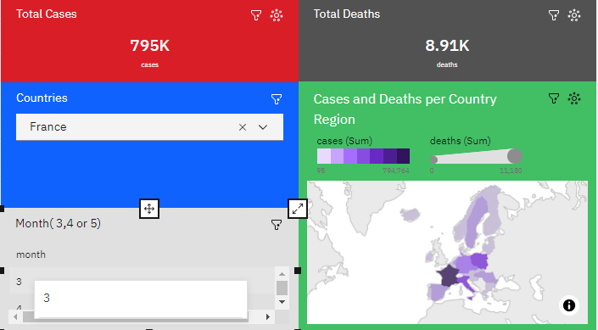

* France(4th Month i.e. April)

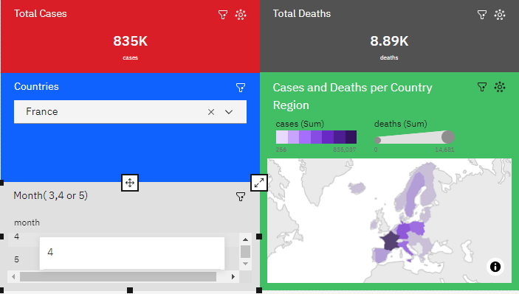

* France(5th Month i.e. May)

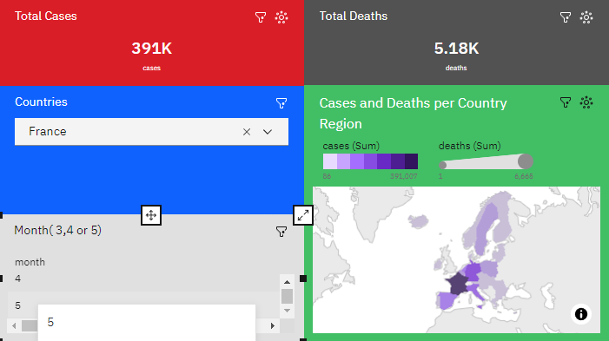

* Germany(No months specified)

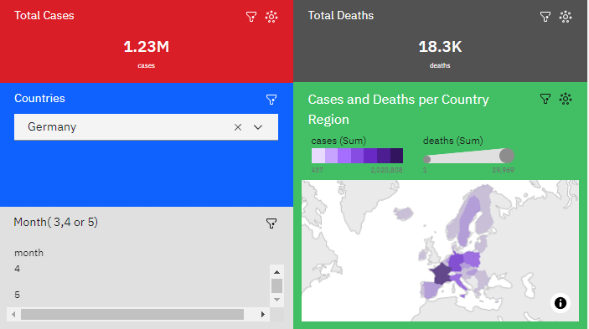

* Spain(No month specified)

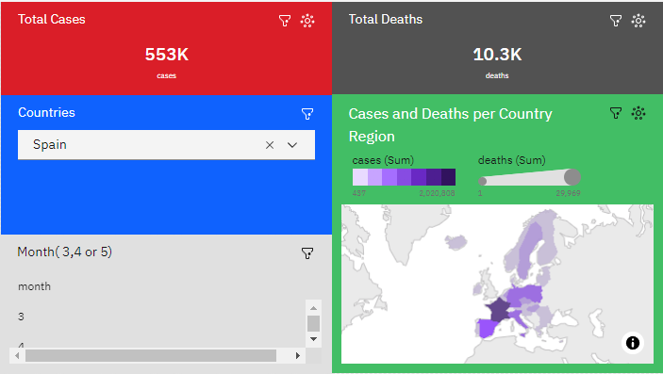

**Conclusion:**

Through the IBM Cognos Analytics tool, we are able to drill down through the COVID-19 Data Module to view the dataset from various individual factors and aspects such as viewing individual country’s total cases and deaths per month. Since the dataset is limited to only 3 months, the use of dashboard allows further modification of data in future when in need(i.e. meaning extra months can be added and the visualization will display as per user’s preference). The Cognos Analytical Tool has brought innovation to our previous design.