**Project 7: COVID-19 using Cognos**

**Phase 4: Development Part 2**

**By Badri N**

**Project Definition:** In this part you will continue building your project.

* Continue building the analysis by creating visualizations using IBM Cognos and deriving insights from the data.
* Create charts and graphs in IBM Cognos to visualize and compare the mean values and standard deviations of COVID-19 cases and associated deaths.
* Analyze the visualizations to identify trends, variations, and potential correlations between cases and deaths.

**Introduction**:

This project is designed to analyze the impact of COVID-19 on various countries in the European region. The main aim is to explore how different nations are responding to the outbreak. This project will help us to list out the cases and deaths rate on these various countries across EU region spread across different days in the year 2021.

**Project Objectives**:

The aim of this project is to enable how to utilize our Data Visualization and Data Analytical skills.

1. To identify emerging trends in the spread of COVID-19.
2. To assess the impact of cases and death rates on the spread of COVID-19.
3. To assess the impact of cases and death rates on the spread of COVID-19 on various days of a month in the year 2021.
4. To create predictive models to better anticipate future cases and death rates related to COVID-19.
5. To provide insights and analyse demographics that could lead to decision making.

**Applying Innovation:**

In this stage, from the previous Development Part 1, we are going to import the operated dataset into IBM Cognos and create a dashboard analyzing the visualizations of deaths, cases and find trends, correlation between them.

**Ideology:**

We are going to create a dashboard in IBM Cognos Analytics. Then, import the refined COVID data module. Import datasets onto the dashboard and visualizations to view cases and deaths within each country individually and find correlations, trends.

**Steps:**

* To begin, create a new dashboard(Open menu > New > Under Present tab > Dashboard).
* Choose a format(Tabbed or Infographic).
* Once the empty dashboard is visible, import “COVID-19 Data Module” from “My Content”.
* Drag and Drop “cases”, “month” and “deaths” column data into empty blocks each having its individual block.
* Create a “Map” visualization by going into the Visualization tab. Add “countriesandTerritories”, “cases” and “deaths” as parameters.
* Add a “Drop down” from the “Visualization” tab and drag-drop “countriesandTerritories” data onto it.
* Dashboard is now completed. It can be modified in future if there’s any updates in datasets from the provided module. The new values can be compared and updated to view from different aspects as per need.

**Dashboard Visualization:**

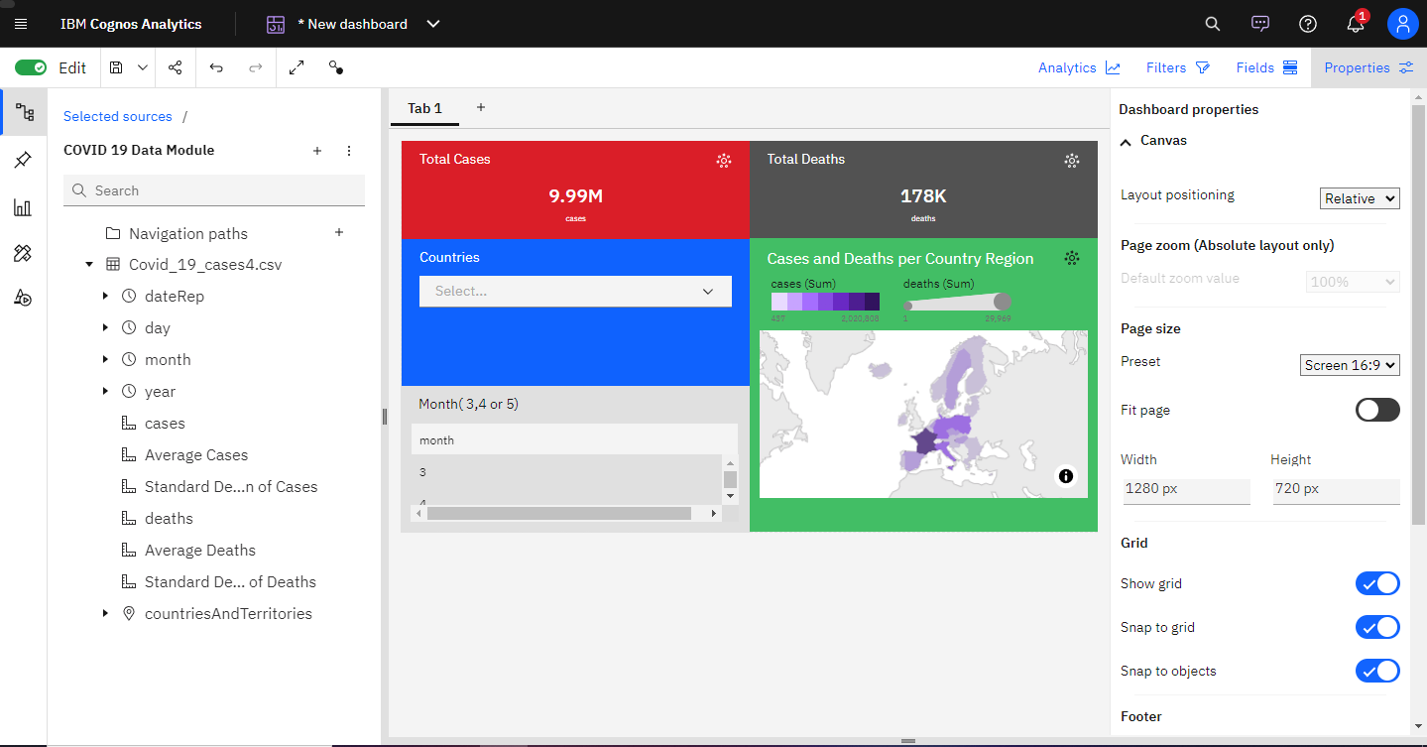

**Working with Example:**

Below listed are individual countries with their Total Cases and Total Deaths represented in the Dashboard.

* France(No months specified)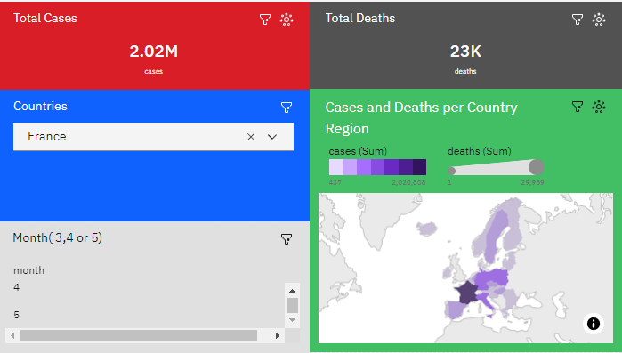
* France(3rd Month i.e. March)

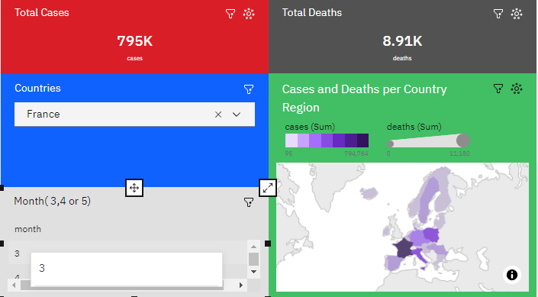

* France(4th Month i.e. April)

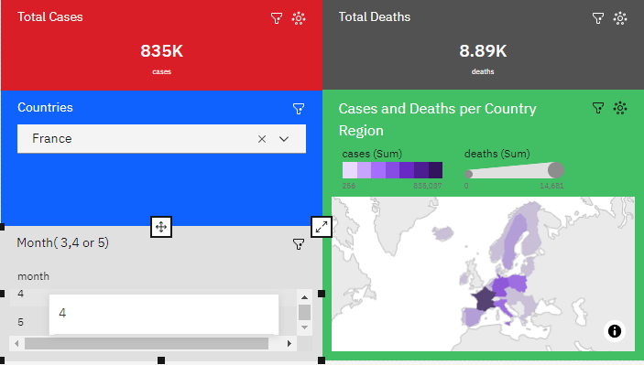

France(5th Month i.e. May)

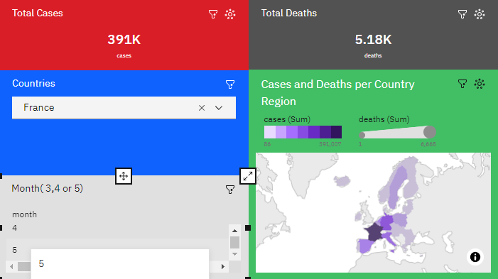

* Germany(No months specified)

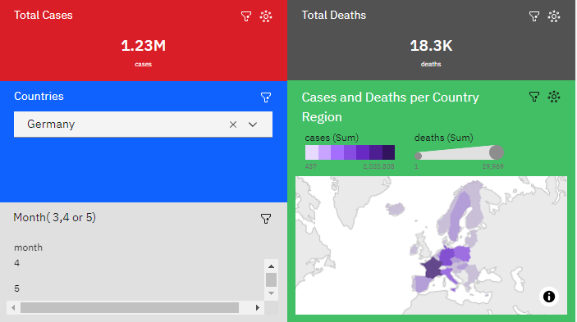

* Spain(No month specified)

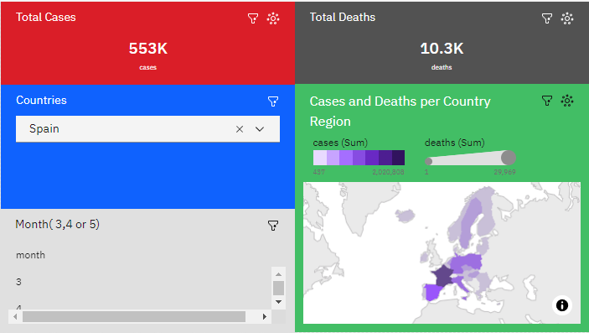

**Conclusion:**

From the previous development, we have imported the dataset to IBM Cognos and successfully created a Data Module. Next, we created a dashboard and imported the COVID Data Module and created visualizations. Through the IBM Cognos Analytics tool, we are able to drill down through the COVID-19 Data Module to view the dataset from various individual factors and aspects such as viewing individual country’s total cases and deaths per month. We are also able to find correlation and trends between cases and deaths. The Cognos Analytical Tool has brought innovation to our previous design.