REACT TRAINING SCREENSHOTS

**MANAGER:**

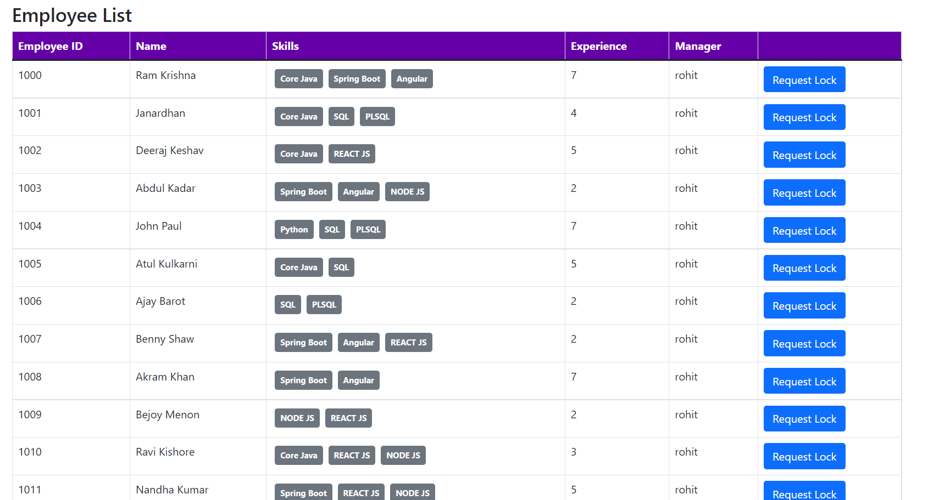

**APPROVER MANAGER LOGIN:**

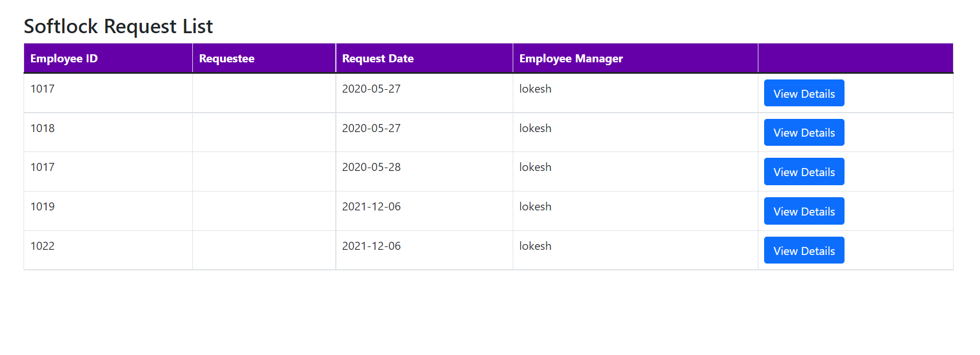

**MANAGER – LOCK REQUEST:**

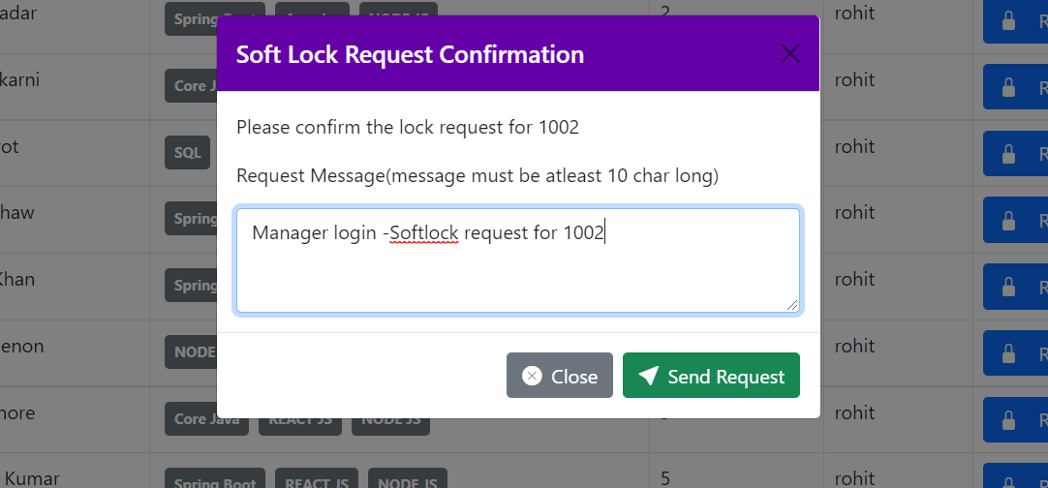

**UPDATE LOOKUP:**

