Requirement Document

Requirements:

1. Introduction
The platform is a public, free-to-use system designed to facilitate the tracking and donation of items prone to damage or expiration. It enables users to post items for donation, browse available items, claim items, and receive notifications for expiring items. The system also provides dashboards and analytics to visualize user activities and item management.

2. System Functions (What the System Will Do)
- User Management
  - Registration and login with verified credentials (e.g., email).
  - Prevent duplicate users; each user must be unique across the platform.
- Item Management
  - Users can post items for donation, providing details such as images, location, phone number, and other relevant information.
  - Users can list, delete (if owned), and view their posted items.
  - Users can browse items posted by others, including images, details, and pickup location.
- Item Claiming and Tracking
  - Users can claim items, marking them as on hold.
  - Claimed items can later be picked up and marked as received.
- Notifications
  - Alerts for items approaching expiration (e.g., 5 days before or on the expiration day).
- Analytics and Visualization
  - Dashboards provide insights on users, items, and a few activities across the platform.
  - Visualization includes charts like histograms and pie charts for better understanding of system usage.

3. Users of the System (Who the Users Are)
- General Public: Anyone with verified credentials can access the platform.
- Registered Users: Can post, browse, claim, and manage items.

4. Main Goals of the System
- Provide a free and accessible platform for item donation.
- Help users track items prone to damage or expiration and provide timely notifications.
- Facilitate posting, browsing, claiming, and managing donated items efficiently.
- Encourage helping people in need by connecting donors with recipients.
- Provide data visualization and analytics for monitoring and improving system performance.
- Ensure data integrity and user uniqueness for secure and reliable operation.

Use Case Diagram:
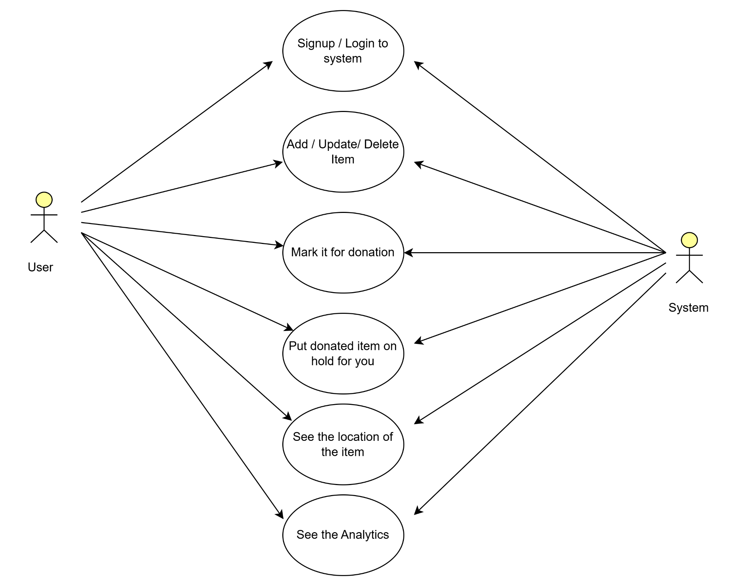

User Stories:

1. Registration and Login
As a user,
I want to be able to register and log in using my email credentials,
So that I can securely access the platform, track donated items, and claim or donate items without creating duplicates.

Acceptance Criteria:
- Users can register with an email address and password.
- Users can log in using registered credentials.
- The system prevents duplicate user registration (e.g., same email address).

2. User Story: Post an Item for Donation
As a registered user,
I want to post items for donation by providing details like item description, image, and pickup location,
So that others can view the item, claim it, and pick it up from the specified location.

Acceptance Criteria:
- Users can provide details like item name, description, image, location, and contact number.
- The system stores and displays the item as available for donation.
- Only the owner can delete or modify their posted item.
- Other users can browse and claim items, with a "claimed" status until it’s marked as "received."

3. User Story: Expiration Reminder for Items
As a user,
I want to receive reminders when an item is approaching its expiration or damage date,
So that I can either mark it as available for donation or take necessary action before it becomes unusable.

Acceptance Criteria:
- The user receives a reminder notification (e.g., 5 days before expiration).
- The system allows the user to mark the item as "available for donation" when nearing expiration.

