How to use Single Sign-on with Office 365?

# Administrator Instructions

## Preparing your Office 365 account for single sign-on with your Moodle installation

Your Office 365 installation needs to be prepared for working with Moodle. This is done by managing your directory called the Windows Azure Active Directory which is the directory underlying Office 365.

1. Before you can use Moodle you will need to create an Azure subscription. You will be required to enter your credit card and phone number for this. However you will not be charged for the subscription if you do not setup VM’s etc and only use it for accessing the directory.
2. You can do this using the following steps
   1. Go to <https://www.windowsazure.com>
   2. Sign in using your Office 365 account and use your Office 365 admin account as the credentials. The picture below highlights the link to click to enter your Office 365 credentials

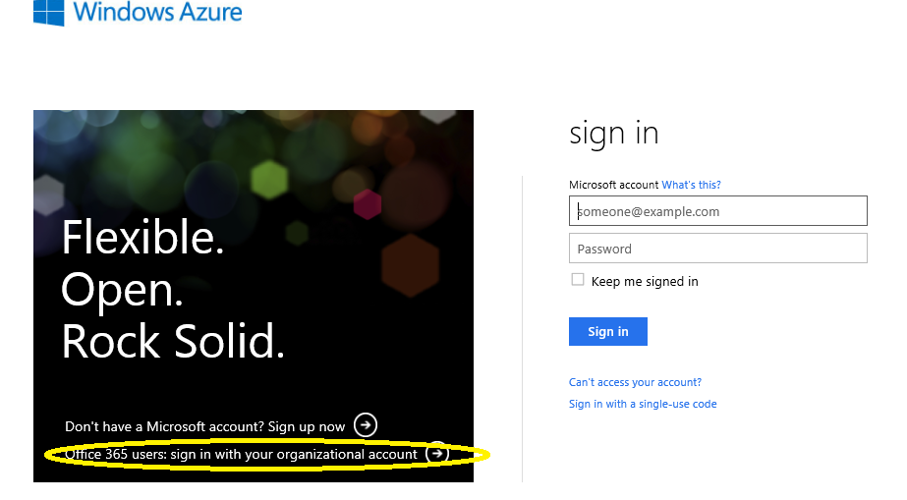

1. After you do this and if you do not have an Azure subscription you will see the following screen. Click the highlighted link to create an Azure subscription

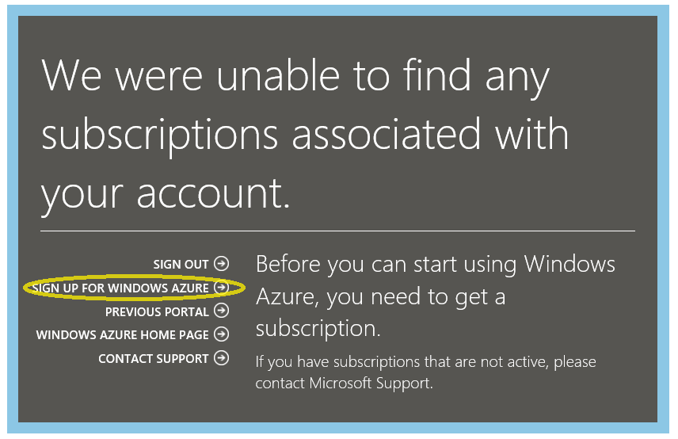

* 1. Sign up for the default offer.

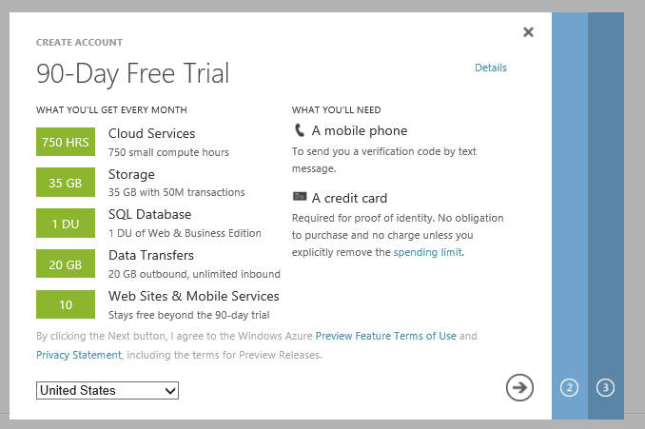

* 1. After you are signed up you should see this screen. Click on the portal as shown

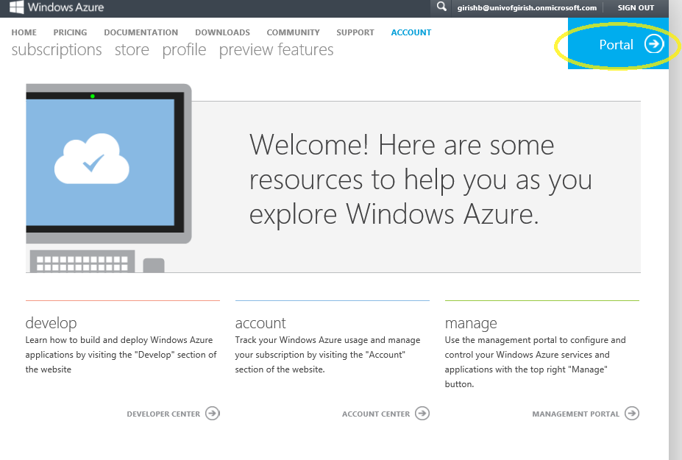

* 1. Go past any of the education screens etc. and you should get to the portal which can also be accessed later thru the <https://manage.windowsazure.com> link. It should like as shown below. Click on the Active Directory Extension and make sure you select the directory tab as highlighted below

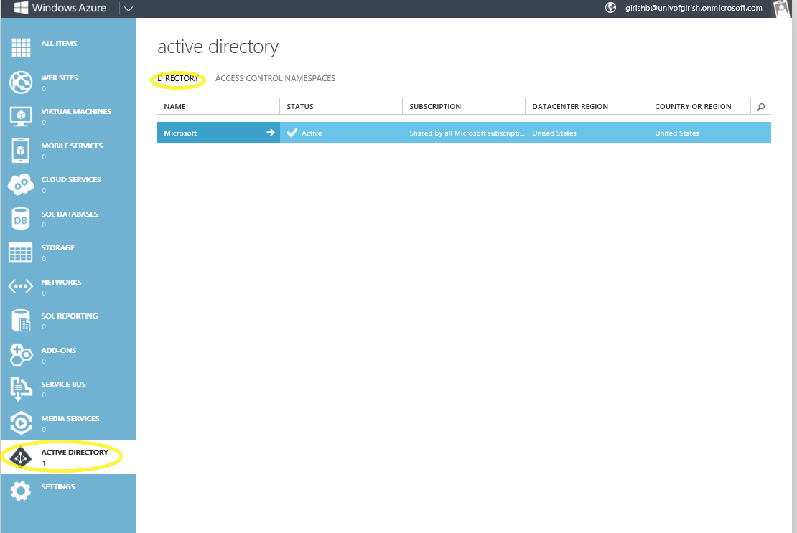

* 1. Click on the -> arrow on the name of your directory entry. This will lead to the directory management screen as shown below. In that screen the default view is users. Click on the integrated apps tab as shown below

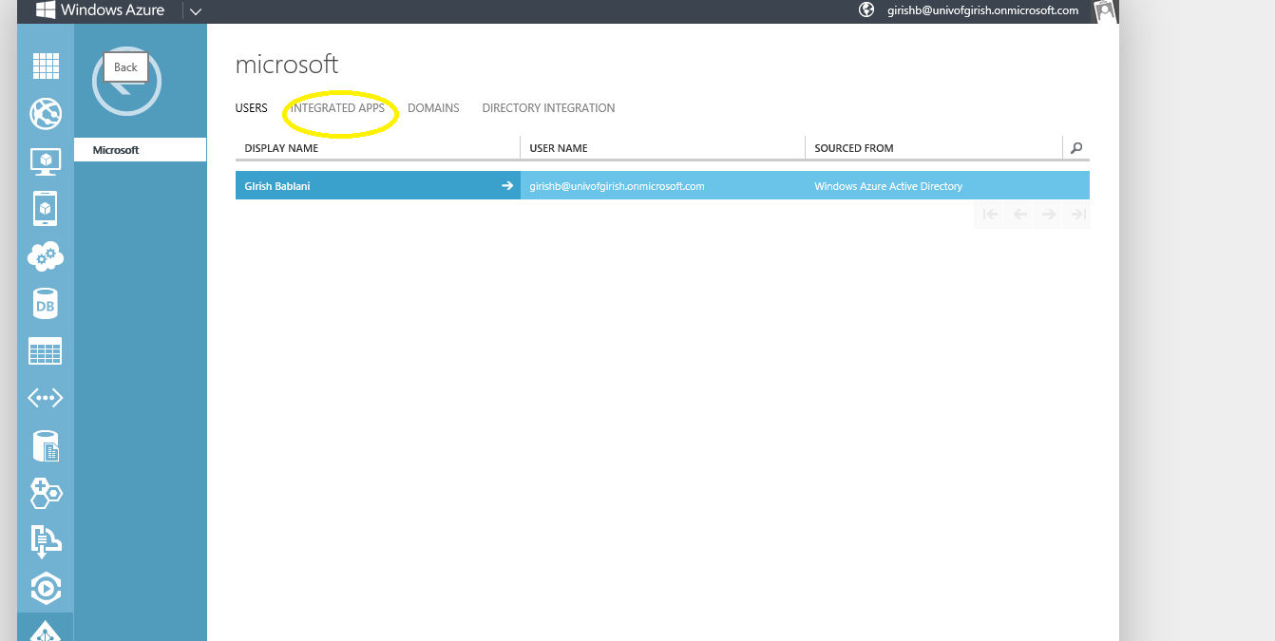

* 1. This will show you apps that that are integrated with your azure active directory which are none. We will now create a new app by clicking the add new app button as shown below

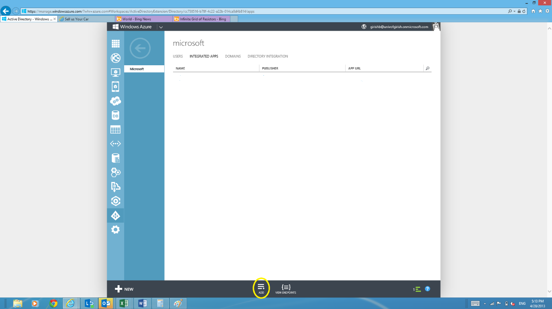

* 1. In the new app add dialog name the app(I named it MoodleApp) and choose Read Access + Single Signon to your directory

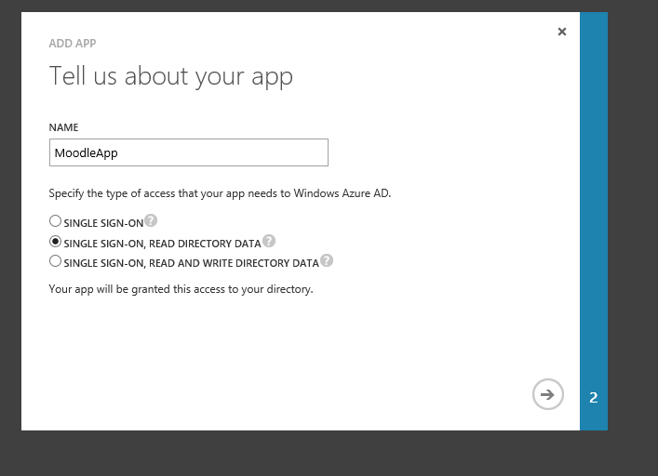

* 1. When you click next you will be asked for the App URI and App URL. The App URI is a unique name for the app and app URL is the http endpoint of your Moodle installation. Note that you will have to enable SSL or hhtps for your moodle installation and will enter the https endpoints. In my case my Moodle installation is at mymoodle.cloudapp.net(Yes it is hosted as a VM in Azure!). So I enter it as follows

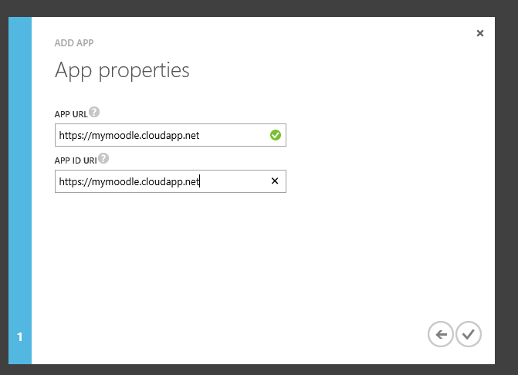

* 1. When you click okay your app will have been added to AzureActiveDirectory as shown below

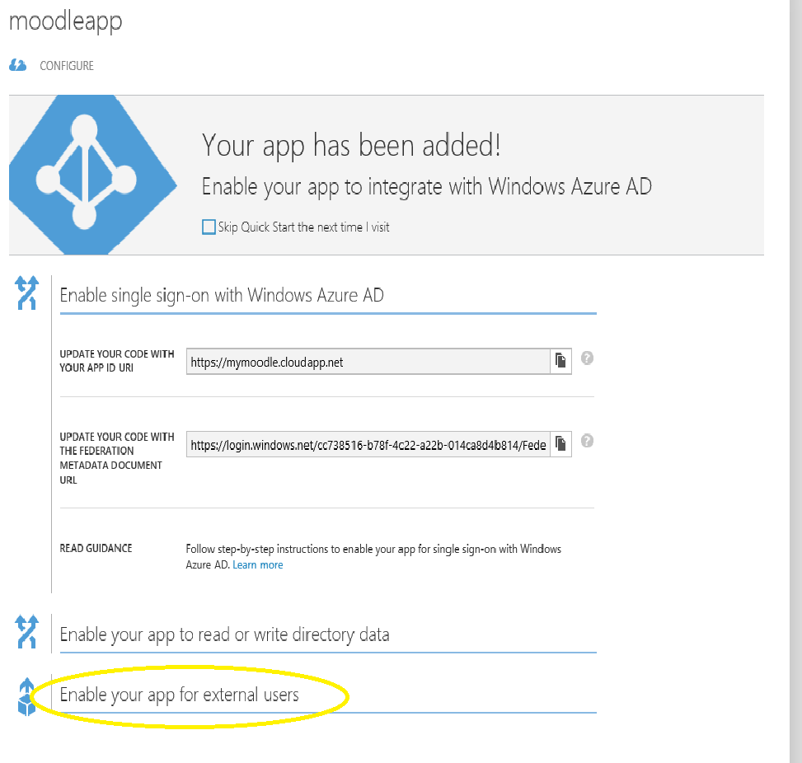

* 1. There are a couple more values and changes you need to make and write down some values which you will need in the next section. The simplest way is to click on the Enable your app for external users link and then press the “Click onfigure access link” as shown.

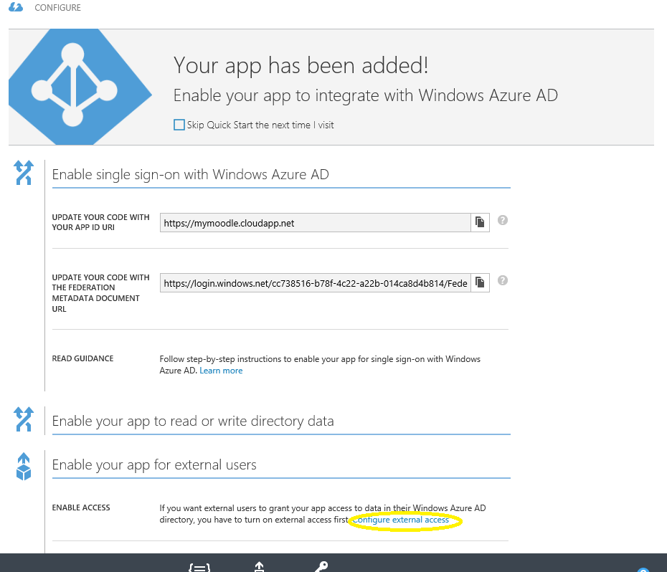

* 1. You will see the screen below

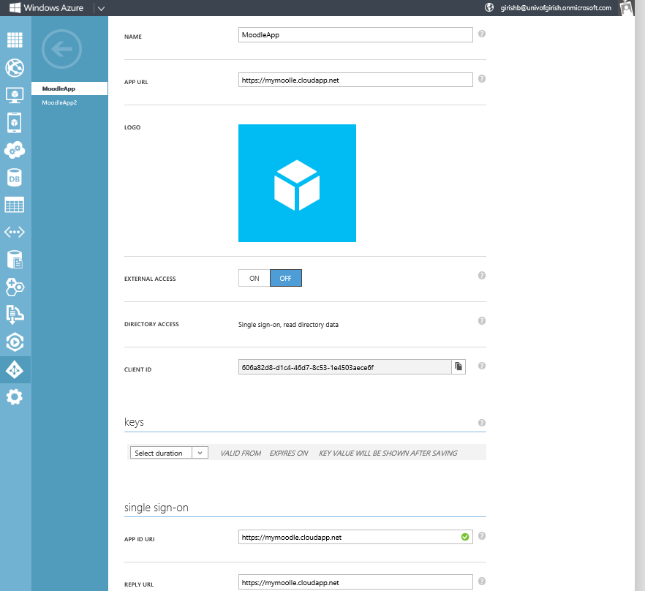

* 1. Take note of the following in Notepad
     1. ClientId – In my case its 606a82d8-d1c4-46d7-8c53-1e4503aece6f. This is also referred to as applicationid
  2. Change the Reply URL from the default to add on /auth/azuread/logincallback.php. So in my case it will look like <https://mymoodle.cloudapp.net/auth/azuread/logincallback.php>.
  3. Add a key with an expiry of 2 years
  4. Hit the save button and make sure you copy the key value into notepad – this is your symmetic key
  5. Hit the View Endpoints button and get your university by looking at the federation data XML and copying the value after login.windows.net and federation metadata not including the / mark and save this as university in your notepad. For me its cc738516-b78f-4c22-a22b-014ca8d4b814
  6. You should know the name of your domain that is registered for your university with Office 365. For example for me its univofgirish.onmicrosoft.com. Copy this value into your notepad as well
  7. You are all done registering

## Adding plugs-ins to Moodle installation

1. There are 2 plug-ins you need to install to enable Office 365 single sign on - a) Azure AD Block b) Azure AD Auth
2. Create a folder call AzureAD in the blocks directory of your moodle installation. Copy all the files in the AzureAD block plug into this directory
3. Create a folder call AzureAD in the blocks directory of your moodle installation. Copy all the files in the AzureAD block plug into this directory
4. Login as admin into your Moodle installation and okay the prompts about the new addins.
5. You should be taken to the settings page of your AzureAD block-plugin. If you are not manually navigate to it from the Site Administrations\Plug-ins\Block\Azure AD menu.
6. The following values are required (and are the values you saved in notepad) to enable Office365.
   1. University id
   2. University Domain
   3. Application Id
   4. Symmetric Key

This is shown in my screen capture from Moodle

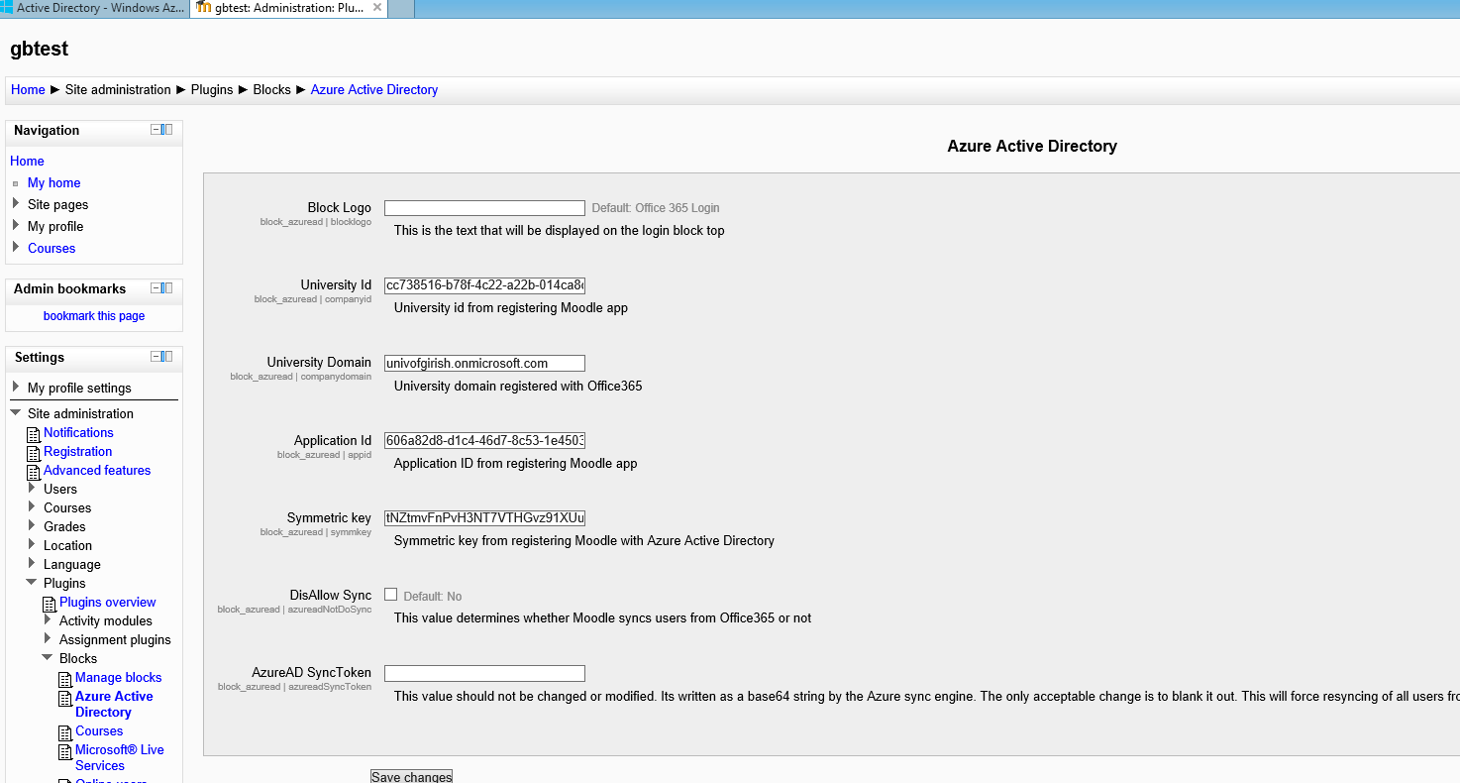

1. Once you have updates the above settings customize your site by placing the Azure AD block onto the home-page. A user with an account in Office 365 for your university will be able to sing-on by clicking the Office 365 sign-in button and logout using the logout button.

## Sync users

By default the Azure-AD plug in will sync users from your Office 365 domain into Moodle i.e. it will create Moodle accounts for all users who are in Office 365. If a user is deleted from your Office365 their account will be automatically deleted from Moodle. If a new user is created in Office 365 they will be automatically created in Moodle.

The syncing activity is performed using the Moodle cron job. If you have not enabled the moodle cron job this synchronization will not take place.

There is a setting “AllowSync” which is checked on by default. If you do not want this behavior turn off this setting.

## User Logon and demand create

When a new Office 365 user from your university domain logs into Moodle they will be authenticated by Office. If they already have an account in Moodle they will be logged into Moodle. However if they do not have an existing Moodle account the account can be created on demand. This behavior is governed by the “Prevent Account Creation During Login” setting in the “Manage Authentication” tab. If you want to disallow this creation uncheck this box.