
REDBUZZ – QA Engineer (AI Native)

Candidate Assessment
Candidate Name: Muhamad Badruni

September 18, 2026

Source-based compilation; no additional application or API execution was performed during document assembly.



TASK 1 – AI-Assisted Requirement Analysis & Test Design

1A. Requirement Analysis
# TASK 1A – Requirement Analysis
Feature: Wallet Top-Up (Web Application)
Objective: Identify ambiguities and missing requirements before testing, focusing on payment reliability, financial accuracy, transaction consistency, and user experience.

1. Ambiguities and Missing Requirements
The following questions should be clarified with the Product Manager, developers, and payment provider before testing.

A. Top-Up Amount and Transaction Limits
1. What is the exact minimum top-up amount in IDR?
2. What is the maximum amount allowed per transaction?
3. What is the maximum daily top-up limit?
4. Is the daily limit calculated based on successful transactions only, or does it also include pending and failed transactions?
5. When does the daily limit reset, and which timezone is used?
6. What happens if a user enters zero, a negative amount, a decimal, non-numeric characters, or an amount exceeding the limit?
7. What happens when a top-up would exceed the remaining daily limit?

B. Payment Methods and Redirect
1. Are Virtual Account, e-wallet partner, and credit card available to all users?
2. Are there different transaction limits, fees, or processing times for each payment method?
3. What happens if the payment provider is unavailable before the redirect?
4. What happens if the redirect fails or the user closes the browser during payment?
5. How does the application determine whether a payment has succeeded, failed, or is still processing?
6. What happens if the user completes payment but never returns to the application?

C. Payment Failure, Slow Response, and Timeout
1. What is the maximum response time before a payment request is considered timed out?
2. What happens if the payment provider responds slowly but eventually processes the payment successfully?
3. What happens if the payment provider returns an error?
4. What happens if the payment provider successfully deducts the user's money but the application does not receive the success response?
5. Does a timeout indicate a failed payment or an unknown payment status?
6. Does the application automatically check the payment status with the provider after a timeout?
7. Can users retry a payment while the previous transaction is still pending or has an unknown status?
8. If money has been deducted but the wallet is not credited, will the system automatically reconcile the transaction or initiate a refund?
9. What is the expected resolution time for payment discrepancies?
Expected clarification: A timeout must not automatically be treated as a failed payment because the provider may have already processed the transaction.

D. Duplicate Payment and Double Charging
1. What happens if a user double-clicks the Pay button?
2. Is the Pay button disabled after the first click until the request is processed?
3. How does the backend prevent duplicate payment requests if two requests arrive almost simultaneously?
4. Does each top-up attempt have a unique transaction ID?
5. Is an idempotency key used to ensure repeated requests for the same payment attempt cannot create duplicate charges?
6. What happens if the same payment callback is received multiple times?
7. Can the same successful provider transaction increase the wallet balance more than once?
8. How are duplicate transactions detected and handled?
Expected clarification: Duplicate prevention must be enforced by the backend, not only by disabling the Pay button.

E. Wallet Balance Consistency
1. When exactly should the wallet balance increase: after the provider confirms payment, after the redirect, or after receiving a verified callback?
2. Can the wallet balance increase while the payment status is still pending?
3. What happens if payment succeeds but updating the wallet balance fails?
4. What happens if the wallet balance is updated successfully but creating the transaction record fails?
5. How does the system prevent the same successful payment from crediting the wallet multiple times?
6. How are concurrent top-up transactions handled?
7. Is there a reconciliation process to detect differences between payment records and wallet balances?
8. What is the expected behavior when a successful payment is reversed or refunded?

F. Transaction Records and History
1. When is a transaction record created: when the user clicks Pay or only after payment succeeds?
2. Are failed, pending, timed-out, and refunded transactions recorded?
3. What information must each record contain (transaction ID, amount, payment method, status, timestamp, fees, and provider reference)?
4. Should the transaction record be created even if payment succeeds but the wallet balance update fails?
5. How is the transaction status updated after a delayed provider response?
6. How does the system ensure that transaction history and wallet balance remain consistent?
7. Does `/transactions` display all transaction statuses or only successful transactions?
8. Is the history sorted by transaction creation time or last update time?
9. What timezone and timestamp format should be displayed?
10. What happens if transaction history cannot be loaded?

G. User-Facing Payment Status and Error Messages
1. What payment statuses should be displayed to users (Pending, Processing, Success, Failed, Timeout/Unknown, Refunded)?
2. What message should appear when payment succeeds?
3. What message should appear when payment fails?
4. What message should appear when the provider is slow or times out?
5. How can users determine whether their money has been deducted?
6. Should users see a pending status while the application verifies an uncertain payment?
7. Is there a payment status refresh mechanism?
8. What instructions should users receive if money has been deducted but their wallet balance has not increased?
9. Should users receive notifications when a pending transaction is resolved?
10. How can users contact support and provide a transaction reference?
Expected clarification: Users should receive clear payment status information and must not be instructed to retry an uncertain payment without duplicate-payment protection.

2. Top 3 Risks Based on User and Business Impact
1. Risk 1
Critical

Duplicate Charging or Duplicate Wallet Credit
Scenario: A user double-clicks Pay, retries after a timeout, or the provider sends duplicate callbacks. The system processes the same payment attempt more than once.
User impact: Users may be charged multiple times for one intended top-up, causing financial loss and loss of trust.
Business impact: Refund costs, increased support tickets, payment disputes, and potential financial losses from duplicate wallet credits.
Required mitigation: Backend idempotency, unique transaction references, duplicate callback handling, and prevention of repeated wallet credits.
2. Risk 2
Critical

Payment Succeeds but Wallet Balance Is Incorrect
Scenario: The payment provider successfully deducts the user's money, but a callback failure, timeout, or internal processing error prevents the wallet balance from increasing.
User impact: Users lose access to money they have already paid and cannot use their purchased wallet balance.
Business impact: Financial reconciliation discrepancies, manual investigations, compensation costs, and reduced customer trust.
Required mitigation: Reliable payment confirmation, exactly-once wallet crediting, consistent transaction recording, and automatic reconciliation for incomplete transactions.
3. Risk 3
High

Unclear Payment Status and Inconsistent Transaction History
Scenario: A payment provider is slow or times out. The application displays Failed even though the payment is still processing or has succeeded. The transaction history is missing or displays an incorrect status.
User impact: Users cannot determine whether their money was deducted and may retry unnecessarily, potentially creating additional payments.
Business impact: Increased support tickets, payment disputes, operational overhead, and customer dissatisfaction.
Required mitigation: Clearly defined payment statuses, a mechanism to verify uncertain payments, accurate transaction history, and user-friendly status messages.

3. QA Priority Before Launch
Given that the launch is next week and there is no formal specification, I would prioritize clarifying and testing the three financial-critical flows first:
1. Duplicate payment prevention: Verify that double-clicks, concurrent requests, retries, and duplicate callbacks do not result in unintended duplicate charges or wallet credits.
2. Payment and wallet consistency: Verify that each confirmed successful payment credits the correct amount exactly once and produces an accurate transaction record.
3. Timeout and payment status handling: Verify that slow responses, timeouts, and missing callbacks do not incorrectly mark successful payments as failed and that users receive accurate information.
The remaining requirements, including amount validation, transaction limits, payment-method behavior, and transaction history sorting, should be clarified and covered based on their impact and available testing time.
QA conclusion: The most important requirement to confirm before launch is how the system maintains consistency between the payment provider, wallet balance, and transaction history, especially when payments are duplicated, delayed, or interrupted. These behaviors must be explicitly defined rather than assumed during testing.

1B. AI-Assisted Test Case Generation
15 curated test cases. P0 and P1 priorities and proposed expected behaviors are retained from the source. Numeric limits, timeout policy and other undefined rules require PM confirmation. TC-015* is the marked QA-added edge case.
ID | Title | Precondition | Steps | Test Data | Expected Result | Priority
TC-001 | Successful wallet top-up | Logged in; provider available | Open Top-Up; enter valid amount; select VA; pay; check wallet/history | IDR 100,000; VA | Success; balance +100,000 exactly; one successful transaction. | P0
TC-002 | Minimum top-up boundary | Minimum MIN configured | Submit MIN-1; then submit MIN | MIN-1; MIN | Below MIN rejected; exact MIN accepted. | P1
TC-003 | Maximum top-up boundary | MAX configured; daily allowance sufficient | Submit MAX; then MAX+1 | MAX; MAX+1 | Exact MAX accepted; MAX+1 rejected. | P1
TC-004 | Invalid amount validation | Logged in | Enter each invalid amount; click Pay | Blank; 0; -1000; abc; 10.5 | Invalid amounts rejected; no payment initiated. Decimal policy pending confirmation. | P1
TC-005 | Daily limit boundary | Daily limit and usage configured | Submit remaining allowance; then exceed it | Limit 1M; used 900K; 100K then 1K | Remaining allowance accepted; exceeding daily limit rejected before payment. Illustrative values. | P0
TC-006 | All supported payment methods | VA, e-wallet and card enabled | Repeat valid top-up using each method; verify wallet/history | VA; e-wallet; credit card | Each method completes successfully and credits wallet exactly once. | P0
TC-007 | Provider payment rejection | Provider decline can be simulated | Submit valid payment; simulate decline; inspect wallet/status | Provider declined | No wallet credit; clear failure message; accurate failed record if supported. | P0
TC-008 | Provider timeout / unknown status | Timeout simulator available | Pay; simulate no response; inspect UI and wallet; reconcile | Provider timeout | Do not falsely report success/failure; show uncertain status; reconcile without duplicate credit. Proposed behavior. | P0
TC-009 | Rapid double-click Pay | Valid amount/method | Double-click Pay rapidly; inspect requests/charges/records | Two rapid clicks | One logical payment; at most one charge, wallet credit and transaction. | P0
TC-010 | Retry after lost success response | Provider charged but response lost | Pay; simulate provider success plus timeout; retry; deliver delayed callback | Success at provider; timeout in app | Retry must not unknowingly duplicate charge; original payment reconciled; wallet credited once. | P0
TC-011 | Duplicate provider callback | One payment completed | Deliver success callback twice; inspect wallet and history | Same provider payment reference | Callback idempotent; exactly one wallet credit and one logical transaction. | P0
TC-012 | Payment succeeds, wallet credit fails | Provider success and wallet DB failure simulatable | Pay; fail wallet update; inspect status; run recovery twice | Provider success; wallet update error | Payment retained for recovery; no false completion; eventual credit exactly once. SLA TBD. | P0
TC-013 | History accuracy and newest-first | Multiple transactions available | Complete two payments; open /transactions; inspect amounts/status/order | 50K then 100K | Accurate records; newest transaction appears first. | P1
TC-014 | Refresh/back during pending payment | Payment initiated and pending | Refresh or Back; return to Top-Up; inspect original transaction | Pending payment | No duplicate charge/credit; original status recoverable. | P0
TC-015* | Concurrent requests bypass daily limit | Remaining limit 100K; same user in two sessions | Submit two 100K top-ups concurrently; inspect charges, accepted requests, wallet | Two simultaneous 100K requests | Atomic limit enforcement: total accepted <=100K; rejected request must not charge. Proposed behavior. | P0

AI Output Review and Manual Curation
3. AI Output Review and ImprovementsI reviewed the AI-generated output and made the following improvements:
- Consolidated repetitive validation scenarios to keep the final test set within 15 test cases.
- Prioritized critical financial scenarios, including double charging, payment timeout, duplicate callbacks, and wallet balance consistency.
- Refined expected results to verify payment charges, wallet credits, and transaction records rather than relying only on UI messages.
- Identified undefined business rules as assumptions requiring PM confirmation.
- Added TC-015* to cover concurrent top-up requests that could bypass the daily limit due to a race condition.
These improvements were made to ensure the final test cases are risk-based, practical, and focused on scenarios that should be tested before launch.

1C. Reviewing AI Output

Section A – Review of Existing Test Cases
ID | Problem Identified | Why It Is a Problem | Recommended Fix
TC-01 | Incomplete steps; vague expected result; no method, provider outcome, balance or history checks. | Cannot reproduce or determine pass/fail; redirect and financial side effects are omitted. | Specify starting balance, amount and method; submit, complete provider payment, verify one successful record and balance increases exactly once by paid amount.
TC-02 | Invented Rp 5,000 minimum; missing amount entry and validation steps. | Minimum is undefined; rejection and error wording are unsupported. | Ask PM to define minimum and message; then test below/at minimum using approved values and verify rejection does not initiate payment or change balance.
TC-03 | Invented Rp 10,000,000 daily limit and warning; lacks cumulative transactions and reset rules. | Limit, counting scope, timezone and boundary behavior are unspecified. | Clarify daily cap, included statuses and reset timezone; test just below/at/above cumulative cap; verify provider is not charged when blocked.
TC-04 | Overlaps TC-01; only balance checked; no payment confirmation, exact delta or transaction record. | An incorrect or duplicate credit could pass; other payment methods are untested. | Keep as VA-specific case: verify provider success, exact single credit, one linked transaction and correct status; parameterize method coverage.
TC-05 | Subjective “looks good/user friendly”; no criteria or steps; unjustified High priority. | No objective pass/fail; distracts from financial integrity. | Replace with measurable UI checks against approved design/accessibility criteria; assign priority based on impact, not blanket High.
TC-06 | Assumes refresh is allowed and an error is correct; does not assert no duplicate charge. | Conflicts with required double-charge prevention; refresh must not imply failure or duplicate processing. | Double-click Pay and refresh during pending flow; verify at most one provider charge, one credit and one transaction; status/recovery per clarified design.
TC-07 | Duplicate of TC-02 with conflicting invented Rp 10,000 minimum. | Contradictory assumptions make expected behavior unreliable. | Merge into one data-driven boundary suite after PM confirms minimum; test below, equal and above.
TC-08 | Expected oldest-first contradicts explicit newest-first requirement; “pass” is not observable. | Would approve incorrect ordering. | Create records with distinct timestamps; open /transactions; verify descending creation time and agreed tie-breaker.
TC-09 | Cross-country scenario not specified; no steps, expected result or supported priority. | Invents scope without policy, currency or geography rules. | Clarify geographic eligibility first; remove/defer unless supported; if supported test documented country restrictions and IDR behavior.
TC-10 | Assumes Rp 1,000,000,000 must succeed; undefined maximum and daily caps. | Could authorize an unsafe transaction or violate an eventual limit. | Clarify maximum per transaction and daily cap; test just below/at/above approved limits; only expect credit after confirmed success.
ALL | Every case marked High; no preconditions/test data; most omit method, steps, assertions and traceability. | Cannot execute consistently, prioritize by risk or distinguish requirements from assumptions. | Use ID, requirement reference, preconditions, steps, data, expected result and risk-based priority; label unresolved rules “PM clarification required”.

Section B – Missing Test Coverage
Missing Scenario | Risk | Recommended Test | Priority
Provider success → financial reconciliation | Money credited incorrectly, duplicated or no audit trail. | For each supported method, confirm provider success; verify balance delta equals amount exactly once and one correctly linked transaction. | P0 – launch blocker
Double-click / concurrent requests / idempotency | Duplicate debit or wallet credit. | Submit simultaneous Pay requests and repeat same payment reference; assert at most one charge, one credit and one logical transaction; clarify idempotency key contract. | P0 – launch blocker
Provider timeout / lost callback after charge | User pays but balance/status unclear; unsafe retry. | Simulate charge succeeded but response/callback lost; verify pending/unknown handling, reconciliation, eventual correct single credit and no false failure claim. | P0 – launch blocker
Retry while pending / refresh / back navigation | Second charge or inconsistent state. | Retry and refresh during unresolved payment; verify no duplicate charge/credit and consistent recovery; confirm retry policy with PM. | P0 – launch blocker
Provider explicit failure / cancellation | Failed payment credited or false success. | Simulate documented failure/cancel; verify no credit, accurate status and record behavior per clarified specification. | P0 – launch blocker
Callback replay / duplicate and out-of-order events | Multiple credits or incorrect final status. | Replay success callbacks and deliver delayed failure after success; verify idempotent final state and one credit. | P0 – launch blocker
Balance/history consistency and atomicity | Ledger mismatch or missing transaction. | Simulate persistence failure between credit and record creation; verify atomic update or recoverable reconciliation, never an unexplained mismatch. | P0 – launch blocker
Pending payment status and user messaging | User cannot tell whether money was deducted. | Check provider-slow state, /transactions and post-refresh status; verify unambiguous pending guidance without asserting timeout = failure; clarify wording. | P0 – launch blocker
E-wallet and credit-card happy paths | Supported payment methods may fail untested. | Run confirmed-success flow for each method, including redirect/return and exact balance/history checks. | P0 – launch blocker
Invalid amount and IDR input | Incorrect amounts or bypassed validation. | Test blank, zero, negative, nonnumeric, decimal/precision and malformed input against confirmed input rules; verify no unauthorized charge. | P1 – high
Minimum / per-transaction maximum / daily boundary | Limit bypass or valid payments rejected. | Obtain approved thresholds, timezone and counting rules; test below/equal/above and cumulative daily cases. | P1 – high; clarification prerequisite
Transaction history newest-first and details | Users cannot reconcile payment. | Create transactions with distinct times and statuses; assert newest-first, amount, method, reference and status against approved fields. | P1 – high
Provider slow / delayed confirmation | Premature failure, duplicate attempts or indefinite spinner. | Delay provider response; verify loading, pending transition and eventual state using documented timeout/reconciliation SLA. | P1 – high; SLA clarification
Unauthenticated access / other user transactions | Unauthorized wallet use or data exposure. | Attempt top-up and /transactions without session and with another account; verify access control and isolation. | P1 – high
UI usability and geographic eligibility | Potential UX or regional policy issue, scope unknown. | Test only against approved measurable UX criteria and documented country eligibility; otherwise defer pending clarification. | P2 – conditional

Section C – Summary of Critical Findings
Topic | Finding / Recommended Action
Confirmed requirements | IDR amount; VA/e-wallet/credit card; provider payment; successful payment credits wallet and creates record; prevent double charging; provider can be slow/fail; history newest first.
Unresolved requirements | Minimum, transaction maximum, daily limit, boundary inclusivity, reset timezone, retry rules, timeout SLA, payment/record status model, message wording and regional eligibility require PM/engineering confirmation.
Most severe AI defects | Fabricated contradictory limits (TC-02/03/07/10); reversed sorting (TC-08); wrong double-click oracle (TC-06); vague assertions and blanket High priorities.
Launch decision gate | Resolve financial-integrity P0 tests and blocking specification questions; verify provider charge, wallet balance and transaction record reconcile across success, failure, timeout and retries.
Review method | Treat generated cases as draft suggestions, trace each to approved requirements, replace subjective oracles with measurable checks and prioritize by financial/user impact.
Scope note | This is a review of supplied test cases only; no application or API execution is claimed.

TASK 2 – Exploratory Testing & Bug Reporting

Exploratory Testing Summary
Executed checks | 18 | BUG-002 (High) | Non-obvious: Backpack link opens Fleece Jacket details for problem_user.
Passed checks | 14 | BUG-003 (High) | Last Name input overwrites First Name and prevents checkout.
Confirmed defects | 3 | BUG-001 (Medium) | All six product thumbnails use the same broken placeholder.
Unverified checks | 1
Standard flow | Login, listing, four sort modes, product details, cart add/remove, same-user cart persistence, checkout validation, order completion, and browser Back/Forward were executed successfully.
Special accounts | locked_out_user denial was verified. problem_user produced three reproducible defects. Other special accounts were not fully executed.
Console | No application-origin console errors were captured. Browser-extension errors were excluded from defect claims.
Network | Not accessible in this execution environment; explicitly marked unverified.

Executed Exploratory Checks

LOG-01 – Login functionality [PASS]
Account: standard_user
Result: PASS
Exact steps: 1. Open https://www.saucedemo.com
2. Enter standard_user / secret_sauce
3. Click Login
Expected result: User is authenticated and inventory page is displayed.
Actual result: Inventory page opened at /inventory.html and six products were visible.
Evidence: Observed URL: https://www.saucedemo.com/inventory.html
Execution status: Executed

LOG-02 – Special user account [PASS]
Account: locked_out_user
Result: PASS
Exact steps: 1. Open login page
2. Enter locked_out_user / secret_sauce
3. Click Login
Expected result: Locked-out account is denied access with a clear message.
Actual result: Login was blocked with: Epic sadface: Sorry, this user has been locked out.
Evidence: Visible alert text on login page
Execution status: Executed

PL-01 – Product listing [PASS]
Account: standard_user
Result: PASS
Exact steps: 1. Login as standard_user
2. Observe inventory list
Expected result: All available products display with name, price, and image.
Actual result: Six products displayed with distinct names, prices, and image source paths.
Evidence: DOM evidence: 6 inventory_item elements
Execution status: Executed

SORT-01 – Product sorting [PASS]
Account: standard_user
Result: PASS
Exact steps: 1. On inventory, select Name (Z to A)
Expected result: Product names are ordered descending alphabetically.
Actual result: Order: Test.allTheThings() T-Shirt (Red), Onesie, Fleece Jacket, Bolt T-Shirt, Bike Light, Backpack.
Evidence: Selected value za; captured rendered product names
Execution status: Executed

SORT-02 – Product sorting [PASS]
Account: standard_user
Result: PASS
Exact steps: 1. On inventory, select Price (low to high)
Expected result: Prices are ordered ascending.
Actual result: $7.99, $9.99, $15.99, $15.99, $29.99, $49.99.
Evidence: Selected value lohi; captured rendered prices
Execution status: Executed

SORT-03 – Product sorting [PASS]
Account: standard_user
Result: PASS
Exact steps: 1. On inventory, select Price (high to low)
Expected result: Prices are ordered descending.
Actual result: $49.99, $29.99, $15.99, $15.99, $9.99, $7.99.
Evidence: Selected value hilo; captured rendered prices
Execution status: Executed

PDP-01 – Product detail [PASS]
Account: standard_user
Result: PASS
Exact steps: 1. Click Sauce Labs Backpack
2. Compare list and detail name/price
Expected result: Selected product detail matches its list card.
Actual result: Detail showed Sauce Labs Backpack at $29.99; URL contained id=4.
Evidence: URL and rendered detail name/price
Execution status: Executed

CART-01 – Add item to cart [PASS]
Account: standard_user
Result: PASS
Exact steps: 1. Add Sauce Labs Backpack
2. Open cart
Expected result: Cart badge increments and selected item appears.
Actual result: Badge displayed 1 and cart contained Sauce Labs Backpack.
Evidence: Cart badge and cart line item text
Execution status: Executed

CART-02 – Remove item from cart [PASS]
Account: standard_user
Result: PASS
Exact steps: 1. In cart, click Remove for Backpack
Expected result: Item is removed and empty-cart badge is absent.
Actual result: Cart contained 0 cart_item elements and badge was absent.
Evidence: Rendered cart item and badge counts
Execution status: Executed

PERSIST-01 – Cart persistence [PASS]
Account: standard_user
Result: PASS
Exact steps: 1. Add Sauce Labs Bike Light
2. Logout
3. Login again as standard_user
4. Open cart
Expected result: Cart state persists for the same user across logout/login.
Actual result: Badge remained 1 and Bike Light remained in cart.
Evidence: Post-login badge and cart contents
Execution status: Executed

CHK-01 – Checkout validation [PASS]
Account: standard_user
Result: PASS
Exact steps: 1. Start checkout
2. Leave all information blank
3. Click Continue
Expected result: Required-field validation identifies the first missing field.
Actual result: Error: First Name is required.
Evidence: Visible checkout error
Execution status: Executed

CHK-02 – Checkout validation [PASS]
Account: standard_user
Result: PASS
Exact steps: 1. Enter first name only
2. Click Continue
Expected result: Required-field validation identifies missing last name.
Actual result: Error: Last Name is required.
Evidence: Visible checkout error
Execution status: Executed

CHK-03 – Order completion [PASS]
Account: standard_user
Result: PASS
Exact steps: 1. Enter Muhamad / Badruni / 15111
2. Continue
3. Review overview
4. Click Finish
Expected result: Overview is shown and order completes once.
Actual result: Overview displayed Total: $10.79; completion page displayed Thank you for your order!
Evidence: URLs /checkout-step-two.html and /checkout-complete.html; confirmation header
Execution status: Executed

NAV-01 – Browser navigation [PASS]
Account: standard_user
Result: PASS
Exact steps: 1. Complete order
2. Browser Back
3. Browser Forward
Expected result: Back returns to prior checkout view; Forward returns to completion without broken state.
Actual result: Back returned to checkout-step-two with Finish visible; Forward returned to checkout-complete.
Evidence: Observed URLs and visible Finish button
Execution status: Executed

BUG-001 – Product listing [CONFIRMED DEFECT]
Account: problem_user
Result: CONFIRMED DEFECT
Exact steps: 1. Login as problem_user
2. Observe all six product thumbnails
Expected result: Each product displays its corresponding image.
Actual result: All six products used the same broken placeholder asset /assets/sl-404-Cq1a9k9X.jpg.
Evidence: Six DOM img src values; unique image count = 1
Execution status: Executed

BUG-002 – Product detail [CONFIRMED DEFECT]
Account: problem_user
Result: CONFIRMED DEFECT
Exact steps: 1. Login as problem_user
2. Click the visible Sauce Labs Backpack name
Expected result: Backpack detail opens with id=4, Backpack name, $29.99, and matching image.
Actual result: Browser opened id=5 and displayed Sauce Labs Fleece Jacket at $49.99.
Evidence: Result URL /inventory-item.html?id=5; rendered name and price
Execution status: Executed

BUG-003 – Checkout validation [CONFIRMED DEFECT]
Account: problem_user
Result: CONFIRMED DEFECT
Exact steps: 1. Add an item and open checkout
2. Fill First Name=Muhamad
3. Fill Last Name=Badruni
4. Fill Postal Code=15111
5. Click Continue
Expected result: Each value stays in its own field and checkout advances.
Actual result: Typing Badruni in Last Name overwrote First Name; Last Name remained blank. Continue showed Error: Last Name is required.
Evidence: Before Continue: first=Badruni, last=blank, postal=15111; URL stayed checkout-step-one
Execution status: Executed

CONSOLE-01 – Console errors [OBSERVATION]
Account: problem_user / standard_user
Result: OBSERVATION
Exact steps: 1. Execute tested flows
2. Read captured console warnings/errors
Expected result: No application-origin errors occur during tested flows.
Actual result: No saucedemo.com-origin errors were captured. Repeated errors came only from a browser extension content script.
Evidence: Console source: chrome-extension://.../content-script.bundle.js
Execution status: Executed; not classified as app defect

NETWORK-01 – Network errors [UNVERIFIED]
Account: All
Result: UNVERIFIED
Exact steps: Network panel/request log was not exposed by the available browser interface.
Expected result: Requests can be reviewed for failed status codes, timeouts, or unexpected retries.
Actual result: Not executed; no claim made.
Evidence: Limitation recorded explicitly
Execution status: Not executed

Confirmed Bug Reports

BUG-001 – All product thumbnails show the same broken placeholder for problem_user
Status: Confirmed
Severity: Medium
Priority: P2
Module / Account: Product listing / problem_user
Environment: Chrome cloud browser; exact version unavailable; saucedemo.com; 2026-09-18 UTC
Preconditions: User can login as problem_user.
Steps to Reproduce: 1. Open SauceDemo.
2. Login with problem_user / secret_sauce.
3. Observe the six product cards.
Expected Result: Each product card displays an image matching its product.
Actual Result: Every product card displays the same placeholder asset: /assets/sl-404-Cq1a9k9X.jpg.
Evidence: All six img src values were identical; unique image count = 1.
Impact: Misleading product presentation and reduced ability to identify products visually.
Recommendation: Use the product-specific image mapping for each inventory item; add UI/data-contract coverage for image URL uniqueness and product ID mapping.

BUG-002 – Clicking Sauce Labs Backpack opens Sauce Labs Fleece Jacket details for problem_user
Status: Confirmed
Severity: High
Priority: P1
Module / Account: Product navigation / problem_user
Environment: Chrome cloud browser; exact version unavailable; saucedemo.com; 2026-09-18 UTC
Preconditions: User is logged in as problem_user and is on the inventory page.
Steps to Reproduce: 1. Locate Sauce Labs Backpack.
2. Click the visible product name.
3. Observe URL, product name, and price.
Expected Result: Backpack detail opens at id=4 with name Sauce Labs Backpack and price $29.99.
Actual Result: Detail opened at id=5 and showed Sauce Labs Fleece Jacket priced $49.99.
Evidence: Clicked Backpack text; result URL https://www.saucedemo.com/inventory-item.html?id=5; rendered name Sauce Labs Fleece Jacket.
Impact: User may review or purchase a different product than selected. This is the non-obvious finding selected for assessment.
Recommendation: Correct the product link-to-ID mapping and add navigation tests asserting selected list item ID equals detail page ID.

BUG-003 – Last Name input overwrites First Name and blocks checkout for problem_user
Status: Confirmed
Severity: High
Priority: P1
Module / Account: Checkout information / problem_user
Environment: Chrome cloud browser; exact version unavailable; saucedemo.com; 2026-09-18 UTC
Preconditions: problem_user has at least one item in cart and is on checkout-step-one.
Steps to Reproduce: 1. Enter First Name: Muhamad.
2. Enter Last Name: Badruni.
3. Enter Postal Code: 15111.
4. Click Continue.
Expected Result: Values remain in their own fields and user advances to checkout overview.
Actual Result: After entering Last Name, First Name became Badruni and Last Name stayed blank. Continue returned Error: Last Name is required.
Evidence: Captured field values before Continue: first=Badruni, last=blank, postal=15111; URL remained /checkout-step-one.html.
Impact: Affected user cannot complete checkout, causing direct conversion loss.
Recommendation: Fix the Last Name input binding/selector and add field-isolation plus end-to-end checkout tests for special accounts.

Observations and Evidence Limitations
Observation ID | Classification | Area | Observation | Why it is not a confirmed defect | Recommended follow-up
OBS-01 | Confirmed | Console | No SauceDemo-origin console errors were captured during the executed flows. | Only chrome-extension content-script errors appeared; these are environment noise and were not logged as product defects. | Do not file against SauceDemo without reproduction in a clean browser and app-origin stack trace.
OBS-02 | Unverified | Network | Request-level Network inspection was not accessible in the available browser surface. | HTTP failures, duplicate requests, caching behavior, and timing were not independently verified. | Re-run manually with DevTools Network: Preserve log, Disable cache, and filter Fetch/XHR/Doc.
OBS-03 | Unverified | Other special accounts | performance_glitch_user, error_user, and visual_user were not fully exercised in this run. | No defect claims are made for those accounts. | Treat as follow-up scope if assessment time permits.
OBS-04 | Observed, not classified | Browser navigation | Back from order completion returned to checkout overview with Finish visible. | No duplicate order record or financial side effect could be verified, so this was not classified as a defect. | Clarify expected post-completion navigation/idempotency behavior before filing.

TASK 3 – API Testing + Database + DevTools

3A. API Testing with Postman
Postman Runner screenshots show one iteration, 21 passed assertions, zero failed, zero skipped, and zero runner errors. The JSON export reports 11 request-level PASS outcomes but does not contain individual assertion names/results or response bodies. Screenshots support the assertion count and named checks; they do not independently establish API contract compliance for undocumented negative statuses.
# | Endpoint & method | Auth? | Body (summary) | Expected status | Actual status | Pass/Fail
1 | POST https://restful-booker.herokuapp.com/auth | No | Official username/password (password omitted from report) | 200 | 200 | PASS
2 | GET https://restful-booker.herokuapp.com/booking | No | None | 200 | 200 | PASS
3 | GET https://restful-booker.herokuapp.com/booking/2 | No | None | 200 | 200 | PASS
4 | POST https://restful-booker.herokuapp.com/booking | No | Distinctive REDBUZZ booking; IDR 315000; 2026-10-10 to 2026-10-12 | 200 | 200 | PASS
5 | GET https://restful-booker.herokuapp.com/booking/2797 | No | None | 200 | 200 | PASS
6 | PUT https://restful-booker.herokuapp.com/booking/2797 | Cookie token required | Full update; IDR 425000; 2026-11-15 to 2026-11-18 | 200 | 200 | PASS
7 | GET https://restful-booker.herokuapp.com/booking/2797 | No | None | 200 | 200 | PASS
8 | DELETE https://restful-booker.herokuapp.com/booking/2797 | Cookie token required | None | 201 | 201 | PASS
9 | GET https://restful-booker.herokuapp.com/booking/2797 | No | None | 404 | 404 | PASS
10 | POST https://restful-booker.herokuapp.com/booking | No | Only firstname; other documented fields omitted | UNDOCUMENTED - capture actual for investigation | 500 | PASS
11 | PUT https://restful-booker.herokuapp.com/booking/2797 | Intentionally omitted | PUT against already-deleted run booking; no token | UNDOCUMENTED - capture actual for investigation | 403 | PASS

CRUD Workflow and Negative Test Assessment
1. Authentication token obtained | TC-API-001 POST /auth returned 200 and request-level PASS. | Supported | Token response body and token assertion are not included.
2. Booking list retrieved | TC-API-002 GET /booking returned 200 and PASS. | Supported | Response body and list assertions are not included.
3. Existing booking retrieved | TC-API-003 GET /booking/2 returned 200 and PASS. | Supported | Response body assertions are not included.
4. New booking created | TC-API-004 POST /booking returned 200 and PASS. | Supported | Created response body is not included.
5. Created booking verified | TC-API-005 GET /booking/2797 returned 200 and PASS. | Supported | Field-level comparison assertions are not included.
6. Booking updated | TC-API-006 PUT /booking/2797 returned 200 and PASS with cookie-token auth required. | Supported | Updated response body and assertions are not included.
7. Updated data persisted | TC-API-007 subsequent GET /booking/2797 returned 200 and PASS. | Supported | Persistence field assertions are not included.
8. Booking deleted | TC-API-008 DELETE /booking/2797 returned 201 and PASS with cookie-token auth required. | Supported | Response body is not included.
9. Deletion confirmed | TC-API-009 subsequent GET /booking/2797 returned 404 and PASS. | Supported | Response body is not included.
TC-API-010 | Create booking with only firstname; other documented fields omitted. | Undocumented; actual behavior captured for investigation. | HTTP 500; request-level PASS. | Exploratory check passed; contract conformance cannot be determined. | A malformed client request produced a server error. No documented validation status or response body is present in the export.
TC-API-011 | PUT without authentication against booking 2797 after that booking was deleted. | Undocumented; actual behavior captured for investigation. | HTTP 403; request-level PASS. | Exploratory check passed; authorization behavior is not isolated. | The missing-auth condition is confounded by the deleted target. The export cannot prove whether 403 was caused only by missing authentication.

Developer Observation
Observed behavior: TC-API-010 sent a create request missing documented fields and received HTTP 500.
Expected behavior / gap: The export marks the expected status as undocumented. A client-validation response is not defined in the available evidence.
Potential risk: Returning a server error for invalid client input can obscure validation problems, complicate client handling, and inflate server-error monitoring.
Recommendation: Define the invalid-payload contract and return a consistent 4xx response with a safe validation message. Add automated schema and error-response assertions.

Evidence Limitations
Individual assertion names and results are absent, so HTTP success cannot be independently separated from field-level assertion success.
Response bodies are absent, preventing independent verification of token presence, booking fields, persistence values, and error payloads.
TC-API-011 combines missing authentication with an already-deleted resource, so it does not isolate authorization behavior.
The negative-test expected statuses are explicitly undocumented; their request-level PASS means execution/capture succeeded, not that the API met a defined contract.
Clarification: TC-API-010 (HTTP 500) and TC-API-011 (HTTP 403) are marked PASS because their capture checks passed; expected contract statuses were undocumented. TC-API-011 targets a previously deleted booking, so missing-auth behavior is not isolated.

3B. SQL
Dialect assumption: PostgreSQL. SQL queries were drafted and reviewed, not executed against a database.

3B.1 SQL Aggregation
SELECT
RoomType,
SUM(AmountIDR) AS TotalAmountIDR
FROM Bookings
WHERE Status = 'COMPLETED'
AND CheckIn >= '2026-07-01'
AND CheckIn < '2026-08-01'
GROUP BY RoomType;
Sums AmountIDR by RoomType for completed bookings checking in during July 2026. The half-open range includes July 31 timestamps and excludes August 1.

3B.2 Duplicate Booking Detection
SELECT
GuestName,
CAST(CheckIn AS DATE) AS CheckInDate,
COUNT(*) AS BookingCount
FROM Bookings
GROUP BY GuestName, CAST(CheckIn AS DATE)
HAVING COUNT(*) > 1;
Groups by guest and calendar date rather than full timestamp. No status filter is applied; results indicate potential duplicates, not confirmed defects.

3B.3 QA Database Integrity
First clarify whether CheckOut must be strictly later than CheckIn and whether both fields are mandatory. Prevent invalid data through frontend validation, backend/API validation, and a database CHECK constraint. Test earlier, equal, and valid later checkout values, timestamp boundaries, invalid API requests, and direct database inserts. These controls prevent new invalid rows; a separate audit query detects existing invalid records. Add NOT NULL constraints separately if dates are mandatory.
ALTER TABLE Bookings
ADD CONSTRAINT chk_checkout_after_checkin
CHECK (CheckOut > CheckIn);
PostgreSQL CHECK permits NULL/unknown results; existing invalid rows must be corrected before applying a validated constraint.

3C. DevTools Quick Check
I submitted the login form with both username and password empty while monitoring the Network tab in Chrome DevTools.
The application displayed the error message 'Epic sadface: Username is required,' but no new HTTP request was sent.
This indicates that the empty-field validation is handled on the client side.
However, this does not prove that server-side validation is absent.
Verbal answer: I submitted the login form with both username and password empty while monitoring the Network tab in Chrome DevTools. The application displayed “Epic sadface: Username is required,” but no new HTTP request was sent. This indicates that empty-field validation is handled on the client side for this scenario. However, this does not prove that server-side validation is absent.

AI USAGE DISCLOSURE

Task 1A
ChatGPT assisted in identifying ambiguities, missing requirements, and risks; candidate reviewed and prioritized three risks.

Task 1B
ChatGPT generated test-case drafts; candidate reports refining scenarios and adding TC-015* for concurrent limit bypass. Verify that these curation statements reflect the actual workflow.

Task 1C
ChatGPT assisted in critiquing the supplied unreviewed AI cases and organizing recommended fixes; no application execution is claimed.

Task 2
ChatGPT Work was requested to explore SauceDemo and prepare the workbook. The source workbook reports execution in a cloud browser; no claim of candidate-manual execution is made.

Task 3A
ChatGPT assisted in collection/assertion design and report analysis. User imported and ran the collection in Postman; execution results and screenshots were supplied.

Task 3B
ChatGPT drafted SQL and integrity discussion; no SQL execution is claimed.

Task 3C
User manually submitted the empty login form and monitored Chrome DevTools; ChatGPT assisted with investigation steps, interpretation of the observed Network activity, and wording of the verbal answer. A candidate-approved reconstructed prompt is included in Appendix A and is explicitly not represented as the verbatim historical prompt.

APPENDIX A – AI PROMPTS
The original prompts below are reproduced from uploaded prompt files, except credential strings are redacted. The Task 3A collection-generation prompt has been corrected using the candidate-supplied revised source. The Task 1B workbook contains a shorter alternative prompt; chronology remains unverified. The Task 3C prompt below is a candidate-approved reconstruction, not a verified verbatim historical prompt.

Task 1A – AI_Prompts – Task 1A_Requirement Analysis(1).txt
AI Tool Used:** ChatGPT
1. Task 1A – Requirement Analysis
How AI was used:
I used ChatGPT to identify ambiguous requirements, missing business rules, and potential risks in the Wallet Top-Up feature. I reviewed the AI suggestions and prioritized the top three risks based on their impact on users and the business.
Prompt Used:
Analyze this Wallet Top-Up requirement from a QA perspective. Identify ambiguities and missing requirements that should be clarified before testing, and identify the top 3 risks based on user and business impact. Pay particular attention to payment failure, timeout, duplicate charging, wallet balance consistency, transaction records, and user-facing payment status.

Task 1B – AI_Prompts – Task 1B_AI-Assisted Test Case Generation.txt
AI Tool Used:** ChatGPT
2. Task 1B – AI-Assisted Test Case Generation
How AI was used:
I used ChatGPT to generate test cases covering positive, negative, boundary, and edge scenarios. I reviewed and refined the results to prioritize financial integrity, payment reliability, and critical scenarios before launch.
Prompt Used:
Act as a Senior QA Engineer and help me complete Task 1B: AI-Assisted Test Case Generation for a Wallet Top-Up web application.
Feature requirements:
- Users can enter a top-up amount in IDR.
- Users can select Virtual Account, e-wallet partner, or credit card.
- Users click Pay and are redirected to the payment provider.
- On successful payment, the wallet balance increases and a transaction record is created.
- Minimum top-up amount and maximum transaction/daily limits are not clearly defined.
- The system must prevent double charging when users click Pay twice.
- The payment provider may be slow, fail, or time out.
- Users must be able to understand whether their money was deducted.
- Transaction history is available at /transactions and displays newest records first.
Task:
1. Generate 10–15 test cases covering positive, negative, boundary, and edge scenarios.
2. Use the table columns: ID, Title, Precondition, Steps, Test Data, Expected Result, Priority.
3. Prioritize the cases that should actually be executed before launch next week.
4. Focus on financial risks, including duplicate charges, timeout handling, retry behavior, wallet balance consistency, and transaction records.
5. Include at least one non-obvious edge case that AI might typically miss and mark it with an asterisk (*).
6. Use clear, specific, and verifiable expected results.
7. Do not invent missing business requirements. Clearly identify assumptions that require PM confirmation.
8. Use P0 for critical launch-blocking scenarios and P1 for high-priority scenarios.
Generate the test cases in professional English and make them concise enough for a 14-minute QA skill assessment.
---
3. AI Output Review and Improvements
I reviewed the AI-generated output and made the following improvements:
- Consolidated repetitive validation scenarios to keep the final test set within 15 test cases.
- Prioritized critical financial scenarios, including double charging, payment timeout, duplicate callbacks, and wallet balance consistency.
- Refined expected results to verify payment charges, wallet credits, and transaction records rather than relying only on UI messages.
- Identified undefined business rules as assumptions requiring PM confirmation.
- Added TC-015* to cover concurrent top-up requests that could bypass the daily limit due to a race condition.
These improvements were made to ensure the final test cases are risk-based, practical, and focused on scenarios that should be tested before launch.
---
4. Final Review
I used AI as an assistant to accelerate requirement analysis and test case generation. I reviewed the output using my QA judgment, focusing on financial integrity, user impact, and launch readiness.
All undefined business rules and proposed expected behaviors require confirmation from the PM before being treated as final acceptance criteria.
And then Create as .xlsx File

Task 1C – AI_Prompts – Task 1C_Reviewing AI Output.txt
Act as a Senior QA Engineer and help me complete Task 1C: Reviewing AI Output for a Wallet Top-Up web application.
Context:
A teammate generated 10 test cases entirely using AI without reviewing them. The original requirements state that users can enter an IDR amount, select Virtual Account, e-wallet, or credit card, and complete payment through a provider. On success, the wallet balance increases and a transaction record is created. The payment provider may be slow or fail, double charging must be prevented, and transaction history must display newest records first. Minimum amounts, maximum amounts, and daily limits have not been formally defined.
Task:
Critically review the 10 AI-generated test cases provided below. Identify every problem you can find, including:
1. Hallucinated requirements or unsupported assumptions.
2. Incorrect expected results or contradictions with the original requirements.
3. Duplicate or redundant test cases.
4. Vague, subjective, or non-verifiable expected results.
5. Missing preconditions, test data, and incomplete test steps.
6. Incorrect or unjustified priorities.
7. Missing positive, negative, boundary, and critical edge-case coverage.
8. Missing financial integrity, timeout, retry, idempotency, and transaction consistency scenarios.
For each existing test case (TC-01 to TC-10), explain the specific problem, why it is a problem, and how to fix it.
Then identify missing coverage that should be added before launch, prioritizing user and business impact.
Use this output format:
Section A – Review of Existing Test Cases: ID | Problem Identified | Why It Is a Problem | Recommended Fix.
Section B – Missing Test Coverage: Missing Scenario | Risk | Recommended Test | Priority.
Section C – Summary of Critical Findings: Briefly summarize the most important issues and recommended actions.
Important instructions:
- Do not invent business requirements or numeric limits.
- Clearly distinguish confirmed requirements from assumptions requiring PM clarification.
- Use specific and objectively verifiable expected results.
- Apply risk-based prioritization rather than assigning High priority to every test case.
- Do not assume that timeout means payment failure.
- Focus on critical issues that should be resolved before launch.
- Write the final answer in professional, concise English suitable for an 8-minute QA skill assessment.
AI-generated test cases to review:
TC-01 - Successful top-up. Steps: enter amount, pay. Expected: 'Top-up works correctly.'
TC-02 - Top-up below minimum (Rp 5.000). Expected: error message shown.
TC-03 - Daily limit enforcement (Rp 10.000.000/day). Expected: blocked with warning.
TC-04 - Top-up with valid amount via Virtual Account. Priority: High. Expected: balance increases.
TC-05 - Verify the UI looks good and is user friendly. Priority: High.
TC-06 - User double-clicks Pay; refreshing the page is allowed. Expected: system shows an error.
TC-07 - Top-up below minimum (Rp 10.000). Expected: rejected.
TC-08 - Transaction history sorted oldest first. Expected: pass.
TC-09 - Top-up from a different country. Priority: High.
TC-10 - Very large amount (Rp 1.000.000.000). Expected: balance increases.
All test cases: Priority = High. No preconditions or test data columns.
Create report Task 3A in .xlsx format.

Task 2 – AI_Prompts – Task 2_Exploratory Testing & Bug Reporting.txt
AI Tool Used:** ChatGPT Work
Act as a Senior QA Engineer.
Open [https://www.saucedemo.com](https://www.saucedemo.com) and perform exploratory testing for Task 2 of my QA assessment.
Use the available demo accounts and password: [REDACTED PASSWORD].
Test the following areas:
1. Login functionality and special user accounts.
2. Product listing and sorting.
3. Product detail pages.
4. Add/remove items from cart.
5. Cart persistence after logout and login.
6. Checkout validation and order completion.
7. Browser navigation and application state.
8. Console and Network errors, if accessible.
For every finding, document the exact steps, expected result, actual result, and available evidence.
Do not invent bugs or claim tests were executed if they were not.
Select 2–3 confirmed bugs, including at least one non-obvious finding, and write professional bug reports using the REDBUZZ assessment template.
Clearly distinguish confirmed defects from unverified observations.
And then Create output as .xlsx File @Spreadsheets

Task 3A – Prompt 1: Collection and Environment – corrected candidate-supplied source
Act as a Senior QA Automation Engineer specializing in API testing and Postman.
Help me complete Task 3A – API Testing with Postman for the REDBUZZ QA Engineer (AI Native) assessment.
Target API: https://restful-booker.herokuapp.com
Time limit: 15 minutes.
OBJECTIVE:
Generate a complete, importable Postman Collection v2.1 and Postman Environment that automate the entire assessment workflow.
STEP 1 – API DOCUMENTATION
First, read the official API documentation at the target website.
Verify all endpoints, HTTP methods, authentication requirements, request schemas, and documented response statuses.
Use the credentials published in the official documentation. Do not invent API behavior or expected statuses.
STEP 2 – GENERATE TWO FILES
Create:
1. Restful_Booker_Task3A.postman_collection.json
2. Restful_Booker_Task3A.postman_environment.json
Provide both as downloadable files.
STEP 3 – COLLECTION REQUIREMENTS
Include requests in this exact logical order:
01. POST /auth – Obtain authentication token.
02. GET /booking – List all bookings.
03. GET /booking/{existingId} – Retrieve one existing booking.
04. POST /booking – Create a new booking.
05. GET /booking/{bookingId} – Verify newly created booking.
06. PUT /booking/{bookingId} – Update the booking.
07. GET /booking/{bookingId} – Verify updated data persists.
08. DELETE /booking/{bookingId} – Delete the booking.
09. GET /booking/{bookingId} – Verify deletion.
10. Negative test – Create booking with invalid or missing required fields.
11. Negative test – Update booking without authentication.
STEP 4 – VARIABLES
Use:
baseUrl
token
existingId
bookingId
Automatically:
- Save the token from the authentication response.
- Capture an existing booking ID from the booking list.
- Capture bookingId from the create-booking response.
- Reuse the correct ID in all subsequent requests.
- Clear stale token and booking IDs at the beginning of each run.
- Stop or safely skip dependent destructive requests if prerequisites fail.
STEP 5 – REQUEST DATA
Use valid booking data that complies with the documented API schema.
Use distinctive test data to identify the booking created during this run.
Use different values for the PUT update so persistence can be verified.
Ensure negative tests cannot accidentally modify or delete the main test booking.
STEP 6 – AUTOMATED ASSERTIONS
Add Postman post-response scripts that verify:
- Expected HTTP status codes.
- Authentication token exists.
- Booking list is valid.
- Booking detail matches the requested ID where supported by the response.
- Booking creation returns a valid booking ID.
- Created booking data matches submitted data.
- PUT changes are persisted after GET.
- Deleted booking cannot be retrieved afterward.
- Negative tests return the documented error response.
Use pm.test() and pm.expect().
For undocumented behavior, record the actual result and flag it for investigation rather than inventing an expected status.
STEP 7 – REPORTING
Each request must have a descriptive name and a unique test ID.
Add scripts that capture:
- Test ID
- HTTP method
- Endpoint
- Authentication requirement
- Request body summary
- Expected status
- Actual status
- Pass/Fail
Ensure the results can be retrieved from a Collection Runner export or Newman JSON report.
Do not store sensitive tokens in report output.
STEP 8 – QUALITY CHECK
Before delivering the files:
- Validate that both JSON files are syntactically correct.
- Confirm Postman Collection schema v2.1.
- Verify variable references and request ordering.
- Ensure scripts use supported Postman sandbox APIs.
- Avoid deprecated Postman APIs.
- Do not claim that API requests were executed unless they actually were.
DELIVERABLES:
1. Downloadable Postman Collection JSON.
2. Downloadable Postman Environment JSON.
3. Short import and execution instructions.
4. List of expected request sequence and documented statuses.
Write explanations in Indonesian, but use English for request names, test scripts, and assessment-related content.

Task 3A – Report – AI_Prompts – Task 3A_API Report.txt
Act as a Senior QA Engineer and analyze the attached Postman Collection Runner execution results for Task 3A of the REDBUZZ QA Engineer (AI Native) assessment.
Target API: https://restful-booker.herokuapp.com
I have attached the actual execution results from Postman.
IMPORTANT:
Use only the attached execution data as evidence.
Do not invent HTTP statuses, response bodies, Pass/Fail results, or observations.
TASK 1 – ANALYZE EXECUTION RESULTS
Extract every executed request and identify:
- Request ID
- HTTP method
- Endpoint
- Authentication requirement
- Request body summary
- Expected HTTP status
- Actual HTTP status
- Assertion results
- Overall Pass/Fail
Distinguish HTTP success from assertion success.
If any required information is missing from the export, mark it as Not Available rather than guessing.
TASK 2 – VERIFY CRUD WORKFLOW
Confirm whether the evidence demonstrates:
1. Authentication token was obtained.
2. Booking list was retrieved.
3. Existing booking details were retrieved.
4. A new booking was created.
5. The newly created booking was verified.
6. The booking was updated.
7. Updated data persisted after a subsequent GET.
8. The booking was deleted.
9. A subsequent GET confirmed deletion.
Do not claim a step passed without execution evidence.
TASK 3 – NEGATIVE TESTS
Analyze at least two negative tests.
For each negative test:
- Identify the invalid condition.
- Compare expected behavior with actual response.
- Determine whether it passed or failed.
- Explain any contract mismatch.
TASK 4 – EXECUTION REPORT
Create the exact assessment table:
# | Endpoint & method | Auth? | Body (summary) | Expected status | Actual status | Pass/Fail
Include every executed request, including verification requests and negative tests.
TASK 5 – DEVELOPER OBSERVATION
Identify one unusual, risky, or undocumented API behavior supported by the actual execution evidence.
Explain:
- Observed behavior.
- Expected behavior or documentation gap.
- Potential risk.
- Recommendation for developers.
Do not present an unverified hypothesis as a confirmed defect.
TASK 6 – FINAL QA ASSESSMENT
Summarize:
- Total requests executed.
- Passed requests.
- Failed requests.
- CRUD verification result.
- Negative test results.
- Remaining risks.
TASK 7 – AI USAGE DISCLOSURE
Write a short, professional AI Usage Disclosure explaining how ChatGPT assisted with:
- API documentation analysis.
- Postman Collection generation.
- Automated assertions.
- Execution result analysis.
- Final report preparation.
Clearly state that actual API execution was performed through Postman, not fabricated by AI.
OUTPUT REQUIREMENTS:
- Write the final assessment report in professional English.
- Follow the REDBUZZ Task 3A deliverable format.
- Keep the report concise and suitable for a 15-minute assessment.
- Do not expose authentication tokens or credentials.
- Identify any missing evidence that prevents a reliable conclusion.
Generate a final submission-ready report based exclusively on the attached execution results.

Task 3B – AI_Prompts – Task 3B-SQL.txt
Act as a Senior QA Engineer with strong SQL and database testing expertise.
Help me complete Task 3B – SQL for the REDBUZZ QA Engineer (AI Native) assessment.
Time limit: 7 minutes.
OBJECTIVE:
Answer all three SQL assessment questions accurately and generate a professional Microsoft Word (.docx) document containing the final answers.
DATABASE SCHEMA:
Table: Bookings
Columns:
- BookingID
- GuestName
- RoomType
- CheckIn
- CheckOut
- AmountIDR
- Status
Possible Status values:
COMPLETED, PENDING, CANCELLED, FAILED.
TASK 1 – SQL AGGREGATION
Write an SQL query to calculate the total AmountIDR per RoomType for COMPLETED bookings with CheckIn dates in July 2026.
Requirements:
- Filter Status = 'COMPLETED'.
- Include CheckIn dates from July 1 through July 31, 2026.
- Use a half-open date range that works correctly if CheckIn contains a timestamp.
- Group results by RoomType.
- Use SUM(AmountIDR).
- Provide a meaningful alias.
- Explain the query briefly.
TASK 2 – DUPLICATE BOOKING DETECTION
Write an SQL query to find GuestNames who have more than one booking on the same CheckIn date.
Requirements:
- Group by GuestName and CheckIn date.
- Use COUNT(*) and HAVING COUNT(*) > 1.
- Return GuestName, CheckIn date, and booking count.
- Handle CheckIn timestamps by extracting the date.
- Do not filter by booking status unless explicitly required.
- Explain the query briefly.
TASK 3 – QA DATABASE INTEGRITY
Answer the interview question:
'Someone inserted a row with CheckOut < CheckIn. As QA, how would you have prevented that data from existing?'
Cover:
1. Clarify whether CheckOut must be strictly later than CheckIn.
2. Frontend validation.
3. Backend/API validation.
4. Database CHECK constraint.
5. Negative and boundary testing.
6. Direct database insertion and API bypass testing.
Provide a PostgreSQL-compatible CHECK constraint example.
IMPORTANT:
- Do not invent database records or execution results.
- Use PostgreSQL-compatible SQL and state the dialect assumption.
- Clearly distinguish prevention from detection.
- Keep the answers concise, accurate, and suitable for a 7-minute assessment.
- Write all assessment content in professional English.
WORD DOCUMENT REQUIREMENTS:
Generate a downloadable Microsoft Word (.docx) file named:
REDBUZZ_Task_3B_SQL.docx
Use the following document structure:
Title:
REDBUZZ – QA Engineer (AI Native)
Candidate Assessment
Section:
Task 3B – SQL
3B.1 SQL Aggregation
- SQL query
- Brief explanation
3B.2 Duplicate Booking Detection
- SQL query
- Brief explanation
3B.3 QA Database Integrity
- Concise interview answer
- Example SQL CHECK constraint
AI Usage Disclosure
- AI tool used: ChatGPT
- How AI was used: SQL query drafting, syntax review, and database integrity analysis.
- Include the prompt used, or place it in a clearly identified appendix.
DOCUMENT FORMATTING:
- A4 page size.
- Normal margins.
- Professional heading hierarchy.
- Font: Calibri or Aptos, size 11 for body text.
- SQL code: Consolas, size 10, with light gray shading.
- Use clear section headings and consistent paragraph spacing.
- Preserve SQL indentation and line breaks.
- Avoid unnecessary decorative elements.
- Keep the main answers within approximately 1–2 pages, excluding the prompt appendix.
- Include page numbers in the footer.
QUALITY CONTROL:
Before delivering:
1. Verify SQL syntax and logical correctness.
2. Confirm July date boundaries include the entire month.
3. Verify duplicate detection groups by date, not full timestamp.
4. Ensure the CHECK constraint prevents invalid checkout dates.
5. Verify the Word file is valid and readable.
6. Do not claim SQL execution or database verification unless actually performed.
FINAL DELIVERABLE:
Provide the downloadable file REDBUZZ_Task_3B_SQL.docx.
Also display a concise preview of the three answers in the chat.

Task 1B – Additional Prompt Embedded in Workbook
Generate 10–15 risk-based test cases for a Wallet Top-Up web application. Users enter an IDR amount, select Virtual Account, e-wallet or credit card, and complete payment through a provider. On success, wallet balance increases and a transaction record is created. The provider may be slow or fail, and duplicate charging must be prevented. Cover positive, negative, boundary and edge cases. Use columns ID, Title, Precondition, Steps, Test Data, Expected Result and Priority. Prioritize launch-critical tests. Identify assumptions and unresolved requirements.
This differs from the separately uploaded Task 1B prompt; exact chronological use is not established.

Task 3C – Candidate-approved reconstructed prompt and AI usage record
RECONSTRUCTED PROMPT (candidate-approved wording; not verified as verbatim historical prompt):
Act as a Senior QA Engineer specializing in browser DevTools and web application testing.
Help me analyze Task 3C of the REDBUZZ QA Engineer (AI Native) assessment.
Task: Submit the SauceDemo login form with both username and password empty. Use Chrome DevTools to determine whether validation happens on the client or server.
Observed evidence:
- Both username and password fields were empty.
- The Login button was clicked.
- The application displayed: "Epic sadface: Username is required."
- No new HTTP request was observed in the Network tab after clicking Login.
Based only on this evidence:
1. Determine whether the observed validation occurs on the client or server.
2. Explain how the Network evidence supports the conclusion.
3. Identify the limitations of this observation.
4. Provide a concise, professional English verbal answer for the interviewer.
Do not claim that server-side validation is absent without additional evidence.
AI USAGE DISCLOSURE:
AI tool used: ChatGPT.
ChatGPT assisted in preparing the DevTools investigation steps, interpreting observed Network activity, and refining the verbal explanation. Actual browser testing and evidence verification were performed manually.
MANUAL VERIFICATION:
I submitted the login form with both username and password empty while monitoring Chrome DevTools. The application displayed “Epic sadface: Username is required,” and no new HTTP request was observed. This supports client-side validation for the tested scenario but does not establish that server-side validation is absent.

APPENDIX B – TEST EVIDENCE
Supporting source files: Task 1A text; Task 1B and 1C workbooks; Task 2 workbook; Task 3A execution JSON and report workbook; Task 3B Word document; Task 3C text; seven standalone prompt files; four Postman Runner screenshots and one DevTools screenshot. Postman collection/environment files were not included in this upload.
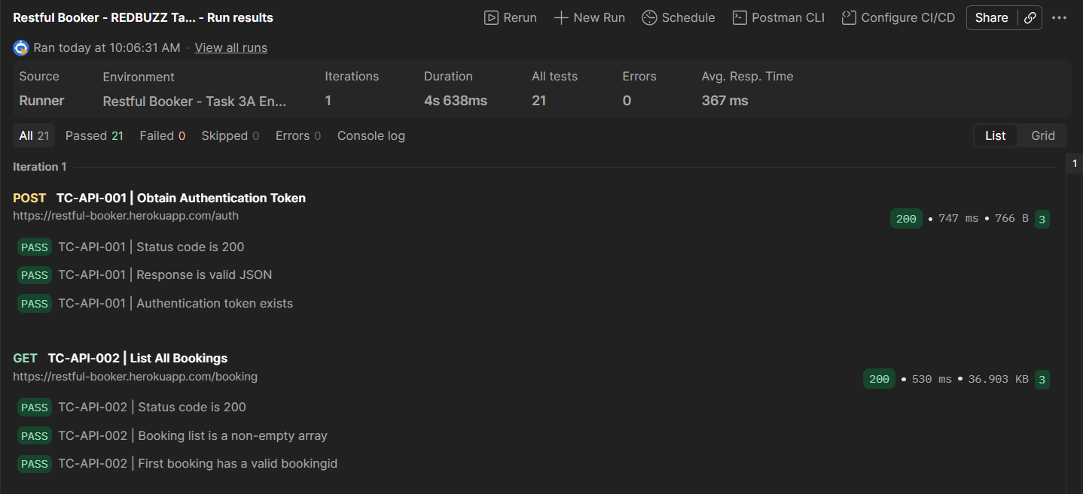
Evidence B1 – Postman Runner: token and booking list assertions.
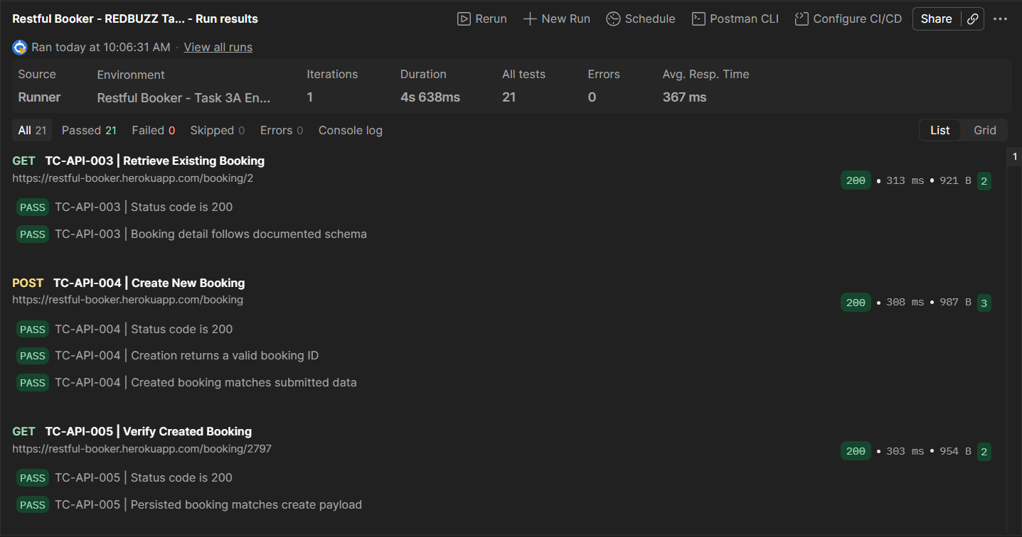
Evidence B2 – Postman Runner: retrieve, create and created-booking verification.
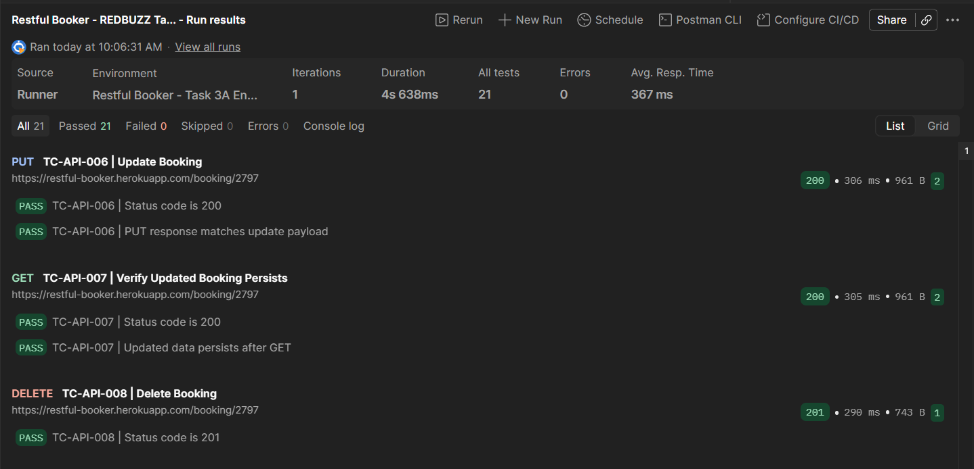
Evidence B3 – Postman Runner: update, persistence and delete.
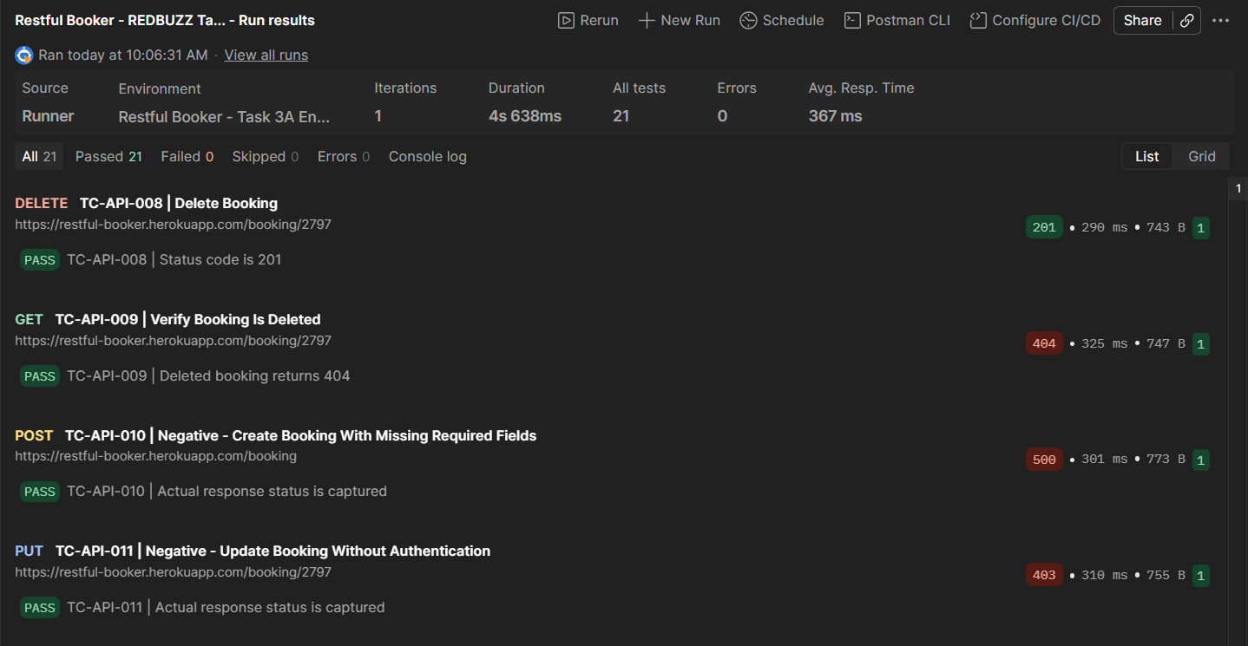
Evidence B4 – Postman Runner: delete verification and negative requests.
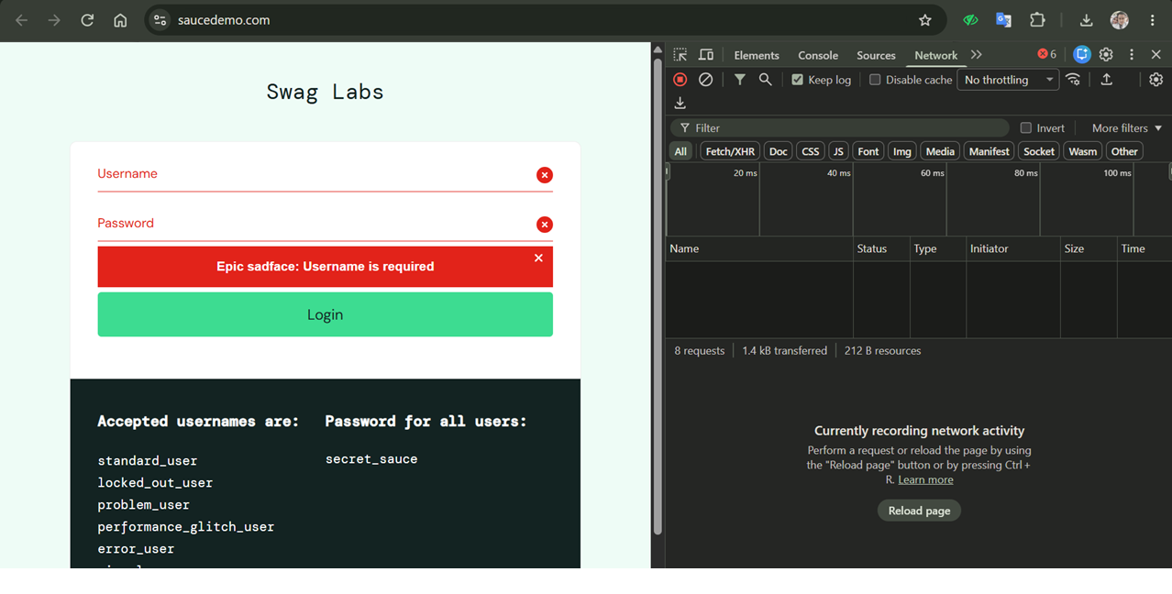
Evidence B5 – Chrome DevTools Network and empty-login validation message.

PRE-SUBMISSION QUALITY CONTROL
Assessment requirement | Status
Task 1A clarifications and top three risks | Complete
Task 1B final test cases | Complete – 15; TC-015* retained; PM assumptions remain
Task 1C review and fixes | Complete
Task 2 three bug reports | Complete in source report; independently reproduced screenshots not supplied
Task 3A 11 requests and developer observation | Complete; negative contract expectations undocumented
Task 3B two queries and integrity answer | Complete; not executed
Task 3C evidence-based conclusion | Complete
AI disclosure for all tasks | Complete with attribution caveats
Exact AI prompts | Needs verification – Task 3C missing; Task 1B prompt variants
Evidence files | Partial – Runner and DevTools screenshots present; Task 2 bug screenshots and collection/environment absent

Candidate verification: (1) Task 3C includes a candidate-approved reconstructed prompt; it is not confirmed as the exact historical prompt. (2) Task 1B contains two prompt versions; chronology requires candidate confirmation. (3) Task 3A collection-generation prompt has been replaced with the corrected candidate-supplied file. (4) Review Task 2 screenshot references and any remaining evidence limitations before submission.

APPENDIX B – ADDITIONAL TASK 2 SCREENSHOT EVIDENCE
The following screenshots were supplied after the initial consolidation. They supplement the original report; they do not independently establish all reproduction steps or the underlying cause.

BUG-001 – Product thumbnails
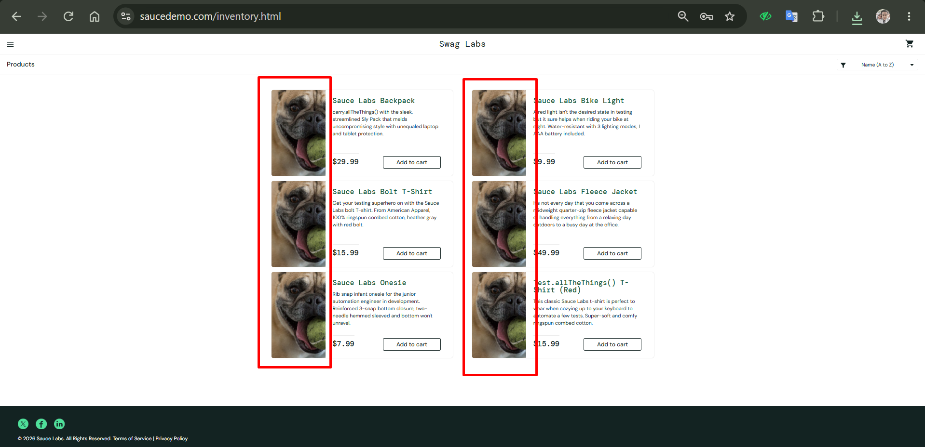
Evidence: Task 2_BUG-001.png — Product listing screenshot showing repeated dog thumbnails across distinct products.
Evidence status: Screenshot provided by candidate; compare with the associated Task 2 execution notes for reproduction steps.

BUG-002 – Product listing before navigation
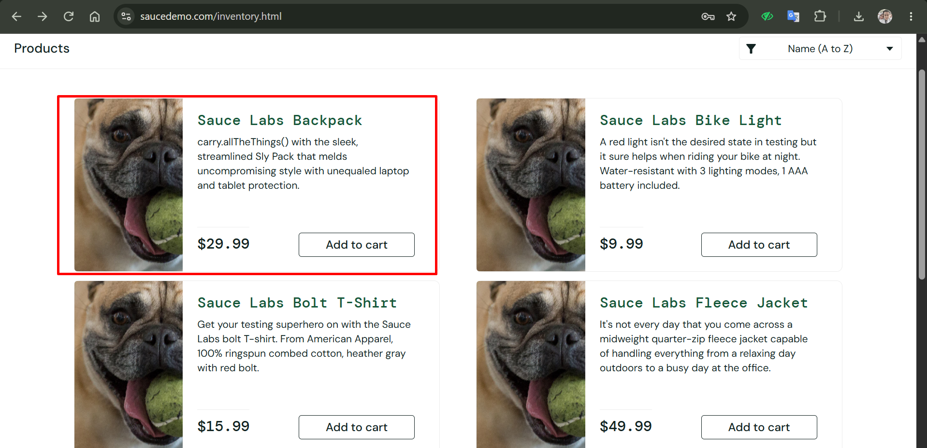
Evidence: Task 2_BUG-002_1.png — Inventory listing showing Sauce Labs Backpack and other products.
Evidence status: Screenshot provided by candidate; compare with the associated Task 2 execution notes for reproduction steps.

BUG-002 – Resulting product detail
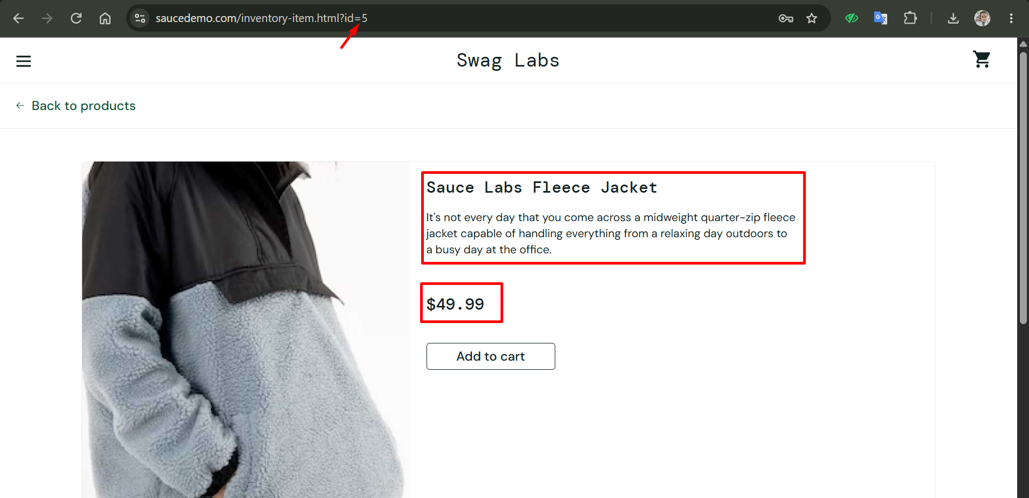
Evidence: Task 2_BUG-002_2.png — Detail page URL contains id=5 and displays Sauce Labs Fleece Jacket. Screenshot alone does not record the click event.
Evidence status: Screenshot provided by candidate; compare with the associated Task 2 execution notes for reproduction steps.

BUG-003 – Checkout form
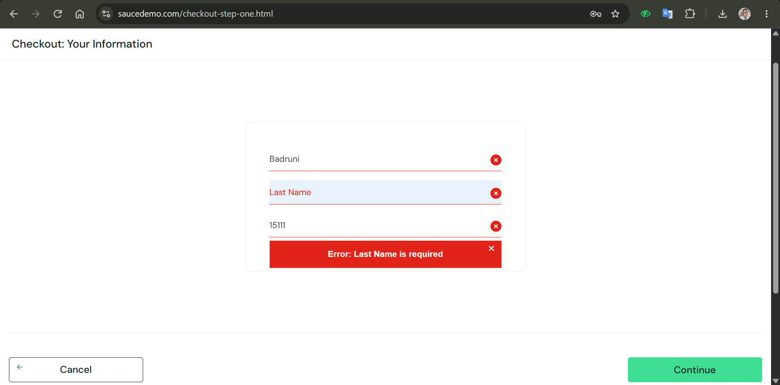
Evidence: Task 2_BUG-003.png — Checkout screenshot: First Name Badruni, Last Name empty, postal code 15111; error states Last Name is required. The screenshot alone does not establish the prior input sequence.
Evidence status: Screenshot provided by candidate; compare with the associated Task 2 execution notes for reproduction steps.

