<!DOCTYPE html>
<html lang="en">
<head>
<meta charset="UTF-8">
<meta name=""viewport" content="width=device-width, initial-scale=1.0">
<title>EXAMPLE OF CONSOLE FUNCTION</title>
</head>
<body>
<script src="JavaScript_function.js"></script>
</body>
</html>

function MyName(name){
return `Hello, ${name}!;`
}

console.log(MyName("nisa"));

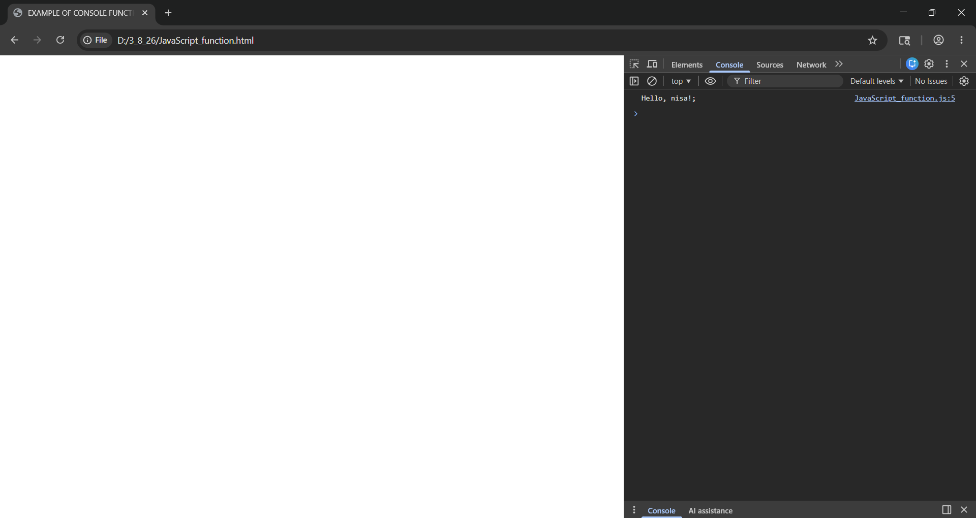

<DOCTYPE html>
<html lang="en">
<head>
<meta charset="UTF-8">
<meta name="viewport" content="width=device-width, initial-scale=1.0">
<title>EXAMPLE OF HOISTED FUNCTION</title>
</head>
<body>
<script src="HoistedFunction.js"></script>
</body>
</html>

const Multiply = (a, b) => {
return a * b;
};
console.log(Multiply(5, 10));

