## **PROJECT BASED ASSIGNMENT EVALUATION SHEET**

|  |  |  |  |  |  |
| --- | --- | --- | --- | --- | --- |
| **Sl.No** | **Criteria** | **CO** | **BTL** | **Max Marks** | **Marks Obtained** |
| **Phase I** | | | | | |
| **1** | Problem definition | **1** | **1** | **1** |  |
| **2** | Data Set | **2** | **2** | **2** |  |
| **3** | Tools and Technologies Used | **2** | **2** | **2** |  |
| 4 | Identification of the DL algorithm, architecture diagram, features, advantages and dis-ad | **2** | **2** | **5** |  |
| **Phase II** | | | | | |
| 5 | Model implementation – code Performance | **3** | **3** | **12** |  |
| 6 | Evaluation and analysis of the model | **4** | **4** | **3** |  |
| 7 | Presentation and Documentation | **Based on the Phases** | | **5** |  |
| **Total Marks** | | | | **30** |  |

|  |  |  |
| --- | --- | --- |
| **Name and USN of the Student** | **Dr S Anupama Kumar**  Associate Professor  Department of MCA  RVCE, Bengaluru –59 | **Dr. Andhe Dharani**  Professor and Director  Department of MCA  RVCE, Bengaluru–59 |

## **RUBRICS FOR EVALUATION**

## **Phase I Evaluation**

|  |  |  |  |  |  |
| --- | --- | --- | --- | --- | --- |
| **Sl.No** | **Component** | **Marks** | **Level 3** | **Level 2** | **Level 1** |
| 1 | Problem Definition  CO1 | 1 Marks | The content lacks a clear point of view and logical sequence of information.  Does not address well posed problem . | The content is vague in conveying a point of view and does not create a strong sense of purpose.  Well posed problem is addressed . | The content is clear and concise, with a very logical progression of ideas.  Clearly addresses well posed problem and defines the tasks in detail. |
|  |  |  | **0 – 0.5** | **0.5-1** | **1** |
| 2 | Data Set, Feature set selection, Data understanding CO2 | 2 Marks | Data set is defined, feature selection and understanding is not complete  Does not address the importance of the features | Data set is defined, feature selection and understanding is partially clear  No visualization of the features and data is visually explained | Data set is defined, feature selection and understanding is clear  visualization of the features and data is well defined in order |
|  |  |  | **0-1** | **1-2** | **2** |
| 3 | Selection of Tools and Techniques  CO2 | 2 Marks | Unclear about the Selection of tools in the defined area  Libraries and Packages are not defined | Identified the different tools that can be implemented  Libraries and Packages are identified and defined. | Identified the different tools that can be implemented and justified the usage of the tool  Libraries and Packages are identified and defined. |
|  |  |  | **0-1** | **1-2** | **2** |
| 4 | Identification of the ML task and algorithm and justification  CO2 | 5 Mark | Identification of the ML task is un clear  No justification for the task and algorithm | Identification of the task is clear but algorithm not clear  Justification of the task is clear and algorithm is unclear | Both task and algorithm are clearly identified  Justification is also clearly specified |
|  |  |  | **0-2** | **2-4** | **4-5** |

## **Phase II Evaluation**

|  |  |  |  |  |  |  |  |  |  |  |
| --- | --- | --- | --- | --- | --- | --- | --- | --- | --- | --- |
| **Sl.No** | | **Component** | | **Marks** | | **Level 3** | | **Level 2** | | **Level 1** |
| 1 | | Model implementation – code CO3 | | 10 Marks | | Code is implemented  Model building is not efficiently carried over. Test cases are not defined properly  No UI  . | | Code is implemented and model is built  Test cases are carried over and completed  Not compared with other models  UI is built | | Model is built with proper split of training and test set.  Test cases are successful. Two or more algorithms are compared for efficient model  UI is built |
|  | |  | |  | | **0-5** | | **5-8** | | **8-10** |
| 2 | | Evaluation and analysis of the model  CO4 | | 5 Marks | | Evaluation and analysis of the model is implemented  The methods are not defined clearly | | Evaluation and analysis of the model is implemented  Methods are defined  Interpretations are not explained | | Evaluation and analysis of the model is implemented  Methods are defined and interpretations are given clearly |
|  | |  | |  | | **0-2** | | **2-4** | | **4-5** |
| **Presentation and Documentation** | | | | | | | | | | |
| 3 | | Documentation | | 2 Marks | | The content lacks a clear point of view and logical sequence of information.  Does not address all the aspects like problem definition, tools and techniques, algorithm, model and interpretation | | The content is vague in conveying a point of view and does not create a strong sense of purpose.  Somewhat addresses definition, tools and techniques, algorithm, model and interpretation | | The content is clear and concise, with a very logical progression of ideas.  Clearly addresses aspects definition, tools and techniques, algorithm, model and interpretation |
|  | |  | |  | | **0-1** | | **1-2** | | **2** |
| **4. Video Based Presentation** | | | | | | | | | | |
| 4.1 | | Quality of the video | | 1 | | Multimedia element is unclear. Sound is not easy to hear/understand. Student video cannot be seen and/ or cannot be heard. | | Multimedia element is not very clear. There is some issue with sound and/or video. | | Multimedia element is clear. Sound is easy to hear / understand. Student video can be seen and/ or can be heard. |
|  | | Content of the presentation | | 1 | | The content lacks a clear point of view and logical sequence of information.  Does not address aspects such as general format/usage, sample code snippet, program example. | | The content is vague in conveying a point of view and does not create a strong sense of purpose.  Somewhat addresses aspects such as general format/usage, sample code snippet, program example. | | The content is clear and concise, with a very logical progression of ideas.  Clearly addresses aspects such as general format/usage, sample code snippet, program example. |
|  | | Presentation Skill | | 1 | | Student is unable to summarize the work effectively.  Student has not developed strong soft skills neither has acquired good knowledge | | Student managed to summarize the work.  Student has developed some soft skills and has acquired some knowledge | | Student is able to summarize the work effectively.  Student has developed strong soft skills and has acquired good knowledge |
|  | |  | |  | | **0-0.5** | | **0.5-1** | | **1** |
| **Info Graphics Presentation** | | | | | | | | | | |
| 4.2 | | Quality of the visualization | | 1 | | The information and graphics are unclear  Images and charts are not prepared properly | | The information is clear and the graphics are not suitably prepared  Images and charts are given but unclear | | The information and graphs are prepared and ported properly |
|  | | Content of the presentation | | 1 | | The content lacks a clear point of view and logical sequence of information.  Does not address aspects such as general format/usage, sample code snippet, program example. | | The content is vague in conveying a point of view and does not create a strong sense of purpose.  Somewhat addresses aspects such as general format/usage, sample code snippet, program example. | | The content is clear and concise, with a very logical progression of ideas.  Clearly addresses aspects such as general format/usage, sample code snippet, program example. |
|  | | Presentation Skill | | 1 | | Student is unable to summarize the work effectively.  Student has not developed strong soft skills neither has acquired good knowledge | | Student managed to summarize the work.  Student has developed some soft skills and has acquired some knowledge | | Student is able to summarize the work effectively.  Student has developed strong soft skills and has acquired good knowledge |
|  | |  | |  | | **0-0.5** | | **0.5-1** | | **1** |
| **Recorded Presentation** | | | | | | | | | | |
| 4.3 | Quality of the Presentation | | 1 | | The information and audio are unclear  The presentation and the audio are not synchronized properly | | The information is clear and audible  The presentation and the audio are not synchronized properly | | The information is clear and audible  The presentation and the audio are synchronized properly | |
|  | Content of the presentation | | 1 | | The content lacks a clear point of view and logical sequence of information.  Does not address aspects such as general format/usage, sample code snippet, program example. | | The content is vague in conveying a point of view and does not create a strong sense of purpose.  Somewhat addresses aspects such as general format/usage, sample code snippet, program example. | | The content is clear and concise, with a very logical progression of ideas.  Clearly addresses aspects such as general format/usage, sample code snippet, program example. | |
|  | Presentation Skill | | 1 | | Student is unable to summarize the work effectively.  Student has not developed strong soft skills neither has acquired good knowledge | | Student managed to summarize the work.  Student has developed some soft skills and has acquired some knowledge | | Student is able to summarize the work effectively.  Student has developed strong soft skills and has acquired good knowledge | |
|  |  | |  | | **0-0.5** | | **0.5-1** | | **1** | |

## **Table of Contents**

|  |  |
| --- | --- |
| **CONTENTS** | **PAGE NO.** |
| **1.Problem definition**  1.1 Objectives of the problem |  |
|  |  |
| **2. Tools and Technologies Used**  2.1 Libraries and packages |  |
| 2.2 System Design |  |
|  |  |
| **3. Implementation**  Steps to build the model with detailed explanation  Code Snippets to be explained  Screen Shots to be pasted and explained  Detailed steps to execute the program |  |
| **Conclusion**  Analysis of the model  Interpretation of the results  Future Enhancement |  |
| **Bibliography** |  |
| **Annexures**  **Video / Info Graphics / Recorded Presentation** |  |

**1. PROBLEM DEFINITION**

We are all well aware about Cortana, Siri, Google Assistant and many other virtual assistants which are designed to aid the tasks of users in Windows, Android and iOS platforms. But to our surprise, there’s no such complete virtual assistant available for Core Windows platform consisting of 70% of the users. So, this is actually a major problem for users where there could be internet instability, server problems and places where internet is not accessible.

**1.1** **OBJECTIVES OF THE PROBLEM**

Main objective of building personal assistant software (a virtual assistant) is using semantic data sources available on the web, user generated content and providing knowledge from knowledge databases. The main purpose of an intelligent virtual assistant is to answer questions that users may have. This may be done in a business environment, for example, on the business website, with a chat interface. On the mobile platform, the intelligent virtual assistant is available as a call-button operated service u ’here a voice asks the user “What can 1 do for you?” and then responds to verbal input. Virtual assistants can tremendously save you time. We spend hours in online research and then making the report in our terms of understanding. JIA can do that for you. Provide a topic for research and continue with your tasks while JIA does the research. Another difficult task is to remember test dates, birthdates or anniversaries. It comes with a surprise when you enter the class and realize it is class test today. Just tell JIA in advance about your tests and she reminds you well in advance so you can prepare for the test. One of the main advantages of voice searches is their rapidity. In fact, voice is reputed to be four times faster than a written search: whereas we can write about 40 words per minute, we are capable of speaking around 150 during the same period of timel5. In this respect, the ability of personal assistants to accurately recognize spoken words is a prerequisite for them to be adopted by consumers

**2. TOOLS AND TECHNOLOGIES USED**

**2.1 PACKAGES AND LIBRARIES**

**Natural Language Processing (NLP) libraries:** Python has several popular NLP libraries such as NLTK, spaCy, and TextBlob that are used for analyzing and understanding natural language text.

**Dialogflow:** This is a Google-owned platform that provides a powerful framework for building conversational agents with AI capabilities. It can be easily integrated with Python using a RESTful API.

**TensorFlow:** This is an open-source machine learning library developed by Google. TensorFlow can be used for training and building machine learning models that can be used in your virtual assistant.

**PyTorch:** This is another popular open-source machine learning library that can be used for building deep learning models. It provides a wide range of tools for building and training neural networks that can be used in your virtual assistant.

**Speech recognition libraries:** Python has several popular speech recognition libraries, such as SpeechRecognition and PocketSphinx, that can be used for converting speech into text, which can be further analyzed by your virtual assistant.

**2.2 DESCRIPTION OF DL ARCHITECTURE**

**2.2.1 ACTIVITY DIAGRAM**

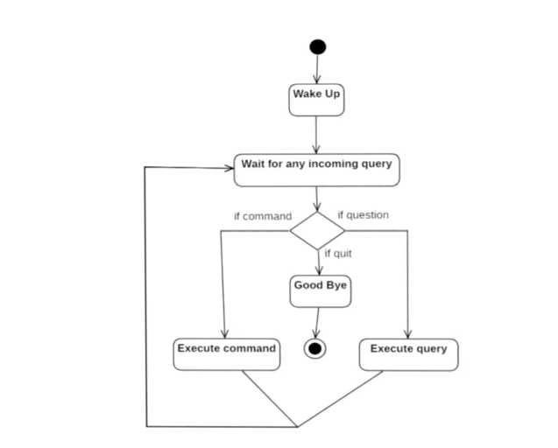

**Figure 1 : Activity Diagram**

Initially, the system is in idle mode. As it receives any wake up cal it begins execution. The received command is identified whether it is a questionnaire or a task to be performed. Specific action is taken accordingly. After the Question is being answered or the task is being performed, the system waits for another command. This loop continues unless it receives quit command. At that moment, it goes back to sleep

**2.2.2 CLASS DIAGRAM**

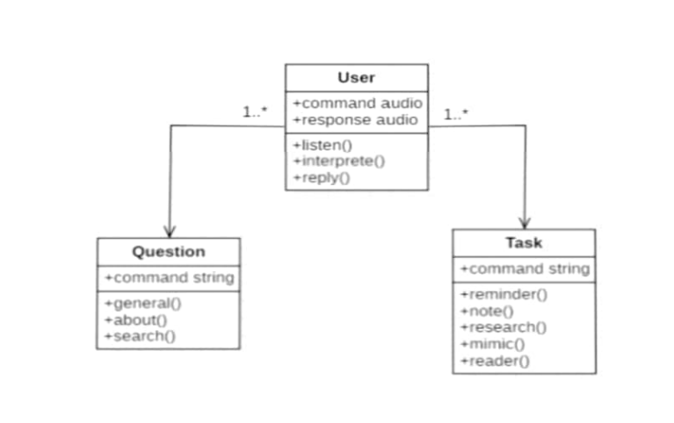

**Figure 2 :Class Diagram**

The class user has 2 attributes command that it sends in audio and the response it receives which is also audio. It performs function to listen the user command. Interpret it and then reply or sends back response accordingly. Question class has the command in string form as it is interpreted by interpret class. It sends it to general or about or search function based on its identification. The task class also has interpreted command in string format. It has various functions like reminder, note, mimic, research and reader.

**2.2.3 USECASE DIAGRAM**

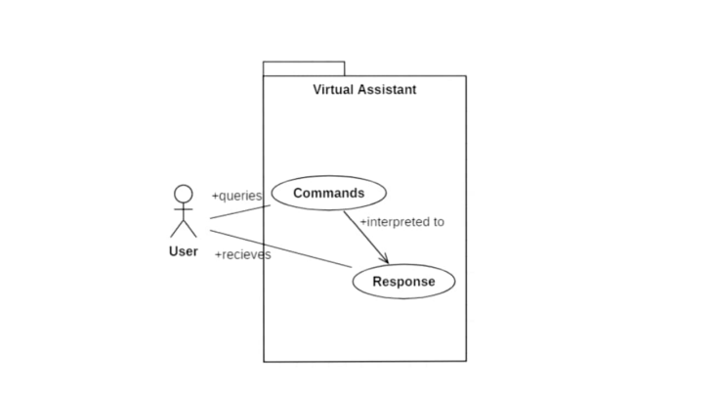

**Figure 3 : Use case Diagram**

In this project there is only one user. The user queries command to the system. System then interprets it and fetches answer. The response is sent back to the user.

**2.2.4 SEQUENCE DIAGRAM FOR TASK EXECUTION**

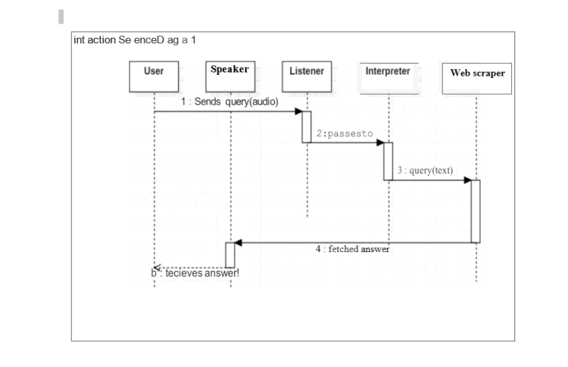

**Figure 4: Sequence Diagram**

The user sends command to virtual assistant in audio form. The command is passed to the interpreter. It identifies what the user has 8 asked and directs it to task executed. If the task is missing some info, the virtual assistant asks user back about it. The received information is sent back to task and it is accomplished. After execution feedback is sent back to user.

**2.2.5 DATA FLOW DIAGRAM**

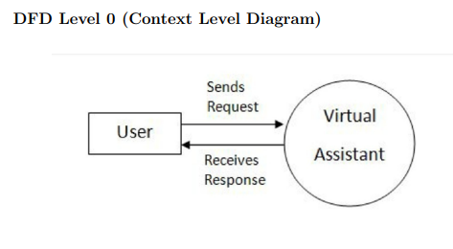

**Figure 5 : DFD 1**

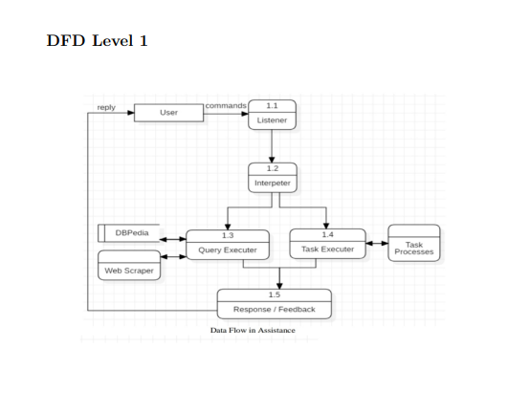

**Figure 6 : Dfd 2**

**2.2.6 COMPOSITE DIAGRAM**

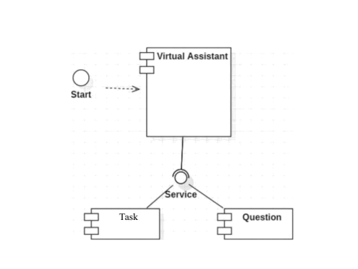

**Figure 7 : Composite Diagram**