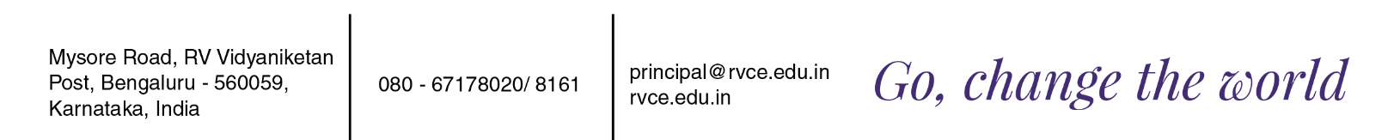

**RV COLLEGE OF ENGINEERING, BENGALURU – 560059**

*(Autonomous Institution, Affiliated to VTU, Belagavi)*

**DEPARTMENT OF MASTER OF COMPUTER APPLICATIONS**

**IV SEMESTER-20MCA36**

**MAJOR PROJECT SYNOPSIS**

**­­­­­­ TOPIC: DEVELOPING A CUSTOM APPLICATION FOR PRODUCT LIFECYCLE MANAGEMENT**

The purpose of this project is to develop a custom application using the Teamcenter API to manage the product lifecycle of a manufacturing organization. The project will focus on developing a solution for the complex challenges associated with product development, including managing product data, processes, and collaboration across the entire product lifecycle. The domain areas of application for this project include product lifecycle management (PLM), computer-aided design (CAD), and engineering. PLM is a critical component of product development, encompassing all aspects of a product's lifecycle from design and engineering to manufacturing and end-of-life management. CAD is used to create digital designs of products, and engineering involves designing and developing products to meet specific requirements. Teamcenter is a powerful PLM tool that can help organizations manage the complexity of modern product development. It provides a platform for managing product data, processes, and collaboration across the entire product lifecycle. By developing a custom application using the Teamcenter API, organizations can tailor the tool to meet their specific needs and gain a competitive edge in the market.

The modules which are present are CAD Data Management: Manage CAD data and integrate with CAD systems to ensure that product designs are up-to-date and accessible to all stakeholders. Document Management: Manage product-related documents such as specifications, drawings, and user manuals. Bill of Materials (BOM) Management: Manage product BOMs and ensure that they are accurate and up-to-date. Change Management: Manage change requests, change orders, and change notices to ensure that product changes are properly documented and tracked. Workflow Management: Define and manage workflows for product-related processes such as engineering change requests and manufacturing change orders. Project Management: Manage projects related to product development, including tasks, timelines, and resource allocation. Collaboration: Enable collaboration between different teams and stakeholders involved in the product lifecycle, such as engineering, manufacturing, and sales.

The outcome of the custom Teamcenter application will be specific to the goals and objectives of the organization and the application. However, some potential outcomes of the application could include: Improved Productivity: The custom Teamcenter application can automate and streamline product-related processes, resulting in increased productivity and efficiency for the organization. Improved Data Management: The application can provide better management of product data, including CAD data, BOMs, and documentation, resulting in improved accuracy and up-to-date information. Overall, the application can provide numerous benefits to an organization, depending on its specific requirements and objectives. The outcome of the application can lead to improved efficiency, quality, and compliance, resulting in increased profitability and competitiveness in the market.

**Student Name: Under the guidance of:**

Nithin Dr. S Anupama

1RV21MC067 Assistant Professor