# 

### Major Project

### 20MCA36

### on

### “Development of Custom Application for Product Lifecycle Management”

Submitted by

**Nithin**

### 1RV21MC067

### Under the Guidance

### of

|  |  |
| --- | --- |
| **Dr. S Anupama Kumar**  **Associate Professor**  **Department of MCA**  **RV College of Engineering**®  **Bengaluru – 560059** | **Mr. Amit Kumar Sharma**  **PLM Developer**  **Koch Business Solutions India**  **Bengaluru – 560066** |

### *Submitted in partial fulfillment of the requirements for the award of degree*

### *of*

### MASTER OF COMPUTER APPLICATIONS

**2022-2023**

**RV College of Engineering®**

**(Autonomous Institution Affiliated to Visvesvaraya Technological University, Belagavi)**

# Department of

# MASTER OF COMPUTER APPLICATIONS

[**Bengaluru**](http://www.bengaluruairport.com/#_blank)**– 560059**



**CERTIFICATE**

Certified that the project work titled Development of Custom Application for Product Lifecycle Management carried out by Nithin, 1RV21MC067, a bonafide student of RV College of Engineering®, Bengaluru submitted in partial fulfilment for the award of Master of Computer Applications of RV College of Engineering®, Bengaluru affiliated to Visvesvaraya Technological University, Belagavi during the year 2022-23. It is certified that all corrections/suggestions indicated for internal assessment have been incorporated in the report deposited in the departmental library. The project report has been approved as it satisfies the academic requirement in respect of project work prescribed for the said degree.

|  |  |  |
| --- | --- | --- |
| **Dr. S Anupama Kumar**  Associate Professor  Department of MCA  RVCE, Bengaluru –59 | **Dr. Andhe Dharani**  Professor and Director  Department of MCA  RVCE, Bengaluru–59 | **Dr. K. N. Subramanya**  Principal  RVCE, Bengaluru–59 |

**RV College of Engineering®**

**(Autonomous Institution Affiliated to Visvesvaraya Technological University, Belagavi)**

# Department of

# MASTER OF COMPUTER APPLICATIONS

[**Bengaluru**](http://www.bengaluruairport.com/#_blank)**– 560059**

**DECLARATION**

I, **Nithin**, student of fourth semester MCA in **Department of Master of Computer Applications,** RV College of Engineering®, Bengaluru declare that the project titled **“Development of Custom Application for Product Lifecycle Management”** has been carried out by me. It has been submitted in partial fulfilment of the course requirements for the award of degree in **Master of Computer Applications** of RV College of Engineering®, Bengaluru affiliated to Visvesvaraya Technological University, Belagavi during the academic year **2022-23**. The matter embodied in this report has not been submitted to any other university or institution for the award of any other degree or diploma.

**Date of Submission: Signature of the Student**

**Student Name: Nithin**

USN: 1RV21MC067

Department of Master of Computer Applications

RV College of Engineering®

Bengaluru-560059

**ACKNOWLEDGEMENT**

The satisfaction and euphoria that accompany the success of any work would be incomplete unless I mention the name of the people, who made it possible, whose constant guidance and encouragement served a beacon light and served our effort with success.

First and foremost, I would like to extend my sincere gratitude to my supervisor **Mr. Hitesh Patel**, Delivery Leader- Guardian, Koch Business Solutions India, Bengaluru, also my project guide **Mr. Amit Kumar Sharma**, PLM Developer, Koch Business Solutions India, Bengaluru for his constant encouragement, support, and guidance during the project work.

I express my wholehearted gratitude to **Dr. Subramanya K N**, Principal, RV College of Engineering® for providing me an opportunity.

I express my special thanks to **Dr. Andhe Dharani**, Professor, and Director, Department of MCA, RV College of Engineering®, Bengaluru for her constant support and guidance.

I express my sincere thanks and wholehearted credit to my Internal guide **Dr. S Anupama Kumar**, Associate Professor, Department of MCA, RV College of Engineering®, Bengaluru for her constant encouragement, support, and guidance during the project work.

I am also thankful to lab in-charge staff and all faculty of the department for their help and support during the seminar. On a moral personal note, my deepest appreciation and gratitude to my beloved family, who have been a fountain of inspiration and have provided unrelenting encouragement and support.

Nithin

Department of MCA

RV College of Engineering®

Bengaluru-59

**ABSTRACT**

A specialised software solution specifically created to meet the demands, processes, and commercial goals of a manufacturing organisation is known as custom application for PLM (Product Lifecycle Management). By fostering cooperation, increasing data accessibility, and improving process efficiency, it plays a significant part in simplifying and optimising product development processes. A customised PLM application gives businesses the tools they need to manage product data efficiently, make informed decisions, and gain a competitive edge on the market, fostering innovation and success throughout the entire product lifecycle. These features include CAD integration, quality assurance management, and customised reporting.

The modules which are present are Document Management: Manage product-related documents such as specifications, drawings, and user manuals. CAD Integration: Allows for seamless connection with CAD software, making it easier to import, convert, and visualise CAD data for collaborative product design and synchronisation, improving product quality and speeding up development. Through inspections, audits, and non-conformance control, quality assurance ensures product quality and compliance, making it possible to quickly identify and address problems. This increases customer satisfaction and promotes continual development. Report & Analytics: Provides users with in-depth reports and visualisations, editable templates, and data aggregation tools for strategic planning, process optimisation, and informed decision-making. This aids in the effective creation of products and the success of businesses.

The outcome of the custom application will be specific to the goals and objectives of the organization and the application. However, some potential outcomes of the application could include Improved Productivity, automation, and streamlining of product-related processes, resulting in increased productivity and efficiency for the organization. Improved Data Management: The application can provide better management of product data, including CAD data, and documentation, resulting in improved accuracy and up-to-date information. Overall, the application provides numerous benefits to an organization, depending on its specific requirements and objectives. The outcome of the application can lead to improved efficiency, quality, and compliance, resulting in increased profitability and competitiveness in the market.

**Publication Details**

**Name of the Conference:** 7th International Conference On “Computational Systems and Information Technology for Sustainable Solutions” (CSITSS-2023).

**Organized By:** RV College Of Engineering, Bengaluru

**Title of Paper:** Virtual Assistant Using Deep Learning Techniques

**Corresponding Author:** Dr. S Anupama Kumar

**Paper ID:** 20

**Publication Status:** Submitted

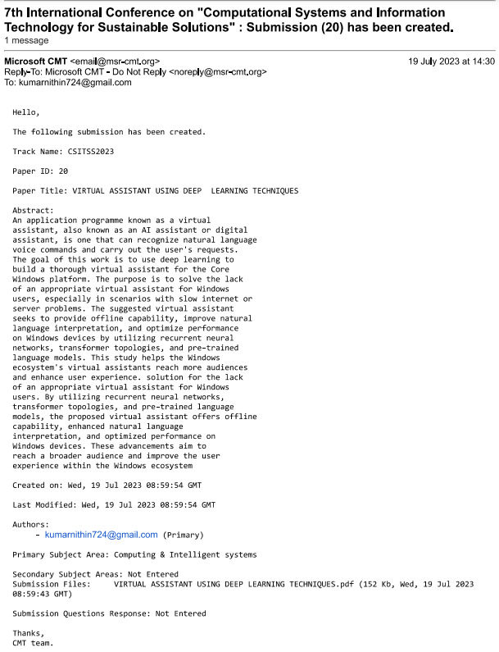

## **Table of Contents**

|  |  |
| --- | --- |
| **CONTENTS** | **PAGE NO.** |
| College Certificate | i |
| Company Certificate | ii |
| Declaration by student | iii |
| Internship Offer Letter | iv |
| Acknowledgement | v |
| Abstract | vi |
| Publication Details | vii |
| Table of Contents | viii |
| List of Tables | ix |
| List of Figures | x |
| **Chapter 1: Introduction** | 1 |
| * 1. Project Description   2. Company Profile   3. Dissertation Organization | 2  3  5 |
| **Chapter 2: Literature Review** | **6** |
| * 1. Literature Survey   2. Existing and Proposed System   3. Tools and Technologies used   4. Hardware and Software Requirements | 6  10  12  14 |
| **Chapter 3: Software Requirement Specifications** | **15** |
| 3.1 Introduction  3.2 General Description  3.3 Functional Requirement  3.4 Non-Functional Requirements  3.5 Design constraints | 15  16  17  19  20 |
| **Chapter 4: System Design** | **22** |
| 4.1 System perspective  4.2 Context Diagram | 19  26 |
| **Chapter 5: Detailed Design** | **28** |
| * 1. Architecture Design   2. Detailed design | 28  33 |
| **Chapter 6: Implementation** | **36** |
| 6.1 Implementation | 36 |
| **Chapter 7: Software Testing** | 41 |
| 7.1 Test cases  7.2 Testing and Validations | 41  46 |
| **Chapter 8: Conclusion** | 48 |
| **Chapter 9: Future Enhancements** | 49 |
| **Bibliography** | 50 |
| **Plagiarism Report** | 54 |

**LIST OF TABLES**

|  |  |  |
| --- | --- | --- |
| **Table no.** | **Table label** | **Page no.** |
| 2.1 | Hardware Requirement | 13 |
| 2.2 | Software Requirement | 13 |
| 3.1 | Abbreviations | 14 |
| 7.1 | Testing the module Document Management | 42 |
| 7.2 | Testing the module CAD Integration | 43 |
| 7.3 | Testing the module Quality Assurance | 44 |
| 7.4 | Testing the module Report and Analytics | 44 |
| 7.5 | Integration Testing of Custom Application for PLM | 46 |
| 7.6 | System Testing of Custom Application for PLM | 47 |

**LIST OF FIGURES**

|  |  |  |
| --- | --- | --- |
| **Figure no.** | **Figure Label** | **Page no.** |
| 4.1 | Block Diagram | 23 |
| 4.2 | Context Diagram | 26 |
| 5.1 | Architecture Diagram | 28 |
| 5.2 | DFD Level 0 | 30 |
| 5.3 | DFD Level - 1 | 30 |
| 6.1 | Document Management | 36 |
| 6.2 | Document Overview | 37 |
| 6.3 | Creating new CAD file | 37 |
| 6.4 | Creating New Design | 38 |
| 6.5 | Quality Assurance | 38 |
| 6.6 | Report Overview | 39 |
| 6.7 | Product Report | 40 |
| 6.8 | Analytics example | 40 |