SDLC for the project.

* Planning -> Defines project goals ,scope, resoureces, costs and risks.
* Requirement analysis -> Involves gathering, analyzing ,and documenting functional and non functional requirements.
* Design -> Translates requirements into a blueprint for the application, covering architecture, components and user interface.
* Implement -> Actual coding and development take place based on design specifications.
* Test -> Conducts various test such as unit testing, integration testing, system testing and user accept testing(UAT).
* Deploy -> Releases the software to users after through testing.
* Maintain -> Ensure the software continuous to operate as a required. Address bug fixes etc.

SDLC Models

1. Waterfall Model :-> A linear and sequential approach, where each phase must be complete before the next begins.
2. Agile Models -> an iterative approach that emphasizes flexibility, collaboration and frequent releases.

DevOps -> DevOps started in 2007 by Patrics debois

DevOps lifecycle

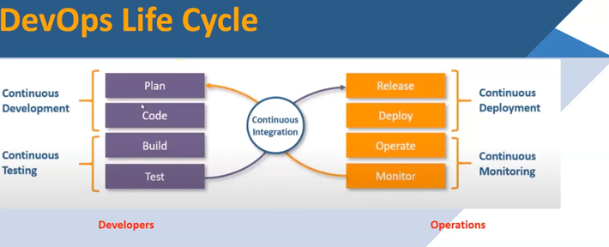

Client Server Architecture

* Client = which required a resources
* Server= which response to the resources

note – Resource = information

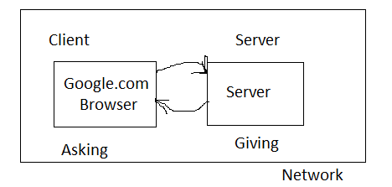

* 1 – Tier Architecture

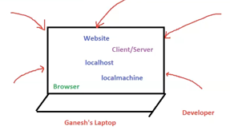

* 2 Tier Architecture

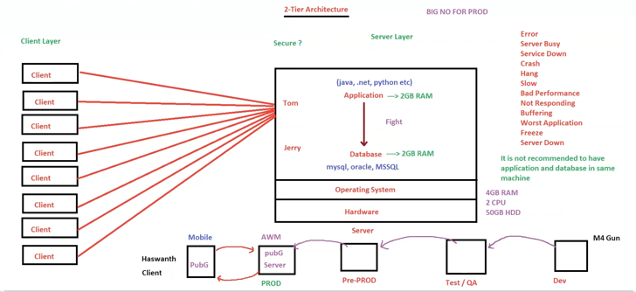

3 Tier Architecture

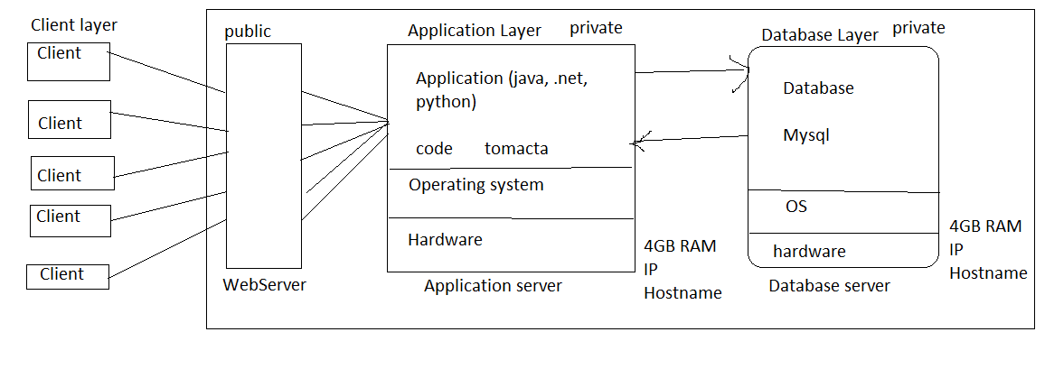

* Application Server = The server which has application hosted is called application server.
* Database Server = The server which has database installed, the server where the database is stored is called a database server.
* Device communicate with each other in the network with IP and Hostname.
* IP (Internet Protocol) = IP is unique identifier for a device in the network
* Host name = name of the server.
* Webserver = Takes the request and redirect to the application server.
* Application server should be always in private network, don’t expose to Internet

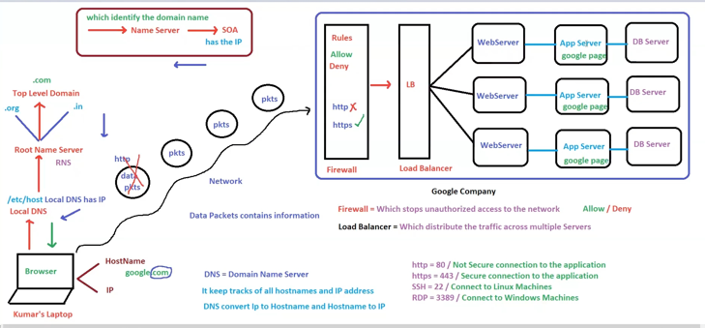

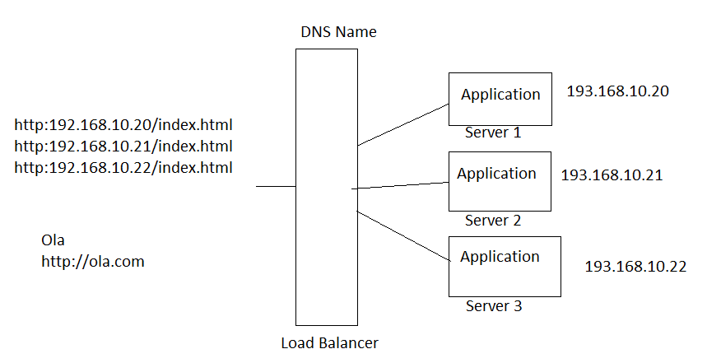

* Round robin method
* Load Balancer = which distribute the traffic across multiple servers

Protocols

* HTTP – Hyper Text Transfer Protocol.
* HTTP default port number 80.
* HTTP transfer the data to and fro from browser to server.

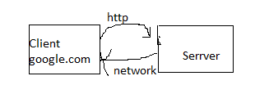

* For customer it should be always default port number (80 or 443).
* htpp://google.com - > protocol://domainname:portNumber
* <http://192.168.10.20:80> –wrong

<http://192.168.10.20:8080> – correct

<http://192.168.10.20> – wrong

* You can customize the port number at application level but for customer, it should be always default port number.
* HTTP Status code

404 – page not found , 500 – Internal server error , 503 – service unavailable

200 – page found, success

* HTTP – is not secure
* HTTPS is secure https = 443 certificates SSL/TLS/HTTPS – Encrypted.
* HTTP Over TCP/IP (Transmission control protocol)
* TCP establish the connection between 2 hosts.
* TCP is like a bridge.

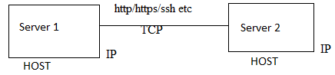

DataCenters

Data Centers which are handled by us is called on-premises .

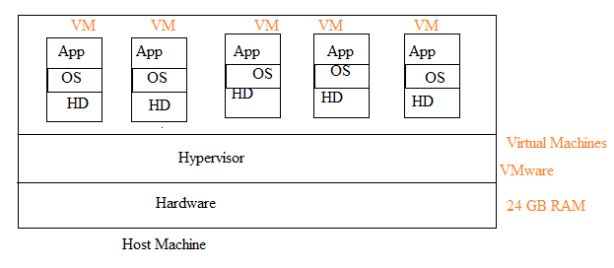

* P2V Migration (Physical to virtual)
* V2C Migration(Virtual to Cloud)

AWS

* AWS has global infrastructure AWS is providing infrastructure as a service , cloud is present in the remote location remote location contains datacenters datacenter contains infrastructure
* Infrastructure contains storage, database, servers, network, VM etc .
* AWS has approximate 36 place his infrastructure
* we need Internet to connect to the cloud
* Amazon Web Services access through Amazon management console
* AWS is a group of services AWS is a cloud provider who provide infrastructure as a service.

Cloud computing

* Instead of doing computing on on-premises/ local machine, now you are doing computing in the remote location(cloud) that is called cloud computing.

Deployment model in cloud (Type of clouds)

* public cloud : - the providers services which are accessed by everyone like AWS, Azure, GCP etc.
* private cloud : - the providers services which are access within the organization like Oracle, IBM
* hybrid cloud : - the combination of public and private cloud.

Service model

* Infrastructure as a service (IAAS)
* Platform as a service [PAAS]
* Software as a service [SAAS]
* AWS does not have any access inside your VM .
* ElasticBeanStalk = Easy and quick deployment of application in AWS.
* AWS work on share responsibility model.
* AWS is a group of service we can access AWS service through Amazon management console
* VM = instances
* EC2 = Elastic compute cloud.
* EC2 is AWS service where we can create virtual machines
* EC2 is aws service where we can launch AC2 instances.

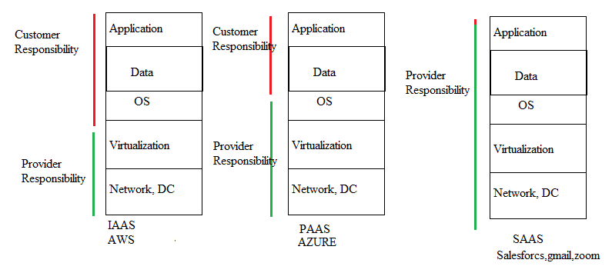

Elasticity

* Increasing and decreasing the number of servers/instances based on the load is called electricity
* Elasticity is a short term
* Elasticity can be achieved in AWS using auto scaling
* Auto scaling = scale out[increasing ,adding] and scale in[decreasing ,removing]
* Elasticity is also called as horizontal scaling
* Use the same capacity of the server is auto scaling

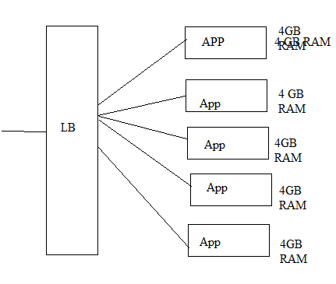

Scalability

* Increase the capacity of servers is called scalability
* Scalability = scale up and scale down
* Scalability is also called as vertical scaling.
* Scalability is long term.
* Scalability can be achieved in AWS by changing the instance type.
* Instance type = memory +CPU

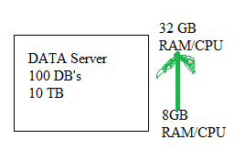

High Availability

* The period of time the service is available to the customer is called high availability
* The period of time the service is not available to the customer is called downtime.
* Load balancer will do the health checks for application not a server
* Load balancer is doing the failover.
* Redundancy = duplicate/ having the same application on different servers
* Monitoring = load balancer will check if application is reachable or not using health checks
* Failover = if one server goes down, other server will take the request send by load balancer
* 0 downtime = auto scaling = fault tolerance

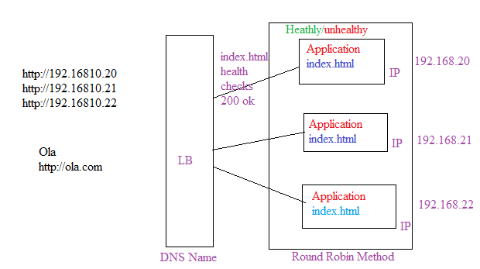

Regions and Availability Zones.

* Region = Its a geographical area, example AWS- Region = Mumbai
* Availability zone = Simply a Datacenter[AZ]
* AWS has global infrastructure
* Region is a place where AWS has its infrastructure
* A region has multiple data centers, A region has multiple DataCenters
* A Region has multiple AZ’s.
* Server = Instances Server/Instance are placed in AZ’s
* AZ’s are sync with each other[network], not a data
* Best practice is to distribute the instances across multiple AZ’s
* 1a or 1b or 1c = group of DataCentres
* 1 AZ’s is a group of DataCentres
* Instances across AZ’s can share the data if required as AZ’s are inter-connected with each other.
* Load balancer can distribute the traffic to multiple EC2 instance across AZ’s
* LB is a specific to region not a AZ’s
* Mumbai = ap-south-1 |||| AZ’s ap-south-1a, ap-south-1b, ap-south-1c
* Region and AZ’s are managed by AWS
* AZ’s can communicate with each other by default
* AZ’s network are inter-connected
* Region don’t communicate with each other by default, if required yes.
* EC2 instance is a specific to Region and AZ

VPC (Virtual private cloud)

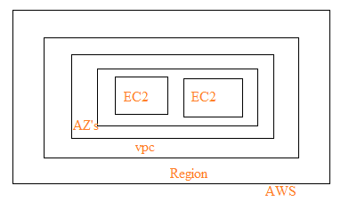

* Every Region contains a default VPC
* 2 VPC’s will not communicate with each other by default , if required yes.

EC2 (Elastic compute cloud)

* In EC2 service, we can launch EC2 instances
* Servers = Instance / EC2 instance (VM’s)
* AWS service can be either regional or global
* EC 2 is a regional service.
* Load balancer = which distribute the traffic to multiple servers.
* Elastic Load Balancer(ELB) = ELB distribute the traffic to multiple EC2 instance across AZ’s.
* ELB is completely managed by AWS (HA,AS, scalability, performance etc
* ELB is a service from AWS not a server.
* You can’t login into ELB, you can access ELB with DNS name .
* ELB doesn’t have any AZ’s it is created at regional level.
* EC2 to launch easy , configure ,deployment, maintain.
* BeanStack - just upload the application and give some configuration.
* Elastic BeanStack = easy and quick deployment of application in AWS ,in general ,PAAS -> you don’t have any control on the servers
* Backbone of BeanStack EC2 instance.
* AWS BeanStack you have full control on EC2 instance launch by BeanStack
* BeanStack handle EC2 instance behalf of us.
* LightSail = if you want to setup and create a virtual lightSaill instance which already have everything installed and ready( WordPress, GitLab, Node jS, Joomla ) NO HA, NO AS, NO scalability.

Lambda

* Lambda is a Serverless
* You can run the code without server
* Lambda is used for automations
* Create function Lambda function created in java,python,.net, ruby etc.
* Lambda is invoked based on the trigger/ Event.
* All Event stored in the Event Bridge

S3

* In AWS all services will start with simple and end with service
* SNS - simple notification service.
* SES - simple Email service
* S3 - simple storage service
* S3 is unlimited storage by AWS, S3 is used to store the files, S3 can store any kind of files.
* With S3 we can upload, download, store the data and access your files.
* You cannot execute any files in S3. you cannot install, run execute any files in S3.
* S3 is serverless, AWS handle ha, performance, scalability etc for S3
* Bucket is a container objects
* Object is a file
* Name of file /object is a key
* S3 is a regional, bucket are regional.
* S3 supports static website hosting -> create a bucket and upload all the HTML files and enable static website hosting. no need to worry about HA, performance, Salability etc because S3 handles it.
* S3 is a object base storage

Laptop - S3

Folder - Bucket

File - Objects

pushpa .MP4 - key

EBS- (Elastic Block Storage)

* Hard Disk = volume = EBS volume
* EBS is a block based storage
* Volumes can be attached and detached. you can attach multiple volumes to the EC2 instance.
* EC2 instance has default volume, that volume is called ROOT volume.
* The root value always contain OS[windows, Linux]
* EC2 supports only server side OS not client side OS.
* If you have OS on the volume, the volume is called root volume
* EC2 instance can have only 1 root volume. EC2 instance can have multiple additional volumes.
* Maximum size of the EBS volumes is 16TB.
* Volume should be pre-provisioned like 50GB, 100GB …Max 16 TB
* You cannot attach volume to a multiple EC2 instance at the same time\*\*\*
* Volume size can be increased on FLY [no need to stop the EC2 instance, no downtime]
* Volume size can’t be decrease[delete the volume and re-create is based on requirement]
* Q - It is possible to detach the root volume while EC2 is running -> No stop the EC2 instance first and then detach the root volume.
* Q- Is it possible to detach additional volume while EC2 is running - >Yes it is not recommended to detach while running. Stop first.
* We can not attach 1a volume to 1b EC2 instance(diff Az)
* We can attach 1a volume to 1a EC2 instance(same AZ)
* You can’t share the volumes among EC2 instances
* For win/Linux -/dev/sda1 /dev/sdb, e f etc
* Root volume is always mounted/attached as /dev/sda1
* EC2 instance has AZ,volumes also has AZ
* EC2 instance and volume should be in the same AZ
* EBS is regional .

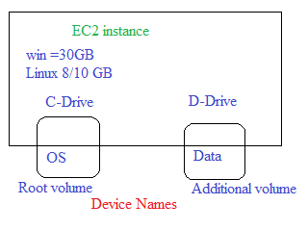

EFS = Elastic File System

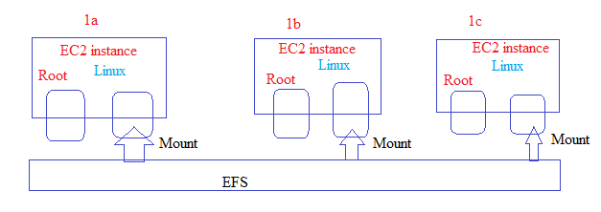

* EFS is completely managed by AWS, EFS is only for Linux EC2 instances
* FSX is for Windows EC2 instances
* EFS works with NFS protocol
* EFS is a file based storage
* EFS is unlimited storage
* EFS does not require any pre-provisioning[ it will automatically increase and decrease the base on the data put in EFS]
* EFS can be mounted to multiple EC2 instances at the same time across AZ’s.
* EFS can be replicated to other regions
* Is it possible to attach a single volume to multiple EC2 instance at the same time? No

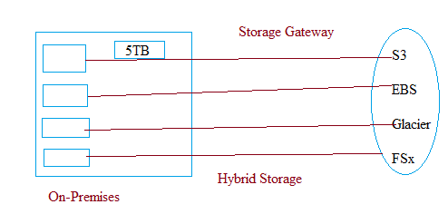

Snow family

* SnowCone - 8TB
* SnowEdge - 100 TB
* SnowMobile PB’s
* snow family is used to transfer huge data from on-prem to AWS and vice versa
* SnowFamily is a physical data transfer using devices

Database service

RDS- Relational database service.

* RDS is completely managed by AWS.
* RDS is a service where we can setup, configure and maintain RDBMS databases.
* RDS is a database service not a database.
* RDS DB instance, RDS support only RDBMS database only.
* RDS support 7 engines

1. MYSQL
2. Oracle
3. MSSQL
4. PostGresql
5. MariaDB
6. Aurora
7. IBM DB2

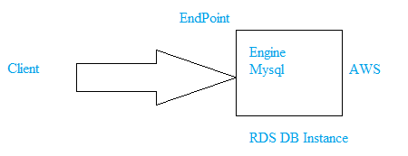

DynamoDB - NOSQL database service[Non-relational]

* Database is used to store the data.
* DataWarehouse it is used to store huge data.
* RedShift = DataWarehouse in AWS

DMS - Data Migration Service

ElasticCache = In memory database caching service

Low latency, High Performance

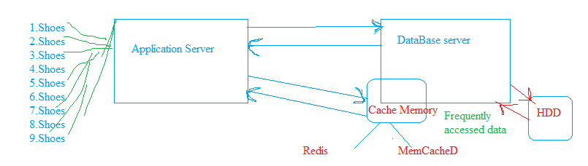

Route53

* R53 is DNS service from AWS, DNS port number is 53
* R53 contains records
* In R53 we do mapping
* R53 is a global

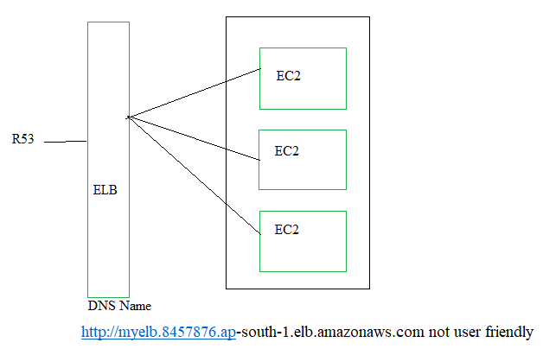

VPC - virtual private cloud

* It is like a virtual datacenter on cloud
* Every region has a default VPC
* VPC is a regional

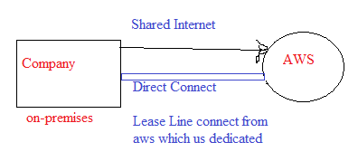

CloudFront

* CDN = Content Delivery Network
* Without CF - High latency -> user-boom.com- R53-ELB-EC2
* With CF - low latency
* User-boom.com-R53-CF(Edge locations) – ELD-EC2
* TTL = time to live example 12 hours
* Invalid cache = delete the cache, it will be catched based on TTL value
* EL’s are manage by AWS
* Edge location = application catching, static and dynamic data
* Create distribution = where is your organization? EC
* North America, Europe, Asia
* Use all edge locations
* Create distribution

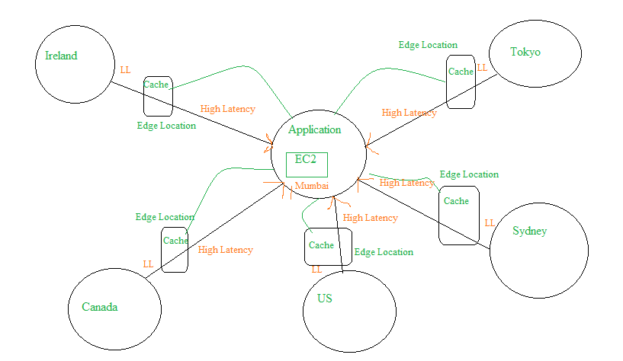

1 IAM - Indentity and Access Management

* You can control the entire AWS using IAM by providing proper permissions to the I am users
* Service quotas - show AWS resource limit
* SNS – simple notification service, SES - simple email service, SQS - simple queue service
* Trusted advisor
* AWS inspector
* Every AWS account has AWS account number /AWS ID 12 digit.
* Organizations = To manage multiple root accounts for better management

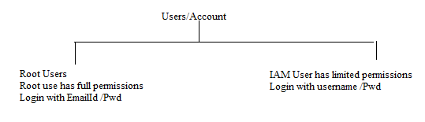

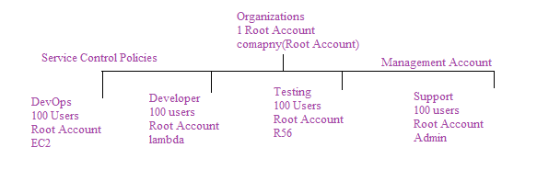

CloudWatch

* CloudWatch is used to monitor all AWS resources[EC2, ELB, S3, RDS etc]
* In CloudWatch we create alarms to monitor AWS resources, cloudwatch monitors the performance
* Basic monitoring = you will get the data points every 5 minutes ,free ,default
* Details monitoring = you will get the data points every one minute, billable

CloudTrail = monitor entire AWS account

* Record, monitor, track, audit, logs etc = investigation purpose

Config = monitors the changes in AWS resources

Secret manager = It is used to store secret [credentials keys etc]

AWS backup= centrally manage and automate backup

WAF = web application firewall

protect your web application from common web exploits

AWS shield = managed DDoS protection secure

AWS support

* Basic support = free
* Developer support
* Business support
* Enterprise support

Security

Encryption can be done in two way

* Encryption In-Transit = while data is travelling
* HTTPS
* Certificates
* ACM = Amazon certificate manager
* Encryption at Rest = while data is resting ,
* keys
* Encryption keys
* KMS = key management service