WEEK 17

MLOps Assignment Deliverables Report
  - Predictive ML and Agentic AI Workflows
Prepared by
Neev Badu
Submission repository
https://github.com/baduneev/fusemachine_learning_journey/tree/main/Week17_Assignment_Neev_Badu
26 September 2026

Executive Summary
This report lists the complete Week 17 submission and explains how both required MLOps tracks were implemented, evaluated, and packaged. The submission is ready to commit and submit. It contains two independent uv environments, MLflow experiment records, production model registration, complete agent traces, and an Evidently HTML report for each track.
Track | What was delivered | Final result
Track A | Three churn models, MLflow registry, FastAPI serving, data and target drift monitoring | Production model registered; intended drift detected
Track B | Three prompt versions, full tool traces, golden regression tests, Gemini based Evidently judges | Behavior and regression gates reached 100% for prompt v3

Assignment Scope
- Both mandatory tracks completed. Track A covers a predictive churn model; Track B covers the Week 16 agentic workflow.
- Reproducibility. Each track contains its own pyproject.toml, .python-version, and uv.lock.
- Experiment tracking. MLflow stores parameters, metrics, artifacts, models, traces, and release decisions.
- Monitoring. Evidently provides an HTML drift report for Track A and an HTML LLM regression report for Track B.
- Optional Airflow work. Airflow was not required and was not included.

Repository Links
- Complete Week 17 submission: https://github.com/baduneev/fusemachine_learning_journey/tree/main/Week17_Assignment_Neev_Badu
- Track A Data Science MLOps: https://github.com/baduneev/fusemachine_learning_journey/tree/main/Week17_Assignment_Neev_Badu/track_a_churn
- Track B Agentic AI MLOps: https://github.com/baduneev/fusemachine_learning_journey/tree/main/Week17_Assignment_Neev_Badu/track_b_agent

Overall Architecture
Both tracks follow the same release pattern: create a reproducible environment, compare controlled versions, promote the strongest candidate with an explicit rule, and produce monitoring evidence that can be reviewed after deployment.
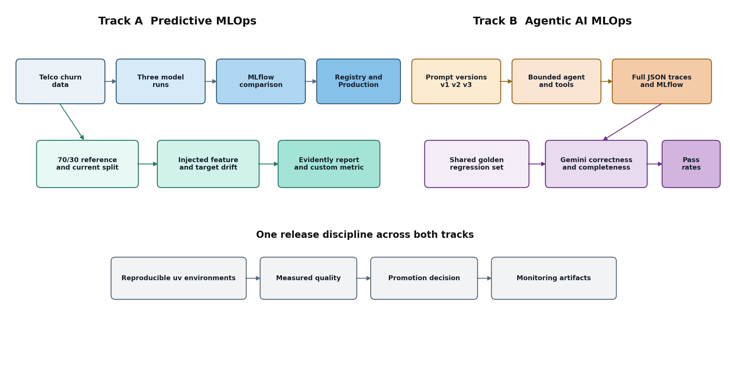
Figure 1. Combined predictive and agentic MLOps architecture

What Happens During Execution
- Track A converts raw customer records into a consistent preprocessing and model pipeline. The same train and test split is used for all candidates so their metrics are directly comparable.
- The highest ROC-AUC model is registered and promoted through Staging to Production. A FastAPI endpoint loads that registered Production model rather than a separately copied file.
- A second Track A workflow creates reference and current datasets, introduces known changes, and checks whether Evidently detects the intended feature and target drift.
- Track B executes the same representative tasks under three prompt and configuration versions. Each action, argument, selected tool result, verifier result, token count, and termination status is retained.
- The same golden regression cases are judged for correctness and completeness after every prompt revision. Their pass percentage is logged to the matching MLflow run.

Track A Data Science MLOps
Track A uses the IBM Telco Customer Churn dataset to demonstrate the full lifecycle of a supervised classification model: repeatable training, objective comparison, registry promotion, serving, and drift monitoring.

Model Experiments
Candidate | Accuracy | Precision | Recall | F1 | ROC AUC
Logistic regression C 0.5 | 0.7518 | 0.5210 | 0.7966 | 0.6300 | 0.8461
Logistic regression C 2.0 | 0.7501 | 0.5188 | 0.7966 | 0.6284 | 0.8459
Random forest 300 depth 8 | 0.7649 | 0.5391 | 0.7816 | 0.6381 | 0.8448

Promotion decision. The predefined rule selected the highest ROC-AUC and used F1 only as a tie breaker. Logistic regression with C 0.5 therefore won, even though the random forest had slightly higher accuracy and F1.

Registry and Serving
Registered model | Version | Stage history | Alias
TelcoChurnBest | 1 | Staging to Production | champion

Serving. FastAPI health and prediction endpoints load the registered Production model.

Monitoring and Drift Results
The monitoring workflow creates a 70 percent reference set and a 30 percent current set. It increases monthly charges, skews contract type toward month-to-month, and changes part of the churn target. These controlled changes test whether the monitoring workflow can detect known production shifts.
Signal | Reference | Current | Outcome
Mean MonthlyCharges | 64.95 | 99.05 | Drift detected
MonthlyCharges mean shift | - | +34.10 or +52.51% | Custom metric
Churn rate | 26.53% | 41.50% | Target drift detected
Contract distribution | Original mix | 55% forced month-to-month | Feature drift detected

Interpretation. The report should trigger investigation of billing and contract data sources. Drift alone does not prove that retraining is the correct response; the upstream pipeline and later time windows should be validated first.

Track B Agentic AI MLOps
Track B evaluates an evidence constrained document agent. The agent searches local documents, reads source pages, verifies exact supporting quotations, and may finish only after verification succeeds. Prompt versions change how the agent searches, repairs rejected claims, and handles tool failures.

Prompt Evolution and MLflow Comparison
Prompt | Change introduced | Behavior pass | Completion | Mean iterations | Tokens
v1 | Generic search verify finish policy | 0% | 0% | 4.0 | 2,291
v2 | Required verification and bounded recovery | 60% | 40% | 2.6 | 1,884
v3 | Targeted follow-up search repair and alternate tool recovery | 100% | 80% | 3.2 | 3,903

Failure Diagnosis
- Prompt v1. Unverified finish attempts were rejected by the guardrail until the step budget expired.
- Prompt v2. Verification improved simple tasks, but correction recovery abstained early and multi-part research could remain incomplete.
- Prompt v3. Targeted second searches, claim repair, and direct source reading after search failure produced the strongest behavior.

Evidently Golden Regression
Prompt | Correctness | Completeness | Both tests pass
v1 | 0% | 0% | 0%
v2 | 66.67% | 66.67% | 66.67%
v3 | 100% | 100% | 100%

Judge sanity check. The combined Gemini judge verdict was compared with human expected labels for all nine prompt and case rows. Agreement was 100 percent on this small delivered set. A larger and more diverse set would be needed before using this score as a production release gate.
Promotion decision. Prompt v3 was selected for quality. Its token total is higher than v2, so the decision records the cost increase alongside the improvement to 100 percent behavior and regression pass rates.

Deliverables Register
The following files form the submission evidence. Paths are relative to the Week17_Assignment_Neev_Badu folder in the repository.
Track | Deliverable | Repository path | Status
Shared | Submission overview and links | README.md | Complete
Shared | Formatted deliverables report | Week17_Assignment_Deliverables_Report.docx | Complete
Track A | Reproducible environment | track_a_churn/pyproject.toml and uv.lock | Complete
Track A | Training and comparison code | track_a_churn/src/train.py | Complete
Track A | MLflow run comparison | track_a_churn/outputs/run_comparison.md | Complete
Track A | Registered model record | track_a_churn/outputs/registry_info.json | Complete
Track A | Production API | track_a_churn/src/serve.py | Complete
Track A | Custom Evidently metric | track_a_churn/src/custom_metrics.py | Complete
Track A | Evidently drift report | track_a_churn/outputs/evidently_drift_report.html | Complete
Track B | Reproducible environment | track_b_agent/pyproject.toml and uv.lock | Complete
Track B | Versioned prompts | track_b_agent/prompts/prompt_v1.txt through prompt_v3.txt | Complete
Track B | Full execution traces | track_b_agent/mlops/outputs/prompt_v*/trace_*.json | Complete
Track B | Prompt comparison | track_b_agent/mlops/outputs/prompt_comparison.md | Complete
Track B | Golden regression set | track_b_agent/mlops/golden_set.json | Complete
Track B | Judge row results | track_b_agent/mlops/outputs/llm_judge_row_results.csv | Complete
Track B | Evidently LLM report | track_b_agent/mlops/outputs/evidently_llm_regression.html | Complete

Direct Report Links
- Track A Evidently drift report
- Track A model comparison
- Track B Evidently LLM regression report
- Track B prompt comparison

Reproduction and Verification
Each track can be reproduced independently from its locked environment. The committed generated outputs allow the reviewer to inspect results immediately, while the commands below recreate them.

Track A Commands
cd Week17_Assignment_Neev_Badu/track_a_churn
uv sync --locked
uv run python -m src.train
uv run python -m src.monitor
uv run pytest -q

Track B Commands
cd Week17_Assignment_Neev_Badu/track_b_agent
uv sync --locked
Copy-Item .env.example .env
Add GEMINI_API_KEY and GEMINI_MODEL to the local .env file
uv run python -m mlops.run_experiments
uv run python -m mlops.run_llm_regression
uv run pytest -q

Completed Verification
Verification | Result
Track A locked dependency sync | Passed
Track A automated tests | 2 passed
Production model load and prediction | Passed
Track B locked dependency sync | Passed
Track B automated tests | 20 passed
Live Evidently Gemini regression | Completed
Working tree secret scan | 171 files passed
Simulated staged commit secret scan | 171 files passed
API keys included in submission | No

Submission Instructions
Submit the complete Week 17 repository folder link. The two track links may also be supplied separately when the learning platform provides multiple URL fields.
- Primary repository link. https://github.com/baduneev/fusemachine_learning_journey/tree/main/Week17_Assignment_Neev_Badu
- Track A link. https://github.com/baduneev/fusemachine_learning_journey/tree/main/Week17_Assignment_Neev_Badu/track_a_churn
- Track B link. https://github.com/baduneev/fusemachine_learning_journey/tree/main/Week17_Assignment_Neev_Badu/track_b_agent
- Optional file upload. Week17_Assignment_Neev_Badu_Submission.zip in the Downloads folder contains the full submission without local virtual environments or secrets.

Safe Commit Commands
git add -- Week17_Assignment_Neev_Badu
python Week17_Assignment_Neev_Badu/track_b_agent/scripts/check_staged_secrets.py --staged
git --no-pager diff --cached --stat
git commit -m "Complete Week 17 MLOps assignment"
git push origin main

Final Submission Checklist
- ☐ Both track folders are present in GitHub.
- ☐ Both uv.lock files are committed.
- ☐ The Track A and Track B Evidently HTML files are committed.
- ☐ The MLflow comparison tables and registered model record are committed.
- ☐ The staged secret scan passes before the commit.
- ☐ The GitHub links open after the push completes.

Conclusion
The assignment demonstrates an end-to-end MLOps process for both a predictive model and an agentic workflow. Track A promotes a measured churn model and monitors changes in production-like data. Track B treats prompts and agent behavior as versioned release candidates, preserves full execution evidence, and uses repeatable regression gates. Together, the deliverables show how model quality, agent quality, reproducibility, monitoring, and release decisions can be documented in one reviewable submission.

