Week 16 Agentic Assistant Project Summary
Neev Badu | Engineering AI System | 19 September 2026
This project extends the Week 15 document assistant with a bounded, model controlled evidence loop. Gemini chooses each next action after seeing the previous result. The system can search again, inspect a page, verify a claim, ask for clarification, abstain, or finish with citations.

How a request moves through the system
- 1 Start The CLI reads a question and loads PDF documents. The default backend uses lightweight lexical search; the optional Week 15 backend uses Chroma embeddings and a reranker.
- 2 Decide Gemini receives the question, source list, recent observations, and a bounded evidence window. It returns one structured JSON action.
- 3 Observe The selected tool returns at most three excerpts. The agent validates metadata and keeps a complete evidence ledger outside the prompt.
- 4 Verify Before finishing, the model supplies factual claims with evidence IDs and exact quotations. Code checks the IDs and quotations, then stores the verified claim set.
- 5 Finish or continue The model may search again or read a page when evidence is missing. A successful finish uses the stored verified claims; clarification, abstention, model error, and the eight decision cap also stop the run.

Why this is an agentic feature
A fixed retrieval and answer sequence cannot know in advance whether the first search will expose missing or conflicting evidence. Here, the model selects a different next action after each observation. The implementation uses one agent because research and checking depend on prior results; adding another agent would add coordination cost without a clear parallel task.

Context and safety boundaries
The prompt carries at most eight recent evidence items, three action summaries, and the latest observation. Each excerpt is capped at 900 characters. The full trace, evidence, and provider reported token usage remain in the output JSON. Document text is treated as untrusted data, and source pages are selected from an allowlisted catalog rather than model supplied paths.
Exact quotation checks establish provenance, not semantic entailment. A cited sentence can still be misinterpreted, so completed live answers require human review. The optional Chroma integration was not exercised in this evaluation.

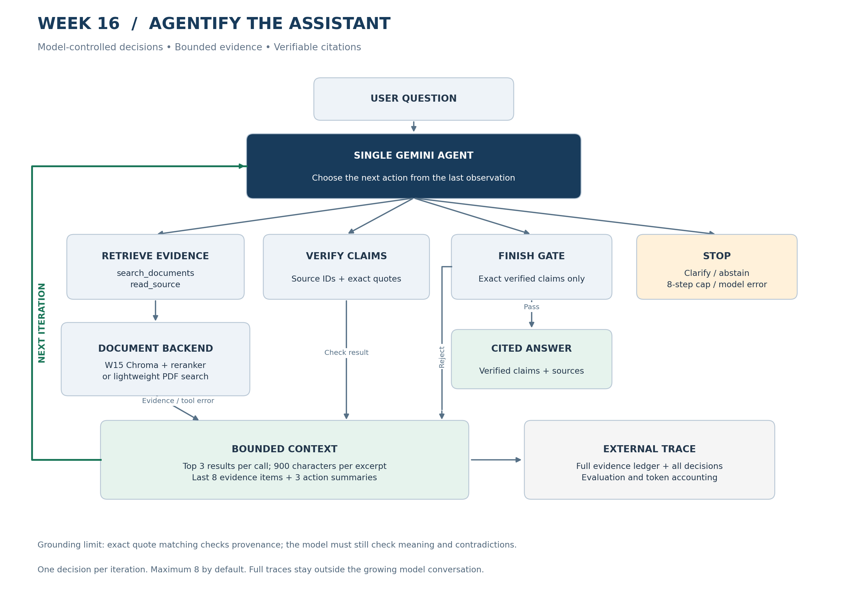

Evaluation output
The offline harness runs the production agent and document tools with a scripted decision model. The live harness uses Gemini on the same controlled excerpt corpus. These results do not measure full PDF retrieval or establish general model accuracy.
Measure | Offline | Current live run
Cases | 10 | 8
Expected behavior | 10/10 (100%) | 4/8 (50%)
Verified factual task completion | 5/10 (50%) | 2/8 (25%)
Tool call correctness | 24/24 (100%) | 11/11 (100%)
Mean decisions per case | 3.3 | 2.4
Unit and integration checks | 17/17 passed | Same codebase

Current live case results
Case | Status | Behavior | Observed issue
simple | completed | PASS | -
research | completed | PASS | -
revision | completed | FAIL | Content rubric
clarification | clarification | PASS | -
unsupported | abstained | PASS | -
conflict | error | FAIL | HTTP 429
timeout | error | FAIL | HTTP 429
malformed | error | FAIL | HTTP 429

The current full live report was overwritten by a rerun. Three later requests received HTTP 429 before the injected tool behavior could be observed. The correction case completed but failed its content rubric. A separately saved correction retry passed in three decisions with 1,773 reported tokens. Token usage for failed HTTP calls is unknown.
Failure injection is demonstrated by the offline timeout and malformed output cases. The timeout led to safe abstention; malformed retrieval was discarded before entering the evidence ledger, and the agent recovered by reading a source page. The harness logs hard, soft, and cascading soft failures.
Source outputs: evaluation/results/offline, evaluation/results/live, and evaluation/results/live-retry. Re-running live evaluation overwrites the live directory.

