**Andrew Tran**

**Computer Science 2253 Lab Experience Four**

**Objectives:**

1. Executing several Assembly language programs.
2. Manipulating bytes by doing direct offset referencing
3. Using the add and sub instructions
4. Utilizing predefined macros from the irvine32.inc library.

**Background Information**

A string of characters is simply an array of bytes. This allows the programmer to directly reference each element of a string by referencing each byte of the memory location by using an appropriate offset.

For example:

.DATA

stringPrompt BYTE “Hello There”

The above code generates an array of characters as follows:

|  |  |  |  |  |  |  |  |  |  |  |
| --- | --- | --- | --- | --- | --- | --- | --- | --- | --- | --- |
| H | e | l | l | o | T | h | e | r | e |  |

Note: Assembler does not automatically place the null character into the array. Therefore when defining strings in assembler it is necessary for the programmer to place the null terminator at the end of the string as follows:

stringPrompt BYTE “Hello There”, 0

The above code changes the array of characters as follows:

|  |  |  |  |  |  |  |  |  |  |  |
| --- | --- | --- | --- | --- | --- | --- | --- | --- | --- | --- |
| H | e | l | l | o | T | h | e | r | e | \0 |

To reference a particular byte in the string we can use the memory location with an offset. **To reference the letter e in Hello, use the notation [stringPrompt + 1].** *Note: The offset can be one since the label refers to a byte. Recall all memory is byte addressable.* Anything else requires a different computation which will be discussed in class.

Manipulation of direct memory storage is now possible using the notation [stringPrompt + n] where n is the offset into the memory block reserved.

Refer to page 612 in regards to the add assembler operation.

**What you are to do:**

1. Write an Assembly language program to convert a string consisting of all uppercase letters into lowercase letters. The string consist of exactly 5 uppercase letters. **Do not use a loop to perform this operation.** (Don't forget to null terminate the string). Display the string before it is converted from uppercase to lowercase and display the converted string to the monitor.  
     
   To display the string to the monitor, use the writestring macro found in irvine32.inc called writestring. To utilize a macro in Assembler the necessary registers specified in the documentation must be initialized to the correct values. To implement the writestring macro the 32 bit register edx must be initialized to the starting address of the label of the string which is returned by the statement OFFSET label name. Insert the following statements in your program before you change the string and after you change the string:

mov edx, OFFSET string ; where string is the data label

;associated with the string you created.

call WriteString

Copy the .asm program into a word document and paste the console window directly below your code.

INCLUDE Irvine32.inc

.data

string DB 'ABCDE',0

.code

main PROC

mov edx, OFFSET string

call WriteString

mov al, string

add al, 20h; converts to lowercase letter

mov string, al

mov al, [string+1]

add al, 20h; converts to lowercase letter

mov [string+1], al

mov al, [string+2]

add al, 20h; converts to lowercase letter

mov [string+2], al

mov al, [string + 3]

add al, 20h; converts to lowercase letter

mov[string + 3], al

mov al, [string + 4]

add al, 20h; converts to lowercase letter

mov[string + 4], al

mov edx, OFFSET string

call WriteString

exit

main ENDP

END main

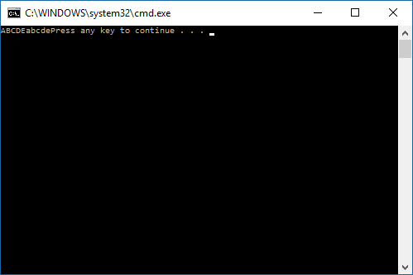

1. Write an Assembly language program to convert a string consisting of all lowercase letters into uppercase letters. The string will consist of exactly 5 lowercase letters. Do not use a loop to perform this operation. (Don't forget to null terminate the string). Display the string before it is converted from uppercase to lowercase and display the converted string to the monitor using the writestring macro described above.  
     
   Copy the .asm program into a word document and paste the console window directly below your code.

INCLUDE Irvine32.inc

.data

string DB 'abcde',0

.code

main PROC

mov edx, OFFSET string

call WriteString

mov al, string

and al, 0DFh; converts to uppercase letter

mov string, al

mov al, [string+1]

and al, 0DFh ; converts to uppercase letter

mov [string+1], al

mov al, [string+2]

and al, 0DFh; converts to uppercase letter

mov [string+2], al

mov al, [string + 3]

and al, 0DFh; converts to uppercase letter

mov[string + 3], al

mov al, [string + 4]

and al, 0DFh; converts to uppercase letter

mov[string + 4], al

mov edx, OFFSET string

call WriteString

exit

main ENDP

END main

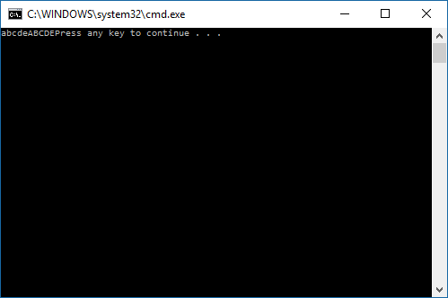

**What to hand in:**

1. Compress the programs created in steps 1-2 and your word document into a single file called {yourName}Lab4.zip. E.g. TimWrennLab4.zip.
2. Place the compressed file into the D2L dropbox labeled Lab4.
3. Hand-in a printout of your word document.