**Andrew Tran**

**Computer Science 2253 Lab Experience Six**

Objectives:

1. Writing loops in Assembler
2. Utilizing predefined macros from the irvine32.inc library.

The purpose of this lab is for you to create your own assembly language instructions. I recommend you load a project solution into Visual C++ express/studio so you do not have to reset the environment variables each time you are to create an assembler program.

NOTE: If you have changed the location of the Irvine libraries, you will have to correct the project properties settings of the project so Visual Studio can locate these files. The authors website contains detail instructions on this is accomplished. The website is <http://kipirvine.com/asm/gettingStarted/index.htm>

Pay close attention to the status flags since we will be using this to control the branching instructions, i.e. looping and decision.

**What you are to do:**

1. Do problems 1, 2, and 3 on page 137.

For each program copy the source code and paste the output window of the program below the source code in a word document.

Problem 1:

INCLUDE Irvine32.inc

.data

arr BYTE 43h,69h,11h,97h

convert DWORD ?

.code

main PROC

mov eax,DWORD PTR arr

mov convert,eax

call WriteHex

exit

main ENDP

END main

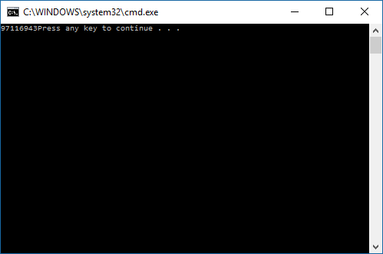

Problem 2:

INCLUDE Irvine32.inc

.data

arr DWORD 1,2,3,4

.code

main PROC

mov esi,0

mov ecx,2

L1:

mov eax, arr[esi]

mov ebx, arr[esi + 4]

mov arr[esi], ebx

mov arr[esi + 4], eax

add esi, 8

loop L1

mov esi, 0

mov ecx, 4

L2:

mov eax, arr[esi]

call WriteInt

add esi, 4

loop L2

exit

main ENDP

END main

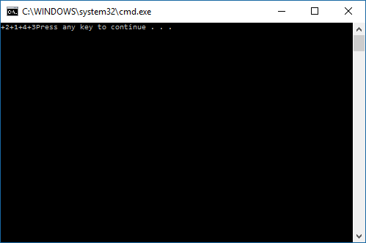

Problem 3:

INCLUDE Irvine32.inc

.data

arr DWORD 3,5,6,9,15

sum DWORD ?

.code

main PROC

mov eax, 0

mov esi, OFFSET arr

mov ecx, LENGTHOF arr - 1

L1:

add eax, [esi + 4]

sub eax, [esi]

add esi, TYPE arr

add sum, eax

loop L1

call WriteInt

exit

main ENDP

END main

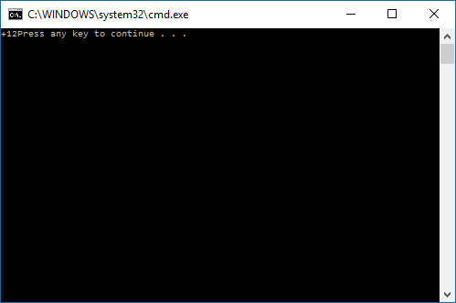

**What to hand in:**

1. Compress the .asm files and the word document into a single file called {yourName}Lab6.zip. For example TimWrennLab6.zip.
2. Place the compressed file into the D2L DropBox labeled Lab Six.
3. Hand-in hard copies of the programs created in step 1
4. Hand-in a hard copy of the word document.

Due Date: One week after your lab session.