**11/10/2018:**

**------------------------------------------------------------------------------------**

**Task 01:**

Youtube Link: https://www.youtube.com/watch?v=RJuA9G-wZw0

**Modified Schematic (if applicable):**

**Modified Code:**

**/\***

**\* ======== hello.c ========**

**\*/**

**/* TI-RTOS Header files */**

**#include <xdc/std.h>**

**#include <ti/sysbios/BIOS.h>**

**#include <ti/sysbios/knl/Task.h>**

**#include <ti/sysbios/knl/Clock.h>**

**#include <ti/drivers/GPIO.h>**

**/* Example/Board Header files */**

**#include "Board.h"**

**void myDelay(int count);**

**/* Could be anything, like computing primes */**

**#define FakeBlockingSlowWork() myDelay(12000000)**

**#define FakeBlockingFastWork() myDelay(2000000)**

**Task_Struct workTask;**

**/* Make sure we have nice 8-byte alignment on the stack to avoid wasting memory */**

**#pragma DATA_ALIGN(workTaskStack, 8)**

**#define STACKSIZE 1024**

**static uint8_t workTaskStack[STACKSIZE];**

**void doUrgentWork(void)**

**{**

**GPIO_write(Board_GPIO_LED1, Board_GPIO_LED_OFF);**

**FakeBlockingFastWork(); /* Pretend to do something useful but time-consuming */**

**GPIO_write(Board_GPIO_LED1, Board_GPIO_LED_ON);**

**}**

**void doWork(void)**

**{**

**GPIO_write(Board_GPIO_LED0, Board_GPIO_LED_OFF);**

**FakeBlockingSlowWork(); /* Pretend to do something useful but time-consuming */**

**GPIO_write(Board_GPIO_LED0, Board_GPIO_LED_ON);**

**}**

**Void workTaskFunc(UArg arg0, UArg arg1)**

**{**

**while (1) {**

**/* Do work */**

**doWork();**

**/* Wait a while, because doWork should be a periodic thing, not continuous.*/**

**myDelay(24000000);**

**}**

**}**

**Void urgentworkTaskFunc(UArg arg0, UArg arg1)**

**{**

**while (1) {**

**/* Do work */**

**doUrgentWork();**

**/* Wait a while, because doWork should be a periodic thing, not continuous.*/**

**myDelay(24000000);**

**}**

**}**

**/\***

**\* ======== main ========**

**\***

**\*/**

**int main(void)**

**{**

**Board_initGeneral();**

**GPIO_init();**

**/* Set up the led task */**

**Task_Params workTaskParams;**

**Task_Params_init(&workTaskParams);**

**workTaskParams.stackSize = STACKSIZE;**

**workTaskParams.priority = 3;**

**workTaskParams.stack = &workTaskStack;**

**Task_construct(&workTask, workTaskFunc, &workTaskParams, NULL);**

**/* Start kernel. */**

**BIOS_start();**

**return (0);**

**}**

**/\***

**\* ======== myDelay ========**

**\* Assembly function to delay. Decrements the count until it is zero**

**\* The exact duration depends on the processor speed.**

**\*/**

**__asm(" .sect \".text:myDelay\"\n"**

**" .clink\n"**

**" .thumbfunc myDelay\n"**

**" .thumb\n"**

**" .global myDelay\n"**

**"myDelay:\n"**

**" subs r0, #1\n"**

**" bne.n myDelay\n"**

**" bx lr\n");**

**------------------------------------------------------------------------------------**

**Task 02:**

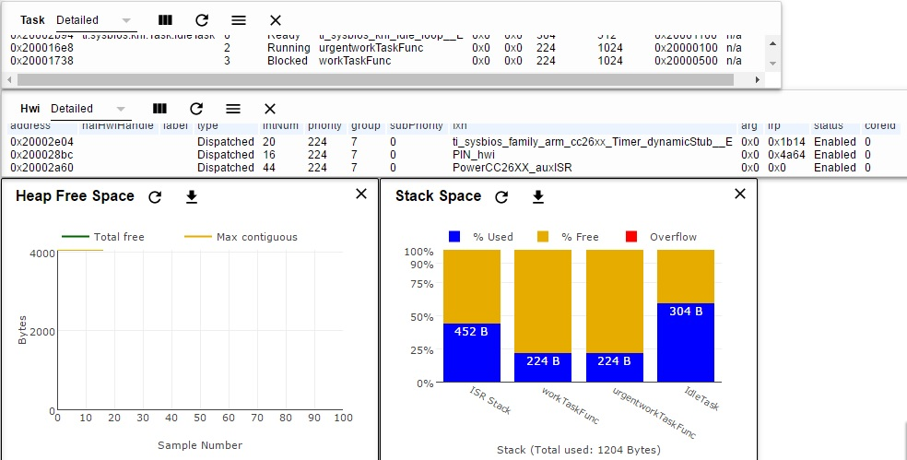

Runtime Object View

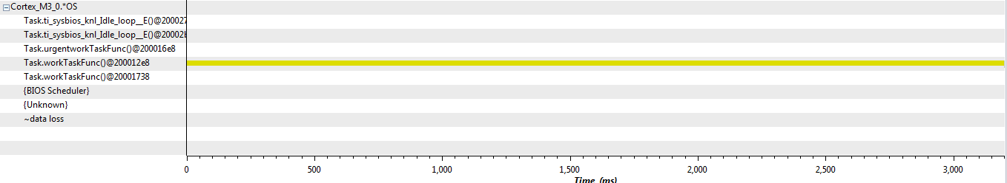

**Execution Graph**

**------------------------------------------------------------------------------------**

**Task 03:**

Youtube Link:

**Modified Schematic (if applicable):**

**Modified Code:**

**/\***

**\* ======== hello.c ========**

**\*/**

**/* TI-RTOS Header files */**

**#include <xdc/std.h>**

**#include <ti/sysbios/BIOS.h>**

**#include <ti/sysbios/knl/Task.h>**

**#include <ti/sysbios/knl/Clock.h>**

**#include <ti/drivers/GPIO.h>**

**/* Example/Board Header files */**

**#include "Board.h"**

**void myDelay(int count);**

**/* Could be anything, like computing primes */**

**#define FakeBlockingSlowWork() myDelay(12000000)**

**#define FakeBlockingFastWork() myDelay(2000000)**

**Task_Struct workTask;**

**/* Make sure we have nice 8-byte alignment on the stack to avoid wasting memory */**

**#pragma DATA_ALIGN(workTaskStack, 8)**

**#define STACKSIZE 1024**

**static uint8_t workTaskStack[STACKSIZE];**

**void doUrgentWork(void)**

**{**

**GPIO_write(Board_GPIO_LED1, Board_GPIO_LED_OFF);**

**FakeBlockingFastWork(); /* Pretend to do something useful but time-consuming */**

**GPIO_write(Board_GPIO_LED1, Board_GPIO_LED_ON);**

**}**

**void doWork(void)**

**{**

**GPIO_write(Board_GPIO_LED0, Board_GPIO_LED_OFF);**

**FakeBlockingSlowWork(); /* Pretend to do something useful but time-consuming */**

**GPIO_write(Board_GPIO_LED0, Board_GPIO_LED_ON);**

**}**

**Void workTaskFunc(UArg arg0, UArg arg1)**

**{**

**while (1) {**

**/* Do work */**

**doWork();**

**/* Wait a while, because doWork should be a periodic thing, not continuous.*/**

**//myDelay(24000000);**

**Task_sleep(500 * (1000 / Clock_tickPeriod));**

**}**

**}**

**Void urgentworkTaskFunc(UArg arg0, UArg arg1)**

**{**

**while (1) {**

**/* Do work */**

**doUrgentWork();**

**/* Wait a while, because doWork should be a periodic thing, not continuous.*/**

**//myDelay(24000000);**

**Task_sleep(50 * (1000 / Clock_tickPeriod));**

**}**

**}**

**/\***

**\* ======== main ========**

**\***

**\*/**

**int main(void)**

**{**

**Board_initGeneral();**

**GPIO_init();**

**/* Set up the led task */**

**Task_Params workTaskParams;**

**Task_Params_init(&workTaskParams);**

**workTaskParams.stackSize = STACKSIZE;**

**workTaskParams.priority = 3;**

**workTaskParams.stack = &workTaskStack;**

**Task_construct(&workTask, workTaskFunc, &workTaskParams, NULL);**

**/* Start kernel. */**

**BIOS_start();**

**return (0);**

**}**

**/\***

**\* ======== myDelay ========**

**\* Assembly function to delay. Decrements the count until it is zero**

**\* The exact duration depends on the processor speed.**

**\*/**

**__asm(" .sect \".text:myDelay\"\n"**

**" .clink\n"**

**" .thumbfunc myDelay\n"**

**" .thumb\n"**

**" .global myDelay\n"**

**"myDelay:\n"**

**" subs r0, #1\n"**

**" bne.n myDelay\n"**

**" bx lr\n");**

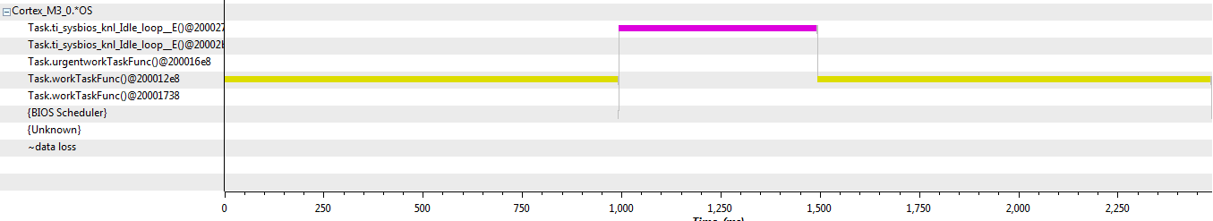

**Execution Graph**

**------------------------------------------------------------------------------------**

**Task 04:**

Youtube Link:

**Modified Schematic (if applicable):**

**Modified Code:**

**/\***

**\* ======== hello.c ========**

**\*/**

**/* TI-RTOS Header files */**

**#include <xdc/std.h>**

**#include <ti/sysbios/BIOS.h>**

**#include <ti/sysbios/knl/Task.h>**

**#include <ti/sysbios/knl/Clock.h>**

**#include <ti/drivers/GPIO.h>**

**/* Example/Board Header files */**

**#include "Board.h"**

**void myDelay(int count);**

**/* Could be anything, like computing primes */**

**#define FakeBlockingSlowWork() myDelay(12000000)**

**#define FakeBlockingFastWork() myDelay(2000000)**

**Task_Struct workTask;**

**/* Make sure we have nice 8-byte alignment on the stack to avoid wasting memory */**

**#pragma DATA_ALIGN(workTaskStack, 8)**

**#define STACKSIZE 1024**

**static uint8_t workTaskStack[STACKSIZE];**

**Task_Struct urgentTask;**

**/* Make sure we have nice 8-byte alignment on the stack to avoid wasting memory */**

**#pragma DATA_ALIGN(urgentTaskStack, 8)**

**#define STACKSIZE 1024**

**static uint8_t urgentTaskStack[STACKSIZE];**

**void doUrgentWork(void)**

**{**

**GPIO_write(Board_GPIO_LED1, Board_GPIO_LED_OFF);**

**FakeBlockingFastWork(); /* Pretend to do something useful but time-consuming */**

**GPIO_write(Board_GPIO_LED1, Board_GPIO_LED_ON);**

**}**

**void doWork(void)**

**{**

**GPIO_write(Board_GPIO_LED0, Board_GPIO_LED_OFF);**

**FakeBlockingSlowWork(); /* Pretend to do something useful but time-consuming */**

**GPIO_write(Board_GPIO_LED0, Board_GPIO_LED_ON);**

**}**

**Void workTaskFunc(UArg arg0, UArg arg1)**

**{**

**while (1) {**

**/* Do work */**

**doWork();**

**/* Wait a while, because doWork should be a periodic thing, not continuous.*/**

**//myDelay(24000000);**

**Task_sleep(500 * (1000 / Clock_tickPeriod));**

**}**

**}**

**Void urgentworkTaskFunc(UArg arg0, UArg arg1)**

**{**

**while (1) {**

**/* Do work */**

**doUrgentWork();**

**/* Wait a while, because doWork should be a periodic thing, not continuous.*/**

**//myDelay(24000000);**

**Task_sleep(50 * (1000 / Clock_tickPeriod));**

**}**

**}**

**/\***

**\* ======== main ========**

**\***

**\*/**

**int main(void)**

**{**

**Board_initGeneral();**

**GPIO_init();**

**/* Set up the urgent task */**

**Task_Params urgentTaskParams;**

**Task_Params_init(&urgentTaskParams);**

**urgentTaskParams.stackSize = STACKSIZE;**

**urgentTaskParams.priority = 2;**

**urgentTaskParams.stack = &urgentTaskStack;**

**Task_construct(&urgentTask, urgentworkTaskFunc, &urgentTaskParams, NULL);**

**/* Set up the led task */**

**Task_Params workTaskParams;**

**Task_Params_init(&workTaskParams);**

**workTaskParams.stackSize = STACKSIZE;**

**workTaskParams.priority = 3;**

**workTaskParams.stack = &workTaskStack;**

**Task_construct(&workTask, workTaskFunc, &workTaskParams, NULL);**

**/* Start kernel. */**

**BIOS_start();**

**return (0);**

**}**

**/\***

**\* ======== myDelay ========**

**\* Assembly function to delay. Decrements the count until it is zero**

**\* The exact duration depends on the processor speed.**

**\*/**

**__asm(" .sect \".text:myDelay\"\n"**

**" .clink\n"**

**" .thumbfunc myDelay\n"**

**" .thumb\n"**

**" .global myDelay\n"**

**"myDelay:\n"**

**" subs r0, #1\n"**

**" bne.n myDelay\n"**

**" bx lr\n");**

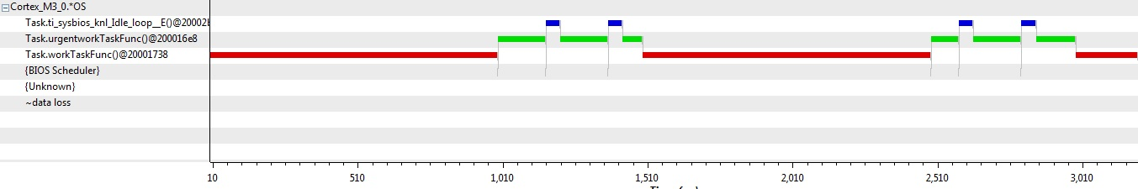

**Execution Graph**

**------------------------------------------------------------------------------------**