**12/3/2018:**

**------------------------------------------------------------------------------------**

**Task 01:**

Youtube Link: <https://www.youtube.com/watch?v=IlFRtgm05vw>

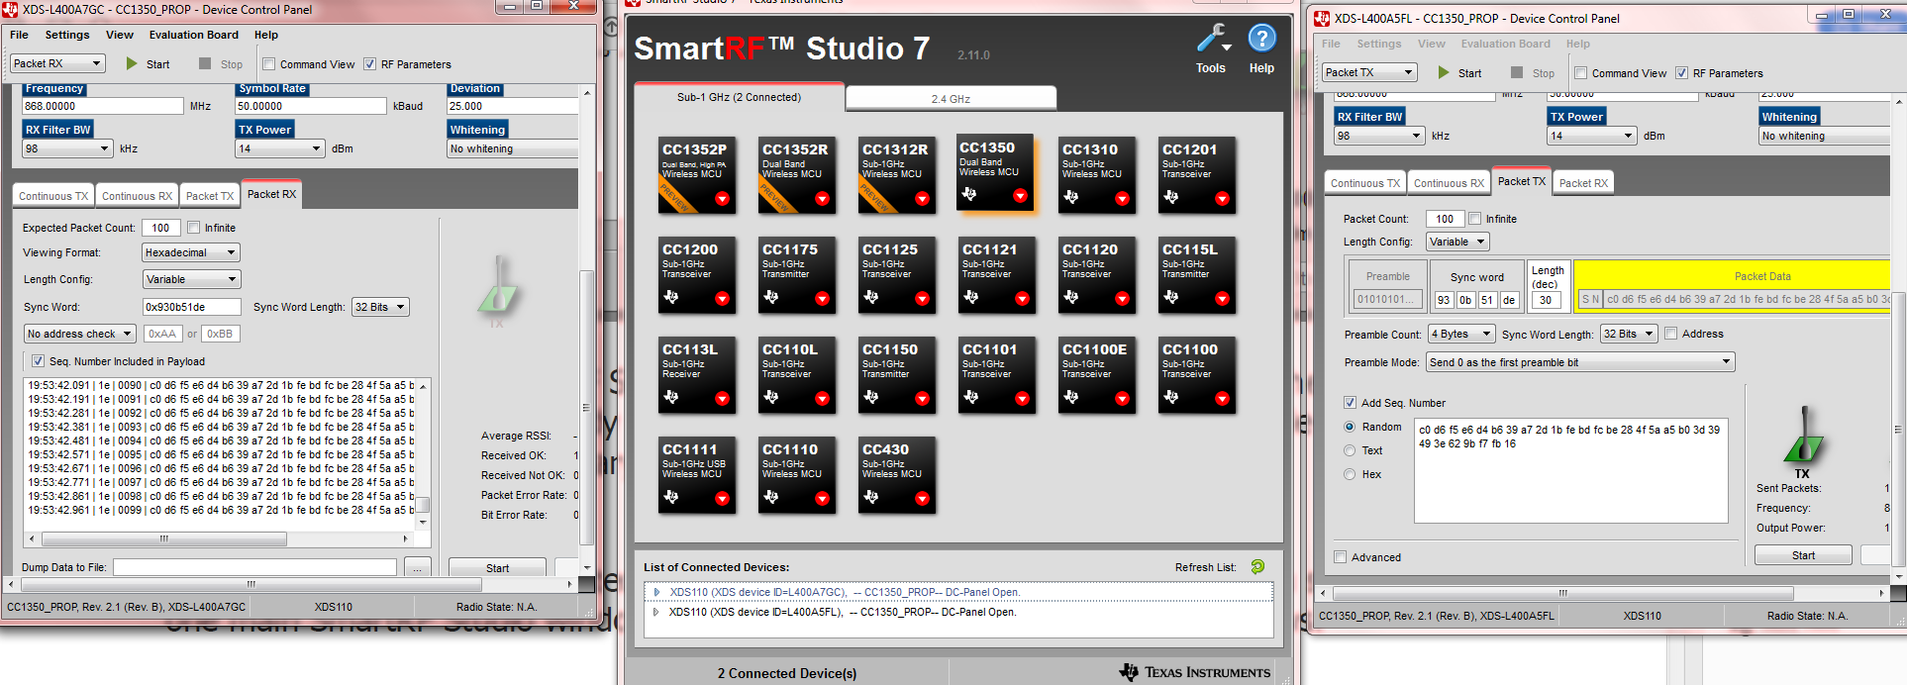

**SmartRF TX and RX**

**------------------------------------------------------------------------------------**

**Task 02:**

**------------------------------------------------------------------------------------**

**Task 03:**

Youtube Link: https://www.youtube.com/watch?v=RbiiwNO-ORw

**------------------------------------------------------------------------------------**

**Task 04:**

Youtube Link: https://www.youtube.com/watch?v=x9ErL-dstz4

**------------------------------------------------------------------------------------**

**Task 05:**

**------------------------------------------------------------------------------------**

**Task 06:**

Youtube Link: https://www.youtube.com/watch?v=NqO9iQP-ICc

**------------------------------------------------------------------------------------**

**Task 07:**

Youtube Link: https://www.youtube.com/watch?v=mt_fyVOqcz0

**------------------------------------------------------------------------------------**