**12/3/2018:**

**------------------------------------------------------------------------------------**

**Task 01:**

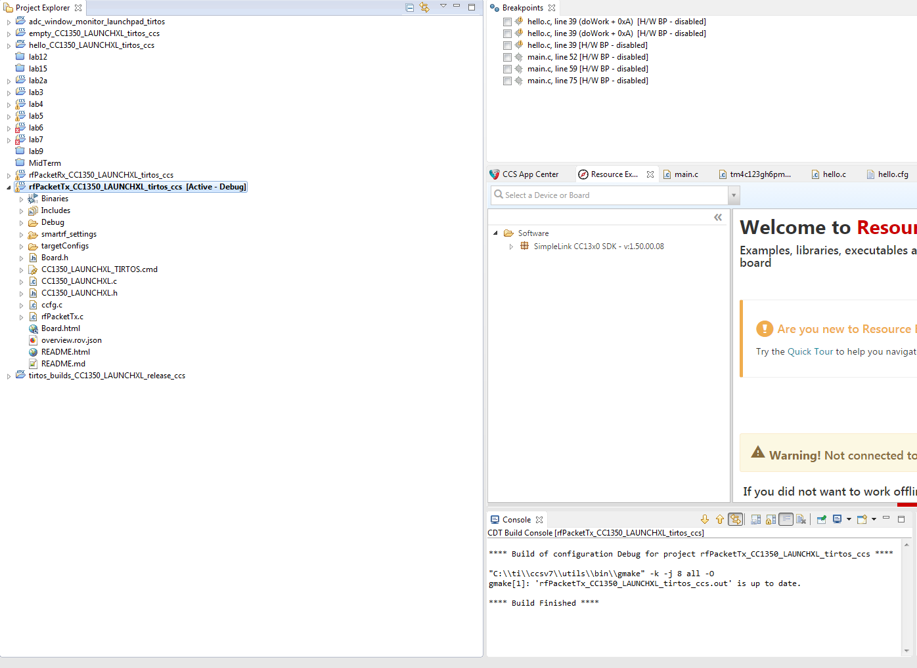

**Code imported**

**------------------------------------------------------------------------------------**

**Task 02:**

Youtube Link: https://www.youtube.com/watch?v=XHExW1-XfZE

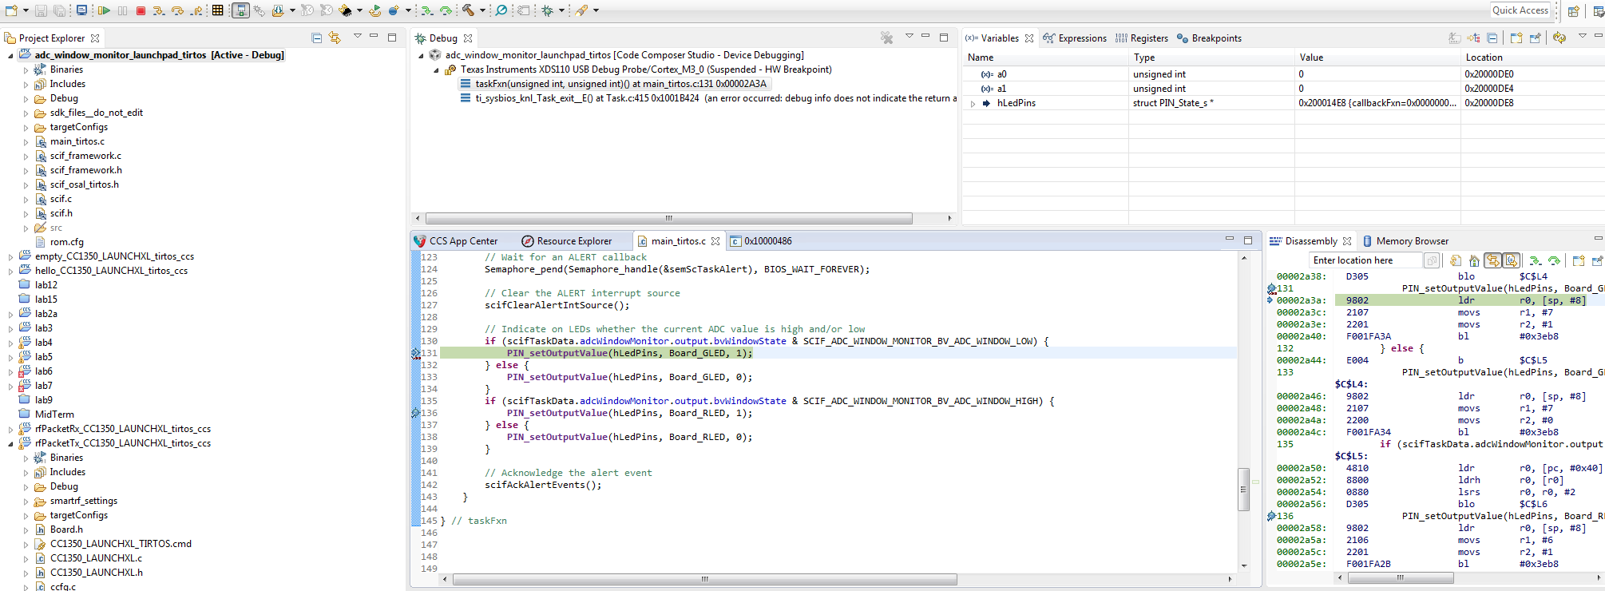

Debug run

**------------------------------------------------------------------------------------**

**Task 03:**

Youtube Link: https://www.youtube.com/watch?v=I-qeld5Eyvc

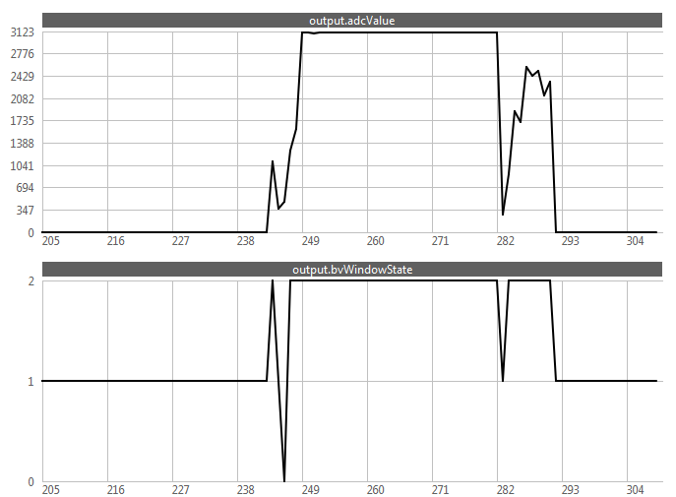

**ADC Output**

**------------------------------------------------------------------------------------**