**10/9/2018:**

**Task 00: Execute provided code**

**------------------------------------------------------------------------------------**

**Task 01:**

Youtube Link: https://www.youtube.com/watch?v=XMVn6frWZVY

**Modified Code:**

**#include <stdint.h>**

**#include <stdbool.h>**

**#include "inc/hw_memmap.h"**

**#include "inc/hw_types.h"**

**#include "inc/tm4c123gh6pm.h"**

**#include "driverlib/debug.h"**

**#include "driverlib/sysctl.h"**

**#include "driverlib/adc.h"**

**#include "driverlib/gpio.h"**

**#include "driverlib/interrupt.h"**

**#include "driverlib/timer.h"**

**#define TARGET_IS_BLIZZARD_RB1**

**#include "driverlib/rom.h"**

**volatile uint32_t ui32TempAvg;**

**volatile uint32_t ui32TempValueC;**

**volatile uint32_t ui32TempValueF;**

**int main(void)**

**{**

**uint32_t ui32Period;**

**// set clock**

**ROM_SysCtlClockSet(SYSCTL_SYSDIV_5|SYSCTL_USE_PLL|SYSCTL_OSC_MAIN|SYSCTL_XTAL_16MHZ);**

**// enable ADC and Port F**

**ROM_SysCtlPeripheralEnable(SYSCTL_PERIPH_ADC0);**

**ROM_SysCtlPeripheralEnable(SYSCTL_PERIPH_GPIOF);**

**ROM_GPIOPinTypeGPIOOutput(GPIO_PORTF_BASE, GPIO_PIN_1|GPIO_PIN_2|GPIO_PIN_3);**

**ROM_ADCHardwareOversampleConfigure(ADC0_BASE, 32);**

**// enable timer1**

**SysCtlPeripheralEnable(SYSCTL_PERIPH_TIMER1);**

**TimerConfigure(TIMER1_BASE, TIMER_CFG_PERIODIC);**

**// configure ADC**

**ROM_ADCSequenceConfigure(ADC0_BASE, 2, ADC_TRIGGER_PROCESSOR, 0);**

**ROM_ADCSequenceStepConfigure(ADC0_BASE, 2, 0, ADC_CTL_TS);**

**ROM_ADCSequenceStepConfigure(ADC0_BASE, 2, 1, ADC_CTL_TS);**

**ROM_ADCSequenceStepConfigure(ADC0_BASE, 2, 2, ADC_CTL_TS);**

**ROM_ADCSequenceStepConfigure(ADC0_BASE,2,3,ADC_CTL_TS|ADC_CTL_IE|ADC_CTL_END);**

**ROM_ADCSequenceEnable(ADC0_BASE, 2);**

**//calculate period**

**ui32Period = (SysCtlClockGet() / 2);**

**TimerLoadSet(TIMER1_BASE, TIMER_A, ui32Period -1);**

**// enable timer interrupt**

**IntEnable(INT_TIMER1A);**

**TimerIntEnable(TIMER1_BASE, TIMER_TIMA_TIMEOUT);**

**IntMasterEnable();**

**// start timer1**

**TimerEnable(TIMER1_BASE, TIMER_A);**

**// turn off LED**

**ROM_GPIOPinWrite(GPIO_PORTF_BASE, GPIO_PIN_3, 0);**

**while(1)**

**{**

**}**

**}**

**void Timer1IntHandler(void)**

**{**

**// Clear the timer interrupt**

**TimerIntClear(TIMER1_BASE, TIMER_TIMA_TIMEOUT);**

**uint32_t ui32ADC0Value[4];**

**// clear ADC and then start it**

**ROM_ADCIntClear(ADC0_BASE, 2);**

**ROM_ADCProcessorTrigger(ADC0_BASE, 2);**

**// wait until ADC is finished**

**while(!ROM_ADCIntStatus(ADC0_BASE, 2, false))**

**{**

**}**

**// grab ADC data**

**ROM_ADCSequenceDataGet(ADC0_BASE, 2, ui32ADC0Value);**

**// calculate Temp**

**ui32TempAvg = (ui32ADC0Value[0] + ui32ADC0Value[1] + ui32ADC0Value[2] + ui32ADC0Value[3] + 2)/4;**

**ui32TempValueC = (1475 - ((2475 * ui32TempAvg)) / 4096)/10;**

**ui32TempValueF = ((ui32TempValueC * 9) + 160) / 5;**

**// check temp and update LED**

**if(ui32TempValueF>=72) {**

**ROM_GPIOPinWrite(GPIO_PORTF_BASE, GPIO_PIN_3, 8);**

**} else {**

**ROM_GPIOPinWrite(GPIO_PORTF_BASE, GPIO_PIN_3, 0);**

**}**

**}**

**Temp Graph**

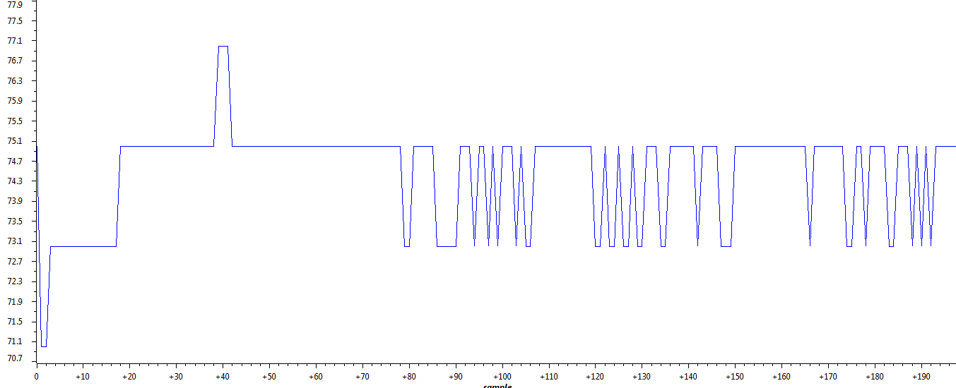

**------------------------------------------------------------------------------------**

**Task 02:**

Youtube Link: https://www.youtube.com/watch?v=k9oGZZJ_4dI

**Modified Schematic (if applicable):**

**Modified Code:**

**#include <stdint.h>**

**#include <stdbool.h>**

**#include "inc/hw_memmap.h"**

**#include "inc/hw_types.h"**

**#include "inc/tm4c123gh6pm.h"**

**#include "driverlib/debug.h"**

**#include "driverlib/sysctl.h"**

**#include "driverlib/adc.h"**

**#include "driverlib/gpio.h"**

**#include "driverlib/interrupt.h"**

**#include "driverlib/timer.h"**

**#define TARGET_IS_BLIZZARD_RB1**

**#include "driverlib/rom.h"**

**volatile uint32_t ui32TempAvg;**

**volatile uint32_t ui32TempValueC;**

**volatile uint32_t ui32TempValueF;**

**int main(void)**

**{**

**uint32_t ui32Period;**

**// set clock**

**ROM_SysCtlClockSet(SYSCTL_SYSDIV_5|SYSCTL_USE_PLL|SYSCTL_OSC_MAIN|SYSCTL_XTAL_16MHZ);**

**// enable ADC and Port F**

**ROM_SysCtlPeripheralEnable(SYSCTL_PERIPH_ADC0);**

**ROM_SysCtlPeripheralEnable(SYSCTL_PERIPH_GPIOF);**

**ROM_GPIOPinTypeGPIOOutput(GPIO_PORTF_BASE, GPIO_PIN_1|GPIO_PIN_2|GPIO_PIN_3);**

**ROM_ADCHardwareOversampleConfigure(ADC0_BASE, 32);**

**// enable timer1**

**SysCtlPeripheralEnable(SYSCTL_PERIPH_TIMER1);**

**TimerConfigure(TIMER1_BASE, TIMER_CFG_PERIODIC);**

**// configure ADC**

**ROM_ADCSequenceConfigure(ADC0_BASE, 2, ADC_TRIGGER_PROCESSOR, 0);**

**ROM_ADCSequenceStepConfigure(ADC0_BASE, 2, 0, ADC_CTL_TS);**

**ROM_ADCSequenceStepConfigure(ADC0_BASE, 2, 1, ADC_CTL_TS);**

**ROM_ADCSequenceStepConfigure(ADC0_BASE, 2, 2, ADC_CTL_TS);**

**ROM_ADCSequenceStepConfigure(ADC0_BASE,2,3,ADC_CTL_TS|ADC_CTL_IE|ADC_CTL_END);**

**ROM_ADCSequenceEnable(ADC0_BASE, 2);**

**//calculate period**

**ui32Period = (SysCtlClockGet() / 2);**

**TimerLoadSet(TIMER1_BASE, TIMER_A, ui32Period -1);**

**// enable timer interrupt**

**IntEnable(INT_TIMER1A);**

**TimerIntEnable(TIMER1_BASE, TIMER_TIMA_TIMEOUT);**

**IntMasterEnable();**

**// start timer1**

**TimerEnable(TIMER1_BASE, TIMER_A);**

**// turn off LED**

**ROM_GPIOPinWrite(GPIO_PORTF_BASE, GPIO_PIN_3, 0);**

**while(1)**

**{**

**}**

**}**

**void Timer1IntHandler(void)**

**{**

**// Clear the timer interrupt**

**TimerIntClear(TIMER1_BASE, TIMER_TIMA_TIMEOUT);**

**uint32_t ui32ADC0Value[4];**

**// clear ADC and then start it**

**ROM_ADCIntClear(ADC0_BASE, 2);**

**ROM_ADCProcessorTrigger(ADC0_BASE, 2);**

**// wait until ADC is finished**

**while(!ROM_ADCIntStatus(ADC0_BASE, 2, false))**

**{**

**}**

**// grab ADC data**

**ROM_ADCSequenceDataGet(ADC0_BASE, 2, ui32ADC0Value);**

**// calculate Temp**

**ui32TempAvg = (ui32ADC0Value[0] + ui32ADC0Value[1] + ui32ADC0Value[2] + ui32ADC0Value[3] + 2)/4;**

**ui32TempValueC = (1475 - ((2475 * ui32TempAvg)) / 4096)/10;**

**ui32TempValueF = ((ui32TempValueC * 9) + 160) / 5;**

**// check temp and update LED**

**if(ui32TempValueF>=72) {**

**ROM_GPIOPinWrite(GPIO_PORTF_BASE, GPIO_PIN_3, 8);**

**} else {**

**ROM_GPIOPinWrite(GPIO_PORTF_BASE, GPIO_PIN_3, 0);**

**}**

**}**

**Temp Graph**



