Jacob Sherman

Venkatesan Muthukumar

CPE 403

12/12/2018

Linux Gateway

**Problem Statement:**

The objective of this project is to show an understanding of the Beaglebone Black as well as an understanding of the CC1350. The project also shows the skills to create a sensor network and to collect and display the data from the sensors.

**pre-requisites:**

Components, tools, software used in the design, install steps etc.

COMPONENTS

2xCC1350

1xBeaglebone Black

1xSD card

3xUSB Cables

Ethernet Cable

FTDI cable

SOFTWARE

Uniflash

TI 15.4-Stack Linux Gateway SDK

Tera Term

Win32DiskImager

**implementation details:**

Steps in implementation all steps with reference to codes and software

STEP 1: Use uniflash to program the “sensor” launchpad

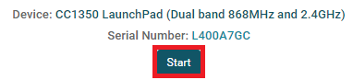

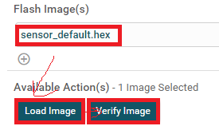

STEP 2: Use uniflash to profram the “Mac-Cop” launchpad

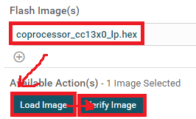

Step 3: Burn am335x-evm-linux-05.01.00.11.img to the SD card with Win32DiskImager

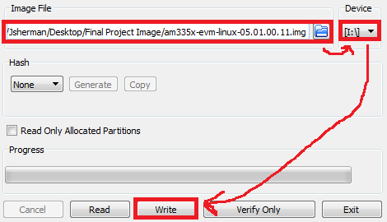

Step 4: Install the Linux Gateway SDK to your computer.

Step 5: Connect FTDI cable to the Beaglebone Black and connect the USB end to your computer

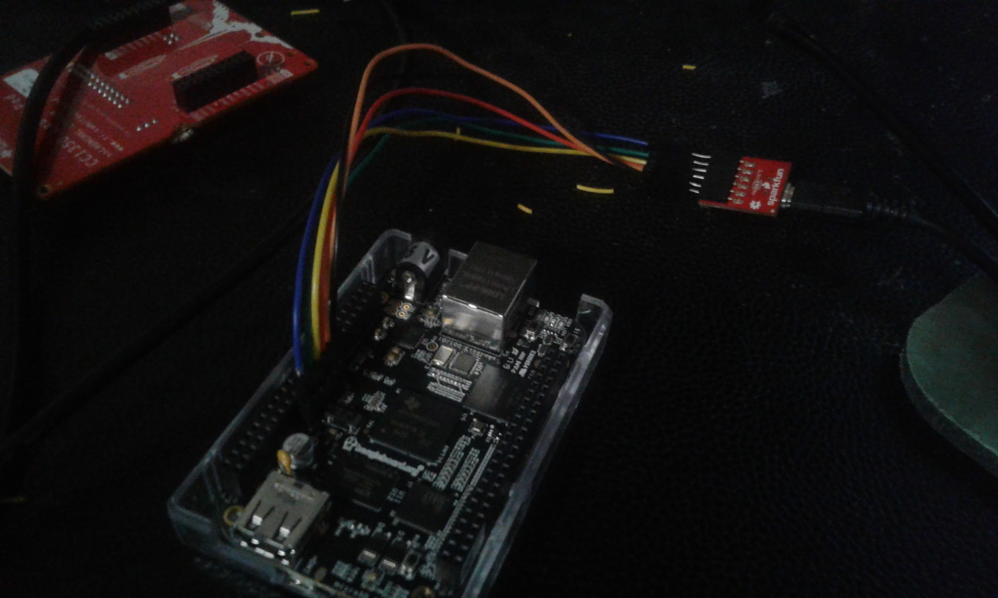

Step 6: Run Tera Term and connect it to the FTDI’s com port and set the baud rate to 115200, 8 data bits, no parity, 1 stop bit, no flow control

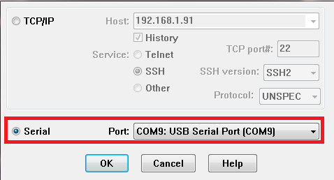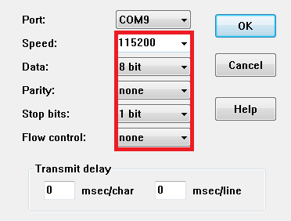

Step 7: Connect the ethernet cable and insert the SD card into the Beaglebone Black.

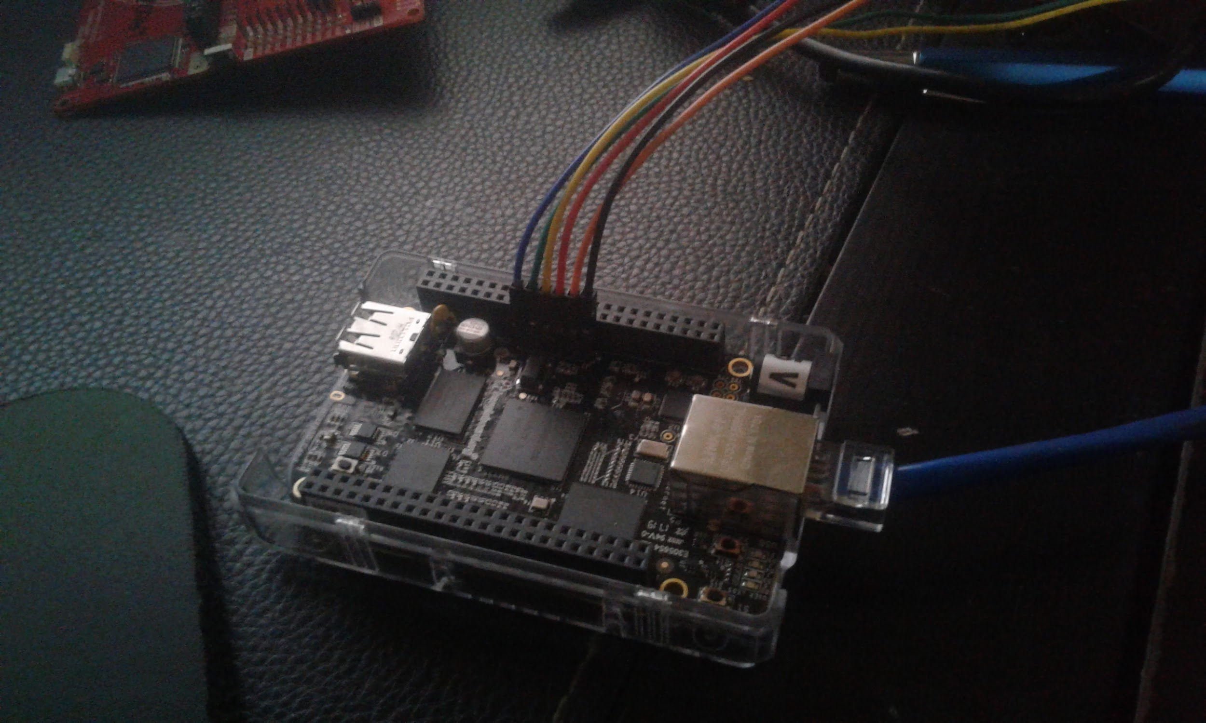

Step 8: Press and hold the boot select button for a few seconds while supplying power to the Beaglebone Black then let go. In 5 to 10 seconds the LEDs should start flashing.

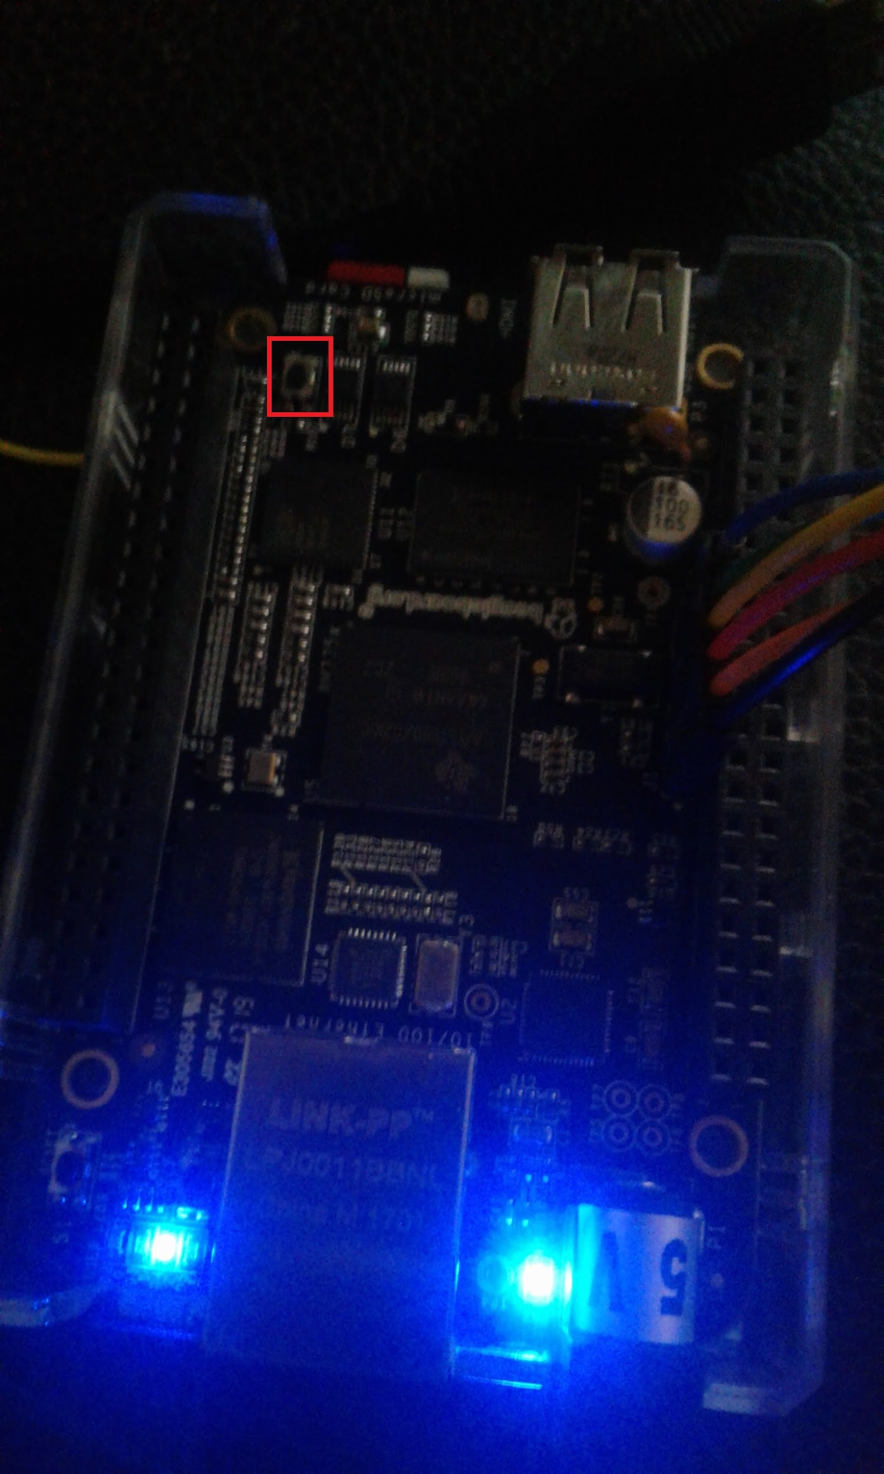

Step 9: Once the Beaglebone Black is up and running the terminal should show the Arago Project Welcome message. The username is root.

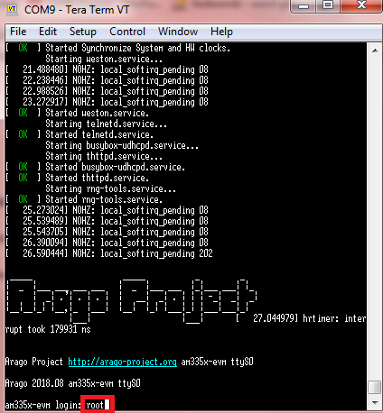

Step 10: Use the ifconfig command to get the ip address of the Beaglebone Black. Then open another terminal to ssh to that ip address.

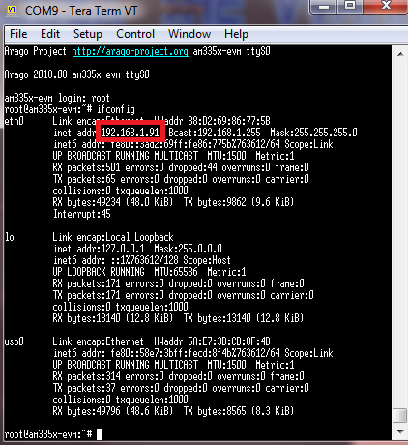

Step 11: Locate the bbb_prebuilt.tar.gz file in the Linux Gateway SDK. bbb_prebuilt.tar.gz should be in the prebuilt directory inside the main SDK folder which is by default installed to ~/ti/ti154stack_linux_x64_2_07_00_16/.

Copy this file over to the Beaglebone Black. You can either use a flash drive or you can scp it through the network if the Beaglebone Black is connected to the same network as the computer you installed to.

Step 12: On the Beaglebone Black, extract bbb_prebuilt.tar.gz

Step 13: Next connect the MAC-CoP Launchpad to the Beaglebone Black using a USB cable. After a few seconds you can check and see if the MAC-CoP connected properly by typing

ls -l /dev/ttyACM*

If it shows both /dev/ttyACM0 and /dev/ttyACM1 then it should be connected properly. If it shows a different number than you may need to change ttyACM0 to a different number in prebuilt/bin/collector.cfg

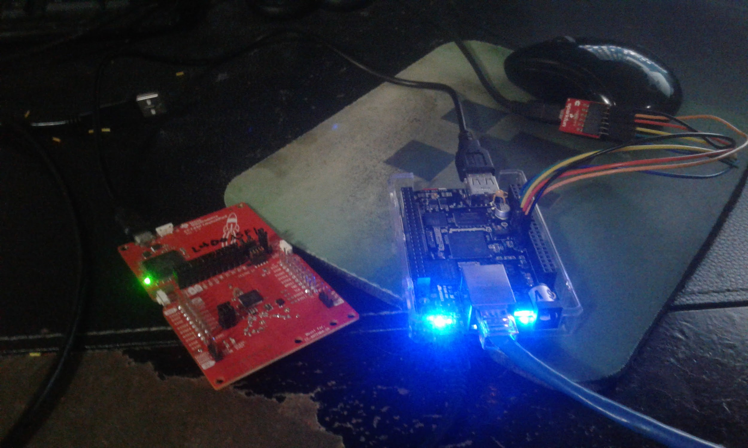



Step 14: So there is actually an error in the bash file used to start the application. This file is run_demo.sh It should be located in the prebuilt folder. You will need to edit it and change GATEWAY_DIR=${HERE}/gateway to GATEWAY_DIR=${HERE}/gateway/gateway. This is because when the bbb_prebuilt.tar.gz is extracted it extracts run_gateway.sh to prebuilt/gateway/gateway and not to prebuilt/gateway.

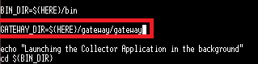

Step 15: Now with that error fixed you should be able to run the application by making sure you are in the prebuilt directory and using ./run_demo.sh. After typing that it should display on the terminal that it is running the application and some tasks. Eventually it will display the address of the collector app. It should be at http://<Beaglebone’s ip address>:1310 Copy the URL to your web browser and you should see the collector app.

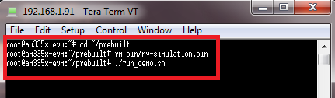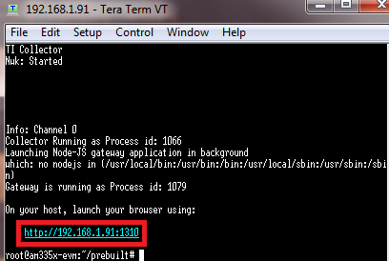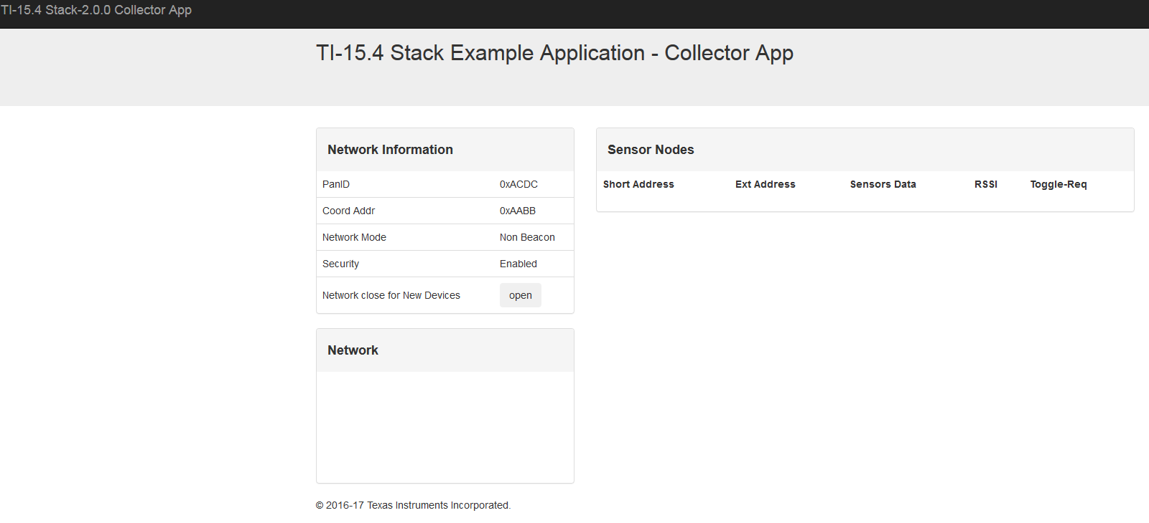

Step 16: Now connect the sensor launchboard to a power source using a USB and then reset it to factory default by pressing and holding button 2 and then pressing and releasing the reset button before releasing button 2.

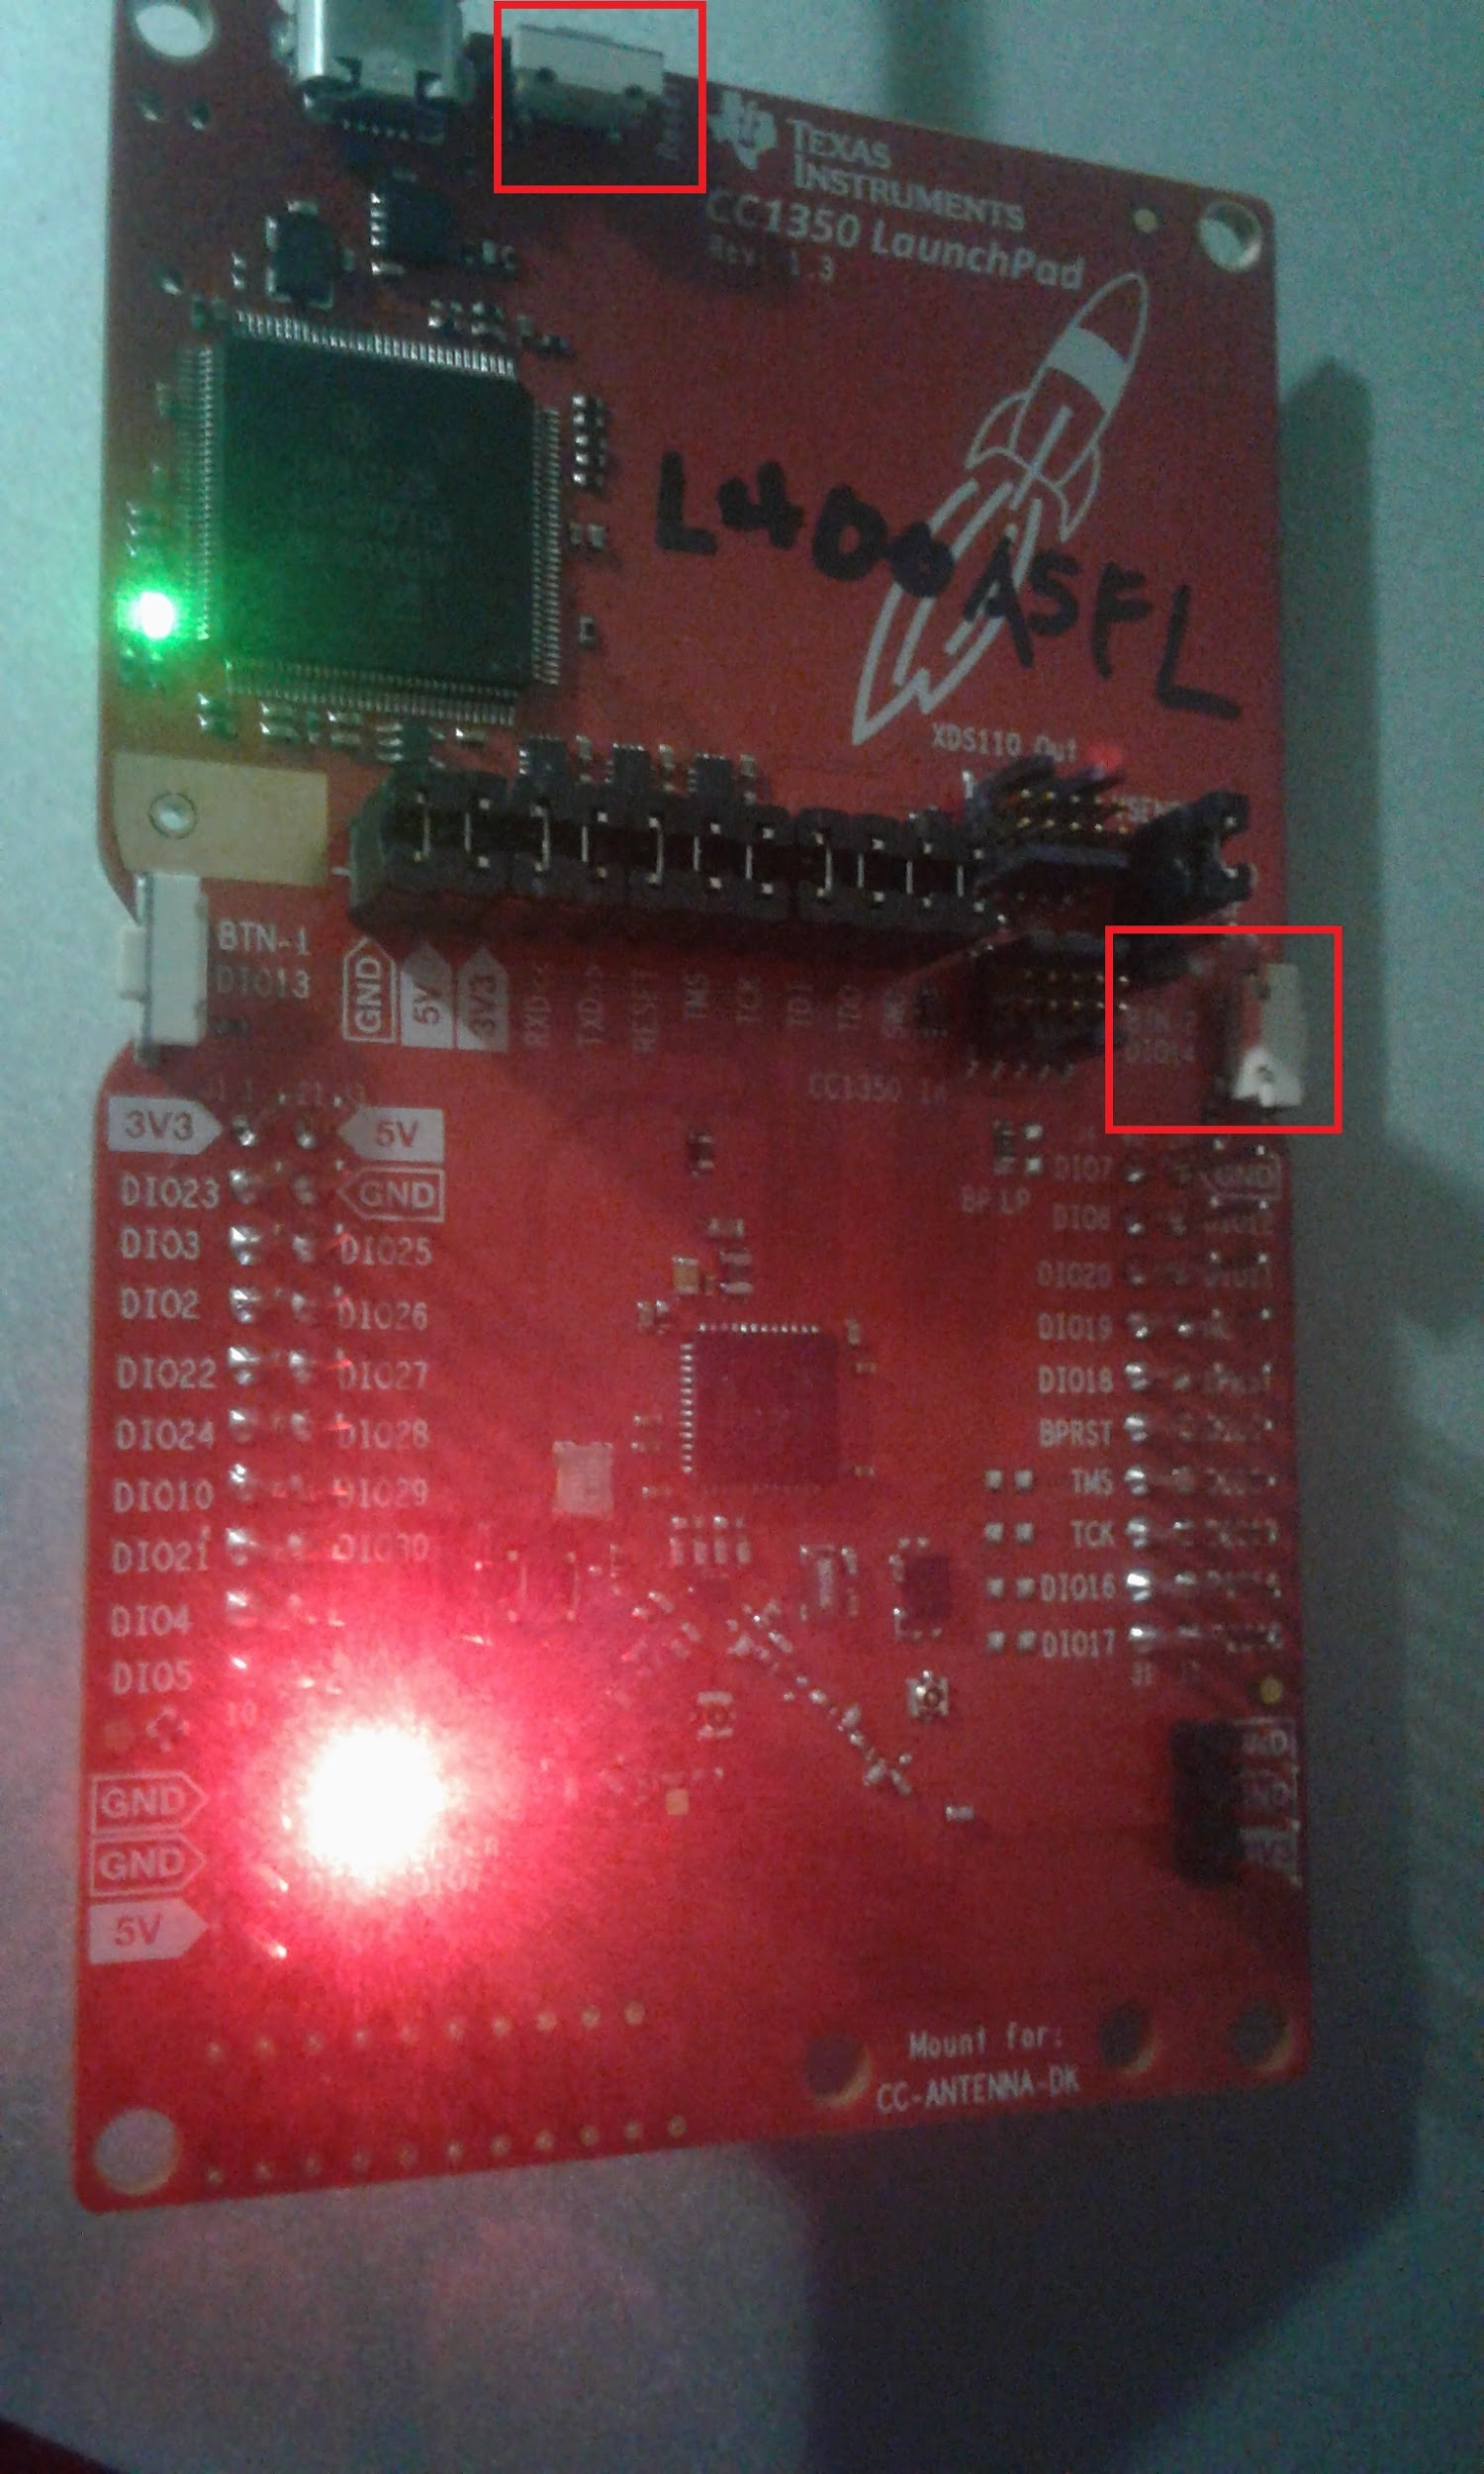

Step 17: Now press the open button on the collector app. Within a few seconds the sensor launchpad should connect and appear on the collector app. You can press LED toggle to turn the green LED on the Sensor on and off. It can sometimes have a few seconds of delay.

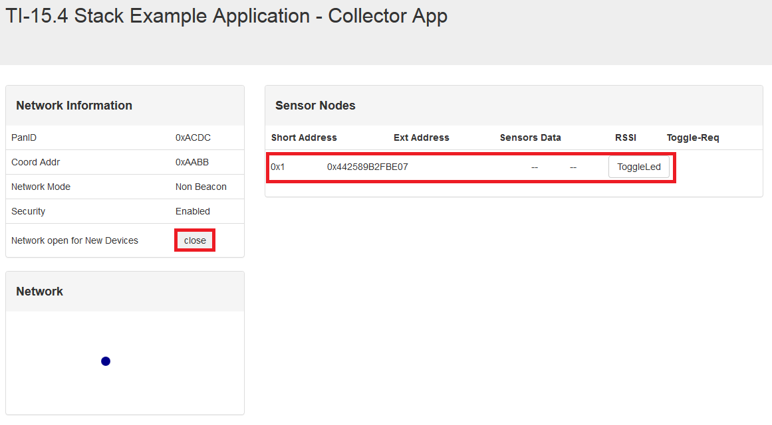

STEP 18: Wait for temperature data to appear. For whatever reason in my tests they do not and the boards sometimes disconnect. I’m not sure the reason for this behavior.

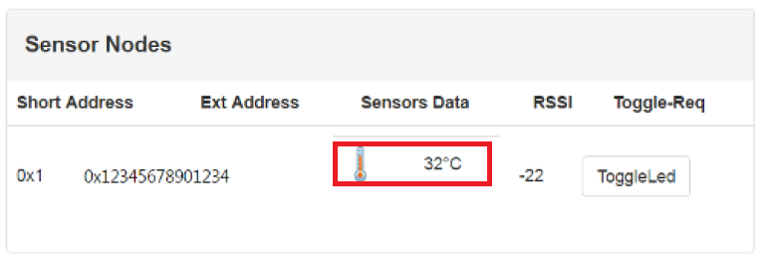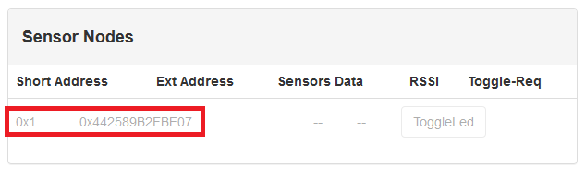

**outcomes, results and conclusions:**

Unfortunately, I was unable to get any sensor data from the boards as they would disconnect before showing any of the data. Because of this I don’t really have any results to analyze. I also have no idea why this issue occurs. I am unsure if it is a problem with the sensor program, the coprocessor program or if it is another bug in the Linux Gateway SDK that I was unable to find. All in all this project was unable to really fulfill the goal at all. I can’t get the temperature data and I don’t seem to have shown any real mastery over the Beaglebone Black or the CC1350.