Title: Cassin’s Sparrows Defend Habitat with More Shrubs than Surrounding Areas

Claire M. Curry1,2, Jeremy D. Ross1, and Eli S. Bridge1

1Oklahoma Biological Survey, University of Oklahoma, Norman, OK 73019, USA.

2Corresponding author; email: [curryclairem@gmail.com](mailto:curryclairem@gmail.com)

Please send page proofs to the corresponding author at the above e-mail address

ABSTRACT.---text.

Key words.---Cassin’s Sparrow, grasslands, habitat, behavior, landscape ecology

Cassin’s Sparrow (*Peucaea cassinii*) is a species of arid and shrubby grasslands of central North America (Dunning, Jr. et al. 1999). It appears to have a stable population in North America based on Breeding Bird Surveys (Sauer et al. 2017), but trends vary by state, region, and time period (Dunning, Jr. et al. 1999). Its temporally and spatially erratic population distribution, with few returns on banded birds, make it difficult to study (Dunning, Jr. et al. 1999). MORE DETAILS HERE.

Few studies have examined this species’ movements or precise habitat preferences (Dunning, Jr. et al. 1999; but see Cooper et al. 2014). Summer rainfall, and possibly grasshopper abundance as a regular food, does appear to be related to the erratic distribution. Some past studies suggest what. Most of these studies, however, do not focus specifically on Cassin’s Sparrows (Ruth 2000; but see Cooper et al. 2014).

In Oklahoma, Cassin’s Sparrow is not currently declining significantly (Sauer et al. 2017). Recent work at one site in northwestern Oklahoma (Cooper et al. 2014) suggests Cassin’s Sparrows there preferred habitat with more sagebrush than surrounding areas and were more often found on northern slopes. MORE DETAILS HERE.

Our study aims to provide further information on Cassin’s Sparrow habitat preferences across multiple habitat types by examining six study sites in short and mixed grass prairies in western Oklahoma. We ranked territorial defense behaviors in response to playbacks across gridded plots to quantify the importance of different vegetation and cover to Cassin’s Sparrow in this region.

METHODS

We conducted our surveys at seven plots within six sites in 2014 (Fig. 1). Ecoregions are as defined in Diamond and Elliot (2015). Black Mesa State Park contains ?? ecoregions. One plot (400 x 1,300 m) was located in ??. Cimarron Hills WMA contains ?? ecoregions. One plot (800 x 800 m) was located in ?? [habitat type]. Optima Wildlife WMA contains ? ecoregions. Two plots (both 800 x 800 m) were located in ??. Packsaddle WMA contains ?? ecoregions. One plot (800 x 800 m) was located in ??. Rita Blanca WMA contains ?? ecoregions. One plot (800 x 800 m) was located in ??. Selman Ranch is a 14,000 acre guest and hunting ranch (Selman Ranch 2009) contains ?? ecoregions. One plot (600 x 600 m) was located in ??.

Plots ranged from 0.36-0.64 km2 with 100 m spacing between survey points within each plot. At each survey point we played a Cassin’s Sparrow primary song three times, with 30 sec of observations between each playback (for a total of 1.5 min observations). Sparrow behavior was categorized as: 0: no response; 1: distant song; 2: chip notes; 3: counter song; 4 counter display; 5 approach; 6: circling playback; and 7: aggressive counter song. Walking time between points was ~5 min and each plot was completed in 2-3 hours. The maximum ranked behavior and closest approach distance (in m) at each point were used as our response variables. Survey points with responses of 0-2 were considered undefended; points with responses of 3-7 were considered to be located within a defended territory.

Vegetation surveys were conducted at ?? points that had been observed both with and without Cassin’s Sparrow territorial defense behaviors. At each sampling location we used four Daubenmire 1 m2 plots (one in each cardinal direction 10 m from the grid point) to record proportions of grass, forbs and woody vegetation, standing dead plants, bare ground, and vegetative litter (Daubenmire 1959). We also counted vegetation <1 m and >1 tall in a 10 m radius around each point in these categories: yucca, sagebrush, sandplum, cholla, tree species, or other shrub species.

Principle Components Analysis (PCA) was used to reduce vegetation variables in Daubenmire plots, counts of shrubs and trees < 1 m, and counts of shrubs and trees > 1 m. We kept PCs with eigenvalue >1. We used Pearson correlations to calculate loadings and interpreted loadings above |0.33| (Tabachnick and Fidell 2007). These reductions resulted in a total of nine variables: Daubenmire PC1, PC2, PC3; shrubs and trees >1m (“tall”), and shrubs and trees <1m (“short”). We used a tenth variable, the ratio of tall shrubs and trees to short shrubs and trees, in addition to the reduced PCs.

We tested whether the presence or absence of defense by a Cassin’s Sparrow was related to the 10 vegetation variables at a given point. A point was classified as undefended (no response, chip notes, or distant song) or defended (counter display; approach; circling playback; and aggressive counter song). We related these Cassin’s Sparrow territorial responses to vegetation PCs using binomial generalized linear mixed models (fixed effects: all vegetation variables; random effect: study site location.

When a sparrow defended a point, we tested whether closest approach distance (assumed to reflect the strength of defense or closeness to a bird’s territory; a point outside a bird’s territory would not be approached as closely and thus that vegetation would not be considered important to it) was related to vegetation PCs using a linear mixed model (with the same effects as the previous model).

We used location as a random effect in all mixed models to account for some points including the same birds defending multiple points. No sightings were at greater than 100 m (the distance between survey points).

RESULTS

Presence or absence of Cassin’s Sparrow territorial defense was significantly related (Table 1) to tall shrubs and trees PC3 (Fig. 2) and short shrubs and trees PC1 (Fig. 3); it was marginally related to tall shrubs and trees PC1. PC loadings indicate what vegetation variables were important in the response (Table 2). Cassin’s Sparrows were more often seen in habitat with more >1m yuccas and fewer >1m trees (typically junipers or acacia) (Fig. 2). For short vegetation (<1m), they were more often present in areas with more short yuccas, less short sagebrush, less short sandplum, more short cholla, and more short other shrubs (Fig. 3). The marginally significant tall shrub PC1 associated more Cassin’s Sparrow presence with fewer tall sagebrush, fewer tall sandplums, more tall cholla, and more tall other shrubs. The closest approach distance to playback was not significantly related to any vegetation variables (Table 1).

The significant PCs show some clustering by site (Fig. 4) but there is no overall separation of defended and undefended points.

DISCUSSION

Our results differ from the Cooper et al. study in that birds at our study sites did not prefer sagebrush despite its presence. In fact, they preferentially defended areas with lower counts of both tall and short sagebrush. We posit that this reflects the vegetation available in our study sites rather than a contradiction of population preferences in a study species with no known genetic structure (citation) and a nomadic existence (citation).

Further study should focus on vegetation structure, particularly heights and densities, rather than species or cover percentages alone, as the dominant species will vary by site across the range potentially encountered by a nomadic individual. The density of the cover provided by a sagebrush (or any given shrub type) at our sites may different from the sagebrush at other studies’ sites, either because of climatic or soil conditions or because different species of sagebrush (or cholla or yucca or any other given type) are present. More extensive sampling across the range should provide more structural than vegetation-species-specific details.

We note that even “resident” species move more than expected. Cite Boyle’s Grasshopper Sparrow work. Such work on intra-season and inter-season movements will be difficult in this species, but would provide additional understanding of how grassland birds choose their territories, which is important both for our understanding of life histories and understanding how best to manage habitat to allow for conservation of grassland species that may require heterogenous habitats (citation).

ACKOWLEDGMENTS

We thank T.E. Smith for help with study design and field work; R. Feliciano and J. Haughawout for assistance in gathering data; and M.A. Patten for statistical discussion We thank the Oklahoma Department of Wildlife Conservation, Oklahoma Tourism and Recreation Department, and the Selman Guest Ranch for land access. This study was conducted under OU IACUC R12-019. This work was funded by USDA-NIFA grant #2013-67009-20369 to ESB. CMC was also supported by National Science Foundation grants IDBR 1014891 and ABI ???? to ESB and Oklahoma Department of Wildlife Conservation grant ??? to M.A. Patten.

LITERATURE CITED

Cooper, B.S., R.D. Elmore, F.S. Guthery and P. Van Els. 2014. Territory characteristics of Cassin’s Sparrows in northwestern Oklahoma. American Midland Naturalist 171: 90–96.

Daubenmire, R. 1959. A canopy-coverage method of vegetational analysis. Northwest Science 33: 43–64.

Diamond, D.D. and L.F. Elliott. 2015. Oklahoma ecological systems mapping interpretive booklet: methods, short type descriptions, and summary results. Oklahoma Department of Wildlife Conservation, Norman, OK.

Dunning, Jr., J.B., R.K. Bowers, Jr., S.J. Suter and C.E. Bock [online]. 1999. Cassin’s Sparrow (Aimophila cassinii). The Birds of North America Online.

Ruth, J.M. [online]. 2000. Cassin’s sparrow (*Aimophila cassinii*) status assessment and conservation plan.

Sauer, J.R., D.K. Niven, J.E. Hines, D.J. Ziolkowski, Jr., K.L. Pardieck, J.E. Fallon and W.A. Link. 2017. The North American Breeding Bird Survey, Results and Analysis 1966 - 2015, Version 2.07.2017. USGS Patuxent Wildlife Research Center, Laurel, MD.

Selman Ranch [online]. 2009. Selman Ranch Home. <http://www.selmanranch.com/main.htm> (20 July 2017).

Tabachnick, B.G. and L.S. Fidell. 2007. Using multivariate statistics, 5th edition. Pearson, Boston.

TABLES

TABLE 1. Model results. Will organize more later.

Response variable: binary presence/absence

Number of obs: 116, groups: Location, 7

Fixed effects:

Estimate Std. Error z value Pr(>|z|)

(Intercept) -0.36161 0.25509 -1.418 0.15631

daubPC1 0.04675 0.18029 0.259 0.79539

daubPC2 -0.27223 0.18608 -1.463 0.14347

daubPC3 0.22978 0.23464 0.979 0.32742

abovePC1 -1.25034 0.60319 -2.073 0.03819 \*

abovePC2 -0.10182 0.51011 -0.200 0.84180

abovePC3 -0.73453 0.38473 -1.909 0.05623 .

belowPC1 0.90338 0.32882 2.747 0.00601 \*\*

belowPC2 0.09608 0.31876 0.301 0.76311

belowPC3 1.08531 0.90079 1.205 0.22826

Response variable: distance to closest approach.

Number of obs: 51, groups: Location, 7

Fixed effects:

Estimate Std. Error df t value Pr(>|t|)

(Intercept) 25.06852 4.37245 41.00000 5.733 1.04e-06 \*\*\*

daubPC1 -0.58357 2.87059 41.00000 -0.203 0.840

daubPC2 0.39245 2.90249 41.00000 0.135 0.893

daubPC3 -0.13150 3.07106 41.00000 -0.043 0.966

abovePC1 -2.47857 8.33795 41.00000 -0.297 0.768

abovePC2 -2.78721 6.78354 41.00000 -0.411 0.683

abovePC3 -4.71780 5.78064 41.00000 -0.816 0.419

belowPC1 -0.03555 4.10650 41.00000 -0.009 0.993

belowPC2 0.16074 4.82987 41.00000 0.033 0.974

belowPC3 0.81591 2.46265 41.00000 0.331 0.742

TABLE 2. Principle components analysis loadings for principle component axes that were significant in vegetation analyses.

FIGURE CAPTIONS

FIG. 1. Map of study sites. To be created.

FIG. 2. Cassin’s Sparrows are more often present in areas with fewer tall trees and more tall yuccas (>1m).

FIG. 3. Cassin’s Sparrows are more often present in areas with more short yuccas, less short sagebrush, less short sandplum, more short cholla, and more short other shrubs (<1m).

FIG. 4. Significant PCs with different locations in different colors (will add legend, interpret more later).

FIGURES

FIG. 1.

MAP

FIG. 2.

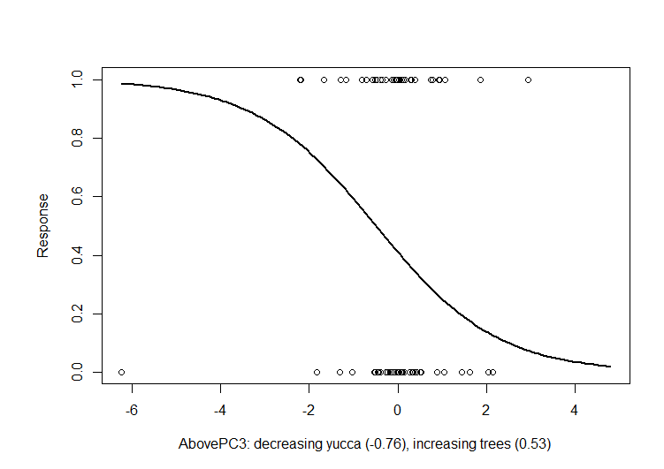

FIG. 3.

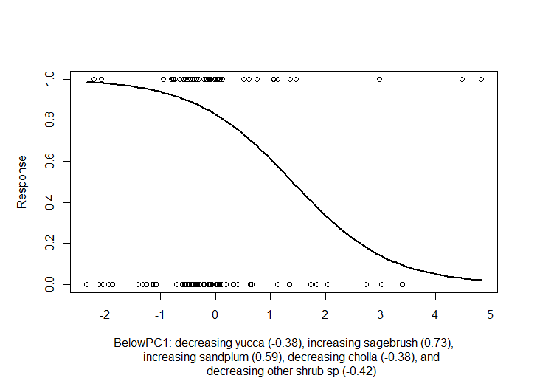

FIG. 4.

