Homework Set #6 - SOLUTION
CSCE2114 – Digital Design
Fall 2016
Due: Monday, November 21, 2016
100 Points (10 points each)

1) Show the truth table for the following circuit.

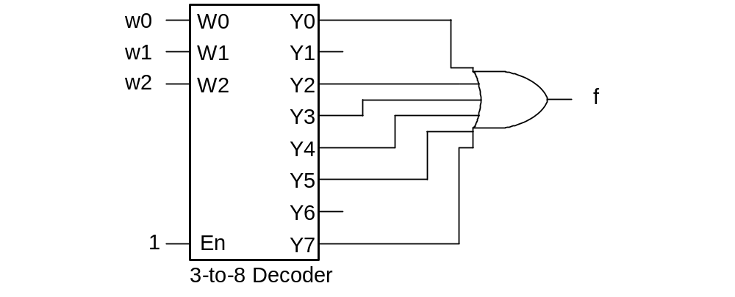

2) Implement f(A,B,C) = Σm(1,2,4,5,6) using a 3-to-8 decoder and an OR gate.

3) Implement f = A’C’ + A’B+ AB using a 2-to-1 multiplexer and any other logic gates needed. Use A for the select on the multiplexer.

4) Implement f(A,B,C) = Σm(1,2,5,7) using a 4-to-1 multiplexer, and any other logic gates needed (AND, OR, or NOT gates). Use A and B as the selects on the multiplexer.

5) Implement f(A,B,C) = Σm(1,3,5,6,7) using a 2-to-1 multiplexer, and any other logic gates needed. Use A as the select on the multiplexer.

6) Given that the CLK and D waveforms shown below are applied to a gated D latch, show the resulting Q waveform. Q is initially zero.
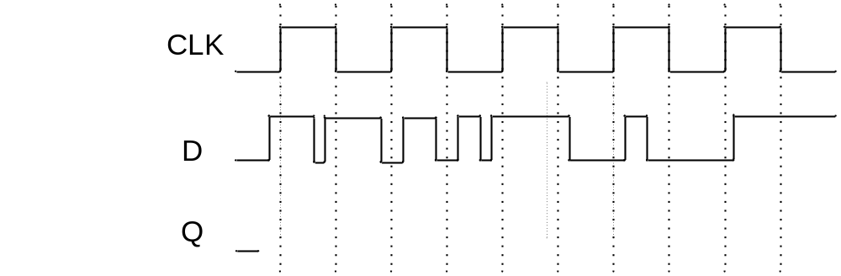

7) Given that the CLK and D waveforms shown below are applied to a rising-edge triggered D flip-flop, show the resulting Q waveform. Q is initially zero.

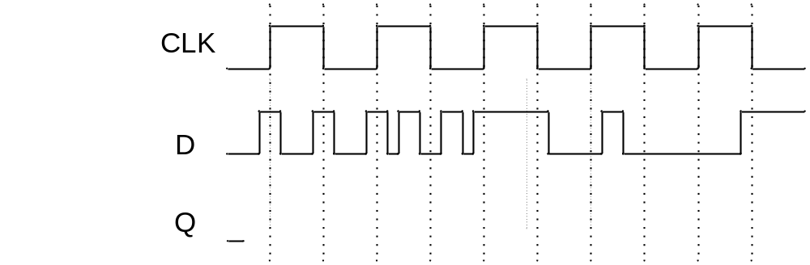

8) Given that the CLK and D waveforms shown below are applied to a falling-edge triggered D flip-flop, show the resulting Q waveform. Q is initially zero.

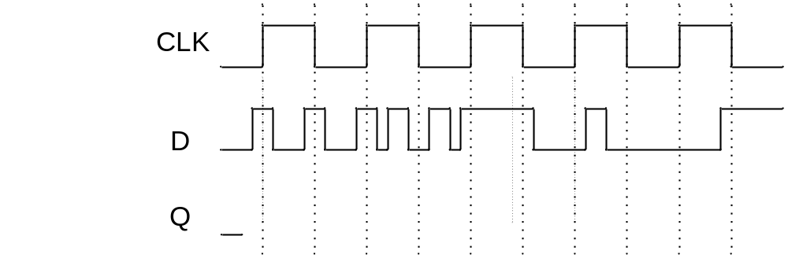

9) Given that the CLK, D, and CLRn waveforms shown below are applied to a rising-edge triggered D flip-flop, show the resulting Q waveform if CLRn is a synchronous active low clear. Q is initially zero.

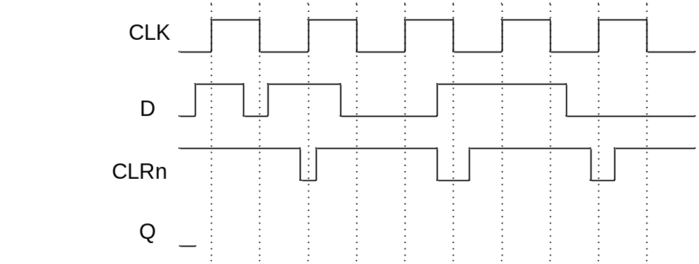

10) Given that the CLK, D, and CLRn waveforms shown below are applied to a rising-edge triggered D flip-flop, show the resulting Q waveform if CLRn is an asynchronous active low clear. Q is initially zero.

