1) Given that the CLK and D waveforms shown below are applied to a gated D latch, show the resulting Q waveform. Q is initially one. Assume gate delays are zero.

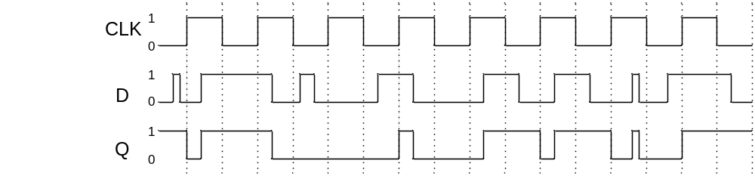

2) Given that the CLK and D waveforms shown below are applied to a rising-edge triggered D flip-flop, show the resulting Q waveform. Q is initially one. Assume gate delays are zero.

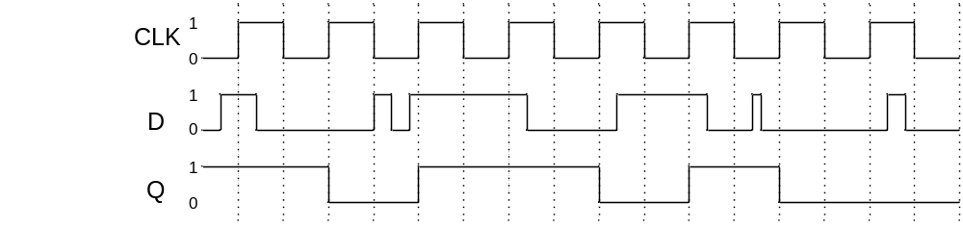

3) Given that the CLK and D waveforms shown below are applied to a falling-edge triggered D flip-flop, show the resulting Q waveform. Q is initially one. Assume gate delays are zero.

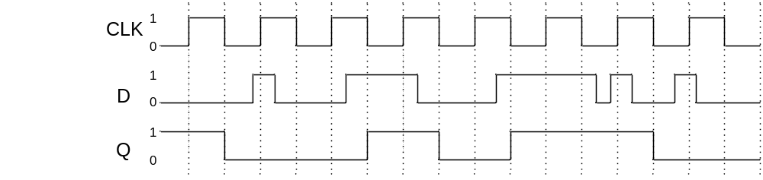

4) Given that the CLK, D, and CLRn waveforms shown below are applied to a rising-edge triggered D flip-flop, show the resulting Q waveform if CLRn is a synchronous active low clear. Q is initially one. Assume gate delays are zero.

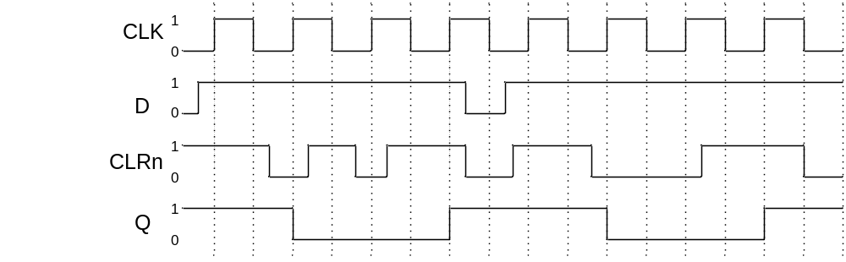

5) Given that the CLK, D, and CLRn waveforms shown below are applied to a rising-edge triggered D flip-flop, show the resulting Q waveform if CLRn is an asynchronous active low clear. Q is initially zero. Assume gate delays are zero.

