Homework Set #7 - SOLUTION
CSCE2114 – Digital Design
Spring 2017
Due: Wednesday, May 3, 2017
60 Points (10 points each)

1) Given that the CLK and D waveforms shown below are applied to a gated D latch, show the resulting Q waveform. Q is initially zero.
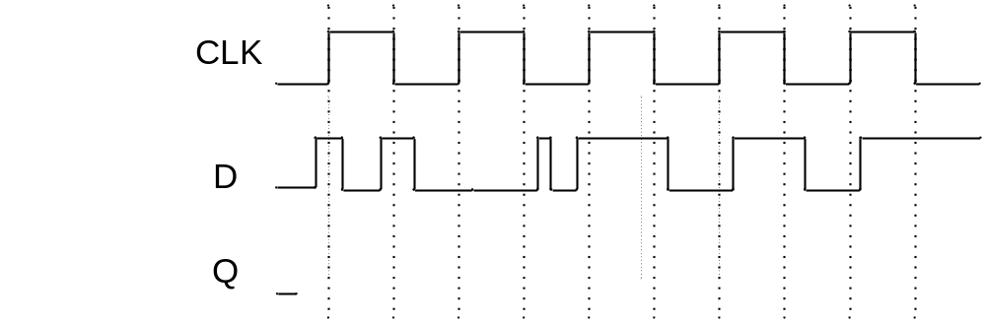

2) Given that the CLK and D waveforms shown below are applied to a rising-edge triggered D flip-flop, show the resulting Q waveform. Q is initially zero.

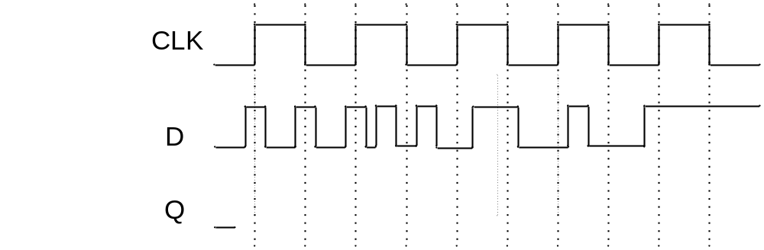

3) Given that the CLK and D waveforms shown below are applied to a falling-edge triggered D flip-flop, show the resulting Q waveform. Q is initially zero.
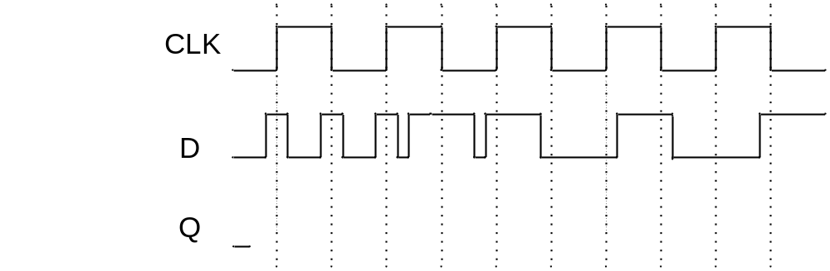

4) Given that the CLK, D, and CLRn waveforms shown below are applied to a rising-edge triggered D flip-flop, show the resulting Q waveform if CLRn is a synchronous active low clear. Q is initially zero.
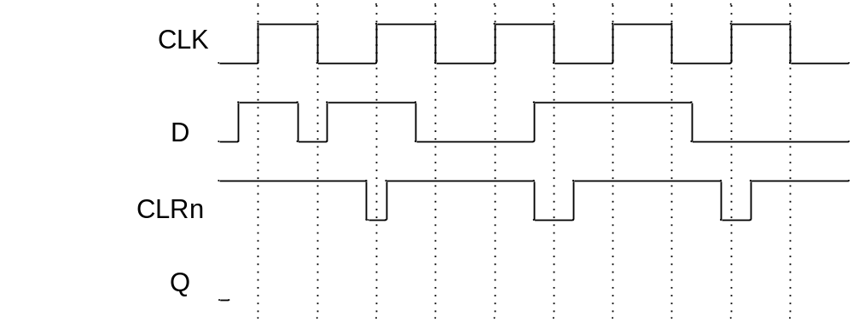

5) Given that the CLK, D, and CLRn waveforms shown below are applied to a rising-edge triggered D flip-flop, show the resulting Q waveform if CLRn is an asynchronous active low clear. Q is initially zero.
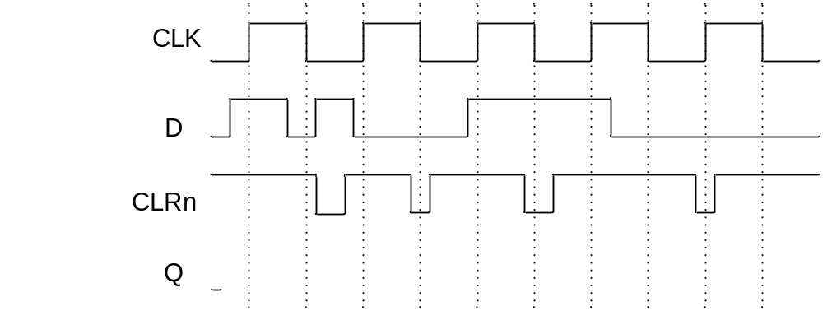

6) Draw the state diagram that corresponds with the VHDL shown below.

LIBRARY ieee ;
USE ieee.std_logic_1164.all ;
ENTITY simple IS
PORT ( Clock, Resetn, w : IN STD_LOGIC ;
z : OUT STD_LOGIC ) ;
END simple ;

ARCHITECTURE Behavior OF simple IS
TYPE State_type IS (A, B, C) ;
SIGNAL y : State_type ;
BEGIN
PROCESS ( Resetn, Clock )
BEGIN
IF Resetn = '0' THEN
y <= A ;
ELSIF (Clock'EVENT AND Clock = '1') THEN
CASE y IS
WHEN A =>
IF w = '0' THEN
y <= B ;
ELSE
y <= A ;
END IF ;
WHEN B =>
IF w = '0' THEN
y <= C ;
ELSE
y <= A ;
END IF ;
WHEN C =>
IF w = '0' THEN
y <= C ;
ELSE
y <= A ;
END IF ;
END CASE ;
END IF ;
END PROCESS ;
z <= '1' WHEN y = B ELSE '0' ;
END Behavior ;

