**CSCE 4013/5013 Cloud Computing and Security**

**Quiz #8 (20 points)**

**Name:_________________________, ID:______________________**

**Problem #1 (10 pts)**

1. Yes / No Do you participate in this quiz?

**Problem #2 (10 pts)**

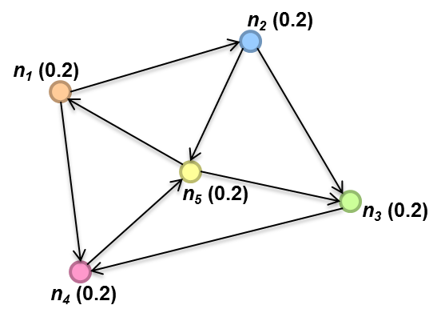

The initial pagerank masses of 5 nodes in the graph are shown above. The random jump factor α=0.2.

The pagerank masses of 5 nodes after the first pass of the first iteration:

|  |  |
| --- | --- |
| **Node ID** | **Pagerank Mass** |
| 1 | 0.1 |
| 2 | 0.1 |
| 3 | 0.2 |
| 4 | 0.3 |
| 5 | 0.3 |

The pagerank masses of 5 nodes after the second pass of the first iteration:

|  |  |
| --- | --- |
| **Node ID** | **Pagerank Mass** |
| 1 | 0.12 |
| 2 | 0.12 |
| 3 | 0.2 |
| 4 | 0.28 |
| 5 | 0.28 |