Hadoop 3.x installation guide
Version 3 and later of Apache Hadoop requires at least Java 8. Here we will use Hadoop 3.2.0 and Java 8. You are free to use other versions.

- Install Java:
$sudo apt-get update
$sudo apt-get install openjdk-8-jre openjdk-8-jdk
Set Java_Home:
$vi ~/.bashrc
Add the following command to the file:
export JAVA_HOME=/usr/lib/jvm/java-8-openjdk-amd64
Save and close the file. Activate the setting immediately with:
$source ~/.bashrc

2. Install Hadoop
Download Hadoop-3.2.0.tar.gz:
$sudo wget http://mirrors.advancedhosters.com/apache/hadoop/common/hadoop-3.2.0/hadoop-3.2.0.tar.gz

Install Hadoop to /usr/local
$ sudo tar -zxvf ./hadoop-3.2.0.tar.gz -C /usr/local
$ cd /usr/local/
$ sudo mv ./hadoop-3.2.0 ./hadoop
$ sudo chown -R username:username ./hadoop (This command is to change permission of hadoop file. Replace the username with your account username. For example, my account username is Fengli and the command will be like: $ sudo chown -R fengli:fengli ./hadoop )

3. Run an example of Hadoop
$cd /usr/local/hadoop
$mkdir input
$cp ./etc/hadoop/*.xml input
$./bin/hadoop jar share/hadoop/mapreduce/hadoop-mapreduce-examples-*.jar grep input output 'dfs[a-z.]+'
$cat ./output/part-r-00000
$rm -R ./output (delete output)
Result:
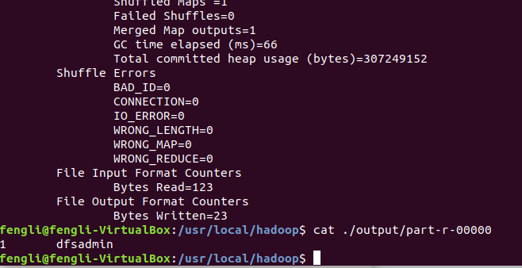
Run MapReduce "WordCount" program
1. Add CLASSPATH to bashrc file.
$ vi ~/.bashrc

Set the Hadoop path by adding the following commands to the file:
HADOOP_HOME=/usr/local/hadoop
export CLASSPATH=$HADOOP_HOME/share/hadoop/common/hadoop-common-3.2.0.jar:$HADOOP_HOME/share/hadoop/mapreduce/hadoop-mapreduce-client-core-3.2.0.jar:$HADOOP_HOME/share/hadoop/common/lib/commons-cli-1.2.jar:$CLASSPATH

Activate the path setting immediately:
$source ~/.bashrc

2. Compile WordCount program(ignore the Warnings)
$javac WordCount.java -Xlint:deprecation

3. Make a jar file
$jar -cvf WordCount.jar ./WordCount*.class

4. Set up input files
$mkdir input
$echo "echo of the rainbow" > ./input/file0
$echo "the waiting game" > ./input/file1

5. Run the program
$/usr/local/hadoop/bin/hadoop jar WordCount.jar WordCount input output

Result:
