**Programming Project Report**

Blake Fasse

010702626

**Problem Statement:**

The goal of this assignment is to use the OpenGL API to create a random number of fireworks of random colors. Each time the window is refreshed a different number of fireworks are created at different locations and each is a different color.

**Design:**

The fireworks were designed by picking random starting points, x1,y1,z1, and then drawing lines to random points, x2,y2,z2. This was all done using the OpenGL API and the accompanying GLUT library. Some cons to using this API is simply if you don’t know how to use it then it makes it kind of hard to use.

**Implementation:**

The starting points are randomly generated inside the display function and then passed into the fireworks function. The window size was made to be 100x100x100 and from there the endpoints, x2,y2,z2, were made by choosing random points between -n to n, with n being some numbers less than 100. That random number is then added to the value of the original starting point. Sample code that was provided was from the trees program inside the source code. The development time took one week.

**Testing:**

Testing was done by figuring out the size of the window and putting the lines within those boundaries. There weren’t any inputs in the terminal but the bounds for the random number generator were hardcoded. Everything worked as expected but end points were not calculated correctly.

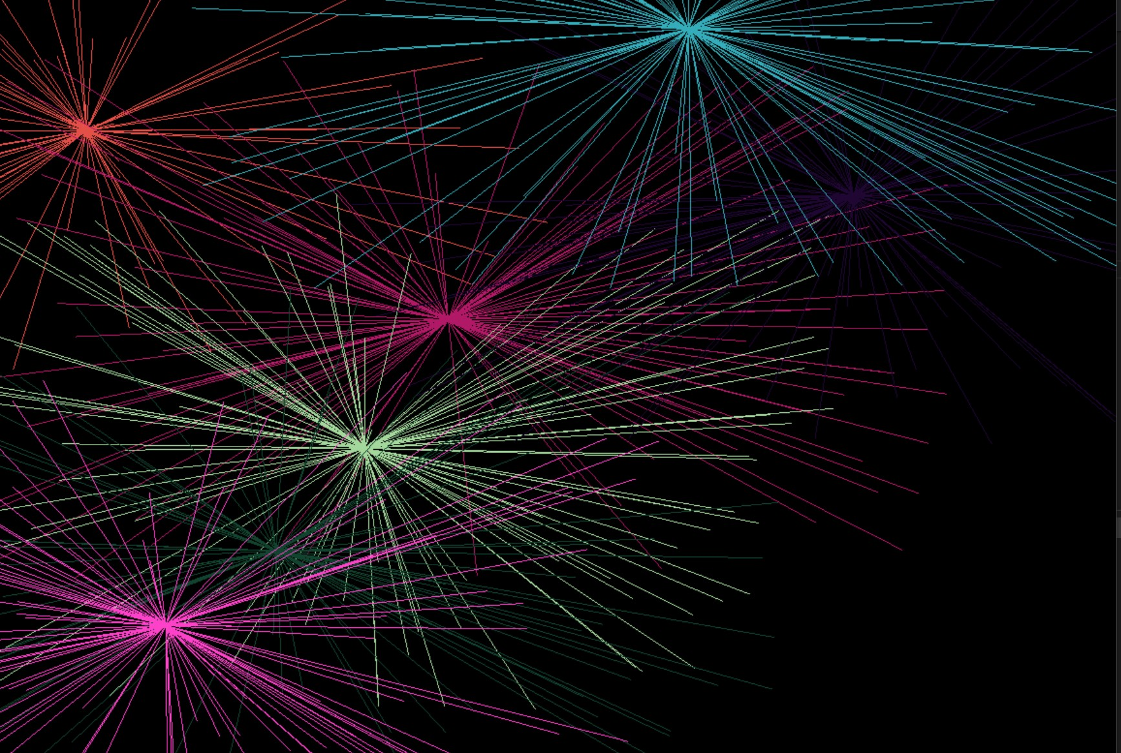

**Conclusions:**

Overall I would say the project was successful. It took me a week to finish the assignment up until the last hour. Some things I would do differently is to allocate more time to work on the project.