**Programming Project Report**

Blake Fasse

010702626

**Problem Statement:**

The goal of this assignment was to understand how to do texture mapping. Normal inputs for the program are upper and lower case XYZ to move the maze and player around. The output of the program was the movement of the maze and player. Error handling was not implemented.

**Design:**

There wasn’t a specific design decision that was made in this program. Some data structures that were used were arrays, for loops, if statements, etc. No special algorithm was used. There are no pros or cons to any of the choices.

**Implementation:**

The way this program was implemented involved reading in a text file that had the maze laid out in ASCII text and then from there was placed inside a 2D array of characters. The text file contained different letters telling us what type of material that part of the maze would be made out of, be it brick, rock, wood, or grass. The array was then looped over and a block was drawn for each element in the array and a texture was assigned to it. No sample code was given initially but there was source code provided to us at the beginning of the semester. Development time took a couple of days.

**Testing:**

Testing was done by going at the assignment piece by piece, starting with reading in the text, then loading the textures in, and finally assigning blocks and textures to the points in the maze. Normal inputs are upper and lowercase XYZ for movement of the player and the maze. Some special cases that were tested were to see what would happen if the program was launched if it could not find the textured folder. Not everything worked as expected though because I could not get the player cube to move in the maze and it was a headache trying to get the textures to work because initially I was not using them properly.

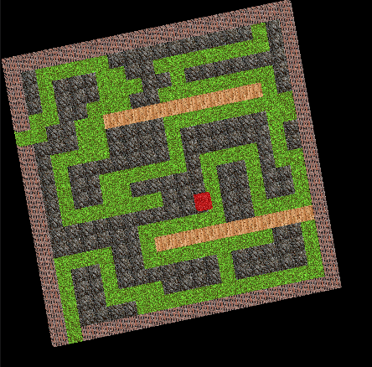**Conclusions:**

Overall I would rate this project as a success, even though I did not get the player character to work because I learned how to map textures to objects. If I could do things differently I would not have included the player character to the assignment. The project took a couple of days to complete because homework in other classes got in the way.