ASSIGNMENT SUBMISSION COVER SHEET

Student Id: **cse22-031**

Student names: **BATHUEL ORATILE BAFOREGI**

Student email: **cse22-031@thuto.bac.ac.bw**

Cohort:

Assignment title: **WARNER BROS. WEBSITE REDESIGN & DEVELOPMENT**

Date of submission:

Programme of Study:

Year of Study: **YEAR 1**

Intellectual property statement By checking the box below, I certify that this assignment is my own work and is free from plagiarism. I understand that the assignment may be checked for plagiarism by electronic or other means and may be transferred and stored in a database for the purposes of data-matching to help detect plagiarism. The assignment has not previously been submitted for assessment in any other unit or to any other institution. I have read and understood the Botswana Accountancy College plagiarism guidelines policy.

☐ Agree



Date………………………………………….

Introduction:

In the current digital era, businesses must have an online presence to engage with their target market and offer practical services. My assignment as a student developer is to organize, record, and create a website for a theater that focuses solely on films distributed by Warner Bros. This report describes the steps involved in creating a website, including the technical brief, website specifications, information design, page template design, quality assurance, publishing and promotion, and suggested improvements.

Website specifics:

1. Website Objective and Goals:

The purpose of the website is to act as an online movie theater, with a particular emphasis on films produced by Warner Bros. The website's objectives are as follows:

* Give details on recent and forthcoming movies, such as release dates, trailers, and synopses.
* Publish online ticket sales for movie screenings.
* Ensure that getting vital information and exploring movie alternatives is a seamless and user-friendly experience.
* Promote the theater's unique events, deals, and promotions.
* By giving customers a place to leave feedback and reviews, you can increase consumer engagement and satisfaction.

1. Target Audience:

The target audience for the website includes movie enthusiasts and theater-goers. Although the audience's demographics may vary, it often comprises of people 16 and older with a variety of interests in various film genres. The target audience is anticipated to have a modest level of technological ability and be accustomed to using websites and online ticketing platforms.

1. Website/Content Type:

The site will have both informational and transactional elements. It will primarily act as a platform to display movie-related information, make ticket purchasing easier, and offer a smooth user experience. The website will also include interactive elements like user comments and reviews.

Taxonomy & Information Design:

The website's information architecture will be structured as follows:

* Home: The homepage of the website, with a large banner advertising recent film releases and special offers.
* Movies: This section will include thorough details on current and forthcoming films, including plot summaries, trailers, cast bios, and showtimes.
* TV Shows: The page highlights and offers details on TV programmes that might be available for watching at movie theaters or associated events. The TV Shows section might have the title of the TV program. A concise explanation of the main idea or plot of the TV program, the TV show's broadcast schedule or movie theater showing times. Visitors can get a taste of the show's content by watching video previews or episode snippets.
* Games & Apps: This page will typically includes interactive entertainment options that complement the moviegoing experience. You might find movie-themed games, Trivia and quizzes (about movies, actors, or general cinema knowledge), mobile apps e.t.c.
* Collections: the page includes carefully chosen collections or subcategories of films that are related by theme, genre, or other identifying traits. These collections' objective is to assist users in finding potential movie interests.
* User Reviews: This section allows viewers to comment on and rate the movies they've seen.

Page Template Design:

Please refer to the attached wireframes and page templates for a visual representation of the website design.

Technical Brief:

The technologies and resources to be used in developing the website are as follows:

* Programming Languages: HTML, CSS, JavaScript
* Design Tools: Adobe Photoshop, Sketch, Figma
* Version Control: Git
* Hosting: GitHub Pages

Quality assurance:

Tests for browser compatibility

screenshots showing how the website appears and works in various browsers like Microsoft Edge, Mozilla Firefox, Safari, and Google Chrome.

Tests on mobile devices:

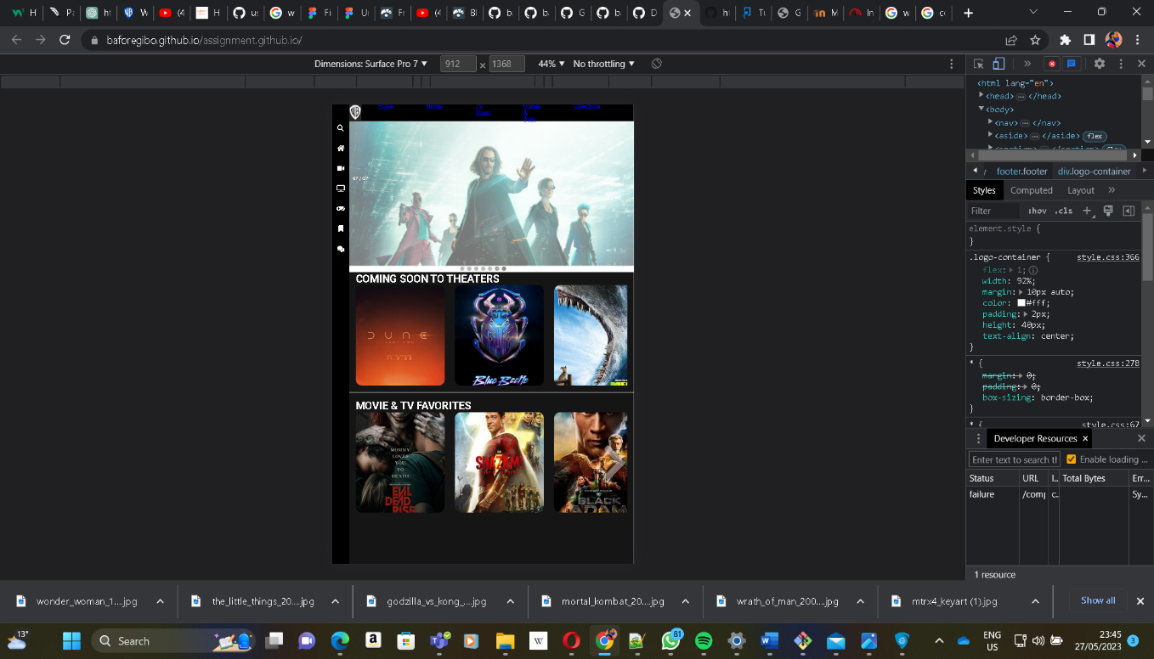

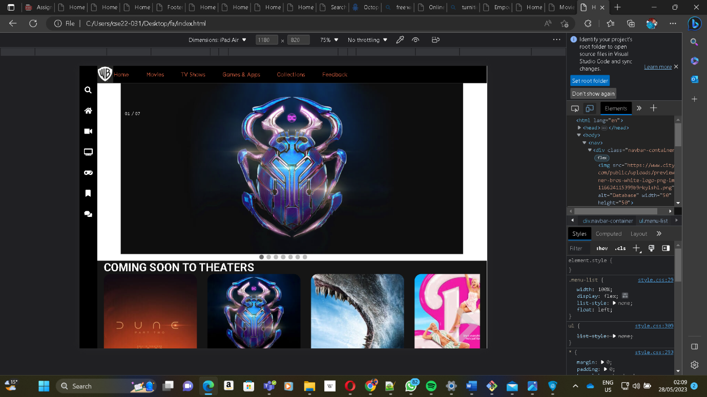

screenshots demonstrating the website's usability and responsiveness on various mobile devices, such as smartphones and tablets that use the iOS and Android operating systems.

Publishing and advertising:

The website will be hosted on GitHub Pages using the tools and techniques listed below:

The project GitHub repository have been created.

* git init - Initialize a local Git repository
* git clone ssh://git@github.com/[username]/[repository-name].git - Create a local copy of a remote repository

To maintain version control and keep track of changes, Git commands will be used. Git commands such as:

* git status - Check status
* git add [file-name.txt] - Add a file to the staging area
* git add -A - Add all new and changed files to the staging area
* git commit -m "[commit message]" - Commit changesgit rm -r [file-name.txt]
* git push origin [branch name] - Push a branch to your remote repository
* git push -u origin [branch name] - Push changes to remote repository (and remember the branch)
* git push - Push changes to remote repository (remembered branch)
* git push origin --delete [branch name] - Delete a remote branch
* git pullUpdate local repository to the newest commit
* git pull origin [branch name] - Pull changes from remote repository
* git remote add origin ssh://git@github.com/[username]/[repository-name].git - Add a remote repository
* git remote set-url origin ssh://git@github.com/[username]/[repository-name].git - Set a repository's origin branch to SSH

Necessary scripts to deploy the website to GitHub Pages have been applied.

**LINK TO THE SITE:** [**https://baforegibo.github.io/assignment.github.io/**](https://baforegibo.github.io/assignment.github.io/)

**LINK TO THE REPOSITORY:** [**https://github.com/baforegibo/wmd-assignment.github.io**](https://github.com/baforegibo/wmd-assignment.github.io)

Future developments and advice

The website can be further enhanced in the future in the following ways:

Including a user account system will allow for more individualized experiences, such as saved preferences, ticket history, and special deals.

the inclusion of a recommendation system for movies based on user preferences and viewing behavior.

people to contribute movie reviews and information on their social media profiles through the implementation of a social media integration.

adding a news or blog area to offer articles about movies, behind-the-scenes information, and updates on the business.

the incorporation of a loyalty program to offer perks and incentives to loyal customers.

Conclusion:

This study has offered a thorough plan for creating a movie theater website that adheres to the website development process. The goals, target market, information design, technological requirements, quality control, publication strategies, and recommendations for the future have all been covered. The goal is to provide a world-class online destination that provides movie fans with access to the newest movies and improves their in-theater viewing experience.